COAL
Assignment – 03
By
Sharjeel
L1F24BSCS0506

CODE

.model small
.stack 0x100
.data
msg db 'Hey, I am Sharjeel Ahmad currently pursuing BsCs at University of Central Punjab, Lahore. This is assignment - 03 of COAL...!$'
row dw 24
col dw 0
.code
main proc
mov ax, @data
mov ds, ax

mov ax, offset msg
push ax
mov ax, row
push ax
mov ax, col
push ax

call printString
add sp, 6
mov ax, 0x4c00
int 0x21
main endp

;function definition
printString proc
push bp
mov bp, sp

push ax
push bx
push cx
push dx
push si
push di

mov si, [bp + 4] ;offset string
mov ax, [bp + 6] ;row
mov bl, 80
mul bl ;ax = row * 80
add ax, [bp + 8] ;ax = row * 80 + col
shl ax, 1 ;ax = (row * 80 + col) * 2
mov di, ax ; di = video memory offset

mov ax, 0xB800 ;video memory segment
mov es, ax

printLoop:
mov al, [si]
cmp al, '$'
je exit

mov es:[di + 0], al
mov byte ptr es:[di + 1], 0xb3 ;grey character with black background
add si, 01
add di, 02

cmp di, 4000
jb printLoop

call scrollUpward
mov di, 3840
jmp printLoop
exit:
pop di
pop si
pop dx
pop cx
pop bx
pop ax
pop bp
ret
printString endp

;function definition
scrollUpward proc
push si
push di
push cx
push ax

mov ax, 0xB800
mov es, ax

mov si, 160 ;2 * 80
mov di, 0
mov cx, 1920 ;80 * 24

scrollLoop:
mov ax, es:[si]
mov es:[di], ax
add si, 2
add di, 2
loop scrollLoop

mov di, 3840
mov cx, 80
clearWithSpace:
mov es:[di], ' '
add di, 2
loop clearWithSpace
exitScroll:
pop ax
pop cx
pop di
pop si
ret
scrollUpward endp

______________________________________________________________________________

Screen Shots

At r = 0, c = 0
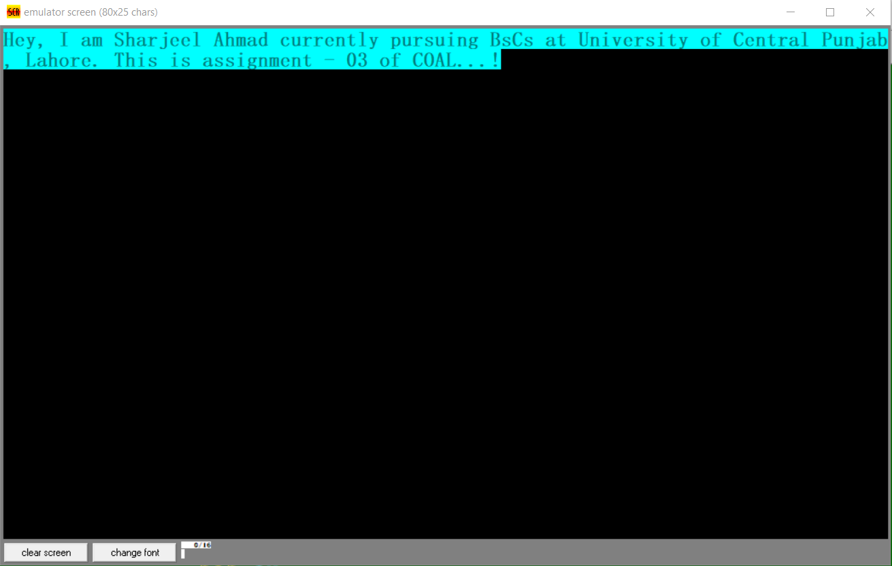

At r = 24, c = 0

