Graded Lab 1
Write an 8086 assembly language program that performs the following operations step by step:
- Store the following 16-bit numbers in memory starting at offset 1000H for current data segment:
- 0x1205, 0x0A3F, 0x00FF, 0x0B20
- Load these numbers one by one into registers and:
  - Add the first and second numbers,
  - Subtract the third number from the result,
  - Then add the fourth number.
- Store the final result in the register DX.

Code
.model small
.stack 100h
.data
num1 dw 0x1205
num2 dw 0x0A3F
num3 dw 0x00FF
num4 dw 0x0B20
.code
main proc
mov ax, @data
mov ds, ax

mov bx, 0x1000 ;offset

;store at memory
mov si, 0
mov ax, num1
mov [bx + si], ax

add si, 2
mov ax, num2
mov [bx + si], ax

add si, 2
mov ax, num3
mov [bx + si], ax

add si, 2
mov ax, num4
mov [bx + si], ax

;load first 2 numbers from memory
mov si, 0
mov ax, [bx + si]
add si, 2
mov dx, [bx + si]
add si, 2

;add first 2 numbers
add ax, dx

;load 3rd number from memory
mov dx, [bx + si]
add si, 2

;subtract 3rd number from result
sub ax, dx

;load 4th number from memory
mov dx, [bx + si]

;add 4th number to result and store in dx
add dx, ax

main endp
.exit

Storing at Memory
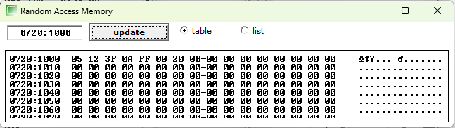

Output
