- Write a program that subtracts two numbers so that the result is negative. Then perform another subtraction that gives zero in output and check the SF and ZF flags.
Code:
.model small
.stack 100h
.data
num1 db 0x05
num2 db 0x08
num3 db 0x06
num4 db 0x06

.code
main proc
mov ax, @data
mov ds, ax

;first subtraction
mov al, num1
sub al, num2

;second subtraction
mov al, num3
sub al, num4

main endp
.exit

First subtraction:

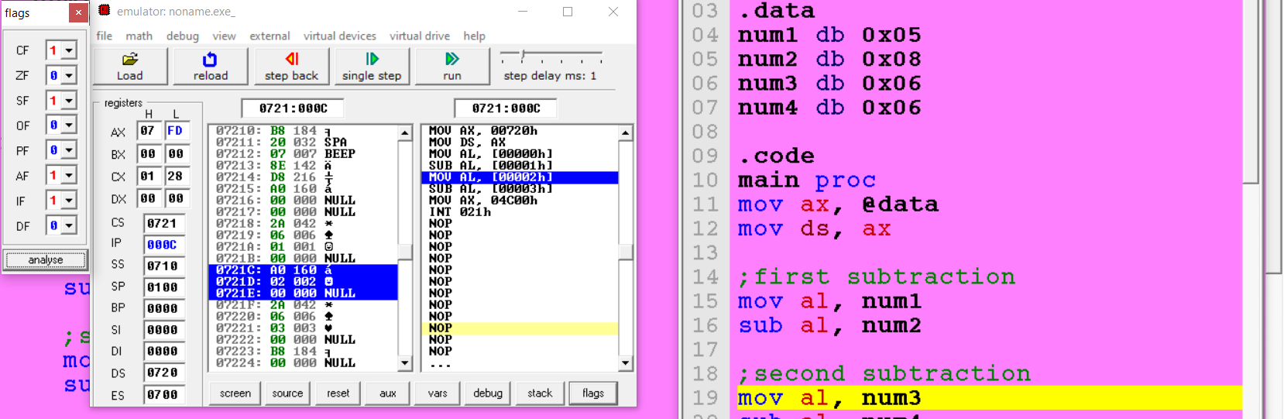

Second Subtraction:

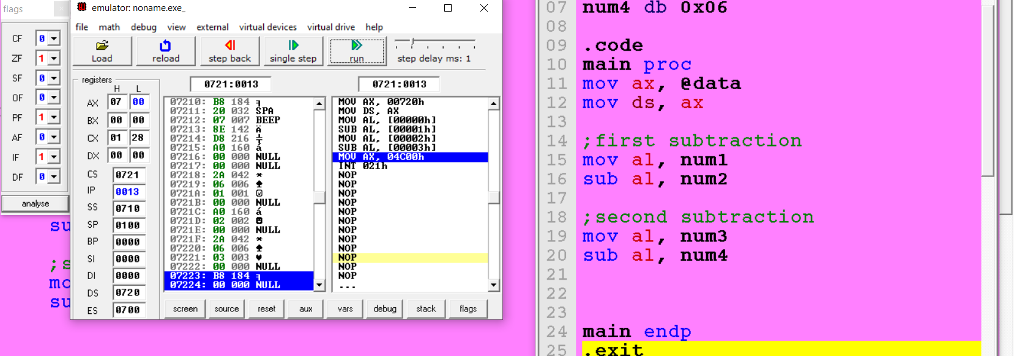

- Write a program that stores the given two 32-bit numbers into the current data segment at offset: 0x1000 and 0x1008, respectively. The program then calculates the sum of these numbers and stores it at the offset: 0x1010. Numbers: 0x1F540398, 0xC0A1F02E.
Code:
.model small
.stack 100h
;2. Write a program that stores the given two 32-bit numbers into the
;current data segment at offset: 0x1000 and 0x1008, respectively.
;The program then calculates the sum of these numbers and stores it at
;the offset: 0x1010.
;Numbers: 0x1F540398, 0xC0A1F02E.
.data
num1 dw 0x0398 ;lower word
num2 dw 0x1f54 ;upper word
num3 dw 0xf02e ;lower word
num4 dw 0xc0a1 ;upper word
.code
main proc
mov ax, @data
mov ds, ax

mov bx, 0x1000 ;offset

;store in memory
mov si, 0
mov ax, num2
mov [bx + si], ax

add si, 2
mov ax, num1
mov [bx + si], ax

add si, 6
mov ax, num4
mov [bx + si], ax

add si, 2
mov ax, num3
mov [bx + si], ax

;load lower words from memory and sum
mov si, 2
mov ax, [bx + si]
add si, 8
mov dx, [bx + si]
add ax, dx
mov [bx + 0xc], ax

;load lower words from memory and sum
mov si, 0
mov ax, [bx + si]
add si, 8
mov dx, [bx + si]
adc ax, dx
mov [bx + 0xa], ax

main endp
.exit

Memory:
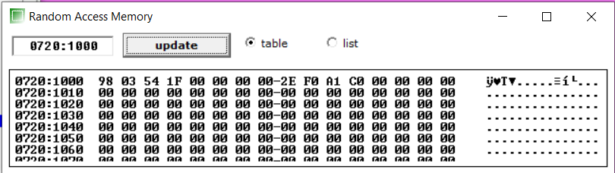

Output stored in memory:
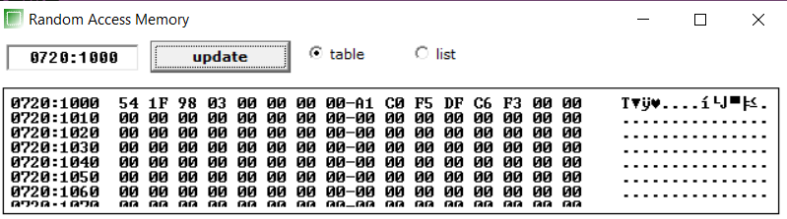

- Write code that set both PF and ZF.
Code:
.model small
.stack 100h
;3. Write code that set both PF and ZF.
.data

.code
main proc
mov al, 0xff
sub al, 0xff

main endp
.exit

Flags:
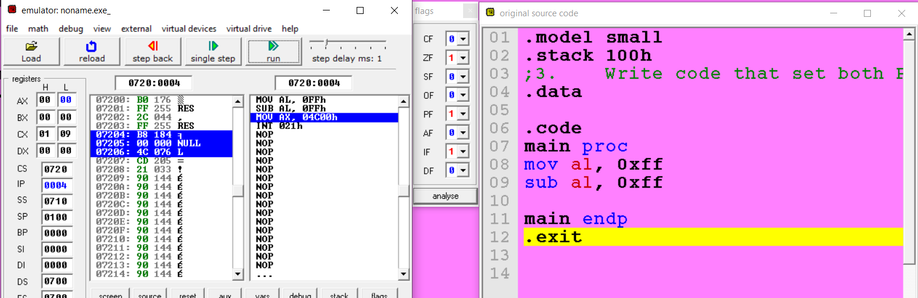
- Write a program that sub two 16-bit numbers stored in memory at offset x2000h and checks if ZF is set. If ZF = 1, store 1 at memory location 4000h; otherwise, store at 0x1000h.(use jmp)

Code:

.model small
.stack 100h
;4. Write program that sub two 16-bit numbers stored in memory at offset x2000h
;and checks if ZF is set. If ZF = 1, store 1 at memory location 4000h;
;otherwise, store at 0x1000h.(use jmp)
.data
num1 dw 0x1234
num2 dw 0x1234
.code
main proc
mov ax, @data
mov ds, ax

mov bx, 0x2000 ;offset

;store in memory
mov ax, num1
mov [bx], ax

mov ax, num2
mov [bx + 2], ax

;load from memory and subtract
mov ax, [bx]
sub ax, [bx + 2]

jz mov_to_0x4000

mov [bx - 0x1000], ax
jmp end

mov_to_0x4000:
mov [bx + 0x2000], ax

main endp
end:
.exit

ZF is set:
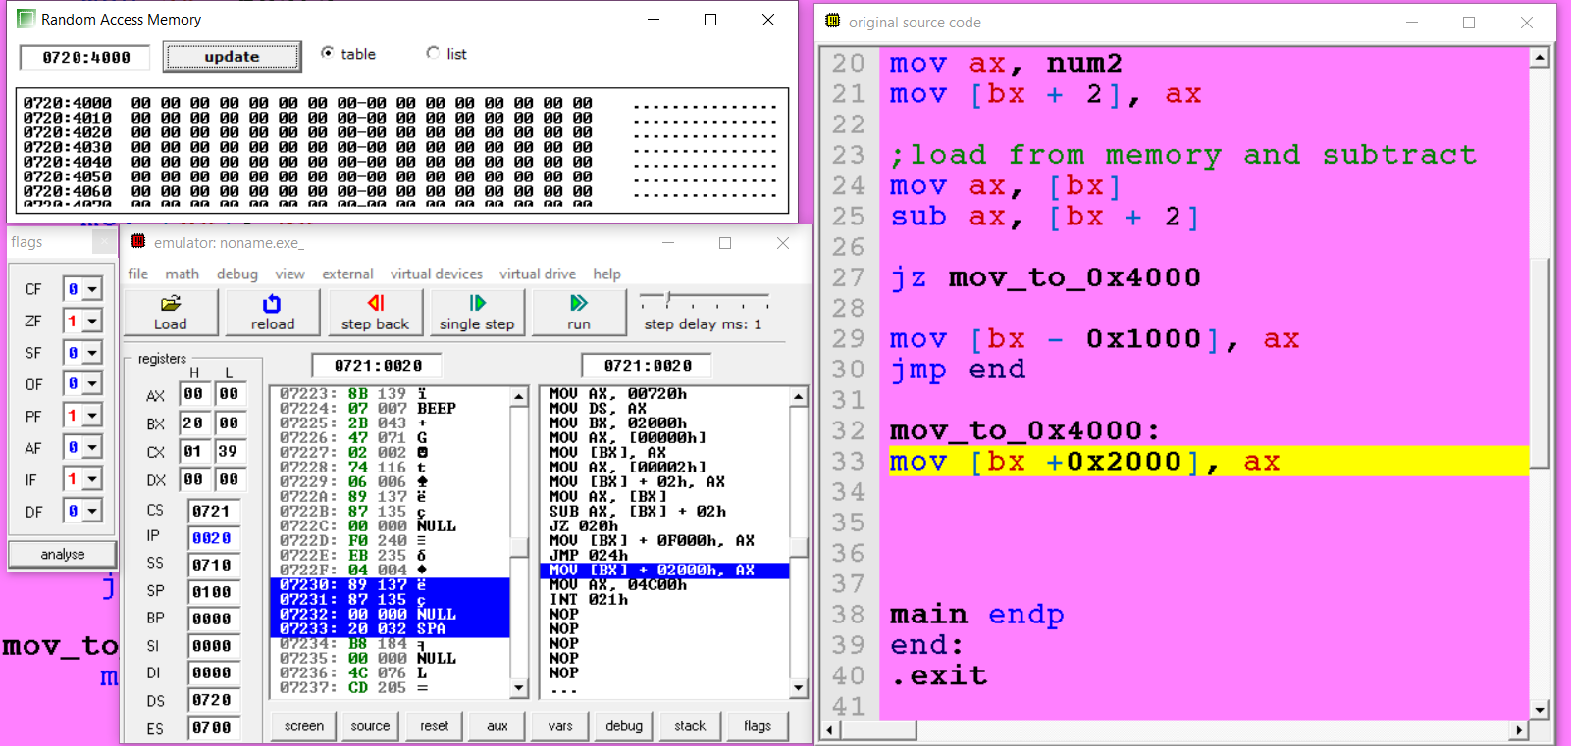

ZF is not set:
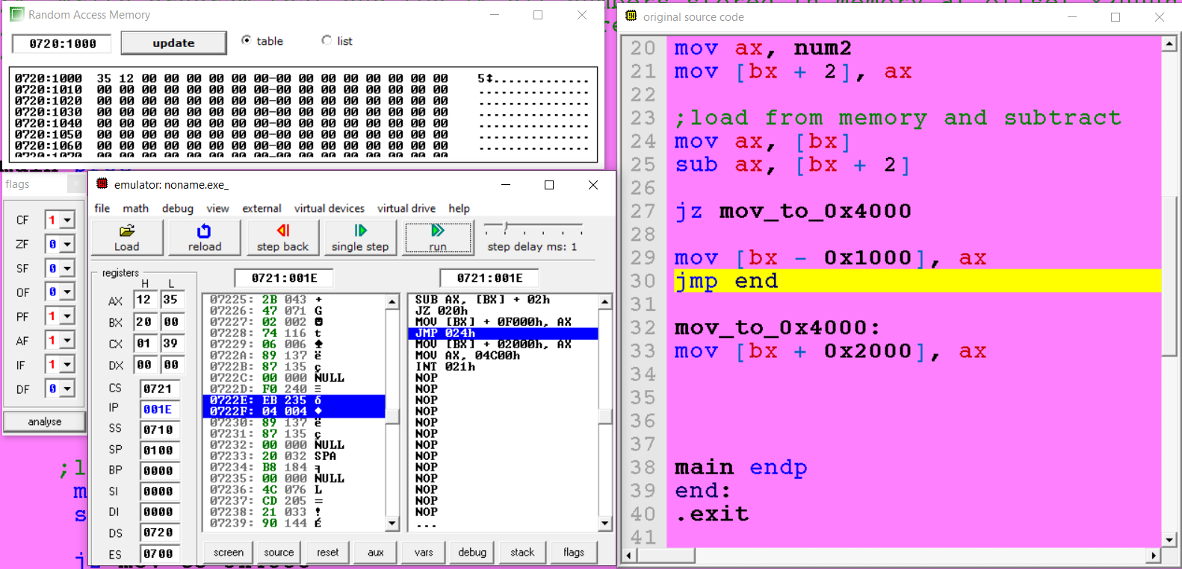

5. Write a program to implement the following equation.
X = ~0xFF12 ^ {0xABFF & (0x2113 | 0x2340)}
~ Invert all bits
^ Bitwise XOR
& Bitwise AND
| Bitwise OR

Code:
.model small
.stack 100h
.data
num1 dw 0xFF12
num2 dw 0xABFF
num3 dw 0x2113
num4 dw 0x2340
x dw 0x0000
.code
main proc
mov ax, @data
mov ds, ax

mov ax, num3
mov dx, num4
or ax, dx

mov dx, num2
and ax, dx

mov dx, num1
xor ax, dx
not ax

mov x, ax

main endp
.exit

Storred in memory:
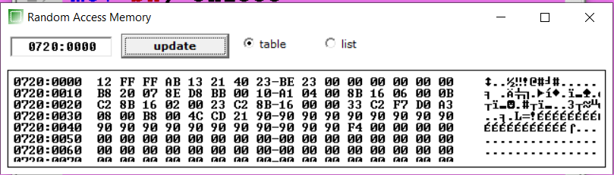

6. Write a program that stores a 32-bit number and a 16-bit number into the current data segment at offsets 0x1000 and 0x1008, respectively. The program then subs these two numbers. 0xC0A1F02E, 0x45FA

Code:

.model small
.stack 100h
;Write a program that stores a 32-bit number and a 16-bit number into the
;current data segment at offsets 0x1000 and 0x1008, respectively.
;The program then subs these two numbers. 0xC0A1F02E, 0x45FA
.data
num1 dw 0xF02E ;lower word
num2 dw 0xC0A1 ;upper word
num3 dw 0x45FA ;second number
lresult dw 0x0000
uresult dw 0x0000
.code
main proc
mov ax, @data
mov ds, ax

mov bx, 0x1000 ;offset

;store in memory
mov si, 0
mov ax, num2
mov [bx + si], ax

add si, 2
mov ax, num1
mov [bx + si], ax

add si, 6
mov ax, num3
mov [bx + si], ax

;load from memory and subtract
mov si, 2
mov ax, [bx + si]
add si, 6
mov dx, [bx + si]
sub ax, dx

;store in result variable
mov dx, [bx]
mov uresult, dx ;stored at 0720:0000 memory(global variables)
mov lresult, ax ;stored at 0720:0000 memory(global variables)

main endp
.exit

Stored in memory:
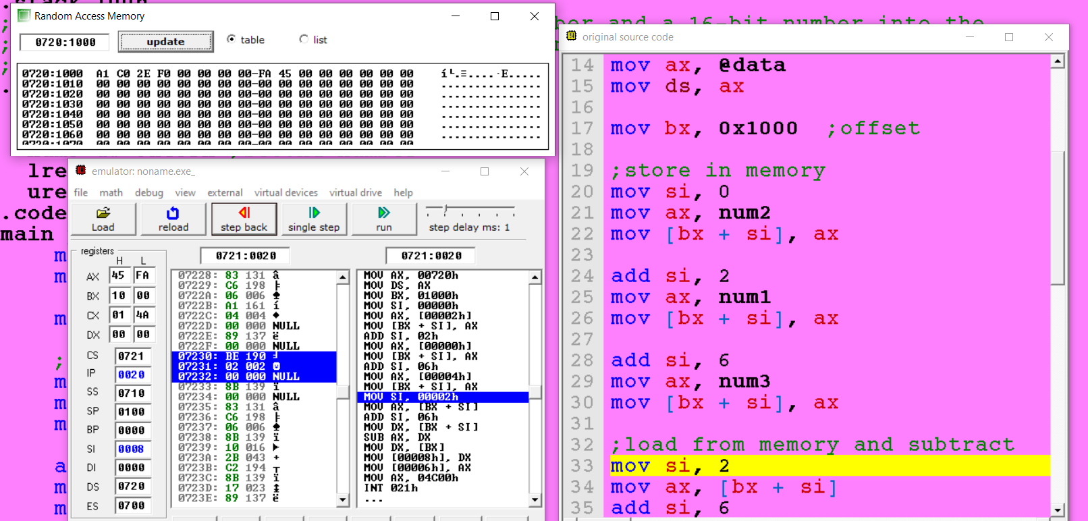

Stored in result variable in data segment:
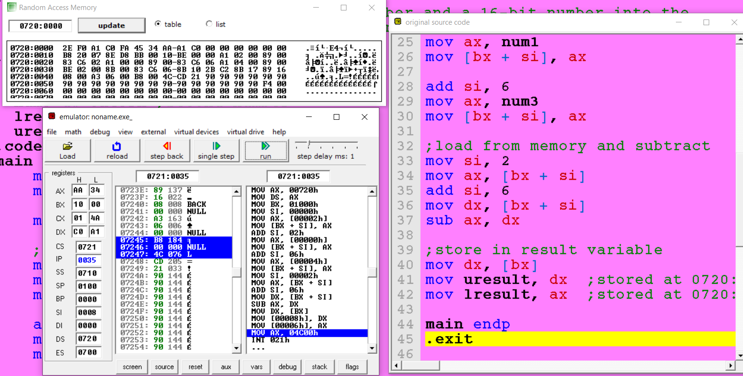

7. Write an assembly program to store 5 numbers in an array and then add them.
Code:
.model small
.stack 100h
;7. Write an assembly program to store 5 numbers in an array and then add them.
.data
array dw 0xaaaa, 0xbbbb, 0xcccc, 0xdddd, 0xeeee
sum dw 0x0000
.code
main proc
mov ax, @data
mov ds, ax

mov cx, 0x0005
mov si, offset array
mov ax, 0

loop:
add ax, [si]
add si, 2
loop loop

mov sum, ax

main endp
.exit

Saved in memory:
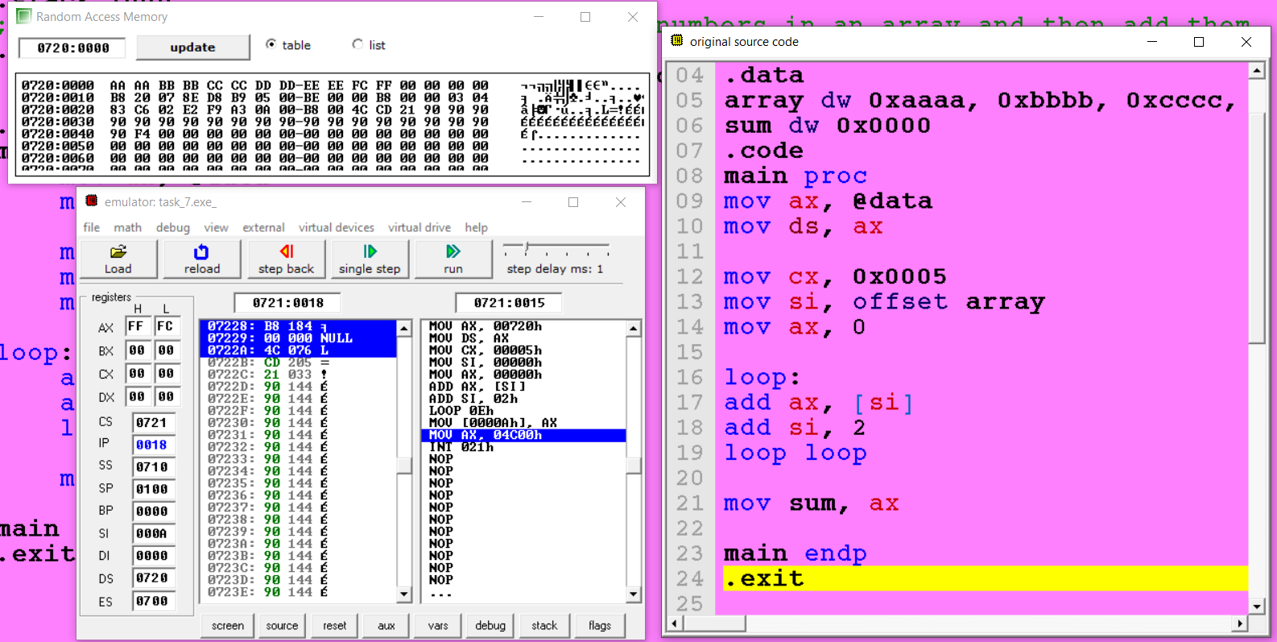

8. Take a variable in .data section, and calculate its table. (use loops).

Code:
.model small
.stack 100h
;8. Take a variable in .data section, and calculate its table. (use loops).
.data
num dw 0x0005
.code
main proc
mov ax, @data
mov ds, ax

mov ax, num
mov cx, 0x0009

;loop runs 9 times
loop:
add ax, 0x0005
loop loop

;save in memory variable
mov num, ax
main endp
.exit

Number 0x0005:
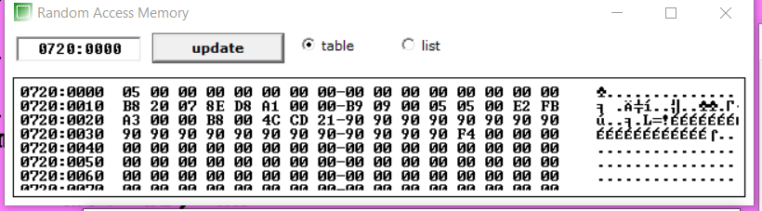

Last value after loop running to print table:

