COAL
Graded Lab - 2
By
Sharjeel
L1F24BSCS0506

CODE

.model small
.stack 100h
;Write an assembly program that declares and initializes an array of 10 numbers.
;The program should count all even numbers in the array and store the result in
;a variable named EVEN_COUNT.

.data
;an array of 10 elements
array db 0x01, 0x02, 0x03, 0x04, 0x05, 0x06, 0x07, 0x08, 0x09, 0x0a
;a variable to store total count of even number occurances
EVEN_COUNT dw 0x0000
.code
main proc
mov ax, @data
mov ds, ax ;initilize the data segment

mov dl, 0x02 ;mov 2 into dl to divide
mov cx, 10 ;loop counter
mov si, 0 ;array index pointer
mov bx, 0x0000 ;to store total number of occurances of even numbers

evenCount:
mov al, [array + si]
mov ah, 0
div dl ;divede by 2

cmp ah, 0 ;compare to find if division by 2 gives any remainder
jnz notCount ;if odd jmp

inc bx

;label which will run if the pointer is on an odd number
notCount:
inc si

loop evenCount

;load bx(total evens in array) into variable
mov EVEN_COUNT, bx

main endp
.exit

ScreenShots

Initilized array and variable in data segment

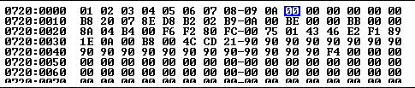

Values at start

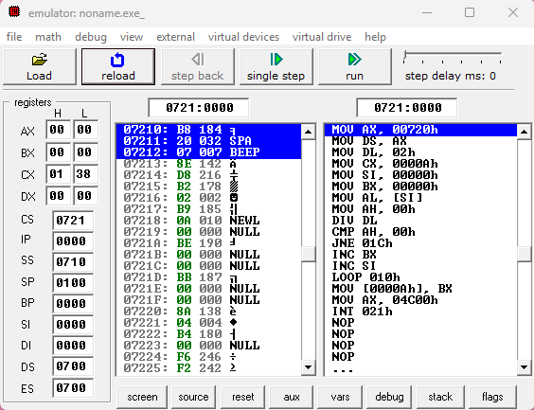

Values at end

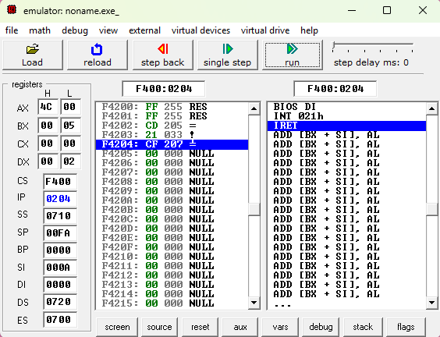

Updated memory with EVEN_COUNT showing total even numbers found in array

