COAL MID
By
Sharjeel
L1F24BSCS0506
Version – II

Question – 1

AX

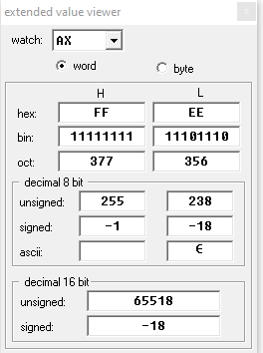

Reversed bits on BX

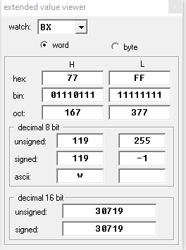

Question – 1 – b

In case of Even
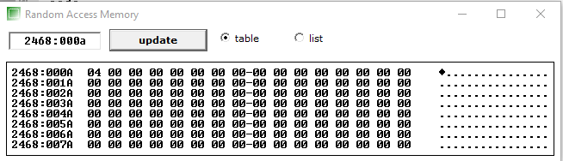

In case of odd result
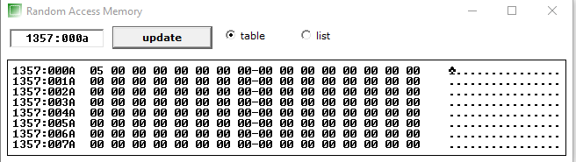

Question – 2

Unsorted
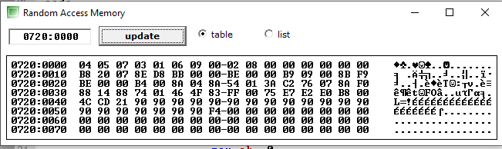

Sorted

