University of Central Punjab -FOIT
COAL Fall 2025
Quiz 2

- The 8-bit number CL=0b10110111 has its lower nibble (4 bits) representing sensor data. Extract the lower nibble and convert it to decimal.
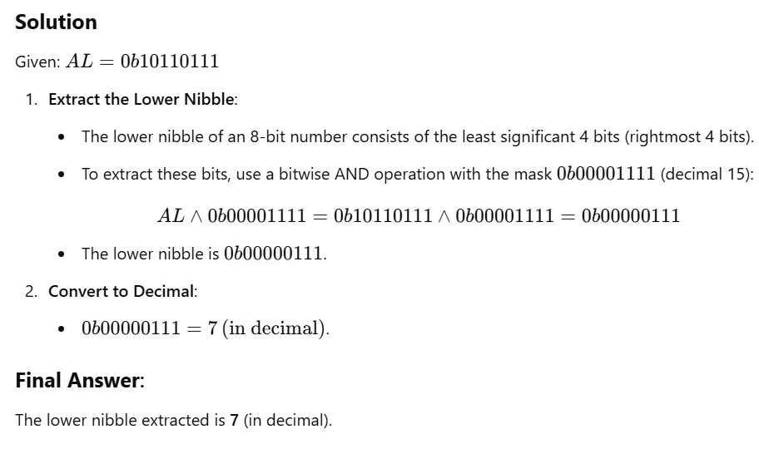

- Perform a left shift by 2 positions on DL=0b00111010. What is the new binary value, and what happens if there is overflow?
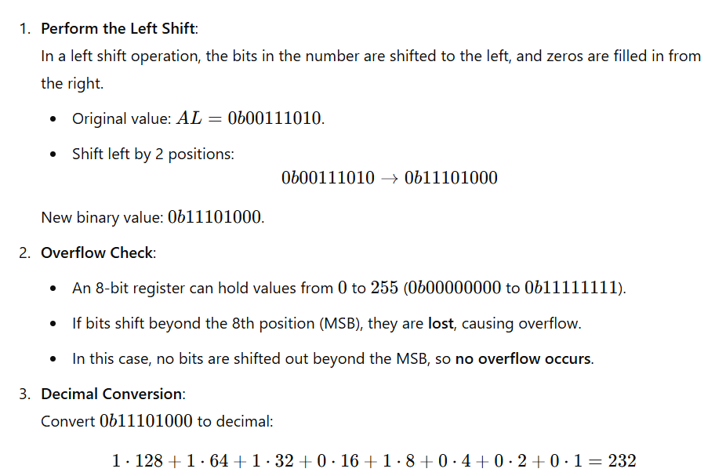

- Apply a series of operations on AL=0b01100111:
a) Perform a rotate left by 2 positions.
b) Perform a right arithmetic shift by 3 positions.
c) Rotate right by 1 position.
Provide the final result in both binary and decimal. Perform binary to decimal conversion at each step.
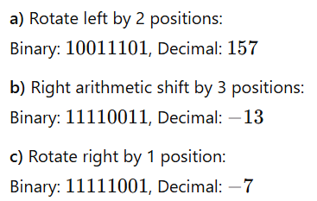
157
243
249

- Consider the following lines of code and give the value stored in CX after each instruction.
Note: CF = 1; CX = 10101100

SHL CX
XOR CX, 11110000
RCR CX

