Assignment 1

Object Oriented Programming

Question #1:
You are designing a class Book for a library system. Each book has a title, author, price, Available Quantity, and Category of the book. You also need a function that calculates a discounted price, and Order a Book for purchase based on a given discount percentage. Make sure all data members should not be accessible for outer programing world. 1 constructor set all data member default values, and another should initialize it to fixed values.
Code:
Book.h
#include <iostream>
#include <cstring>
#include <iomanip>
using namespace std;
class Book {
private:
char* m_title;
char* m_author;
char* m_category;
double m_price;
int m_quantity;
public:
Book();
Book(const char*, const char*, const char*, double, int);
~Book();

void setTitle(const char*);
void setAuthor(const char*);
void setCategory(const char*);
void setPrice(double);
void setQuantity(int);

char* getTitle();
char* getAuthor();
char* getCategory();
double getPrice();
int getQuantity();

void orderBook(int);
double calculateDiscount(int);

void printBook();
};

Book.cpp
#include "Book.h"

Book::Book() {
m_title = nullptr;
m_author = nullptr;
m_category = nullptr;
m_price = 0.0;
m_quantity = 0;
}

Book::Book(const char* title, const char* author, const char* category, double price, int quantity) {
m_title = new char[strlen(title) + 1];
strcpy(m_title, title);

m_author = new char[strlen(author) + 1];
strcpy(m_author, author);

m_category = new char[strlen(category) + 1];
strcpy(m_category, category);

m_price = price;
m_quantity = quantity;
}

Book::~Book() {
delete[] m_title;
delete[] m_author;
delete[] m_category;
}

void Book::setTitle(const char* title) {
delete[] m_title;
m_title = new char[strlen(title) + 1];
strcpy(m_title, title);
}

void Book::setAuthor(const char* author) {
delete[] m_author;
m_author = new char[strlen(author) + 1];
strcpy(m_author, author);
}

void Book::setCategory(const char* category) {
delete[] m_category;
m_category = new char[strlen(category) + 1];
strcpy(m_category, category);
}

void Book::setPrice(double price) {
m_price = price;
}

void Book::setQuantity(int quantity) {
m_quantity = quantity;
}

char* Book::getTitle() {
if (m_title == nullptr) return nullptr;
char* temp = new char[strlen(m_title) + 1];
strcpy(temp, m_title);
return temp;
}

char* Book::getAuthor() {
if (m_author == nullptr) return nullptr;
char* temp = new char[strlen(m_author) + 1];
strcpy(temp, m_author);
return temp;
}

char* Book::getCategory() {
if (m_category == nullptr) return nullptr;
char* temp = new char[strlen(m_category) + 1];
strcpy(temp, m_category);
return temp;
}

double Book::getPrice() {
return m_price;
}

int Book::getQuantity() {
return m_quantity;
}

double Book::calculateDiscount(int disc) {
return m_price - (m_price * disc / 100);
}

void Book::orderBook(int quantity) {
if (quantity > m_quantity) {
cout << "Not enough stock available! Only " << m_quantity << " books left." << endl;
return;
}

cout << "Do you want to redeem discount? (y/n): " << endl;
char choice;
cin >> choice;

double total = 0.0;
if (choice == 'y' || choice == 'Y') {
int disc;
cout << "Enter discount percentage: ";
cin >> disc;
total = calculateDiscount(disc) * quantity;
} else {
total = m_price * quantity;
}
m_quantity -= quantity;
cout << "Order placed successfully!" << endl;
cout << "Total amount: " << total << endl;
cout << "Remaining stock: " << m_quantity << endl;
}

void Book::printBook() {
//This function can also get values without getters
cout << "Title: " << getTitle() << endl;
cout << "Author: " << getAuthor() << endl;
cout << "Category: " << getCategory() << endl;
cout << "Price: " << fixed << setprecision(3) << getPrice() << endl;
cout << "Quantity: " << getQuantity() << endl;
}

Void Book
#include "Book.h"

void book() {
system("cls");

Book b_1("Udaas Naslen", "Abdullah Hussain", "Fiction", 500, 20);
Book b_2;

cout << "Enter book title" << endl;
char* title = new char[20];
cin.ignore();
cin.getline(title, 20);
b_2.setTitle(title);

cout << "Enter book author" << endl;
char* author = new char[20];
cin.getline(author, 20);
b_2.setAuthor(author);

cout << "Enter book category" << endl;
char* category = new char[20];
cin.getline(category, 20);
b_2.setCategory(category);

cout << "Enter book price" << endl;
double price;
cin >> price;
b_2.setPrice(price);

cout << "Enter book quantity" << endl;
int quantity;
cin >> quantity;
b_2.setQuantity(quantity);
system("cls");
cout << "Book 1 with parameterized constructor: " << endl;
b_1.printBook();
cout << endl << "Book 2 with updated values: " << endl;
b_2.printBook();

cout << "How many books do you want to order? " << endl;
int n;
cin >> n;
b_2.orderBook(n);

system("pause");
}

Screenshot:
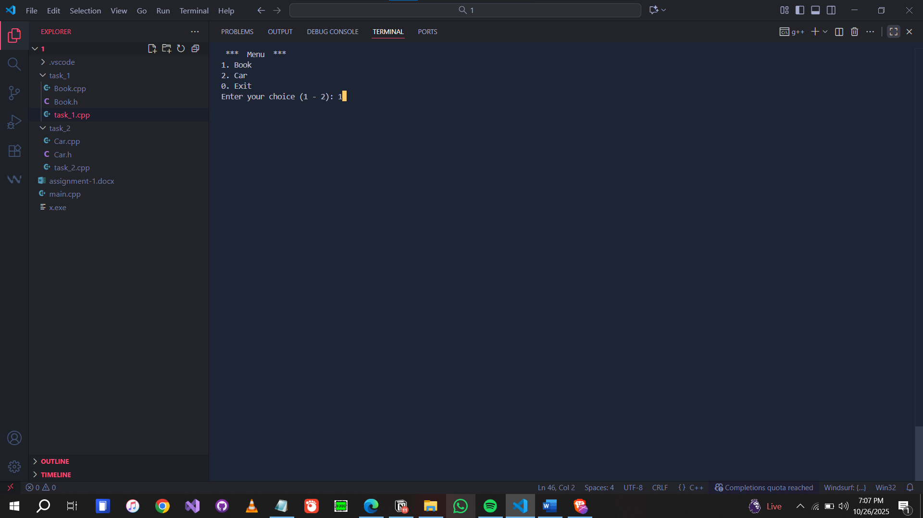

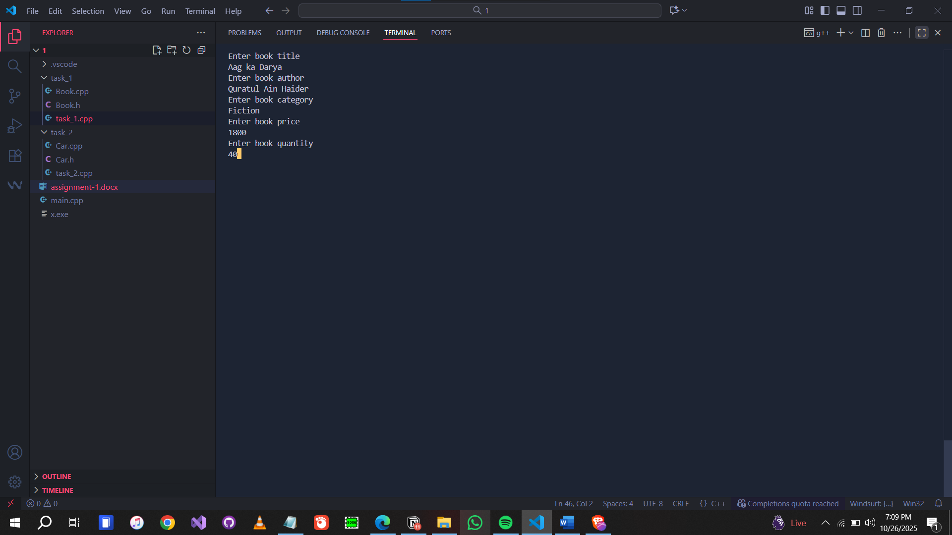

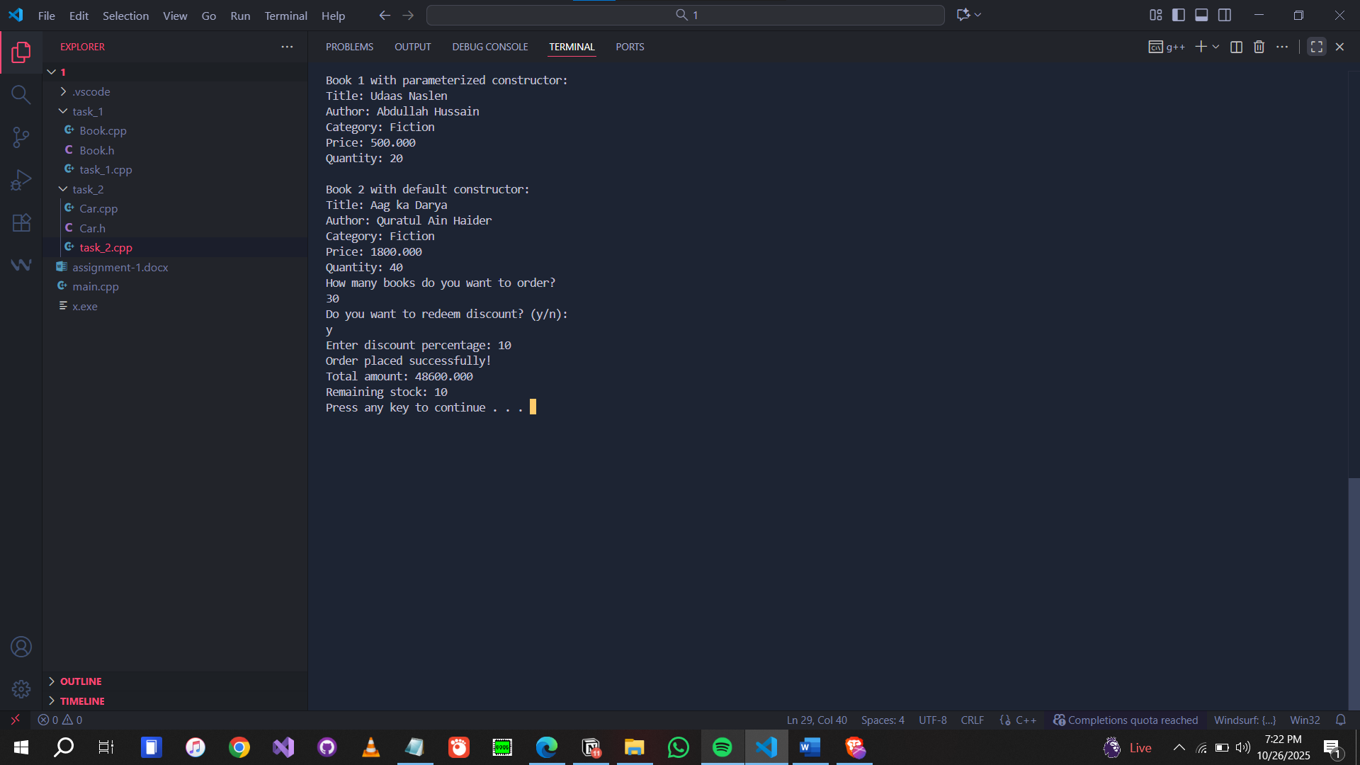

Question #2:
Write a class Car that has:
- Data members: brand, model, and price.
- A default constructor that sets default values ("Unknown", "N/A", 0).
- Constructor Overloads take all values
- A function display() that shows all details.
Task:
- Create two objects: one using the default constructor and another using a parameterized constructor.
- Display both cars’ details.
- Use getter and setter function to set and get the car attributes values

Code:
Car.h
#include <iostream>
#include <cstring>
#include <iomanip>
using namespace std;
class Car {
private:
char* m_brand;
char* m_model;
int m_year;
double m_price;
public:
Car();
Car(const char*, const char*, int, double);
~Car();

void setValue(char*, char*, int, double);
char* getBrand();
char* getModel();
int getYear();
double getPrice();
void display();
};

Car.cpp
#include "Car.h"

Car::Car() {
m_brand = new char[strlen("Unknown") + 1];
strcpy(m_brand, "Unknown");

m_model = new char[strlen("N/A") + 1];
strcpy(m_model, "N/A");

m_year = 0;
m_price = 0.0;
}

Car::Car(const char* brand, const char* model, int year, double price) {
m_brand = new char[strlen(brand) + 1];
strcpy(m_brand, brand);

m_model = new char[strlen(model) + 1];
strcpy(m_model, model);

m_year = year;
m_price = price;
}

Car::~Car() {
delete[] m_brand;
delete[] m_model;
}

void Car::setValue(char* brand, char* model, int year, double price) {
delete[] m_brand;
m_brand = new char[strlen(brand) + 1];
strcpy(m_brand, brand);

delete[] m_model;
m_model = new char[strlen(model) + 1];
strcpy(m_model, model);

m_year = year;
m_price = price;
}

char* Car::getBrand() {
if (m_brand == nullptr) return nullptr;
char* temp = new char[strlen(m_brand) + 1];
strcpy(temp, m_brand);
return temp;
}

char* Car::getModel() {
if (m_model == nullptr) return nullptr;
char* temp = new char[strlen(m_model) + 1];
strcpy(temp, m_model);
return temp;
}

int Car::getYear() {
return m_year;
}

double Car::getPrice() {
return m_price;
}

void Car::display() {
//This function can also get values without getters
cout << "Brand: " << getBrand() << endl;
cout << "Model: " << getModel() << endl;
cout << "Year: " << getYear() << endl;
cout << "Price: Rs. " << getPrice() << endl;
}

Void Car
#include "Car.h"

void car() {
system("cls");
Car c_1("Mercedes", "Benz", 2022, 1000000);
Car c_2;

cout << "Car 1 with parameterized constructor: " << endl;
c_1.display();
cout << endl << "Car 2 with default constructor: " << endl;
c_2.display();
system("pause");

char* brand = new char[20];
char* model = new char[20];
int year = 0;
double price = 0;

cout << endl << "Enter car brand: " << endl;
cin.ignore();
cin.getline(brand, 20);
cout << "Enter car model: " << endl;
cin.getline(model, 20);
cout << "Enter car year: " << endl;
cin >> year;
cout << "Enter car price: " << endl;
cin >> price;

c_2.setValue(brand, model, year, price);

cout << endl << "Car 2 with updated values: " << endl;
c_2.display();

system("pause");
}

Screenshot:
