ISD TERM PROJECT
Software Requirements Specifications

UniVerseX



Project Advisor

Ayesha Zaheer

Presented by:

L1F24BSCS0494 | Sania Nasir
L1F24BSCS0340 | Seerat Fatima
L1F24BSCS0506 | Sharjeel Ahmad

Table of Contents
1. Introduction and Background 4

1.1 Problem Statement 4
1.2 Background 4
1.3 Scope 5
1.4 Objectives 6
1.5 Challenges 6
1.6 Learning Outcomes 7
1.7 Nature of End Product 7
1.8 Completeness Criteria 8
1.9 Business Goals 8
1.10 Related Works 8
1.11 Document Conventions 9

2. Overall Description 10

2.1 Product Features 10
2.2 User Classes and Characteristics 11
2.3 Operating Environment 12
2.4 Design and Implementation Constraints 13
2.5 Assumptions and Dependencies 14

3. Project Management 15

3.1 Work Breakdown Structure 15
3.2 Activity Graph 15
3.3 Critical Path. 16
3.4 Gantt chart 16

4. Functional Requirements 17

4.1 Requirements Analysis and Modeling 17
4.2 Use Cases 19
4.3 State Diagram 21

5. Non-Functional Requirements 23

5.1 Performance Requirements 23
5.2 Safety Requirements 23
5.3 Compatibility Requirements 23
5.4 Security Requirements 24
5.5 Usability Requirements 24
5.6 Reliability Requirements 24
5.7 Scalability Requirements 24

7. Designing 25

7.1 Class diagram 25
7.2 Data Flow Diagram 26
7.3 ER Diagram 28
7.4 Physical design of database 29
7.5 Sequence diagrams 30
7.5.1 Create Post 30
7.5.2 Create Community 31
7.5.3 Create Marketplace Listing 32

8. Estimation 33

8.1 Cost Benefit Estimation 33
8.1.1 Return of Investment {1st year} 34
8.1.2 %gain on ROI {1st year} 34
8.1.3 Payback Period in years 34
8.2 FP based Estimation 35
8.3 COCOMO Estimation 35

9. References 37

INTRODUCTION AND BACKGROUND
UniVerseX is a mobile application designed to create a social platform for university students to communicate, share knowledge, and conduct peer-to-peer transactions. Currently, students’ discussions scatter across WhatsApp, Facebook, and Instagram, making important information difficult to retrieve and maintain continuity. Our platform consolidates academic discussions, social interaction, and student commerce into a single, structured environment accessible on both iOS and Android devices.
1.1. Problem Statement
University students face fragmented communication channels where academic discussions, social posts, and marketplace activity are scattered across multiple unstructured platforms. This fragmentation results in:
- Loss of important academic information in group chats
- Difficulty finding answers to repeated questions
- Unsafe, unmoderated student commerce
- No dedicated space for campus-specific discussions
UniVerseX solves this by providing a unified platform where students can:
- Post and discuss course-related topics in moderated communities
- Share confessions and social content anonymously
- Buy, sell, and barter textbooks, notes, and campus accessories
- Access all information within a single, organized interface in various dedicated communities
1.2. Background
In universities, communication is essential for academic success and campus life. Students currently rely on general-purpose social media platforms not specifically designed for academic purposes. WhatsApp groups become cluttered, Facebook groups are public and unprofessional, and Instagram stories fade within 24 hours. There is a clear demand for a dedicated student platform that is community-driven.
The proposed solution draws inspiration from successful platforms: Reddit, Piazza and Empor remaining lightweight and prototype-focused using MIT App Inventor.
The platform will emphasize moderation, user safety, and organized architecture to ensure a healthy discussion environment.
1.3. Scope
UniVerseX will be developed as a cross-platform mobile application (iOS/Android) with the following core features:
Authentication & Profile:
- Email/password registration and login
- User profile with username and reputation score
- Profile view showing user's posts and marketplace listings
Discussion Features:
- Create text-based posts with optional image uploads
- Post categorization (Question, Discussion, Confession)
- Moderated communities
- Comment threads under posts
- Upvote/downvote mechanism for post visibility
- Search posts by keyword, category, or community (Limited)
Marketplace Features:
- List items for sale or barter (books, notes, accessories, etc.)
- Contact seller through in-app messaging
- User ratings for marketplace transactions
- Item details with images, price, and barter options

Moderation:
- Community moderators (admins) appointed per community
- Ability to report inappropriate content
- Admin dashboard for content removal
- Spam and abuse prevention

Technical Stack:
- Frontend: MIT App Inventor (cross-platform blocks)
- Backend: CloudDb (Realtime Database + Authentication)
- Image Storage: Cloudinary (free tier)
- Target: Android + iOS

1.4. Objectives
- Provide a centralized, organized platform for student communication and knowledge sharing
- Demonstrate practical application of software engineering principles in a real-world project
- Eliminate information fragmentation across multiple apps
- Create safe, moderated spaces for academic and social discussions
- Improve student engagement and sense of campus community
- Enable peer-to-peer student commerce with built-in trust mechanisms

1.5. Challenges
Real-time Synchronization: Ensuring feed updates reflect new posts and comments instantly across users
Database Complexity: Managing relationships between users, posts, comments, and marketplace listings
Image Handling: Optimizing image uploads and storage within app size constraints
User Trust: Building confidence in marketplace transactions (ratings, reviews, dispute resolution)
Performance: Managing and organizing a large number of posts and comments
MIT App Inventor Limitations: Lack of advanced features like nested queries and complex business logic

1.6. Learning Outcomes
Upon completion, team members will have gained:
- Understanding of Software Requirements Specification documentation
- Mobile app development using MIT App Inventor and visual programming
- Cloud database design and real-time synchronization with Firebase
- Team collaboration and version control (document management)
- Software engineering lifecycle from specification to prototype

1.7. Nature of End Product
UniVerseX will be delivered as a functional prototype demonstrating core functionality:
- Cross-Platform app
- Fully functional discussion and post features
- Working marketplace with image uploads
- Real-time Firebase backend integration
- Moderated community system
- User authentication and profile management
The prototype prioritizes functionality over polish; advanced features like performance optimization and complex analytics are excluded.

1.8. Completeness Criteria
The project will be considered complete when:
- Users can register, log in, and maintain profiles
- Posts can be created, displayed, and deleted by authors
- Comments appear under posts in real-time
- Upvote/downvote system functions correctly and reflects in post scoring
- Communities can be created and moderated
- Marketplace listings can be posted with images and descriptions
- Search functionality returns relevant results
- Feed displays posts sorted by newest and popularity
- Marketplace transactions show contact options
1.9. Business Goals
- Increase student engagement within the university ecosystem
- Provide a safe alternative to unmoderated third-party platforms
- Reduce dependency on external social media for campus discourse
- Enable sustainable student commerce with built-in buyer protection
- Build a foundation for potential university adoption and expansion

1.10. Related Works
Reddit (reddit.com): Community-driven discussion platform with upvote/downvote ranking, moderated subreddits, and user reputation. UniVerseX adopts the moderated community model and post-based discussion format.
Piazza (piazza.com): Academic Q&A platform used in universities with instructor monitoring and structured answers. UniVerseX incorporates the educational focus and moderation hierarchy.
OLX / Facebook Marketplace: Peer-to-peer marketplace platforms. UniVerseX integrates marketplace functionality with trust ratings and in-app messaging.
UniVerseX differentiates itself by combining all three elements (discussion, academic focus, and marketplace) in one platform specifically designed for universities, rather than adapting general-purpose tools.
1.11. Document Conventions
Key Terms: User, Post, Comment, Community, Moderator, Listing, Marketplace are used consistently throughout
Terminology: "Post" refers to discussion content; "Listing" refers to marketplace items
Hierarchy: Communities contain Posts; Posts contain Comments.

OVERALL DESCRIPTION
2.1. Product Features
The major features of the system are listed below:
A. Discussion & Posts
- Create posts with title, body text, tags and optional images
- Tags: Question, Discussion, Confession, etc. to improve organization
and searchability
- Upvote/downvote mechanism with score calculation
- Comment threads on each post
- Edit and delete own posts
- Pin important posts (moderators only)
- Search posts by keyword, tag, or community
B. Communities
- Create communities around topics, courses, or interests
- Join communities
- View community-specific feed
- Moderator appointment and role management
- Community moderation tools (pin, remove posts)
- Community rules and description

C. Marketplace
- List items for sale or barter with images
- Item categories (Books, Notes, Accessories, Electronics, etc.)
- Seller contact information and ratings
- In-app messaging between buyer and seller
- Transaction status tracking (Available, Sold, Exchanged)
- User reputation/ratings system

D. User & Authentication
- Email/password registration and login (must be university mail)
- Profile customization (username, bio, profile picture)
- View user's posts and marketplace listings
- Reputation score (based on upvotes and transaction ratings)
- Follow users (optional, for future phases)
E. Moderation & Safety
- Report inappropriate content
- Content removal and user warnings
- Spam detection and prevention
- Transaction dispute resolution tools
- Moderator dashboard per community

2.2. User Classes and Characteristics
1. Regular Students (Primary Users)
- University students aged 18 – 25
- Basic to intermediate mobile app experience
- Use the app for academic discussions, social posts, and buying/selling items
- Expect fast, intuitive interface with minimal learning curve
- May create 5 – 10 posts per week on average
2. Moderators (Secondary)
- Experienced users appointed by admins or community creators
Responsibility: monitor content, remove spam, enforce community guidelines
- Higher privileges: ability to pin/remove posts, warn users
Typically 1 – 2 per community of 100+ members

3. Administrators (System Admins)
- Full platform access: view all posts, remove any content, manage moderators
- Italics indicate special role; appointed by development team
- Ability to disable accounts and enforce platform-wide policies
4. Guest Users (Optional, Future Phase)
- Non-registered users who can view public posts (read-only)
- Cannot create posts, comment, or access marketplace
- Encouraged to register for full experience

2.3. Operating Environment

Platform Specifications:
- Mobile OS: Android 8.0+ and iOS 8.0+
- Network: Requires active internet connection (WiFi or mobile data)
- Hardware: Minimum 2GB RAM, 50MB storage

Development & Deployment:
- Development Tool: MIT App Inventor (visual blocks programming)
- Backend: CloudDb (Realtime Database + Authentication + Hosting)
- Testing: Android emulator + physical device testing
- Image Storage: Cloudinary
Browser Requirements:
- Modern browsers supporting Service Workers
- HTTPS required for all communications

2.4. Design and Implementation Constraints
MIT App Inventor Limitations:
- Limited to visual block programming (no direct code)
- No native support for complex nested queries
- Maximum app size ~50MB after compilation

CloudDb Free Tier:
- 100 concurrent connections maximum
- 1GB total storage
- Rate limiting on reads/writes

Image Handling:
- Cloudinary free tier limited to 10GB/month bandwidth
- Images must be optimized before upload

Cross-Platform Support:
- Native Android recommended for full feature parity
- Testing required on both platforms despite code reuse

Development Scope:
- Scalability features (caching, CDN, load balancing) excluded
- Advanced analytics and machine learning not included
- Real-time notifications may have delays
- Project prototype status; not production-ready

2.5 Assumptions and Dependencies
Assumptions:
- All users have access to mobile devices and have internet connectivity
- Users possess basic mobile app literacy
- University emails are available for authentication
- CloudDb services remain available throughout project
- Cloudinary API availability for image uploads

Dependencies:
- MIT App Inventor: Platform for development and compilation
- Google Account: Required to access Firebase and MIT App Inventor
- Internet Services: Continuous connectivity for real-time sync

External Risks:
- Dependency on CloudDb availability and pricing changes
- MIT App Inventor updates may affect compilation
- Cloudinary service disruptions

Project Management
3.1. Work Breakdown Structure
- 1.0 Initiation & Requirements
1.1 Problem Statement Analysis
1.2 System Requirements Specifications (SRS)

- 2.0 Design & Architecture
2.1 UI/UX Screen Wireframing
2.2 CloudDb Database Schema Mapping

- 3.0 Core Application Development
3.1 Authentication and Profile Blocks
3.2 Discussion Feed & Comment Threads
3.3 Marketplace Listings Layout
3.4 Community Moderation Controls

- 4.0 Verification & Deployment
4.1 Integration Testing via Android Emulator
4.2 Final Prototype Sign-off

3.2. Activity Graph

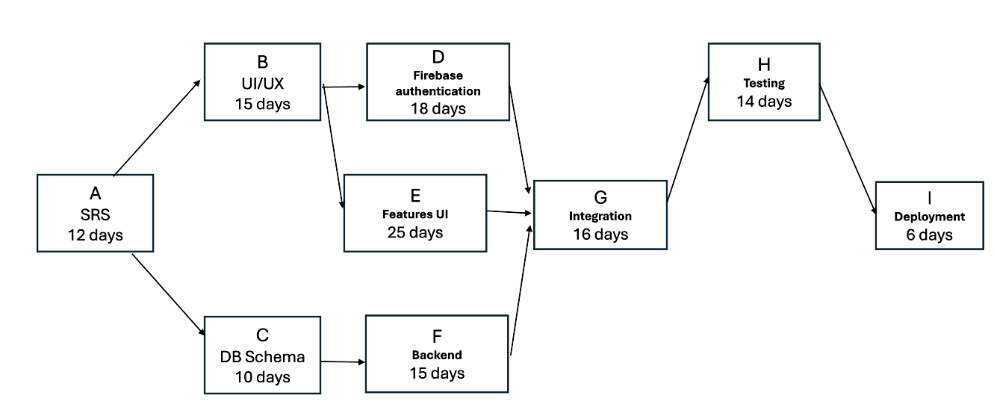

3.3. Critical Path
Path | Sequence of Activities | Total Duration
Path 1 | A → B → E → G → H → I | 88 days
Path 2 | A → B → D → G → H → I | 81 days
Path 3 | A → C → F → G → H → I | 73 days

Critical path: A → B → E → G → H → I (88 days)

3.4. Gantt chart
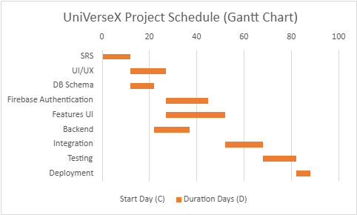

FUNCTIONAL REQUIREMENTS

4.1. Requirements Analysis and Modeling
Actors:
- User (Regular Student): Primary actor interacting with discussion and marketplace features
- Admin (System Administrator): Platform-wide moderation and management
- Moderator (Community Moderator): Community-specific content management

Main Use Cases:
- Register Account
- Login to Account
- Manage Profile
- Create/Join Community
- Create Post
- Comment on Post
- Upvote/Downvote Post
- Search Posts/Content
- Create Marketplace Listing
- Contact Seller / In-App Messaging
- Rate/Review Transaction
- Report Content
- Moderate Content (Remove Posts/Users)
- View Community Feed
- Delete Own Post

Use-Case Diagram:

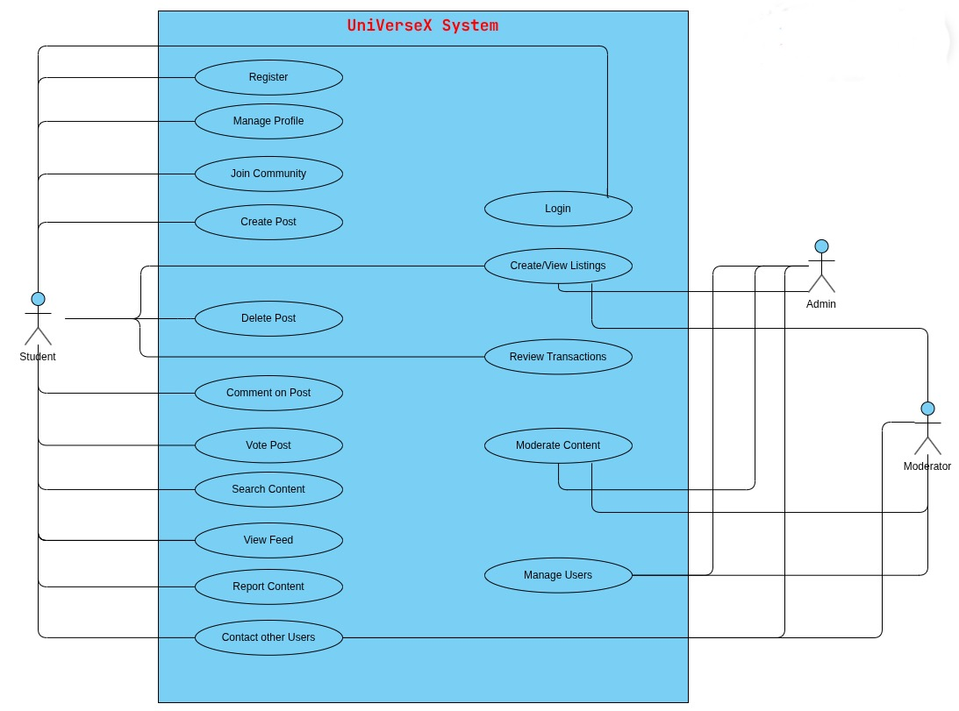

4.2. Use Cases

1. Create/Join Community

Identifier |  | UC - 01
Purpose |  | To allow users to join/create communities
Actor |  | Student
Priority |  | High
Pre-conditions |  | User must be logged in
Post-conditions |  | - User successfully joins an existing community OR  - User creates and becomes admin of a new community
Typical Course of Action
S# | Actor Action |  | System Response
1 | User views communities |  | System shows list of available communities
2 | User selects community OR chooses “Create Community” |  | System shows details OR creation form
3 | User clicks “Join” |  | System adds user as a member
4 | User enters community details (for creation) and submits |  | System creates new community and assigns user as admin
Alternate Course of Action
S# | Actor Action |  | System Response
1 | User tries to join a private community |  | System requests approval or sends join request
2 | User is already a member |  | System displays “Already a member” message
3 | User submits incomplete/invalid creation form |  | System shows error and asks for corrections
4 | Community creation fails (e.g., duplicate name) |  | System displays failure message and prompts retry

2. Create Post

Identifier |  | UC - 05
Purpose |  | To allow users to publish posts on profile or in communities.
Actor |  | Student
Priority |  | High
Pre-conditions |  | User must be logged in.
Post-conditions |  | Post is published.
Typical Course of Action
S# | Actor Action |  | System Response
1 | User selects create post |  | System opens editor
2 | User enters content |  | System validates
3 | User submits post |  | System publishes
Alternate Course of Action
S# | Actor Action |  | System Response
1 | Empty post submitted |  | System rejects and show error
2 | Unsupported file format uploaded |  | System denies upload
3 | Network failure during submission |  | System does not publish post and show retry message

3. Create Marketplace Listing

Identifier |  | UC - 03
Purpose |  | To allow users to sell or barter items
Actor |  | Student
Priority |  | Medium
Pre-conditions |  | User logged in
Post-conditions |  | Listing or transaction is processed
Typical Course of Action
S# | Actor Action |  | System Response
1 | User opens marketplace |  | System shows listings
2 | User clicks create listing |  | System shows form
3 | User submits details |  | System publishes listing
Alternate Course of Action
S# | Actor Action |  | System Response
1 | Invalid listing details |  | System rejects listing submission
4.3. State Diagram
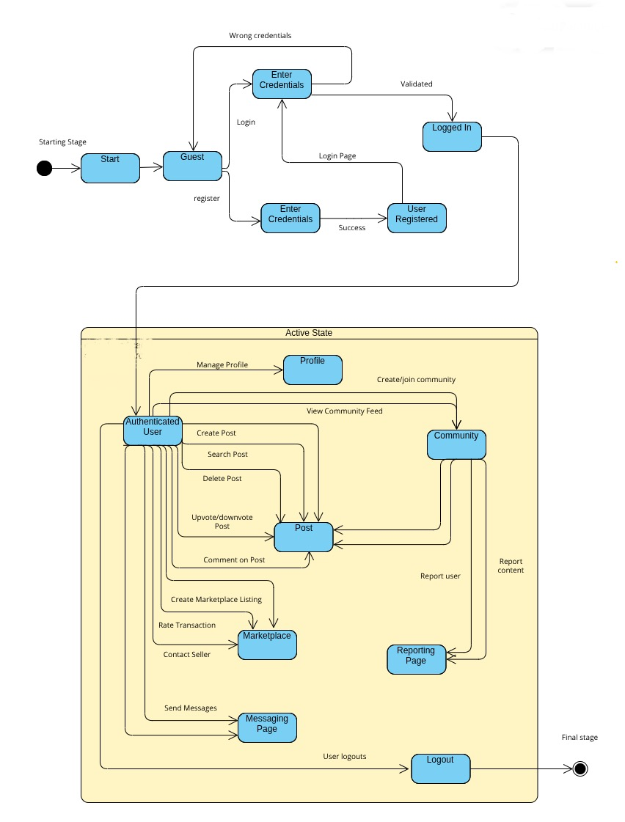

State Diagram Info:
The state diagram of UniVerseX represents the different states a user or system component transitions through during interaction with the application. It illustrates how the system responds to user actions such as logging in, creating posts, interacting with content, and logging out. Initially, the system starts in an Unauthenticated State, where the user can either register or log in. Upon successful authentication, the user transitions to the Authenticated State, gaining access to features like viewing the feed, joining communities, creating posts, commenting, and interacting with the marketplace. Each action (e.g., creating a post, sending a message, or listing an item) represents a transition that leads to corresponding states such as Post Created, Comment Added, or Listing Published. The system also handles alternate transitions like errors (invalid input, network failure) and moderation actions (content removal), ensuring proper flow control. Finally, the user can transition to the Logged Out State, returning the system to its initial state. This diagram helps visualize system behavior, ensuring all possible user interactions and system responses are clearly defined and managed.

Non-Functional Requirements
This section defines the quality attributes of the UniVerseX system. These requirements ensure that the system performs efficiently, remains secure, and provides a smooth user experience for students.

5.1. Performance Requirements
The system is designed to support real-time interaction and must respond quickly to user actions.

- The system shall load the main feed within 2–3 seconds under normal conditions.
- The system shall reflect new posts and comments in real-time or near real-time.
- The system shall support multiple active users without noticeable delay.
- The system shall handle image uploads efficiently without slowing down the application.

5.2. Safety Requirements
The system must provide a safe environment for users, especially due to user-generated content and marketplace interactions.

- The system shall allow users to report inappropriate or abusive content.
- The system shall enable moderators to take action against reported content.
- The system shall prevent misuse of the platform through moderation controls.
- The system shall ensure safe interaction between buyers and sellers.

5.3. Compatibility Requirements
The system should work across supported devices and platforms.

- The system shall run on Android and iOS devices.
- The system shall function on devices with basic hardware requirements.
- The system shall require an active internet connection for operation.

5.4. Security Requirements
Security is essential to protect user data and ensure controlled access.

- The system shall allow access only to authenticated users.
- The system shall use secure methods for user authentication.
- The system shall protect user data from unauthorized access.
- The system shall ensure secure communication between user and system.

5.5. Usability Requirements
The system should be simple and easy to use for university students.

- The system shall provide a clear and user-friendly interface.
- The system shall allow users to perform key actions easily (posting, commenting, searching).
- The system shall provide feedback messages for user actions.
- The system shall maintain consistency across all screens.

5.6. Reliability Requirements
The system must remain stable and dependable during usage.

- The system shall operate with minimal downtime.
- The system shall ensure that user data is not lost during failures.
- The system shall handle errors without crashing.
- The system shall confirm successful completion of user actions.

5.7. Scalability Requirements
The system should support future growth and expansion.
- The system shall handle an increasing number of users and posts.
- The system shall support future feature enhancements.
- The system shall allow integration with more advanced services if required.

Designing

7.1. Class Diagram

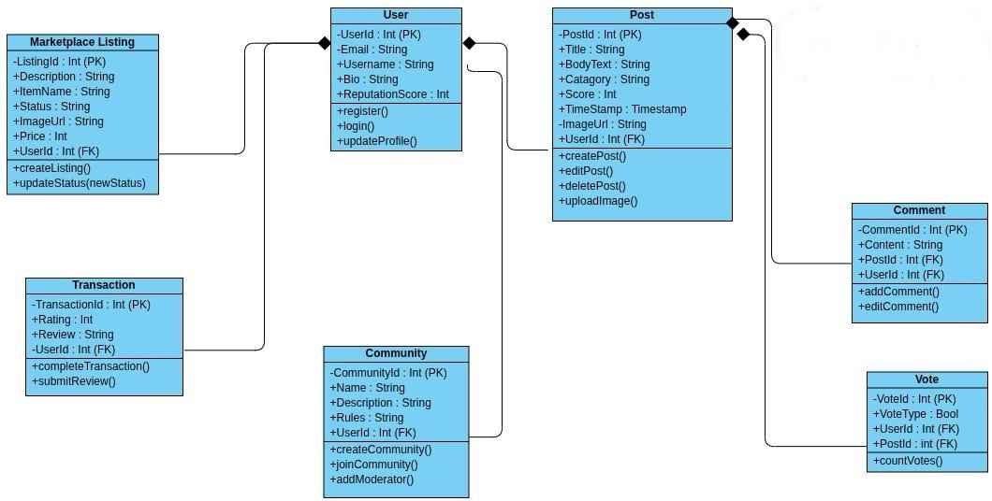

7.2. Data Flow Diagram
7.2.1. DFD – (Level – 0)

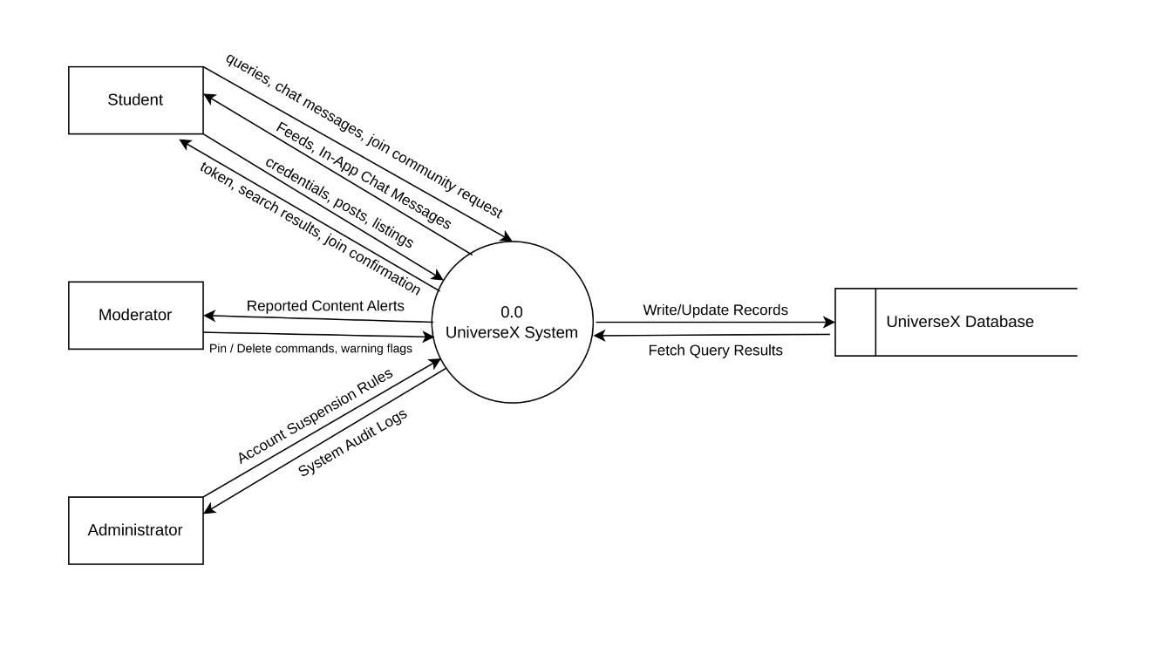

7.2.2. DFD – (Level – 1)

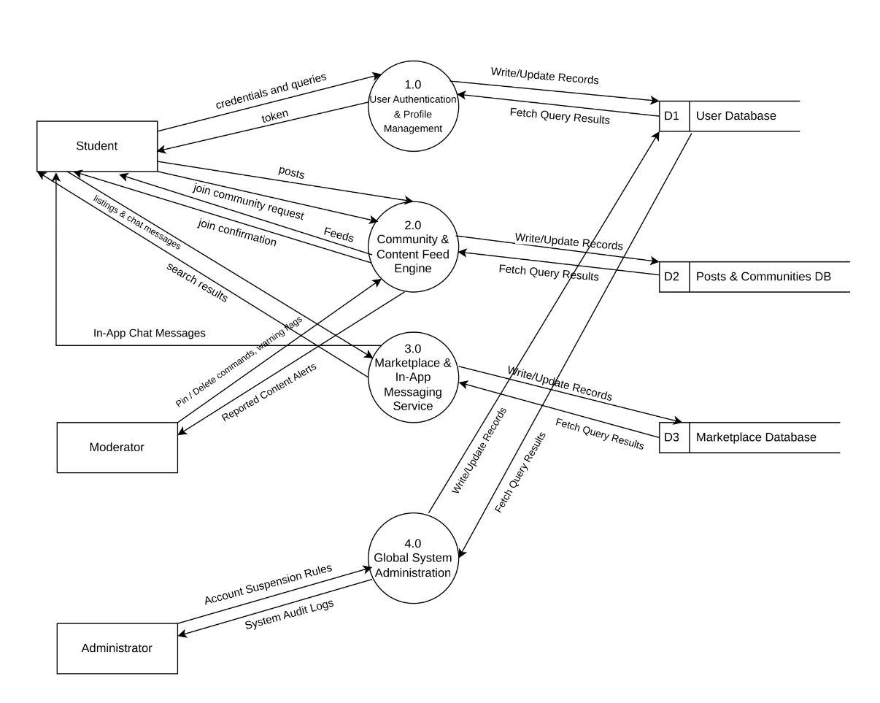

7.3. ER Diagram

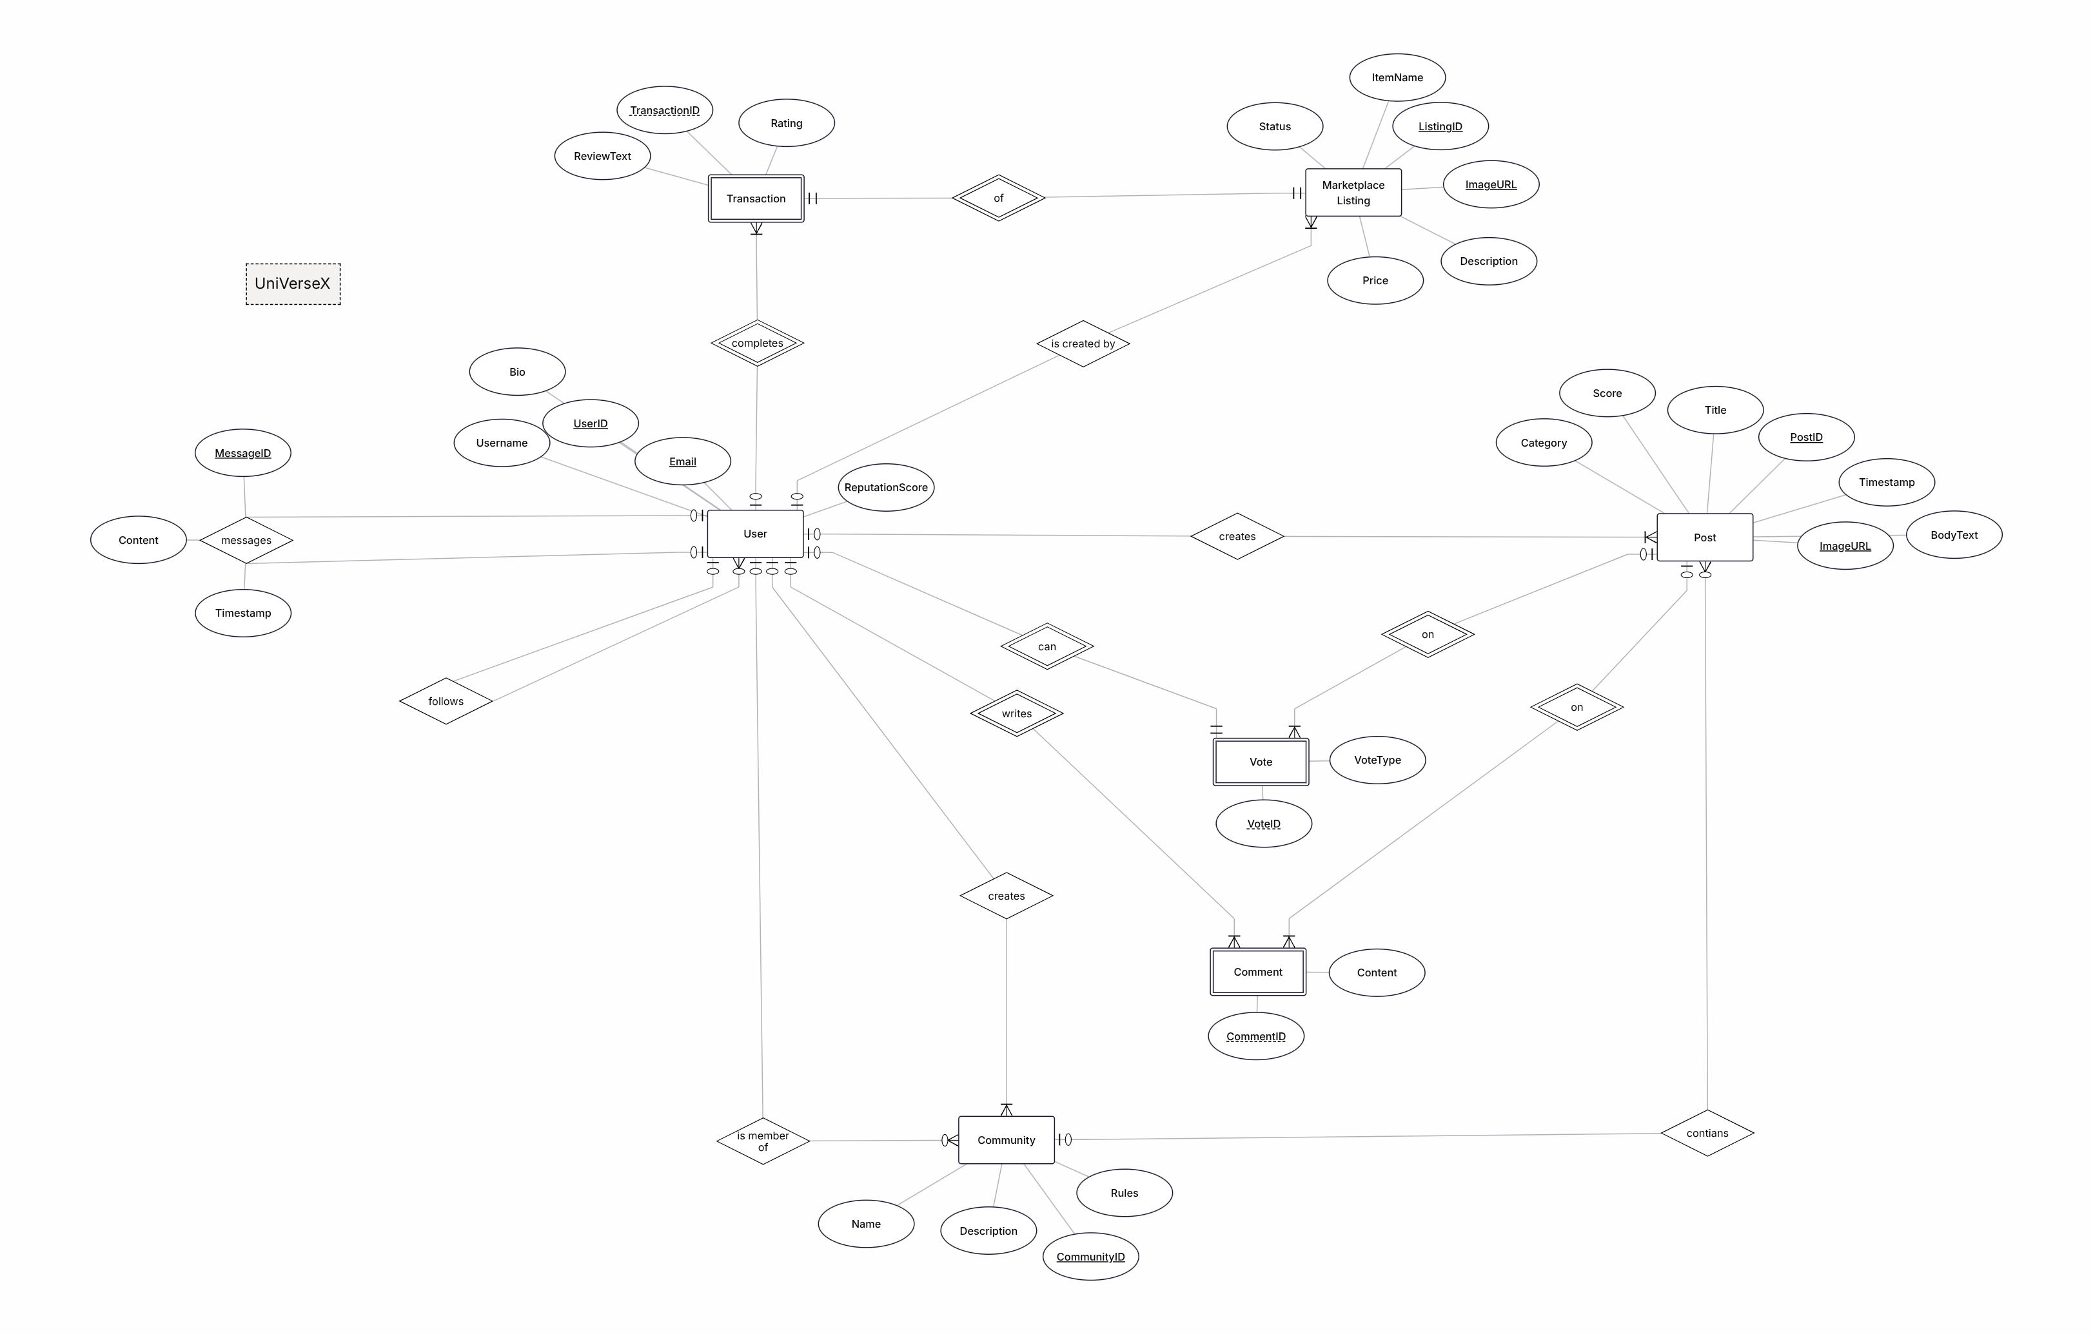

7.4. Physical design of database

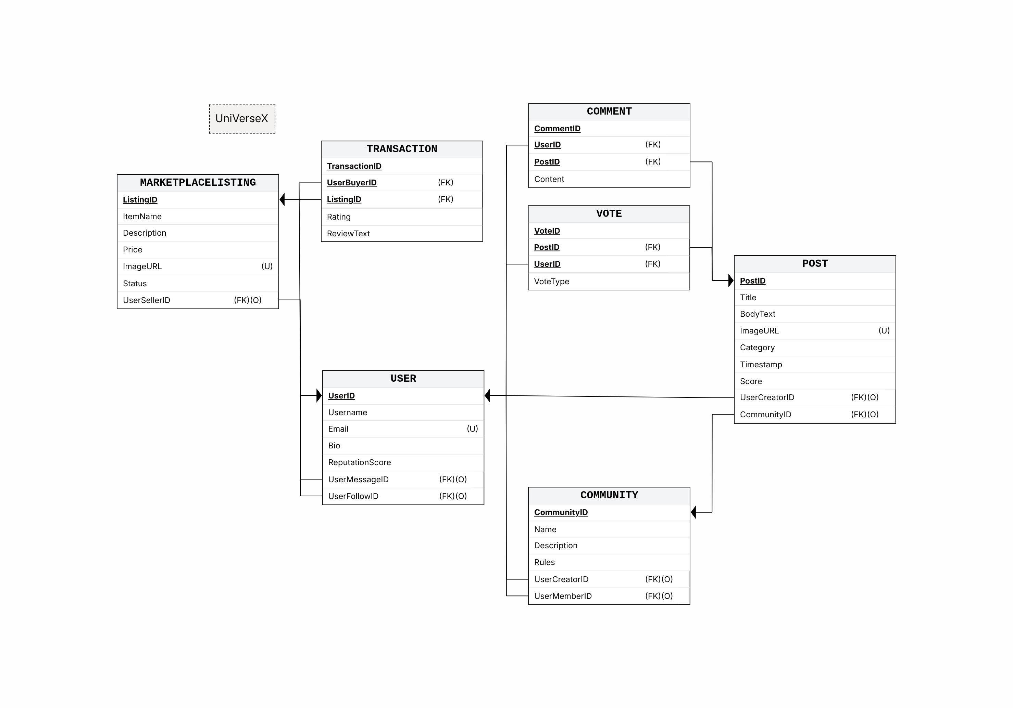

7.5. Sequence Diagrams
- 7.5.1. Create Post

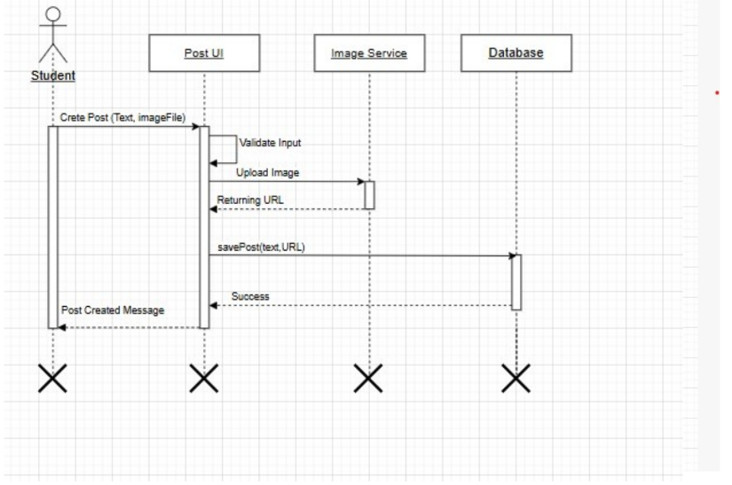

- 7.5.2. Create Community

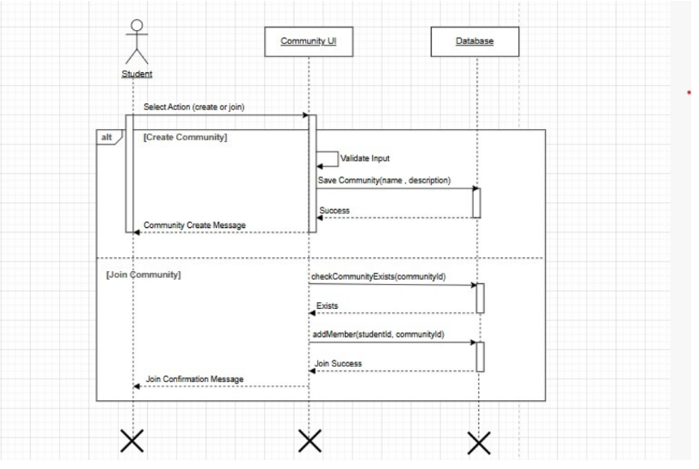

- 7.5.3. Create Marketplace Listing

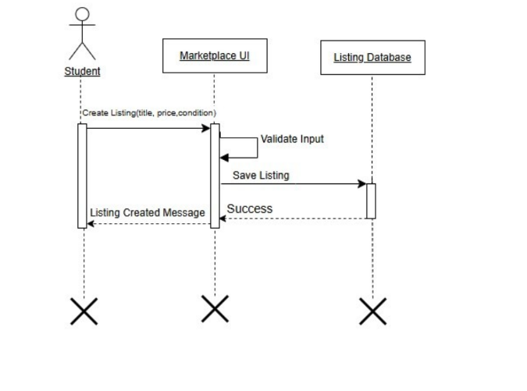

Estimation
8.1. Cost Benefit Estimation

Estimated Development Cost (1st Year)

Item | Estimated Cost (PKR)
Development Effort | 150,000
Testing & Maintenance | 30,000
Cloud Services & Storage | 20,000
Miscellaneous Expenses | 10,000
Total Cost | 210,000

Estimated Benefits (1st Year)

Benefit Source | Estimated Value
Student Marketplace Transactions | 180,000
University Adoption Value | 100,000
Advertisement Opportunities | 80,000
Increased Student Engagement Value | 40,000
Total Benefits | 400,000

8.1.1. Return of Investment {1st year}
Total cost= Rs 210,000
Total benefit= Rs 400,000

ROI =

=

= 1.90
Interpretation: For every Rs. 1 invested, the project is expected to return approximately Rs. 1.90 during the first year.
8.1.2. %gain on ROI {1st year}
Formula of %gain on ROI =

= 90.48%

8.1.3. Payback Period in years
Formula of payback period =

=

= 0.53 Years ≈ 6.4 Months
Interpretation: The initial investment is expected to be recovered within approximately 6 months.

8.2. FP Based Estimation

Function Point Analysis

Function Type | Count | Weight | FP
External Inputs (Login, Registration, Create Post, Create Listing, Join Community) | 5 | 4 | 20
External Outputs (Feeds, Profiles, Listings, Search Results) | 4 | 5 | 20
External Inquiries | 3 | 4 | 12
Internal Logical Files (Users, Posts, Communities, Listings, Messages) | 5 | 10 | 50
External Interface Files | 2 | 7 | 14

Unadjusted Function Points (UFP) = 116
Assuming Value Adjustment Factor (VAF) = 1.05
Adjusted FP = 116 × 1.05 = 121.8 ≈ 122 FP

8.3. COCOMO Estimation

Step 1: Convert FP to KLOC
For a mobile application:
1 FP ≈ 50 LOC
LOC = 122 × 50
LOC = 6,100
KLOC = 6.1

Step 2: Effort Estimation

E ≈ 16
Effort ≈ 16 Person-Months

Step 3: Development Time

= (2.5) ×
≈ 7
Time ≈ 7 Months

Step 4: Team Size
Team Size =
=
≈ 2–3 Developers

References
[1] IEEE Std 830-1998, IEEE Recommended Practice for Software Requirements Specifications
[2] IEEE Std 1016-2009, IEEE Standard for Information Technology—Systems Design Software
[3] IEEE Std 1012-2016, IEEE Standard for System, Software, and Hardware Verification
[4] IEEE Std 802.11-2020, IEEE Standard for Information Technology, Telecommunications and Information Exchange
[5] IEEE Std 730-2014, IEEE Standard for Software Quality Assurance Processes
[6] IEEE Std 1219-1998, IEEE Standard Application and Management of the Systems and Software
[7] IEEE 829-2008, IEEE Standard for Software and System Test Documentation

