Introduction to Database
Semester Final Project

Pakistan Census Database

Session: Spring 2026



Group Members
Azma | L1F24BSCS0674
Sarmad | L1F24BSCS0716
Sharjeel | L1F24BSCS0506
Zakia | L1F24BSCS0587

1. Project Title

Pakistan Census Database

2. Project Overview
The Pakistan Census Database is a centralized system built to collect and manage national demographic, household, and geographic data.
- Geographic Tracking: Organizes data down a strict chain from Provinces and Districts to local Census Blocks.
- Property & Housing Utilities: Tracks the quality of physical structures and access to water, power, and fuel.
- Population Registries: Stores citizen profiles, including CNICs, family structures, literacy, and income.
- Field Operations: Manages the census workforce by linking local enumerators to their regional supervisors.
Ultimately, this system provides fast, reliable data slicing to help the government make accurate decisions regarding resource allocation and national planning.

3. Objectives
Objective 1: Securely store and quickly find data across all geographic levels, from whole provinces down to local census blocks.
Objective 2: Track citizen details accurately, including CNICs, family structures, income, literacy, and housing conditions.

Objective 3: Support generating clear population reports, literacy rate summaries, and regional development statistics for government planning.

Objective 4: Perform complex SQL queries to filter and analyze deep demographic trends and employment rates across different regions.

Objective 5: Ensure database normalization and strict integrity constraints so that data remains clean, connected, and free of duplicates.

4. Scope

What is Included:
- Geographic & Personnel Infrastructure: Tracking administrative boundaries from provinces down to local census blocks, along with the operational field staff hierarchies.
- Property & Household Metrics: Managing details of physical structures, domestic utility profiles, and family household groupings.
- Citizen Demographics: Storing individual citizen records, including identity verification numbers (CNICs), family relations, educational status, and income levels.
- Backend Database Optimization: Developing index structures, relational constraints, and core SQL queries for backend data analysis.

What is Not Included:

- Front-End Applications: The project does not include building web or mobile applications for data entry or public dashboards.
- Live GPS Tracking: It maps static coordinates for structures but does not support real-time GPS tracking of field staff.
- Biometric Verification System: The database processes text-based CNIC records but does not handle direct fingerprint or facial biometric verification processing.

5. Entities and Attributes

Entity | Attributes
Water_Source | water_source_id, source_name
Lighting_Source | lighting_source_id, source_name
Cooking_Fuel_Source | fuel_source_id, fuel_source_name
Washroom_Status | washroom_status_id, status_name
Kitchen_Status | kitchen_status_id, status_name
Biological_Sex | sex_id, sex_name
Religion | religion_id, religion_name
Mother_Tongue | mother_tongue_id, tongue_name
Education_Level | education_level_id, level_name
Employment_Status | employment_status_id, status_name
Marital_Status | marital_status_id, status_name
Disability_Type | disability_type_id, disability_name
Occupation | occupation_id, occupation_name
Industry | industry_id, industry_name
Relationship_Type | relationship_type_id, relationship_name

Entity | Attributes
Census_Cycle | census_id, census_year, census_title, start_date, end_date
Census_Staff | staff_id, first_name, last_name, staff_role, contact_number, email, assigned_census_block_id, supervisor_id, employment_date

Entity | Attributes
Nationality | nationality_id, country_name, citizenship_status
Province | province_id, province_name
Division | division_id, division_name, province_id
District | district_id, district_name, division_id
Tehsil | tehsil_id, tehsil_name, district_id
Union_Council | union_council_id, union_council_name, union_council_classification_id, tehsil_id
Census_Block | census_block_id, census_block_code, estimated_household_count, is_urban, area_sq_km, union_council_id
Union_Council_Classification | union_council_classification_id, classification_name, description

Entity | Attributes
Person | person_id, household_id, first_name, last_name, cnic_number, sex_id, date_of_birth, nationality_id, religion_id, mother_tongue_id, marital_status_id, relationship_type_id, head_person_id, is_literate, education_level_id, currently_attending_school, employment_status_id, occupation_id, industry_id, monthly_income, data_entry_operator_id, created_date
Person_Disability | person_disability_id, person_id, disability_type_id
Migration_History | migration_id, person_id, previous_district_id, migration_reason, year_of_migration

Entity | Attributes
Structure_Type | structure_type_id, type_name, description
Structure | structure_id, structure_address_no, gps_latitude, gps_longitude, created_date, census_block_id, structure_type_id, water_source_id, lighting_source_id, fuel_source_id, washroom_status_id, kitchen_status_id
Structure_Residential | structure_id, total_residential_units
Structure_Commercial | structure_id, commercial_type_id, business_name, estimated_active_employees, has_industrial_power_connection, has_active_license
Structure_Institution | structure_id, institution_type, organization_name, population_count, is_government
Commercial_Sector_Type | commercial_type_id, commercial_type_name, description
Household | household_id, structure_id, census_id, household_sub_token, household_category_id, residential_status_type_id, owner_sex_id, number_of_rooms, household_size, data_entry_operator_id, created_date
Household_Category | household_category_id, category_name, description
Residential_Status_Type | residential_status_type_id, status_name, description

6. Relationships

1. Geographic Hierarchy Chain
Province to Division:
- Cardinality: 1:M (One Province can have Many Divisions).
- Participation: Total on Division side (A division cannot exist without being mapped to a province).
- Foreign Key: Division.province_id references Province.province_id.
Division to District:
- Cardinality: 1:M (One Division contains Many Districts).
- Participation: Total on District side (A district must belong to an administrative division).
- Foreign Key: District.division_id references Division.division_id.
District to Tehsil:
- Cardinality: 1:M (One District oversees Many Tehsils).
- Participation: Total on Tehsil side.
- Foreign Key: Tehsil.district_id references District.district_id.
Tehsil to Union Council:
- Cardinality: 1:M (One Tehsil contains Many Union Councils).
- Participation: Total on Union Council side.
- Foreign Key: Union_Council.tehsil_id references Tehsil.tehsil_id.

Union Council to Census Block:
- Cardinality: 1:M (One Union Council contains Many localized Census Blocks).
- Participation: Total on Census Block side.
- Foreign Key: Census_Block.union_council_id references Union_Council.union_council_id.

2. Building Extension Layers
Structure to Structure_Residential:
- Cardinality: 1:1
- Participation: Partial on Structure side, Total on Residential side (The profile cannot exist without its base parent building asset).
- Foreign Key: Structure_Residential.structure_id references Structure.structure_id.
Structure to Structure_Commercial:
- Cardinality: 1:1
- Participation: Partial on Structure side, Total on Commercial side.
- Foreign Key: Structure_Commercial.structure_id references Structure.structure_id.
Structure to Structure_Institution:
- Cardinality: 1:1.
- Participation: Partial on Structure side, Total on Institution side.
- Foreign Key: Structure_Institution.structure_id references Structure.structure_id.

3. Core Operational Census Operations
Census_Block to Structure Location:
- Cardinality: 1:M (One Census Block encompasses Many physical building structures).
- Participation: Total on Structure side (Every building must be cataloged inside an active census block boundary).
- Foreign Key: Structure.census_block_id references Census_Block.census_block_id.
Structure Location to Household Unit:
- Cardinality: 1:M (A physical building structure can host Multiple separate living households).
- Participation: Total on Household side (Every household must be linked to a physical address/structure asset).
- Foreign Key: Household.structure_id references Structure.structure_id.
Household Unit to Person Profile:
- Cardinality: 1:M (One Household unit contains Many citizens living/eating together).
- Participation: Total on Person side (An individual citizen must be accounted for within an registered household cohort).
- Foreign Key: Person.household_id references Household.household_id.

4. Recursive Self-Referencing Links
Census_Staff to Census_Staff (Management Hierarchy):
- Cardinality: 1:M (One Supervisor manages Many field staff members/enumerators).
- Participation: Total on enumerators side (Enumerators have supervisors).
- Foreign Key: Census_Staff.supervisor_id references Census_Staff.staff_id.
Person to Person (Household Head Mapping):
- Cardinality: 1:M (One household head is referenced by Many living family members in the house).
- Participation: Partial on both sides (A chosen household head points to null or themselves, while family members point to the head).
- Foreign Key: Person.head_person_id references Person.person_id.

5. Junction Tables
Person to Disability_Type via Person_Disability:
- Cardinality: M:N (One person can have multiple concurrent functional health challenges; one disability type applies to many citizens).
- Participation: Total on the junction table (Person_Disability), Partial on the individual tables (A citizen might have zero disabilities listed).
- Foreign Keys: Person_Disability.person_id references Person.person_id. Person_Disability.disability_type_id references Disability_Type.disability_type_id.

Person to District via Migration_History:
- Cardinality: M:N (A citizen can move through multiple locations over time; a single district acts as a historical home for many citizens).
- Participation: Total on the history tracker (Migration_History), Partial on individual tables.
- Foreign Keys: Migration_History.person_id references Person.person_id. Migration_History.previous_district_id references District.district_id.

7. ERD (Entity Relationship Diagram)

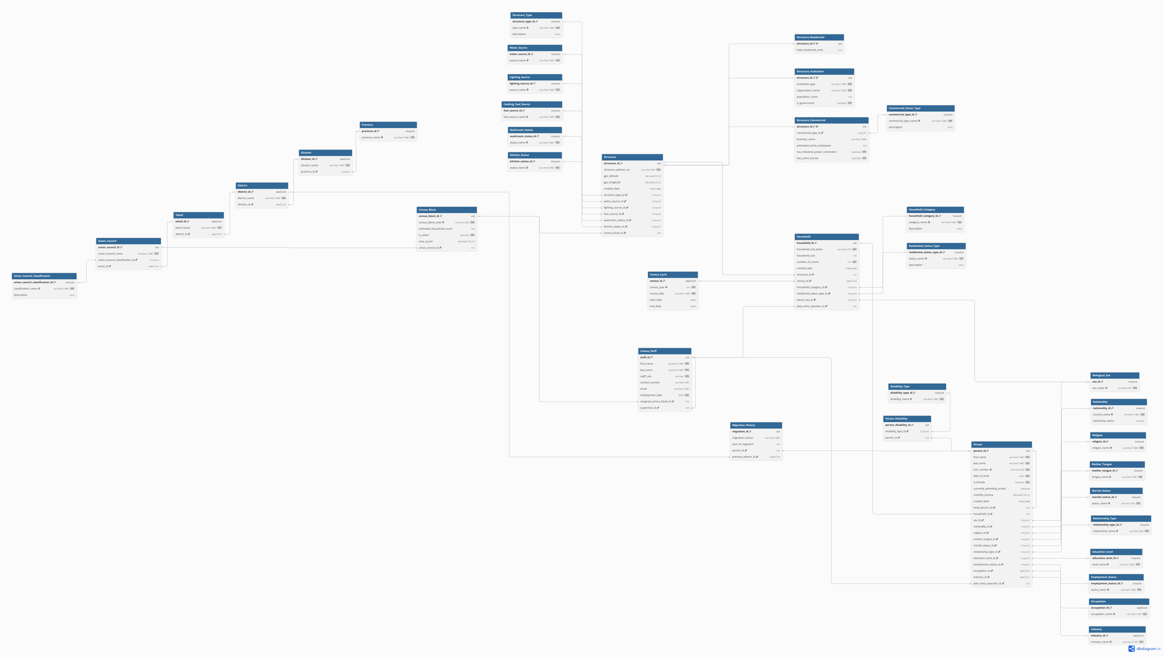

8. Relational Schema*
- Water_Source (water_source_id, source_name)
- Lighting_Source (lighting_source_id, source_name)
- Cooking_Fuel_Source (fuel_source_id, fuel_source_name)
- Washroom_Status (washroom_status_id, status_name)
- Kitchen_Status (kitchen_status_id, status_name)
- Household_Category (household_category_id, category_name, description)
- Residential_Status_Type (residential_status_type_id, status_name, description)
- Biological_Sex (sex_id, sex_name)
- Religion (religion_id, religion_name)
- Mother_Tongue (mother_tongue_id, tongue_name)
- Education_Level (education_level_id, level_name)
- Employment_Status (employment_status_id, status_name)
- Marital_Status (marital_status_id, status_name)
- Disability_Type (disability_type_id, disability_name)
- Occupation (occupation_id, occupation_name)
- Industry (industry_id, industry_name)
- Relationship_Type (relationship_type_id, relationship_name)
- Nationality (nationality_id, country_name, citizenship_status)
- Union_Council_Classification (union_council_classification_id, classification_name, description)

- Census_Cycle (census_id, census_year, census_title, start_date, end_date)
- Structure_Type (structure_type_id, type_name, description)
- Commercial_Sector_Type (commercial_type_id, commercial_type_name, description)
- Province (province_id, province_name)
- Division (division_id, division_name, province_id references Province.province_id)
- District (district_id, district_name, division_id references Division.division_id)
- Tehsil (tehsil_id, tehsil_name, district_id references District.district_id)
- Union_Council (union_council_id, union_council_name, union_council_classification_id references Union_Council_Classification.union_council_classification_id, tehsil_id references Tehsil.tehsil_id)
- Census_Block (census_block_id, census_block_code, estimated_household_count, is_urban, area_sq_km, union_council_id references Union_Council.union_council_id)
- Census_Staff (staff_id, first_name, last_name, staff_role, contact_number, email, assigned_census_block_id references Census_Block.census_block_id, supervisor_id references Census_Staff.staff_id, employment_date)
- Structure (structure_id, structure_address_no, gps_latitude, gps_longitude, created_date, census_block_id references Census_Block.census_block_id, structure_type_id references Structure_Type.structure_type_id, water_source_id references Water_Source.water_source_id, lighting_source_id references Lighting_Source.lighting_source_id, fuel_source_id references Cooking_Fuel_Source.fuel_source_id, washroom_status_id references Washroom_Status.washroom_status_id, kitchen_status_id references Kitchen_Status.kitchen_status_id)
- Structure_Institution (structure_id references Structure.structure_id, institution_type, organization_name, population_count, is_government)
- Structure_Commercial (structure_id references Structure.structure_id, commercial_type_id references Commercial_Sector_Type.commercial_type_id, business_name, estimated_active_employees, has_industrial_power_connection, has_active_license)
- Structure_Residential (structure_id references Structure.structure_id, total_residential_units)
- Household (household_id, structure_id references Structure.structure_id, census_id references Census_Cycle.census_id, household_sub_token, household_category_id references Household_Category.household_category_id, residential_status_type_id references Residential_Status_Type.residential_status_type_id, owner_sex_id references Biological_Sex.sex_id, number_of_rooms, household_size, data_entry_operator_id references Census_Staff.staff_id, created_date)
- Person (person_id, household_id references Household.household_id, first_name, last_name, cnic_number, sex_id references Biological_Sex.sex_id, date_of_birth, nationality_id references Nationality.nationality_id, religion_id references Religion.religion_id, mother_tongue_id references Mother_Tongue.mother_tongue_id, marital_status_id references Marital_Status.marital_status_id, relationship_type_id references Relationship_Type.relationship_type_id, head_person_id references Person.person_id, is_literate, education_level_id references Education_Level.education_level_id, currently_attending_school, employment_status_id references Employment_Status.employment_status_id, occupation_id references Occupation.occupation_id, industry_id references Industry.industry_id, monthly_income, data_entry_operator_id references Census_Staff.staff_id, created_date)
- Person_Disability (person_disability_id, person_id references Person.person_id, disability_type_id references Disability_Type.disability_type_id)
- Migration_History (migration_id, person_id references Person.person_id, previous_district_id references District.district_id, migration_reason, year_of_migration)

*HOW TO READ
- Fields styled in bold represent the Primary Key (PK) of the table.
- Fields styled in italics represent a Foreign Key (FK) along with its explicit relational table direction map.
- Fields styled in bold italics represent a composite setup acting concurrently as both the table's Primary Key and its parent class Foreign Key identifier (1:1 structural extension).

9. SQL Queries and Data Retrieval

A. Joins
INNER JOIN
Shows top 5 districts in Pakistan with highest number of households.
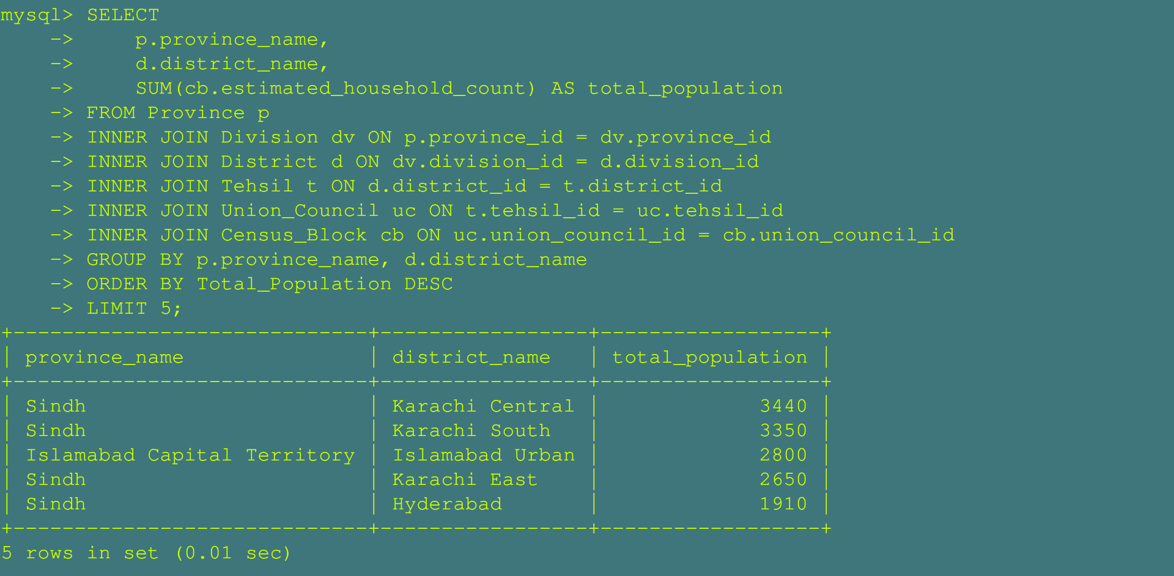
Shows people who have Bachelors, Masters or PhD degree with their job and income.
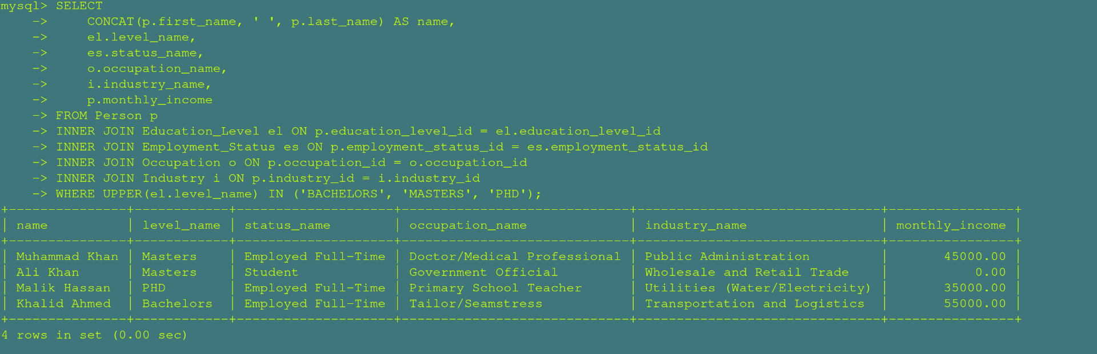

LEFT JOIN
Shows all persons with their education, job, occupation and nationality — even if some info is missing.
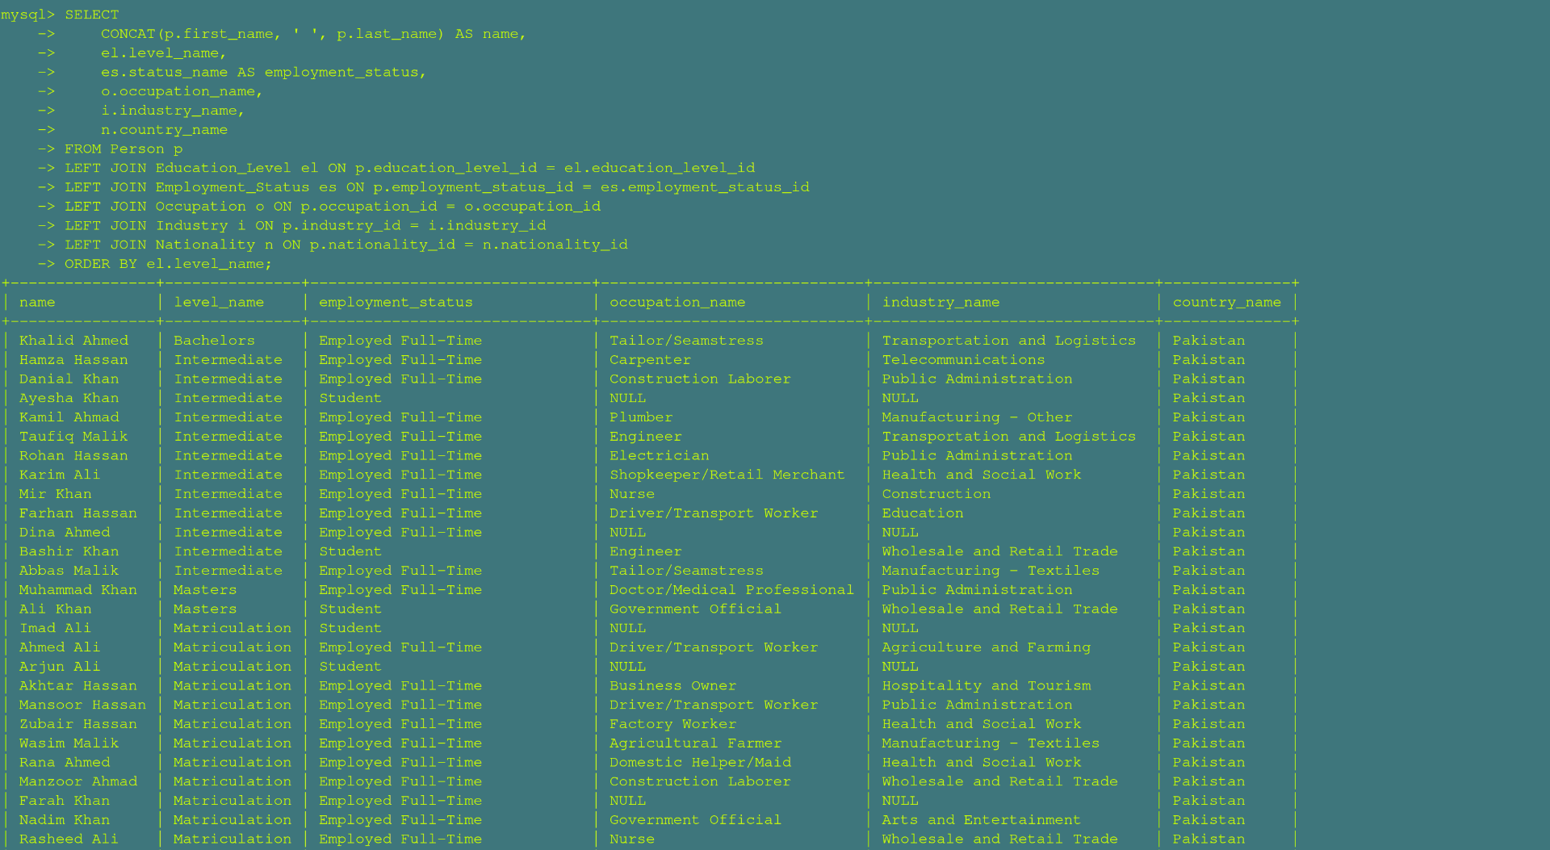
Shows all married persons with their household size information.
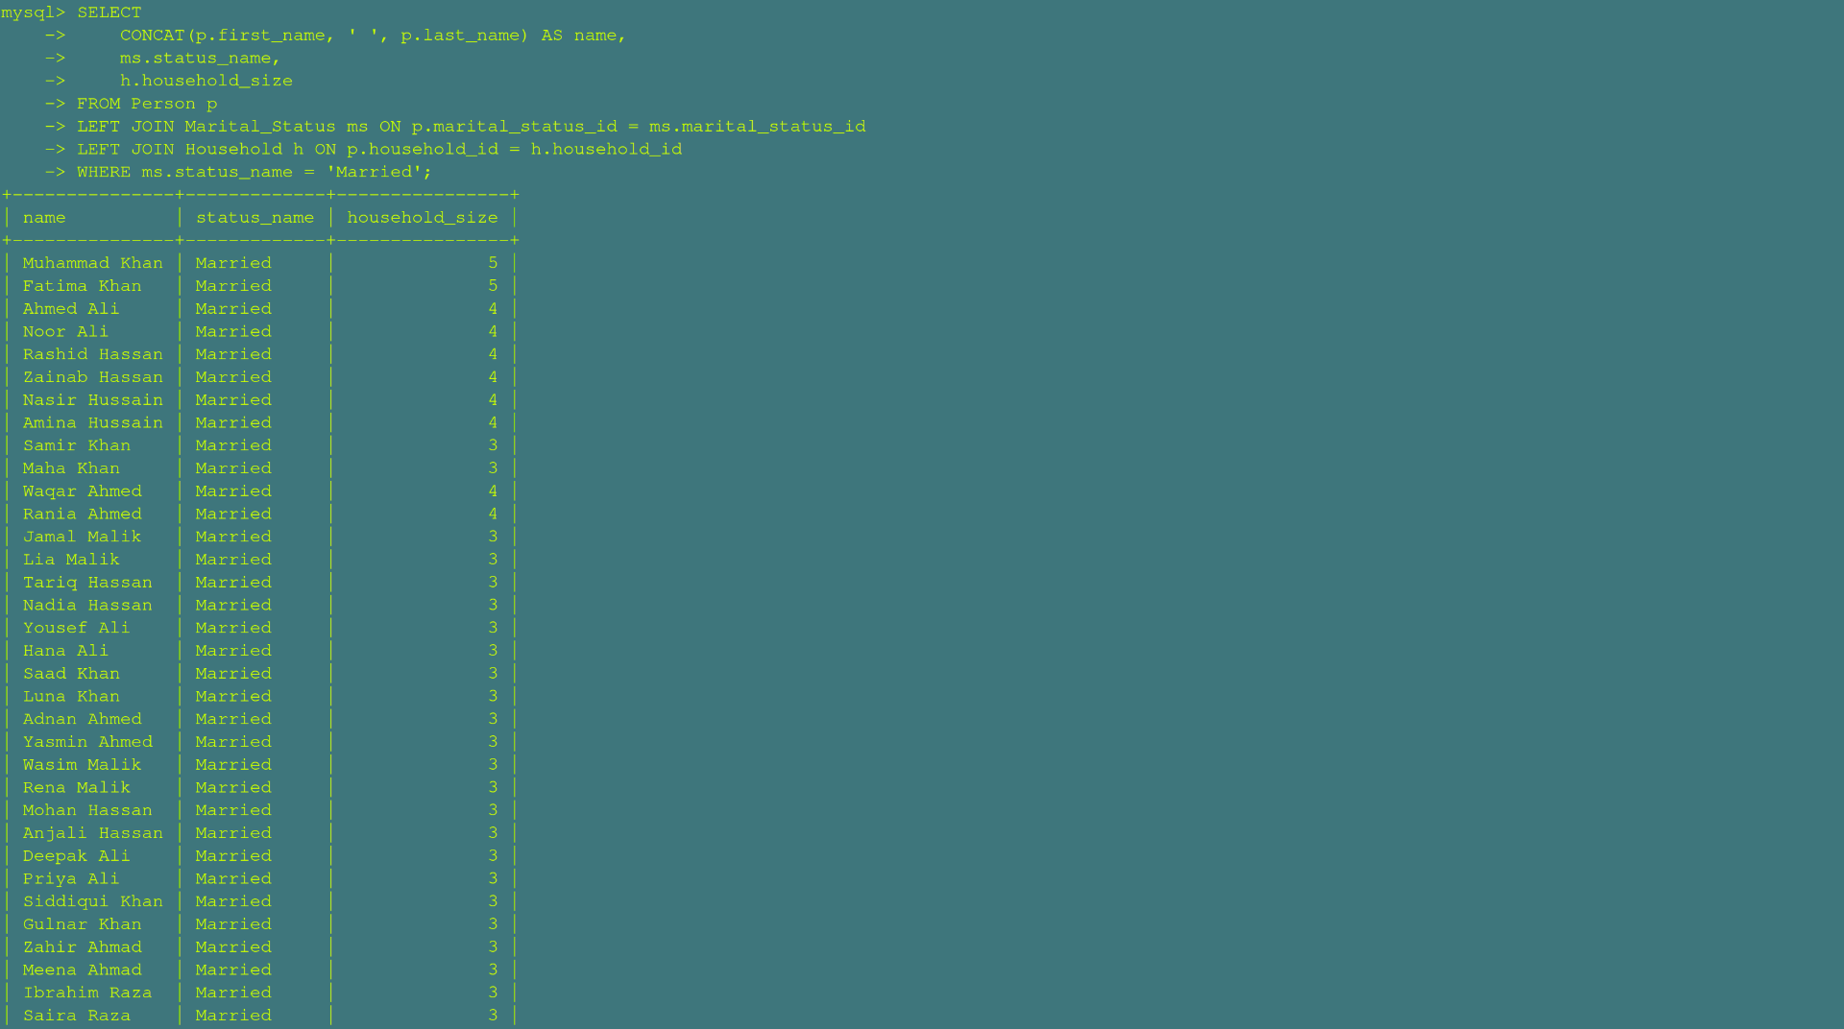
RIGHT JOIN
Shows urban census blocks with more than 300 households and their assigned staff.
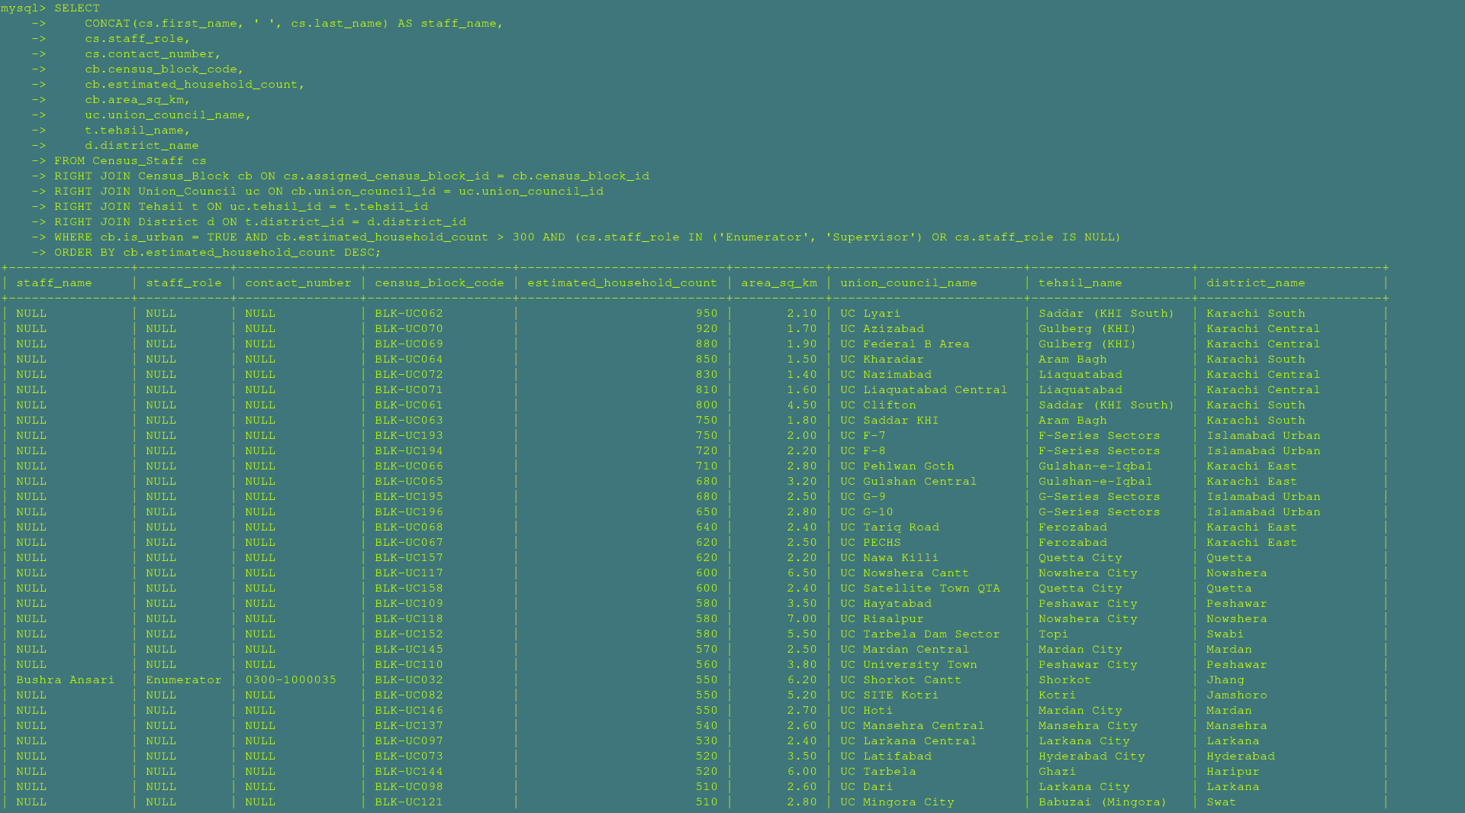
Shows educated and full-time employed persons with their religion and mother tongue profile.
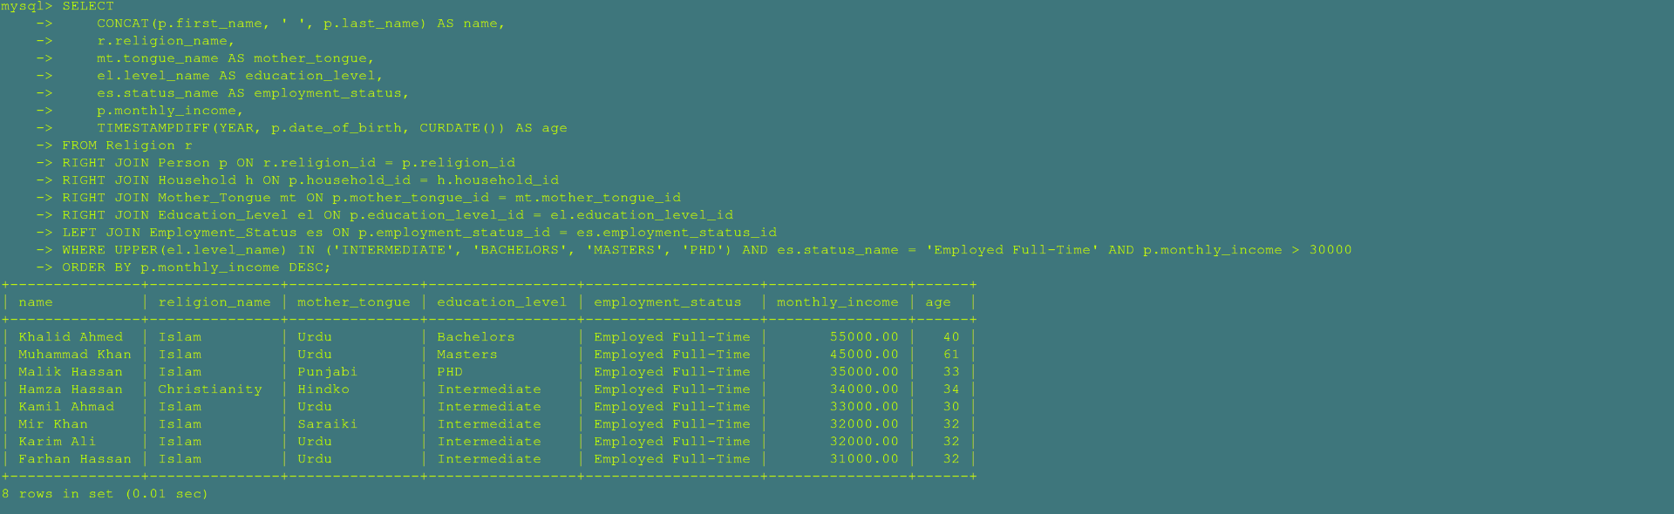

NATURAL JOIN
Shows married individuals with an income above 20,000, joined implicitly on marital_status_id.

Shows individuals with premium employment statuses earning over 30,000, joined implicitly on employment_status_id.
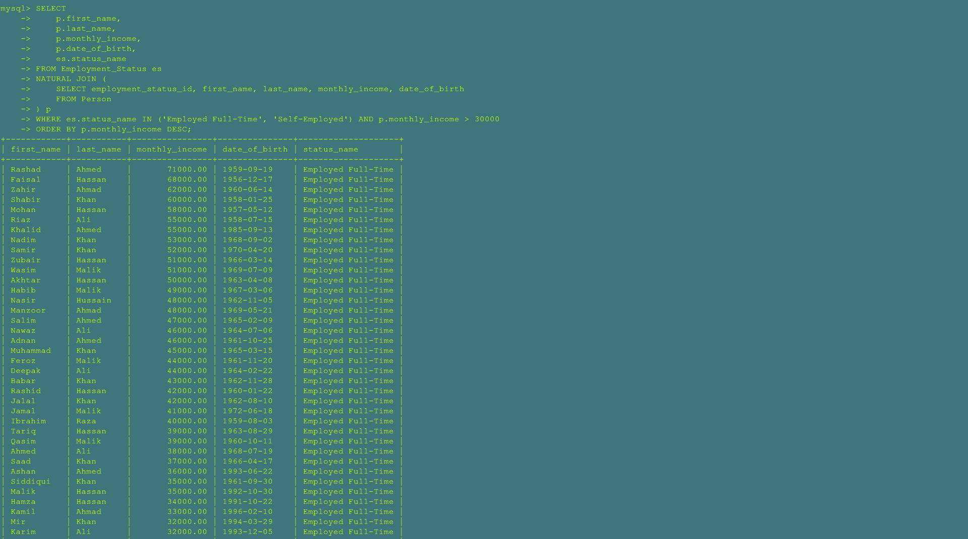
SELF JOIN
Maps out the internal management hierarchy of the census field staff team.

Maps out biological family dynamics by identifying the official household head for each member.


B. Nested and Correlated Queries

Retrieves names of citizens who live in crowded families with more than 4 members.
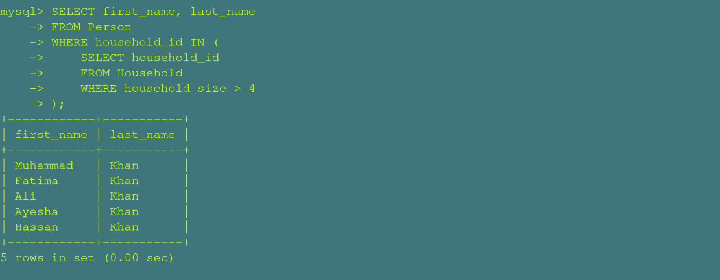

Finds citizens earning more than at least one individual of biological sex male.
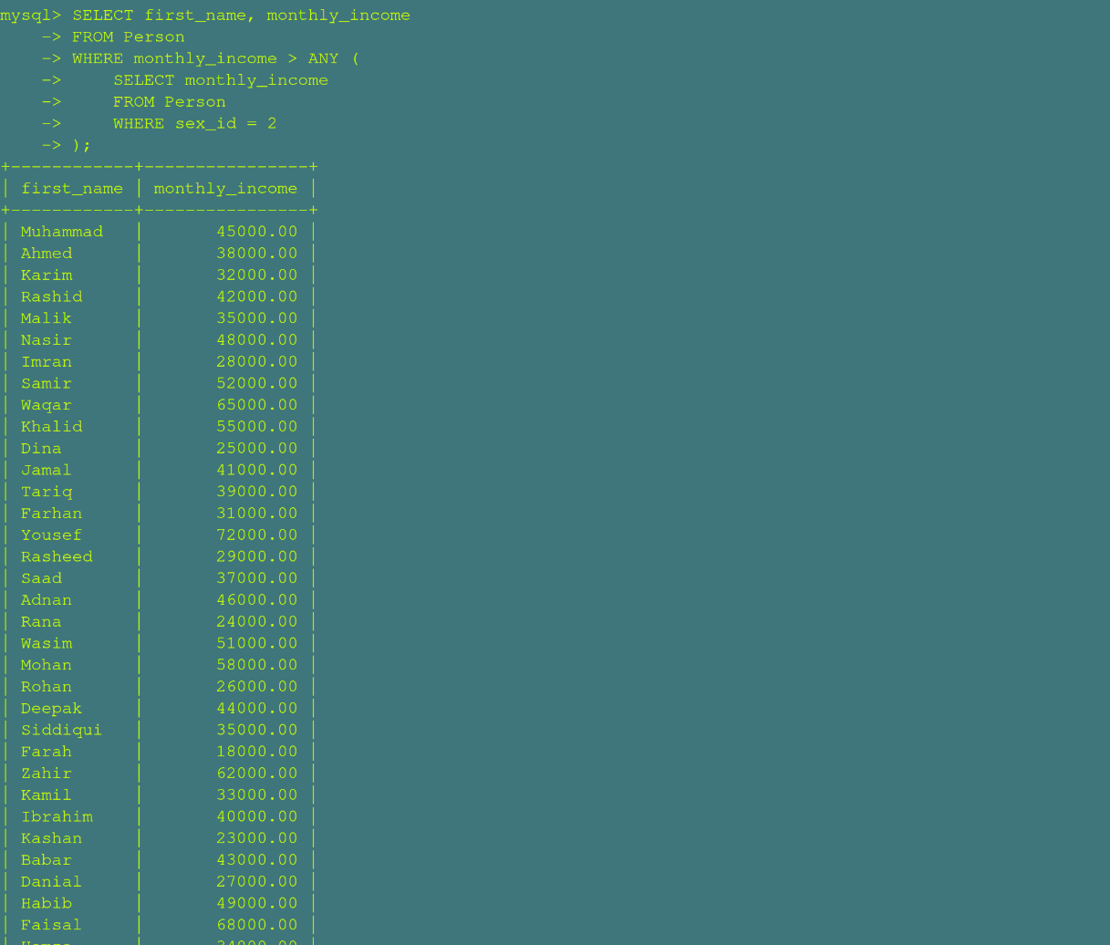

Finds citizens earning more than all females


Lists all citizens who have never migrated or shifted their residential district.


Finds citizens earning less than or equal to the absolute lowest salary among males.


Finds citizens earning less than or equal to at least one individual of among males.


Identifies citizens who have an active internal migration or relocation history record.
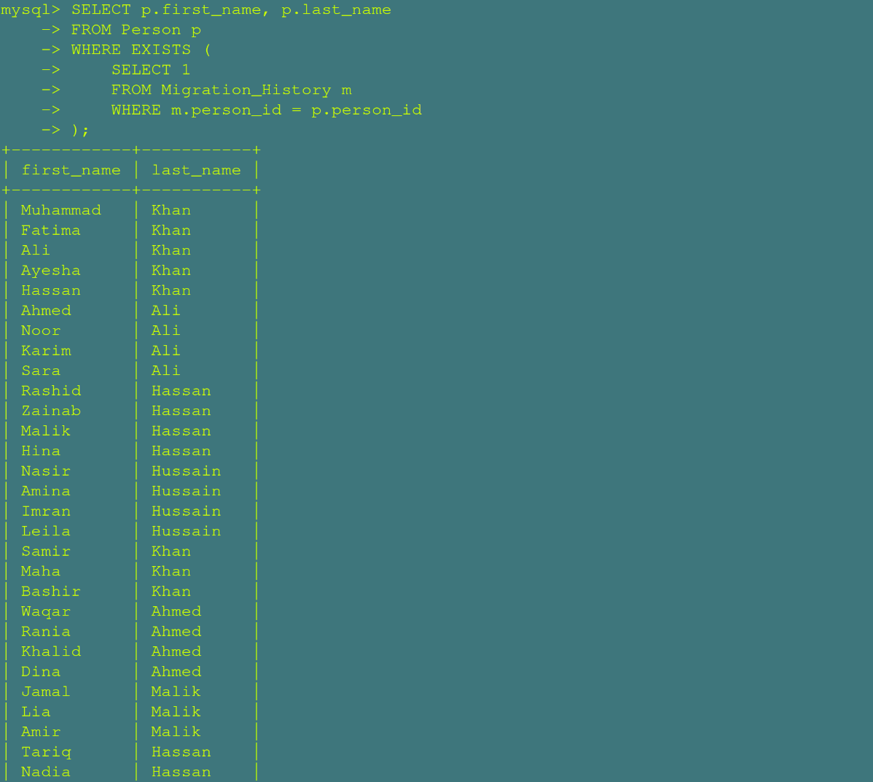

Identifies stable citizens who have zero documented history of changing districts.
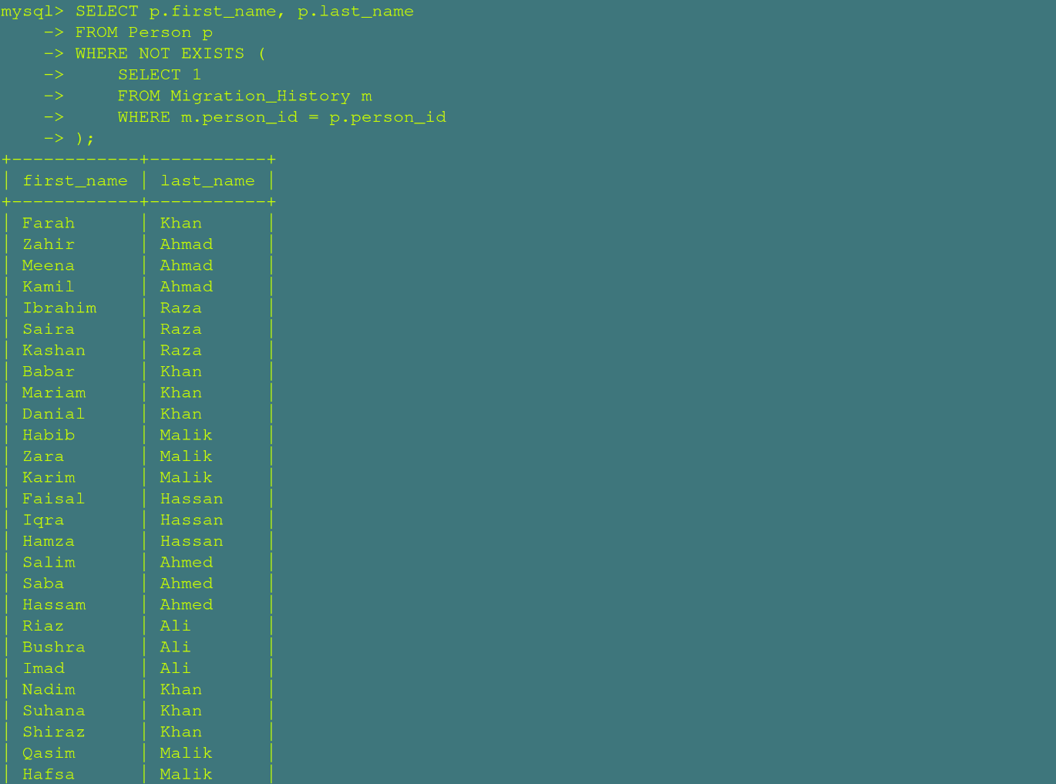

C. Aggregate Queries
Calculates the total headcount of recorded citizens in the census system database.
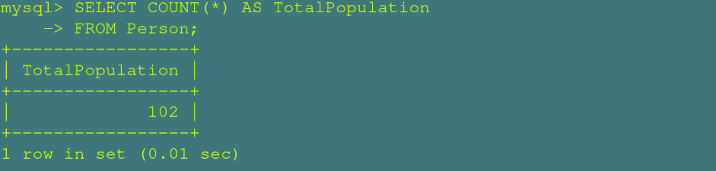
Computes the gross combined monthly income of the entire surveyed population.
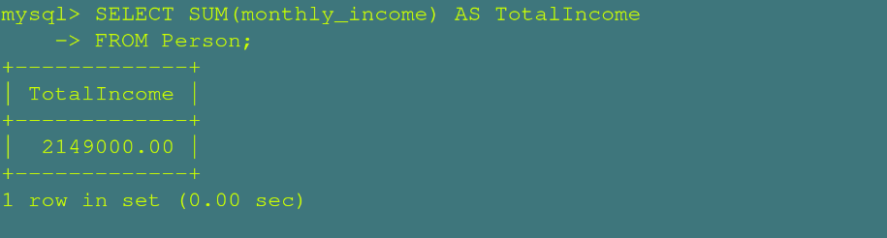
Evaluates the national baseline average monthly income across all citizens.
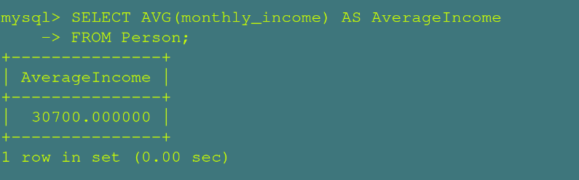

Pinpoints the absolute lowest recorded individual monthly income entry.
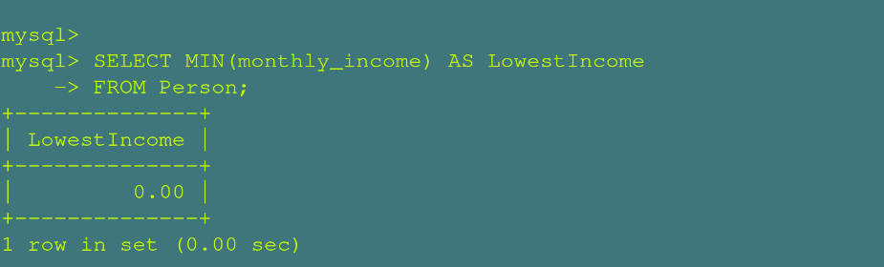
Pinpoints the absolute highest recorded individual monthly income entry.
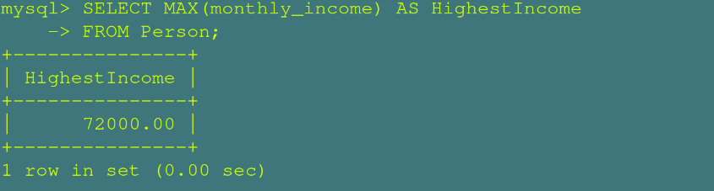
Groups and counts total population distribution cleanly across distinct biological sexes.
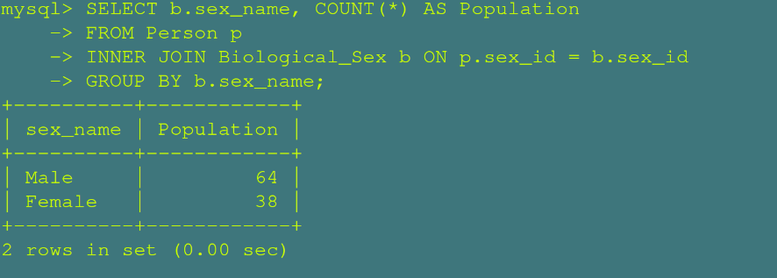

Filters demographic categories to show only biological sexes with more than 40 individuals.
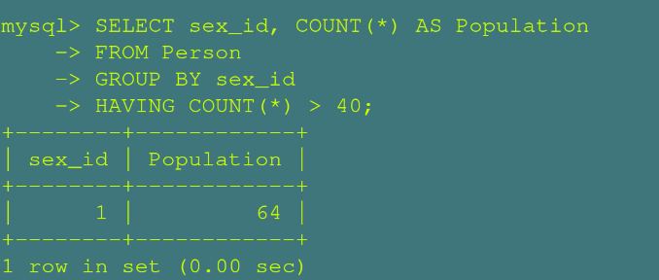

Breaks down population counts and average monthly income metrics categorized by religion.
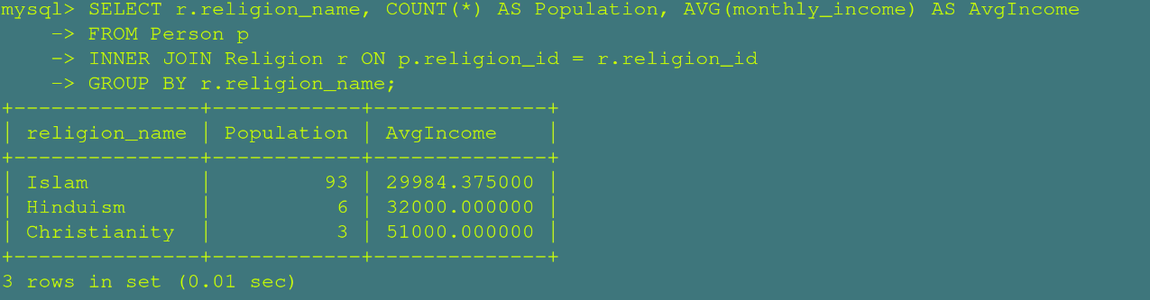

Combines distinct first names from both citizens and field staff, removing duplicate values.
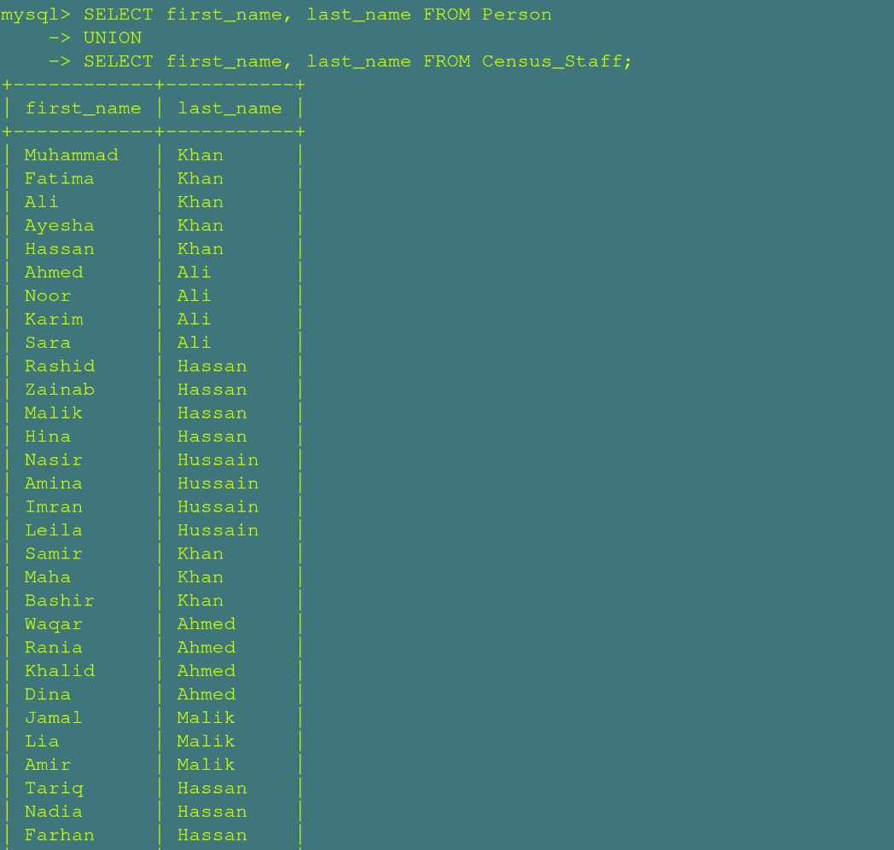

Combines all first names from citizens and field staff, preserving every duplicate entry.
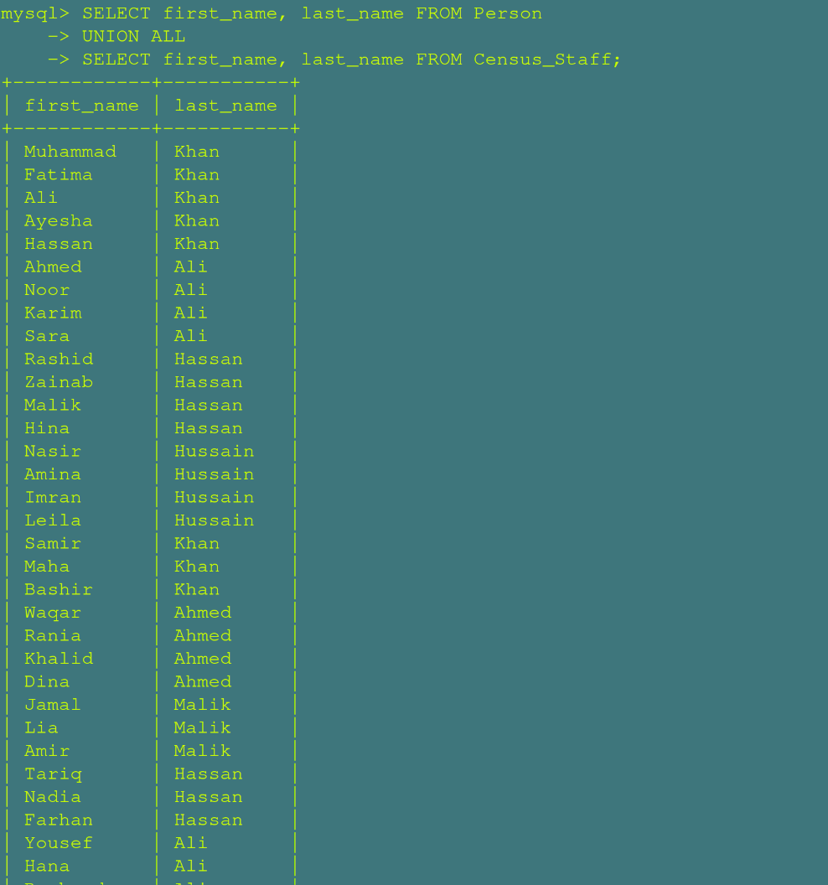

Finds common names shared by both active citizens and field census staff.
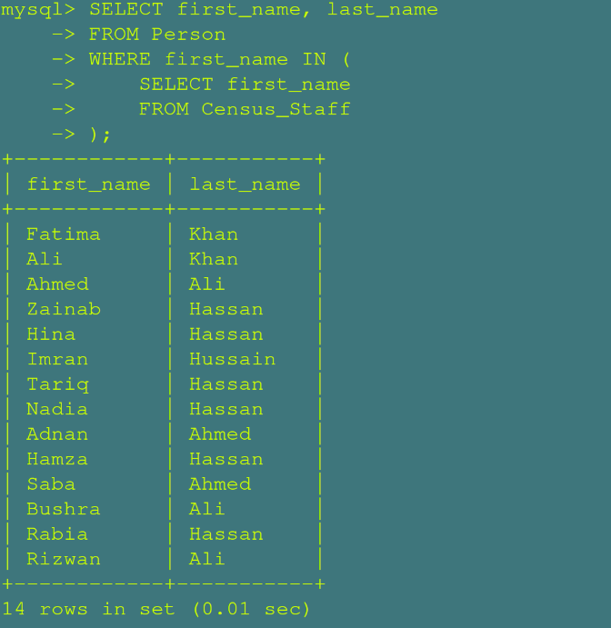

Lists first names unique to citizens that do not exist among census staff.
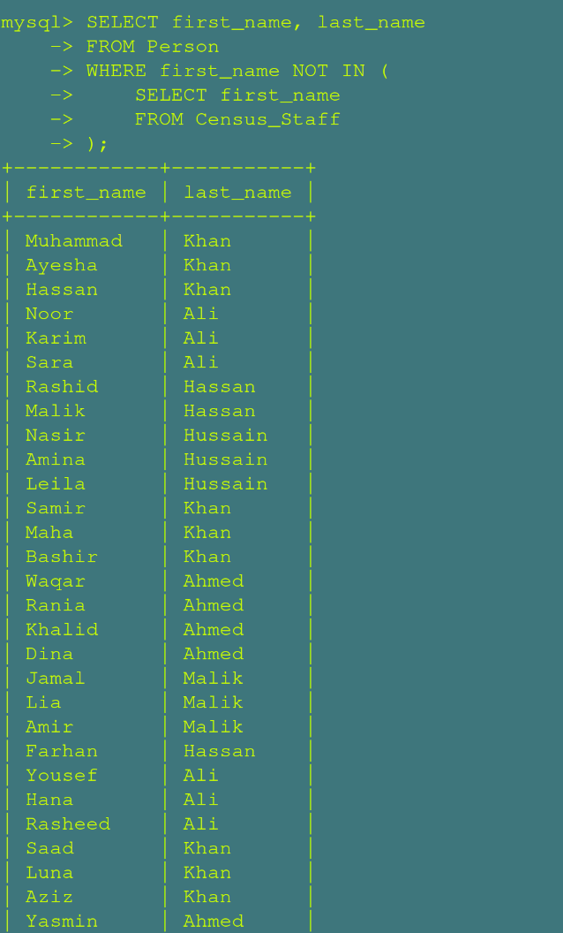

D. Views

Shows a complete profile of each citizen, including their full name, age, education, job, and income in plain words instead of codes.
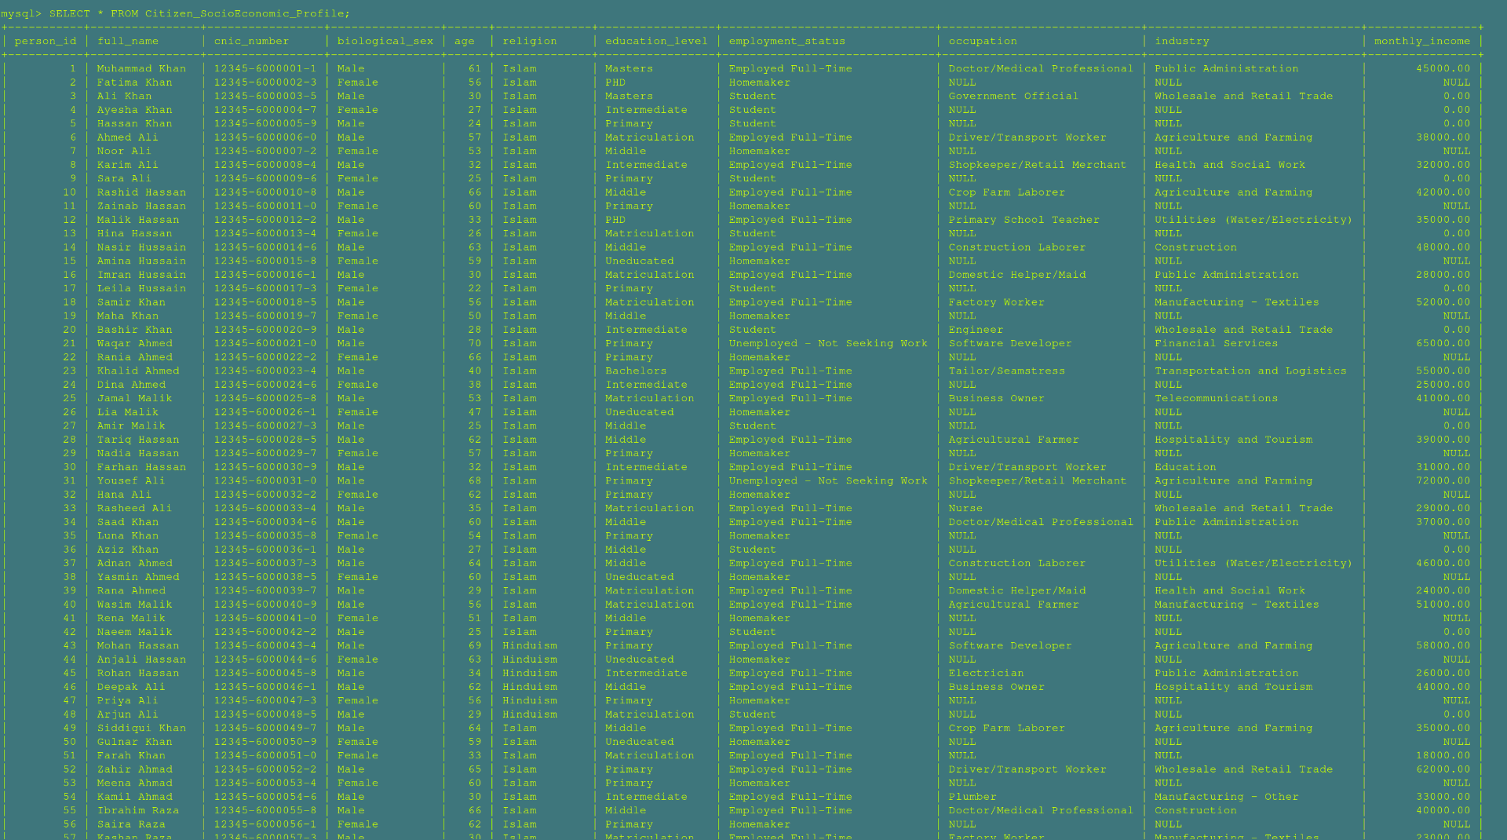

Shows the living conditions of each home, tracking things like room counts, clean water access, electricity, and whether it is in a city or a village.
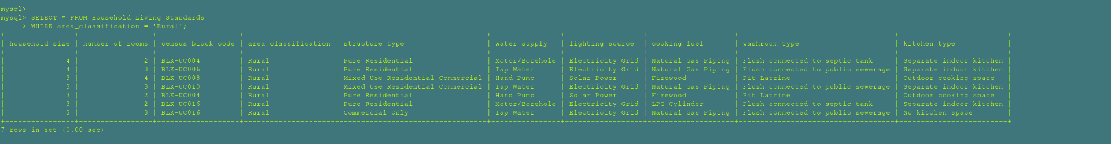

Groups Pakistan's geographic areas together to show the total number of census blocks and households in every region at a glance.
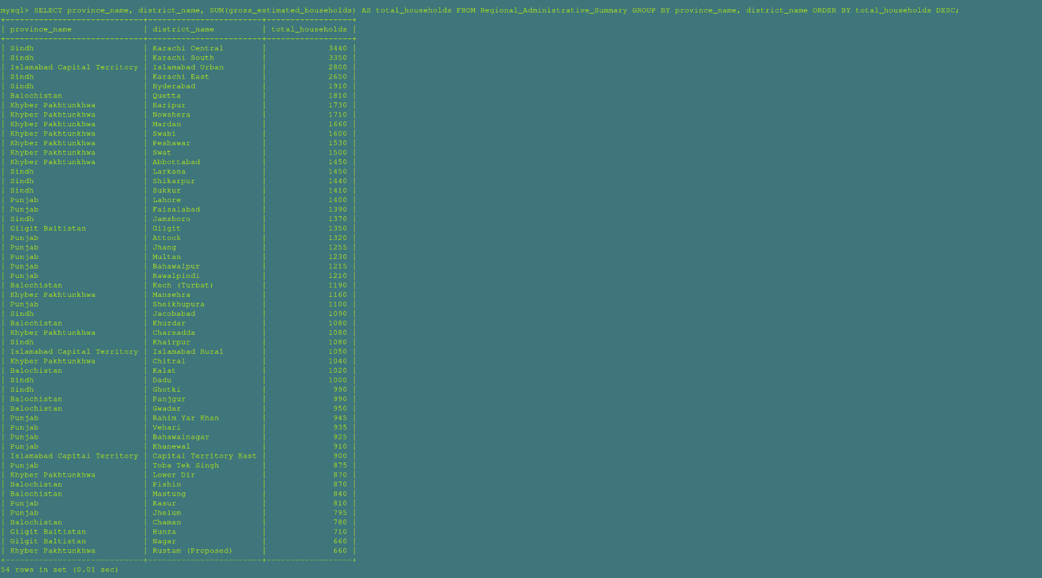

10. Cascading Operations

• ON DELETE CASCADE
In our census architecture, the Migration_History table acts as a tracking log for changing districts. It is completely dependent on a person's profile existing in the Person table. If a citizen is legally removed from the census database (due to data entry errors or fraud cancellation), keeping their old migration history is meaningless and leaves orphaned logs.
By applying ON DELETE CASCADE, removing a record from the Person table automatically triggers a chain reaction that deletes all corresponding relocation entries from Migration_History.
• ON DELETE SET NULL
Our census operations utilize a supervisor network in the Census_Staff table. Field enumerators are monitored via a recursive self-referencing foreign key column called supervisor_id. If a supervisor resigns, retires, or is removed from the staff workforce database, we absolutely do not want to lose or delete the subordinate field enumerators they managed.
By using ON DELETE SET NULL, when a supervisor's record is removed, the field enumerators they were managing remain perfectly intact in the database; their supervisor_id simply switches to NULL (meaning they are temporarily unassigned until a new manager takes over).

11. Challenges and Risks

1. Handling Large Data Efficiently
- The Challenge: A national census involves capturing records for tens of millions of citizens and millions of households. Standard un-normalized or flat-file database architectures experience catastrophic performance degradation and massive disk space bloating when handling data at this scale.
- Our Strategy (Normalization & Storage Optimization):
  - Elimination of Redundant Text: Instead of storing repetitive textual data (e.g., storing the string "Tap Water" or "Employed Full-Time" millions of times across individual household and person rows), these attributes were extracted into micro-lookup tables (Water_Source, Employment_Status, etc.).
  - Strategic Use of Compact Data Types: By linking parent tracking records via TINYINT (1 byte per row, supporting up to 255 distinct lookup categories) instead of INT (4 bytes) or VARCHAR text strings, our schema dramatically compresses the overall database footprint. When scaled to 200 million citizen records, saving 3 bytes per column across dozens of columns prevents gigabytes of unnecessary data footprint, ensuring data blocks fit efficiently into system cache memory during intense analytical processing.
  - Achieving 3rd Normal Form (3NF): The database schema was systematically advanced to 3NF. Every non-prime attribute depends purely, directly, and non-transitively on the primary key anchor of its respective table, ensuring computational efficiency and keeping data storage structurally lean.

2. Ensuring Referential Integrity
- The Challenge: In a highly relational database with deep organizational hierarchies (e.g., Province --> Division --> District --> Tehsil --> Union_Council --> Census_Block --> Structure --> Household --> Person), deleting or updating a higher-level record risks creating orphaned child data blocks and breaking internal consistency.
- Our Strategy:
  - Implemented structural relational rules via declarative foreign keys.
  - Applied ON DELETE CASCADE on strict target operational tracking tables (such as wiping out a citizen's internal logs in Migration_History automatically if their baseline Person profile is deleted).
  - Applied ON DELETE SET NULL on organizational management linkages (such as self-referencing workforce hierarchies in Census_Staff), ensuring field enumerator operational performance data is preserved if a supervisor's account is removed.

3. Handling Complex Queries and Optimization
- The Challenge: As the volume of deep relational tables grows into millions of data points, executing multi-table statements utilizing numerous INNER JOIN, LEFT JOIN, or nested aggregate operations can lead to slow performance due to intensive nested loop evaluations or extensive full table scans.
- Our Strategy:
  - Relational Views: Wrapped multi-tier joins inside predefined logical relational SQL views (Most_Populated_Cities, Highly_Educated_Persons, Citizen_Record). This abstracts structural execution complexities and helps the database engine optimize compilation paths.

Group Members & Project Roles
Members | Roles
Azma | Wrote sub queries, co-related queries and aggregate functions
Sarmad | Developed multi-table Joins, added Views and documentation
Sharjeel | Designed the erd, schema and documentation
Zakia | Designed erd, managed data Insertion and wrote queries

