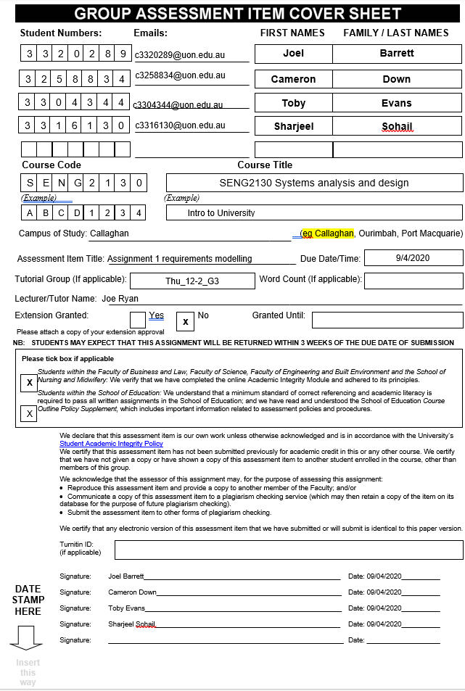

# Brief Use Case Description

**Register Appointment**: The client registers a service appointment that could include a burial or cremation with an additional religious service.

**Burials**: A service where a grave is dug, and a body is lowered into it at a specified time. A service can be held in conjunction.

**Cremation**: A service whereby a body is incinerated in a furnace and their ashes are collected.

**Dig Graves**: The ground staff digs a grave in order to let system schedule a burial.

**Tidy Grounds**: Staff member is responsible for keeping the grounds clean/tidy so that the burial services can be done easily.

**Erecting Tents**: Staff pitches the tents so that the system can schedule Marquis for graveside services.

**Cleaning Chapel**: Ground staff cleans the chapel to run the burials neatly and professionally.

**Servicing the Crematorium**: Crematorium is serviced by the staff (e.g. cleaning, servicing machinery etc) to get cremation done.

**Marquis**: Marquis for mourners is arranged post-burial upon request

**Maintenance Log Book**: Maintenance records are being entered by ground staff into maintenance log book

**Provision of Sling:** The use case in which ground staff will set-up a Sling on to be used grave sites for upcoming burials

**Book Service:** The use case in which Service Staff perform either a memorial or religious service to honour the deceased

**Request Floral Arrangement:** The use case for a client wanting flowers for their deceased to be logged by the Office Staff and collected from the onsite greenhouse by the Ground Staff

**Import Exotic Blooms:** The use case for the event in which flowers requested by the client are not available onsite, the Office Staff order them in from a supplier

**Create Perpetual Care Contract:** The use case in which a contract is made up and honoured to maintain the ground and facilities hosting a clients cremated deceased onsite.

**Return Ashes:** Post cremation the ashes are returned to the client

**Purchase Urns:** Arrangement is placed for purchase of urn

**Rent Wall Space:** General public renting wall space for display of urns

**Schedule Furnace:** Scheduling a cremation service

# Fully Developed Use Case Descriptions

|  |  |  |
| --- | --- | --- |
| **Use Case Name** | **Register Appointment** | |
| **Brief Description** | The client registers a service appointment that could include a burial or cremation with an additional religious service. | |
| **Actors** | Client, Office Staff | |
| **Related Use Cases** | Burials, Cremation and Service | |
| **Entry Condition** | The client contacting office staff. | |
| **Exit Condition** | Appointment is registered. | |
| **Flow of Events** | **Actors** | **System** |
| 1. Client requests service type.  2. If “burial” is selected, office staff asks if client wants a cross or a plaque.  3. Office staff inquire if client would like an additional religious service.  4. Office staff inquire if client would like additional floral arrangements | 4.1 Appointment is made and logged in appointment book |
| **Exception Condition** | 1.1 If there are no available times or the available times do not suit the client,   1. Inform client that “We are sorry for the inconvenience” 2. Cease communication | |

|  |  |  |
| --- | --- | --- |
| **Use Case Name** | **Burials** | |
| **Brief Description** | A service where a grave is dug, and a body is lowered into it at a specified time. A service can be held in conjunction. | |
| **Actors** | Ground Staff | |
| **Related Use Cases** | Dig Graves, Provision of slings, Marquis, Service | |
| **Entry Condition** | When appointment book is checked. | |
| **Exit Condition** | Once burial has ended and is logged. | |
| **Flow of Events** | **Actors** | **System** |
| 1. Appointment book is checked  2. Burial site is prepared  3. Coffin is lowered into grave  4. Grave is filled  5. Plaque/cross is placed | 1.1 If Service is listed in appointment book, hold service   * 1. End of burial is entered and logged |
| **Exception Condition** | 1.1 If the client has cancelled the service,   1. Site is not prepared, cancel service | |

|  |  |  |
| --- | --- | --- |
| **Use Case Name** | **Cremation** | |
| **Brief Description** | A service whereby a body is incinerated in a furnace and their ashes are collected. | |
| **Actors** | Client, Ground Staff, Service Staff | |
| **Related Use Cases** | Schedule furnace, Service, Return ashes | |
| **Entry Condition** | When appointment book is checked. | |
| **Exit Condition** | Once cremation has ended and is logged. | |
| **Flow of Events** | **Actors** | **System** |
| 1.1 Cremation site is prepared  3.1 Incinerate body in furnace  3.2 Ashes are collected | 1. Appointment book is checked  2. If there is a religious service listed, that service is commenced  3. Cremation is held  4. End of cremation is entered and logged |
| **Exception Condition** | 1.1 If the client has cancelled the service,  a) Crematorium is not prepared, cancel service | |

|  |  |  |
| --- | --- | --- |
| **Use Case Name** | Dig Graves | |
| **Brief Description** | The ground staff digs a grave as required for the burial | |
| **Actors** | Ground staff | |
| **Related Use Cases** | Burials (Includes) | |
| **Entry Condition** | The request is sent to dig a grave | |
| **Exit Condition** | Grave is ready for the burial service and logged | |
| **Flow of Events** | **Actors** | **System** |
| 1. Checks if the tools are available to dig 2. Digs the grave and make it ready for the burial 3. Writes the work that’s been done into log book | 1. The request is sent to dig a grave for burial 2. Grave is dug successfully 3. logs into the Maintenance log book |
| **Exception Condition** | 1) The tools are not available and being used by other staff members   1. Re-schedule the request to later or next day | |

|  |  |  |
| --- | --- | --- |
| **Use Case Name** | Tidy Grounds | |
| **Brief Description** | Staff member is responsible for keeping the grounds clean/tidy so that the burial services can be done easily | |
| **Actors** | Ground Staff | |
| **Related Use Cases** | - | |
| **Entry Condition** | Staff member collects the equipment for cleaning | |
| **Exit Condition** | The grounds are tidy and logged | |
| **Flow of Events** | **Actors** | **System** |
| * 1. Staff member collects the equipment required  1. Cleans and Service the ground 2. Cleans and picks rubbish from the parking space 3. Writes the summary in Maintenance log book | 1. Ground is tidy and logged into the Maintenance log book |
| **Exception Condition** | 1) If equipment for cleaning ground is not available;   * 1. Creates a summary report for maintenance book | |

|  |  |  |
| --- | --- | --- |
| **Use Case Name** | Erecting Tents | |
| **Brief Description** | Staff pitches the tents so that the system can schedule Marquis for graveside services | |
| **Actors** | Ground staff | |
| **Related Use Cases** | Marquis (excludes) | |
| **Entry Condition** | System sends a request to erect tents | |
| **Exit Condition** | Tents are pitched and logged and ready for Marquis to be scheduled | |
| **Flow of Events** | **Actors** | **System** |
| 1. Staff member checks for the equipment to erect tents 2. Pitches tents 3. Identify the no. of attendants can fit under tents 4. Writes the information in the log book | 1. Sends a request to erect tents 2. Logs the no. of attendants fit under tents in log book 3. Tents are erected and Information is recorded into the Maintenance log book |
| **Exception Condition** | 1) If the tents are not available / already in use   1. Cancels the request of erecting tents | |

|  |  |  |
| --- | --- | --- |
| **Use Case Name** | Cleaning Chapel | |
| **Brief Description** | Ground staff cleans the chapel to run the burials neatly and professionally | |
| **Actors** | Ground staff | |
| **Related Use Cases** | - | |
| **Entry Condition** | User gather tools to clean the chapel | |
| **Exit Condition** | Chapel is cleaned, logged, and ready for graveside services | |
| **Flow of Events** | **Actors** | **System** |
| * 1. Ground staff gather tools to clean the chapel  1. Picks rubbish from the chapel 2. Cleans and sanitise the chapel 3. Writes the chapel as cleaned into the log book | 1. Cleaned chapel is logged into the Maintenance log book |
| **Exception Condition** | - | |

|  |  |  |
| --- | --- | --- |
| **Use Case Name** | Servicing the Crematorium | |
| **Brief Description** | Crematorium is serviced by the staff (e.g. cleaning, servicing machinery etc) to get cremation done | |
| **Actors** | Ground Staff | |
| **Related Use Cases** | - | |
| **Entry Condition** | User cleans and services the crematorium | |
| **Exit Condition** | Crematorium and machinery is cleaned and logged | |
| **Flow of Events** | **Actors** | **System** |
| 1. Cleans and service the crematorium 2. Checks for equipment to clean machinery 3. Service vehicle required for cremation 4. Cleans diggers 5. Cleans garden equipment 6. Records the summary into log book | 1. Cleaned crematorium is logged into the Maintenance log book 2. Equipment is cleaned and logged into the Maintenance log book |
| **Exception Condition** | 2) Machinery is being used for cremation   * 1. Writes down in the summary and logs into the log book | |

|  |  |  |
| --- | --- | --- |
| **Use Case Name** | Marquis | |
| **Brief Description** | Marquis for mourners is arranged post-burial upon request | |
| **Actors** | Client, Office staff | |
| **Related Use Cases** | Burials (includes) | |
| **Entry Condition** | Client requests to arrange marquis | |
| **Exit Condition** | Marquis is organised for mourners at the burial | |
| **Flow of Events** | **Actors** | **System** |
| 1. Client requests to arrange marquis after burial to office staff 2. Office staff arranges the Marquis 3. Office staff checks if tents are available 4. Office staff arrange pitching of tents and sends confirmation to the client 5. Office staff sends summary to the system | * 1. Logs the Marquis as required   2. Receives summary report of Marquis |
| **Exception Condition** | 3.1) If the tents are unavailable;   * 1. System puts the request on hold and generates the summary report | |

|  |  |  |
| --- | --- | --- |
| **Use Case Name** | Maintenance Log Book | |
| **Brief Description** | Maintenance records are being entered by ground staff into maintenance log book | |
| **Actors** | Ground Staff | |
| **Related Use Cases** | Tidy Grounds, Erecting Tents, Cleaning Chapel, Servicing the Crematorium | |
| **Entry Condition** | User enters the Maintenance work | |
| **Exit Condition** | Records has been saved in the book | |
| **Flow of Events** | **Actors** | **System** |
| 1. User writes their details and signs when done digging grave 2. User writes their details and signs when done cleaning the grounds 3. User writes the no. of attendants that can fit under tent and signs 4. User write their details and signs when done erecting tents 5. User write their details and signs when done cleaning chapel 6. User write their details and signs when done cleaning the crematorium 7. User write their details and signs when done servicing the machinery of cremation | * 1. User information and job done is logged   2. User information and job done is logged   3. User information and job done is logged   4. User information and job done is logged   5. User information and job done is logged   6. User information and job done is logged   7. User information and job done is logged |
| **Exception Condition** | - | |

|  |  |  |
| --- | --- | --- |
| **Use Case Name** | **Provision of Sling** | |
| **Brief Description** | It is a role of the Ground Staff to provide an upcoming burial with a Sling (coffin lowering device). | |
| **Actors** | Ground Staff | |
| **Related Use Cases** | Burials | |
| **Entry Condition** | Ground staff prepare burial site | |
| **Exit Condition** | Site is logged as having sling set up | |
| **Flow of Events** | **Actors** | **System** |
| * 1. Ground Staff prepare burial site   2. Ground staff install sling at burial site | 1. Site is logged as having sling |
| **Exception Condition** |  | |

|  |  |  |
| --- | --- | --- |
| **Use Case Name** | **Service** | |
| **Brief Description** | It is a service in honour of the deceased individual, either religious or memorial. | |
| **Actors** | Service Staff, Office Staff, Client | |
| **Related Use Cases** | Register Appointment, Burials, Cremation, Register Floral Arrangement | |
| **Entry Condition** | The client requests a service | |
| **Exit Condition** | Service staff conclude the service | |
| **Flow of Events** | **Actors** | **System** |
| * 1. The client requests a service from the office staff   2. The office staff check appointment book for available timeslots   3. The client selects a timeslot for their service   4. The service staff hold the service | 1. The available timeslots are found in the appointment book 2. The clients selected timeslot is logged    1. The service is logged as being completed |
| **Exception Condition** | * 1. The client cancels the service   2.1 There are not available timeslots that work for the client | |

|  |  |  |
| --- | --- | --- |
| **Use Case Name** | **Request Floral Arrangement** | |
| **Brief Description** | The flowers for upcoming appointments are collected from the onsite greenhouse. | |
| **Actors** | Ground Staff, Office Staff | |
| **Related Use Cases** | Request Appointment, Import Exotic Blooms | |
| **Entry Condition** | The appointment is logged as needing flowers | |
| **Exit Condition** | Flowers are logged as being collected | |
| **Flow of Events** | **Actors** | **System** |
| 1. Office staff inform ground staff of flower requirements or upcoming appointment 2. Ground staff find and collect flowers 3. Ground staff inform office staff flowers are collected | * 1. The office staff log the flowers as collected |
| **Exception Condition** | * 1. Flowers are not available and need to be imported | |

|  |  |  |
| --- | --- | --- |
| **Use Case Name** | **Import Exotic Blooms** | |
| **Brief Description** | The office staff order in exotic or out of season blooms for upcoming appointment when not available on site. | |
| **Actors** | Office Staff, Ground Staff, Client | |
| **Related Use Cases** | Request Floral Arrangement | |
| **Entry Condition** | The flowers are unavailable onsite | |
| **Exit Condition** | Exotic Blooms are ordered | |
| **Flow of Events** | **Actors** | **System** |
| 1. The Ground Staff advise The Office Staff that the flowers will need to be imported 2. The office staff advise the customer that the flowers will need to be imported 3. Client decides if they want to import blooms 4. The office staff import the flowers from an available supplier | * 1. The flower order is logged |
| **Exception Condition** | 2.1 Customer indicates they do not want to import flowers | |

|  |  |  |
| --- | --- | --- |
| **Use Case Name** | **Perpetual Care Contract** | |
| **Brief Description** | It is a contract between the client and the burial ground to maintain the burial site or interment site of a deceased individual | |
| **Actors** | Office Staff, General Public | |
| **Related Use Cases** |  | |
| **Entry Condition** | A member of the general public requests a perpetual care contract | |
| **Exit Condition** | Contract is finalized | |
| **Flow of Events** | **Actors** | **System** |
| 1. A member of the General Public requests a Perpetual Care Contract from The Office Staff 2. Office Staff write contract 3. Both actors sign contract | * 1. Contract is logged in system and put into effect |
| **Exception Condition** | 1.1 The member of general public cancels contract | |

|  |  |  |
| --- | --- | --- |
| **Use case name** | **Return ashes** | |
| **Brief Description** | Post cremation the ashes are returned to the client | |
| **Actors** | Client, service staff, Staff member | |
| **Related Use cases** | Cremation, register appointment | |
| **Entry condition** | Client wants to book cremation. | |
| **Exit condition** | Client receives ashes | |
| **Flow of events** | **Actors** | **System** |
| 1. Client receives ashes | * 1. Cremation service has concluded   2. Ashes are prepared   3. pickup is recorded in register. |
| **Exception condition** | NA | |

|  |  |  |
| --- | --- | --- |
| **Use case name** | **Purchase Urns** | |
| **Brief Description** | Arrangement is placed for purchase of urn | |
| **Actors** | Staff member, General Public | |
| **Related Use cases** | return ashes | |
| **Entry condition** | General Public requests to purchase urn | |
| **Exit condition** | Public member receives urn | |
| **Flow of events** | **Actors** | **System** |
| 1. Public member requests Urn 2. Public member selects from catalogue 3. Public member receives urn | * 1. Catalogue is presented   2. transaction is processed |
| **Exception condition** | * Stock unavailable * Client decides not to purchase urn | |

|  |  |  |
| --- | --- | --- |
| **Use case name** | **Rent wall space** | |
| **Brief Description** | General public renting wall space for display of urns | |
| **Actors** | General public, Staff | |
| **Related Use cases** | Return Ashes | |
| **Entry condition** | General public requests wall rent space | |
| **Exit condition** | Wall space is rented | |
| **Flow of events** | **Actors** | **System** |
| 1. Public member requests wall space 2. Wall space option is selected by public member 3. Public member gives urn for display | * 1. Checks available wall space   2. Wall space is reserved for urn   3. Urn is received and put up for display by staff |
| **Exception condition** | * 1. (System) No space available * Public member decides not to rent space | |

|  |  |  |
| --- | --- | --- |
| **Use case name** | **Schedule Furnace** | |
| **Brief Description** | Scheduling a cremation service | |
| **Actors** | Client, Staff member, Service Staff | |
| **Related Use cases** | Book service | |
| **Entry condition** | Service has concluded, body is ready for cremation. | |
| **Exit condition** | Cremation is booked. | |
| **Flow of events** | **Actors** | **System** |
| * 1. Client select available time | 1. Available times presented 2. Time booked |
| **Exception condition** | * 1. (Actor) Furnace is booked | |

# Activity Diagrams

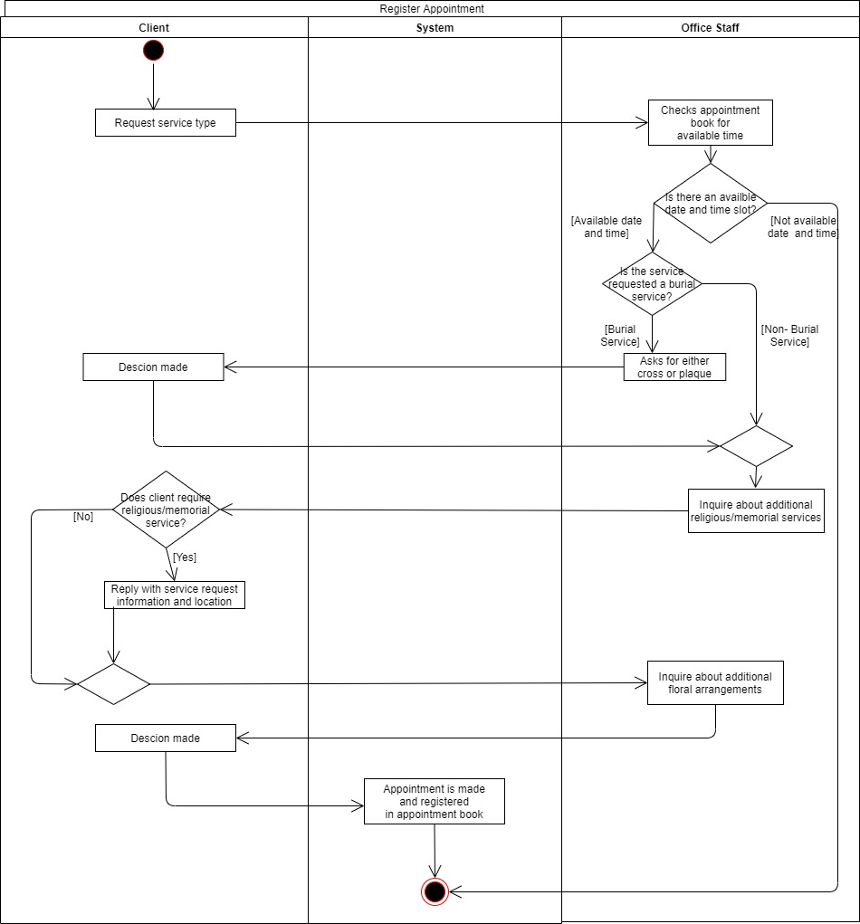

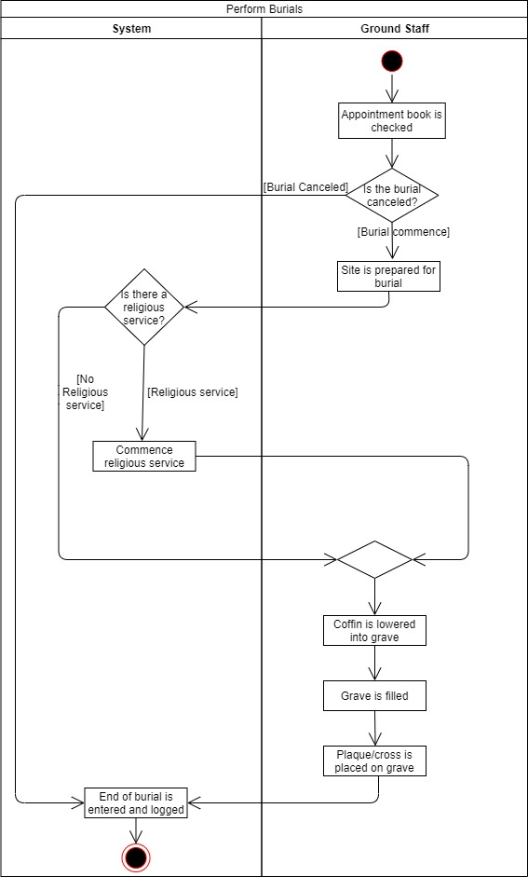

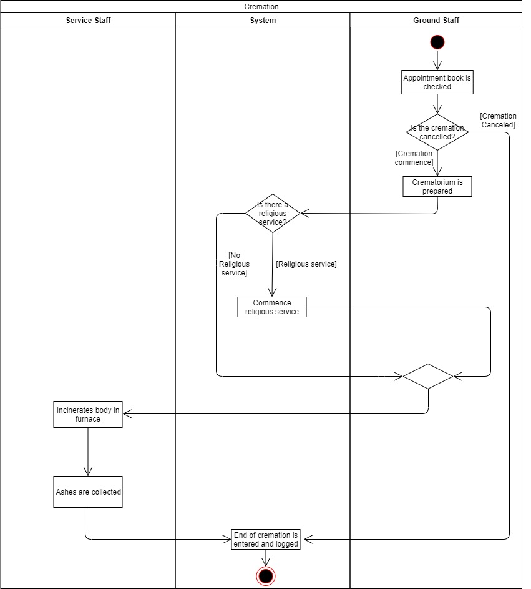

**Dig Graves**

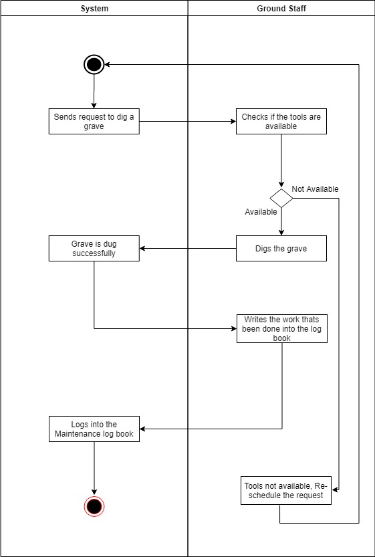

**Tidy Grounds**

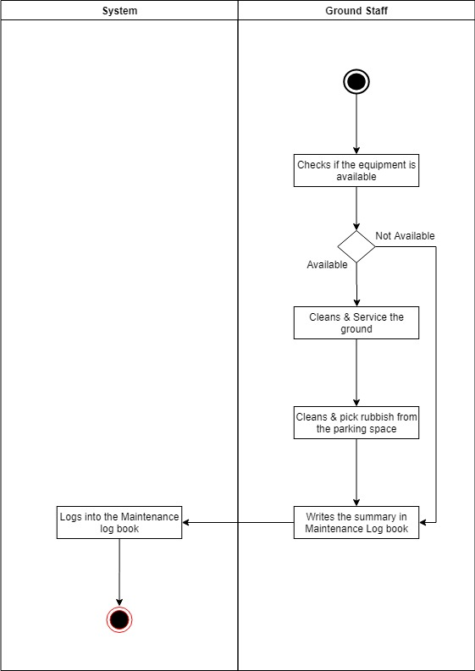

**Erecting Tents**

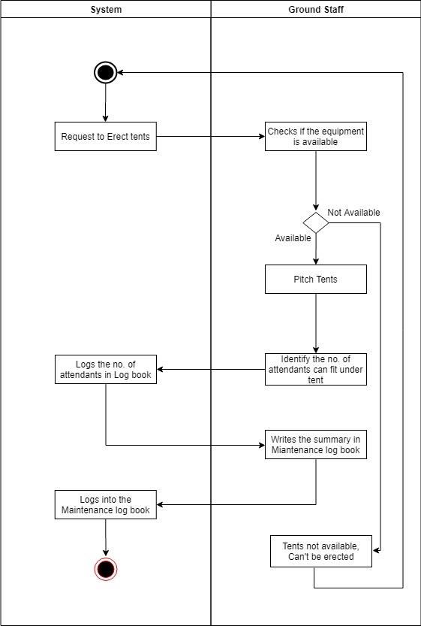

**Cleaning Chapel**

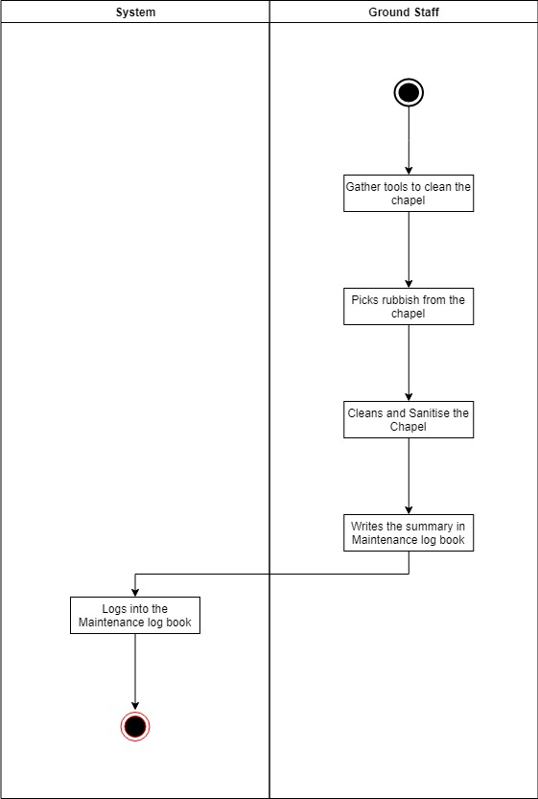

**Servicing the Crematorium**

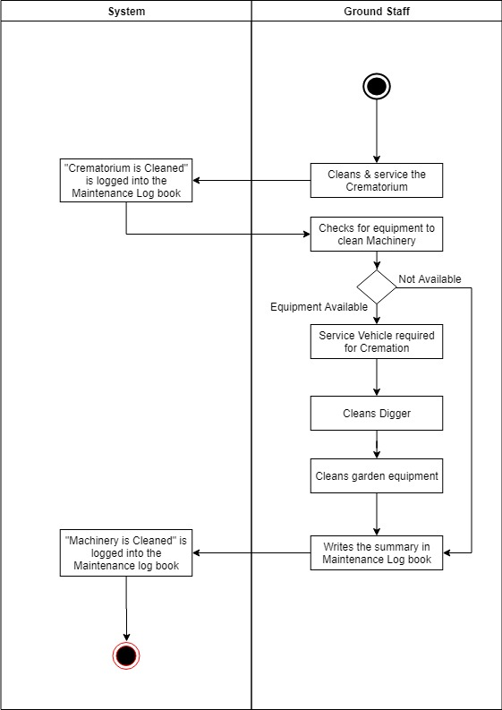

**Marquis**

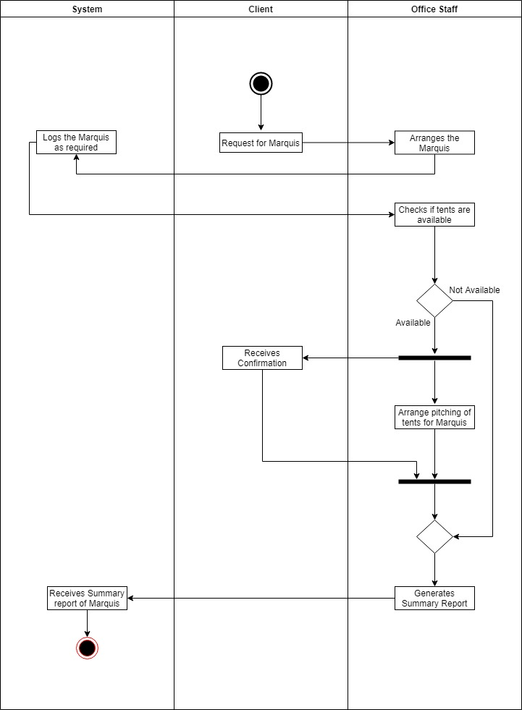

**Maintenance Log Book**

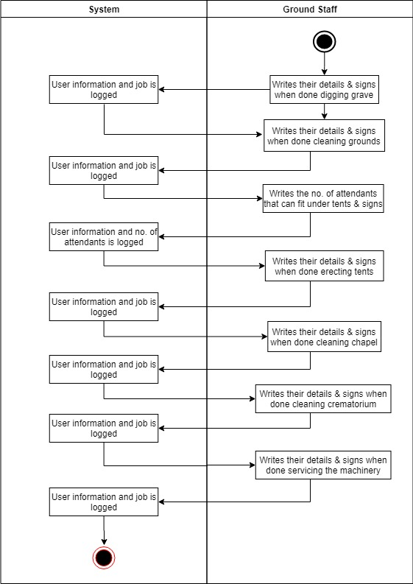

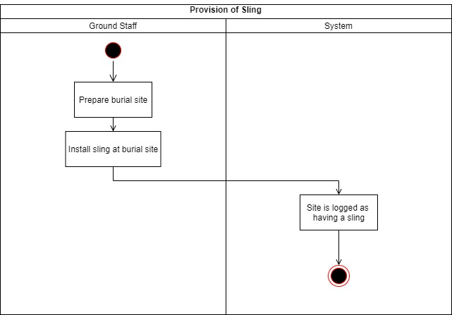

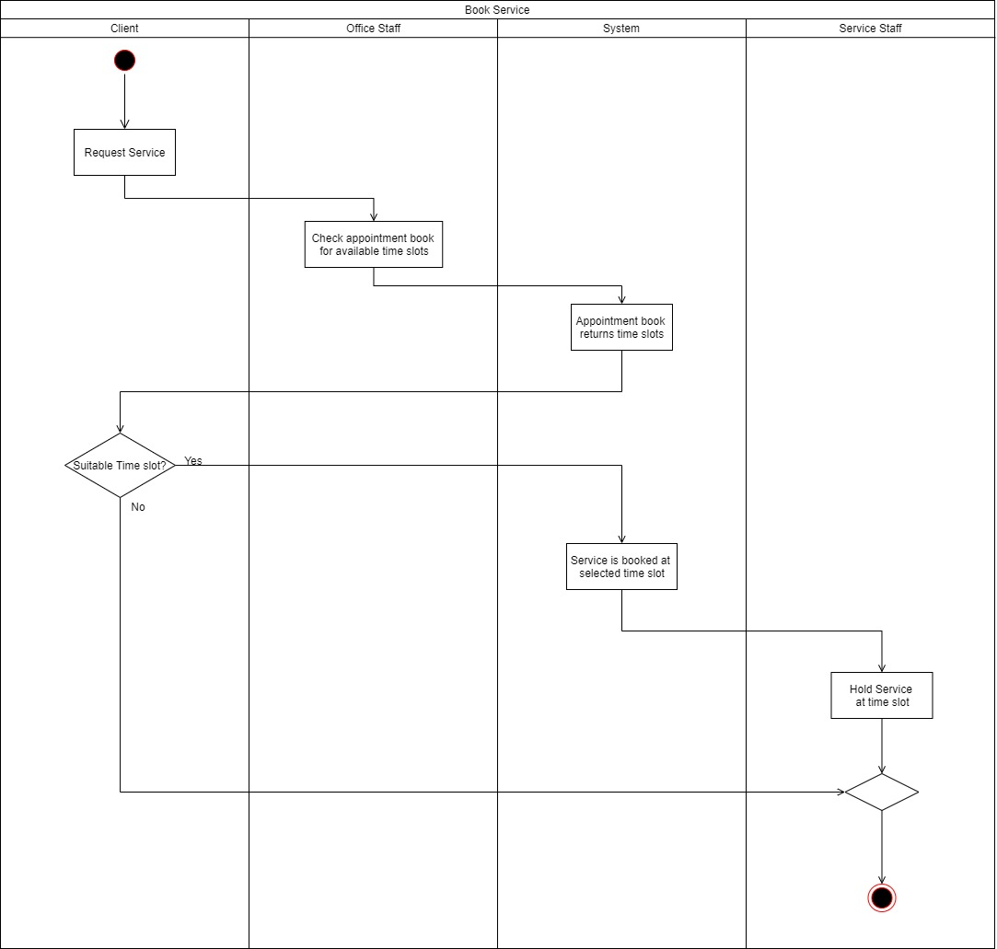

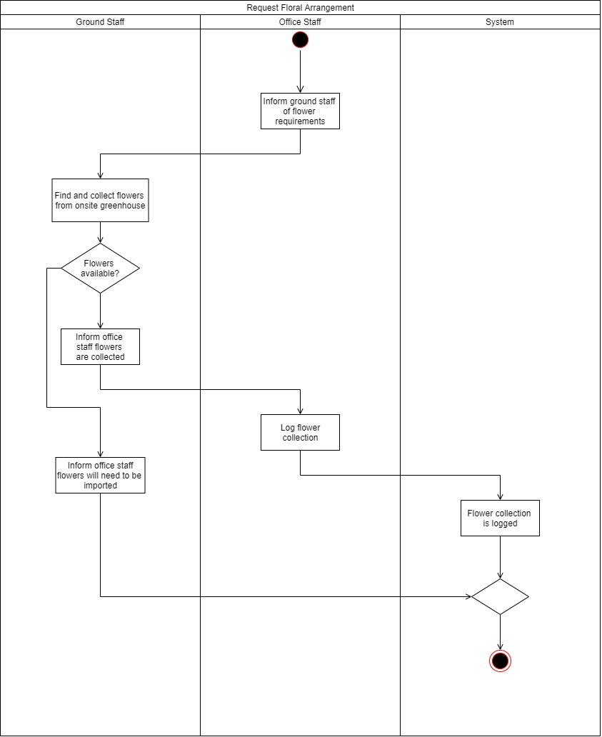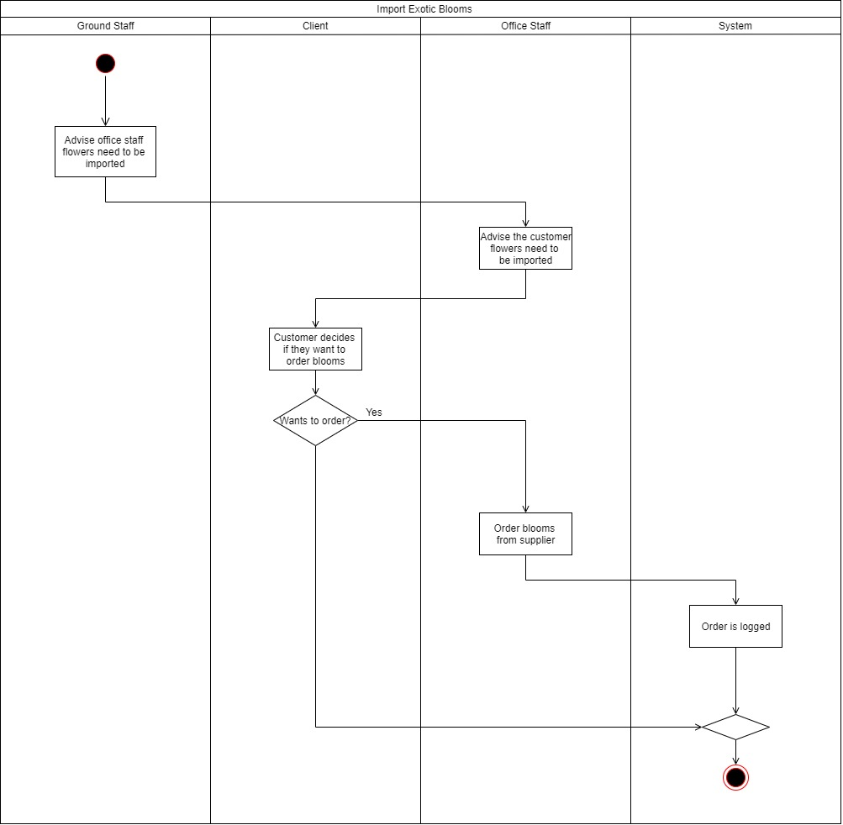

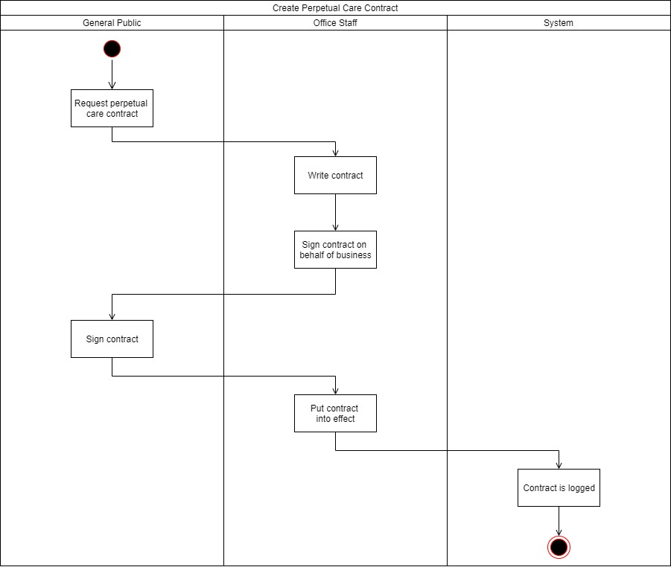

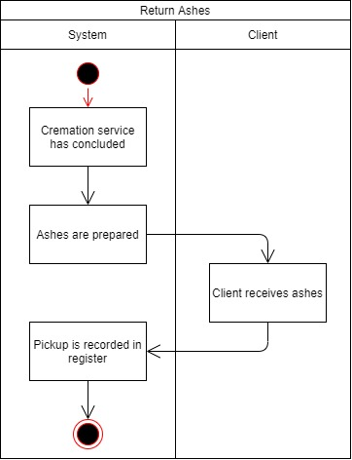

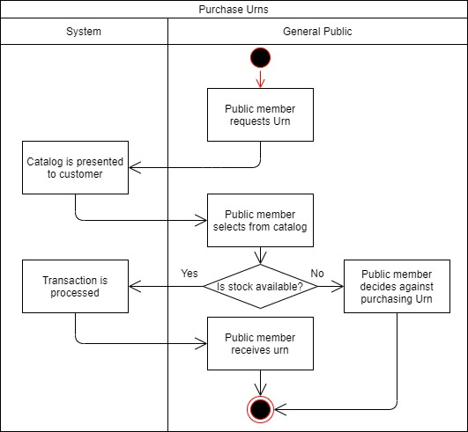

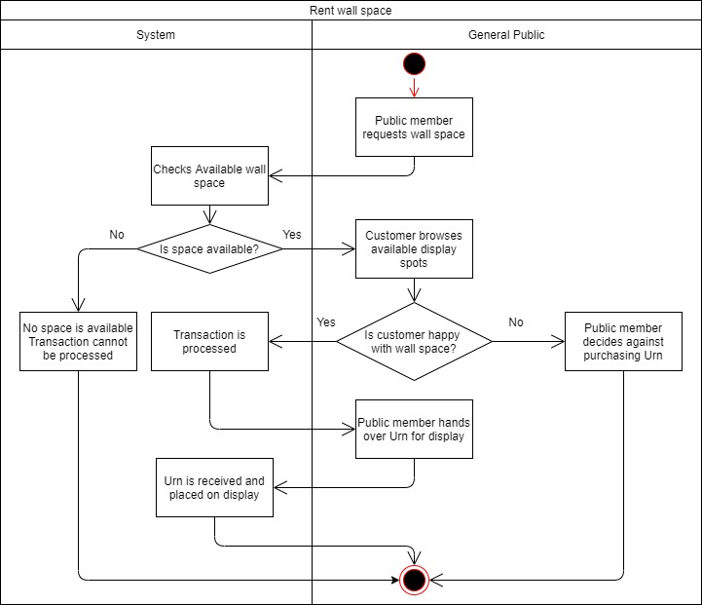

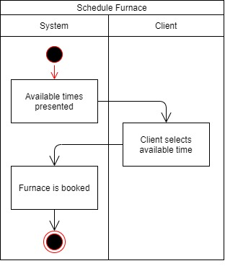

# Class Diagram