# 

Assessment 02

Pearly Gates Cemetery & Crematorium

Toby Evans, Joel Barrett, Sharjeel Sohail, Cameron Down

# Table of Contents

### Use Case Diagram 4

### Intermediate Descriptions 5

### Class Diagram 9

### Sequence Diagrams 10

### Deployment Strategy 18

### UI Design 19

Use Case Diagram

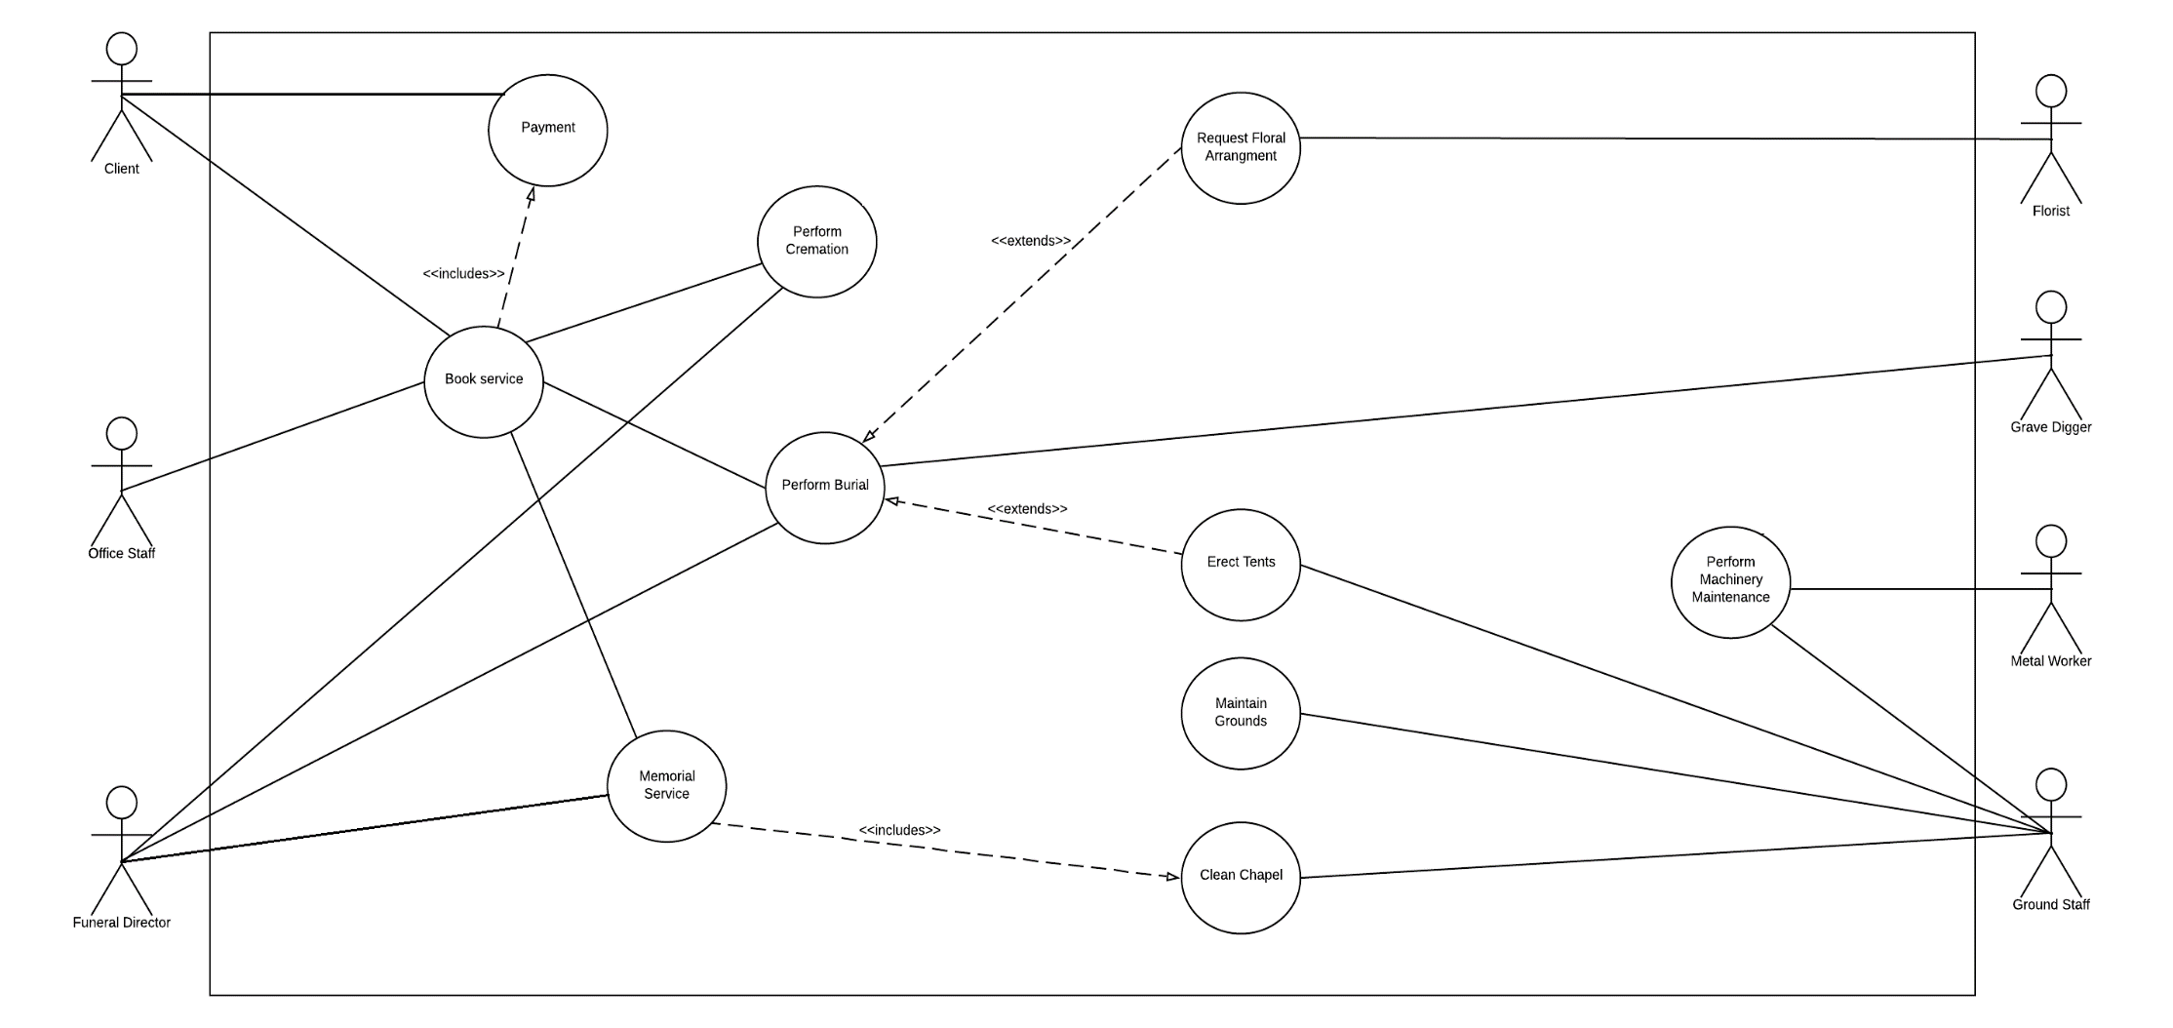

Intermediate Descriptions

|  |
| --- |
| **Flow of activities for Book Service** |
| **Main Flow:**   1. Client contacts office staff with a request for a service. 2. Office staff checks available times requested by the client. If time specified is not available, other available times are offered. 3. Office staff request client’s personal details. 4. Client gives Office staff personal details. 5. Office Staff request details of the deceased. 6. Client gives office staff details of the deceased. 7. If a burial is requested, Office staff offer either the plaque of cross options available to be placed upon grave. Client gives selection. 8. If a cremation is requested, Office staff ask if the client would like to purchase an urn.   If the client wants one, they specify what type they want, and Office staff update their bill.   1. Office staff input date, time, and all other details into the system. 2. System sends a service confirmation message to the client. |
| **Exceptions:**  2. If there are no available times and cannot be put in before or after hours,  a. The client is informed that there are no available times |

|  |
| --- |
| **Flow of activities for Perform Burial** |
| **Main Flow:**   1. System notifies grave digger to prepare the grave at appropriate time. 2. Grave digger prepares grave for burial by digging the grave and providing sling. 3. Grave digger confirms, in the system, that the site is ready for burial. 4. Grave digger lowers coffin into grave. 5. Grave digger fills in grave. 6. Grave digger places cross/plaque onto grave site 7. Grave digger confirms the completion of the burial and is logged into the system. |
| **Exceptions:** |

|  |
| --- |
| **Flow of activities for Perform Cremation** |
| **Main Flow:**   1. At appropriate time, the system notifies the funeral director when they need to prepare the crematorium for cremation 2. Funeral director prepares crematorium. 3. Funeral director cremates body. 4. Funeral director collects ashes and places them in urn. 5. Funeral director confirms the completion of the cremation and is logged into the system. |
| **Exceptions:** |

|  |
| --- |
| **Flow of activities for scenario of Clean Chapel** |
| Main Flow:   1. System interface requests to clean the chapel 2. Ground Staff member checks if machinery is available 3. Ground staff member picks the rubbish 4. Ground staff member sanitises the chapel 5. Ground staff member updates the chapel as cleaned 6. System interface updates the database |
| Exceptions:   1. Machinery is unavailable |

|  |
| --- |
| **Flow of activities for scenario of Maintain Grounds** |
| Main Flow:   1. Ground staff member checks for maintenance of grounds 2. System interface sends a request for maintenance to ground staff member 3. Ground staff member checks if the equipment is available 4. Ground staff member picks the rubbish 5. Ground staff member mows the grass 6. Ground staff member removes the weeds 7. Ground staff member updates the grounds maintenance as complete 8. System interface updates in the database |
| Exceptions:   1. Equipment is unavailable |

|  |
| --- |
| **Flow of activities for scenario of Erect Tents** |
| **Main flow:**   1. Client requests service with tent 2. Office member checks for available times in the system 3. System returns available times to office member 4. Office member provides available times for client to choose from 5. Client gives their details 6. Office member requests service and required tent details 7. Client provides service and tent details 8. Details are input to system by office member 9. Booking information and tent details are sent to groundskeeper from system 10. groundskeeper arranges tent(s) for service 11. groundskeeper sets up tent(s) for service 12. groundskeeper confirms tent(s) prepared for service to system 13. Service is held 14. Groundskeeper packs tent(s) down after service 15. Groundskeeper confirms to the system that the tent(s) has been taken down and put into storage after the service has concluded |
| **Exceptions:**   1. Time unavailable    1. Request new time    2. Request Denied |

|  |
| --- |
| **Floral Arrangement** |
| **Main flow**   1. Client requests service with floral arrangement 2. Office member checks for available times in the system 3. System returns available times to office member 4. Office member provides available times for client to choose from 5. Client gives their details 6. Office member requests service and floral arrangement details 7. Client provides service and floral arrangement details 8. Details are input to system by office member 9. Floral arrangement details are sent to florist from system 10. Florist arranges Flowers for service 11. Florist prepares and sets up floral arrangement for service 12. Florist confirms arrangement is prepared for service to system 13. Service is held 14. Florist manages any remaining flowers from service after its conclusion 15. Florist confirms to the system that the floral arrangement has been cleared after the service has concluded |
| **Exceptions:**   1. Time unavailable    1. Request new time    2. Request Denied |

|  |
| --- |
| **Flow of activities of Perform Machinery Maintenance** |
| **Main flow:**   1. The machinery schedule pings the metal worker to perform machinery maintenance 2. The metal worker performs machinery maintenance 3. The system updates the machinery maintenance logs 4. The metalworker schedules the next machinery maintenance |
| **Exceptions:**   1. The ground staff identify an issue with the machinery    1. The maintenance is performed immediately    2. The maintenance is performed when the metal worker is capable |

|  |
| --- |
| **Flow of activities of Perform Service** |
| **Main flow:**   1. The system schedule pings the funeral director to perform a service 2. The funeral director performs the service 3. The system updates the client account for a completed memorial service |
| **Exceptions:** |

|  |
| --- |
| **Flow of activities of Make Payment** |
| **Main flow:**   1. The client requests to make a payment 2. The office staff looks up the client account in the system interface 3. The system interface returns the client account details 4. The office staff requests a payment for the account 5. The system requests the payment amount 6. The client uses their card to make the payment 7. The system requests card authentication from the bank system 8. The bank system accepts the card authentication 9. The system requests the payment amount from the bank system 10. The bank system approves the payment 11. The system updates the account payments 12. The system interface returns to the client that the payment was approved |
| **Exceptions:**  6.1 The client is paying with cash  6.2 The pays the correct amount to the office staff  6.2.a1 The client pays too much cash  6.2.a2 The office staff gives the client change  6.2.b1 The client gives too little cash  6.2.b2 The office staff tell the client their cash is insufficient  6.3 The office staff update the client account payments on the user interface  8.1 The bank system declines the card authentication  8.2 The transaction is cancelled  9.1 The bank system declines the payment amount  9.2 The transaction is cancelled |

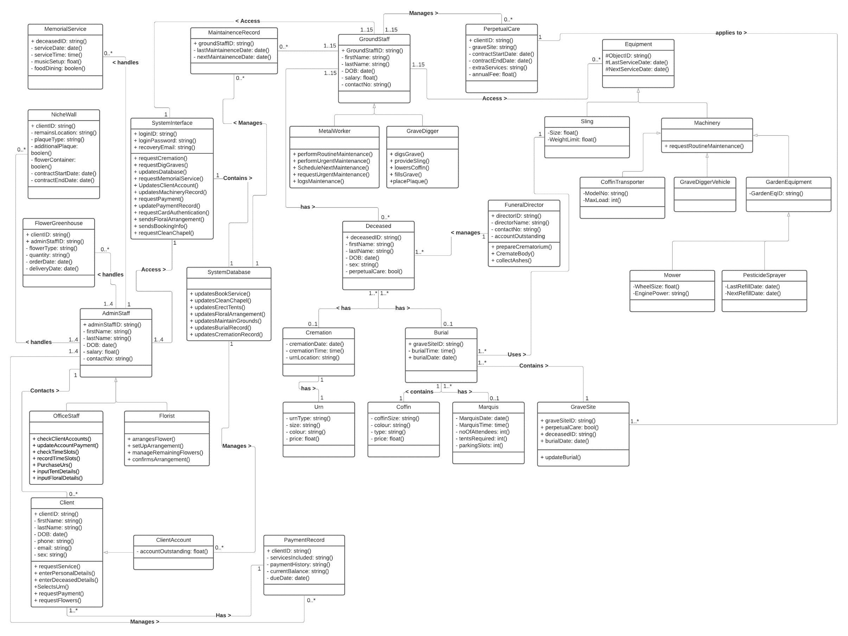

Class Diagram

Sequence Diagrams

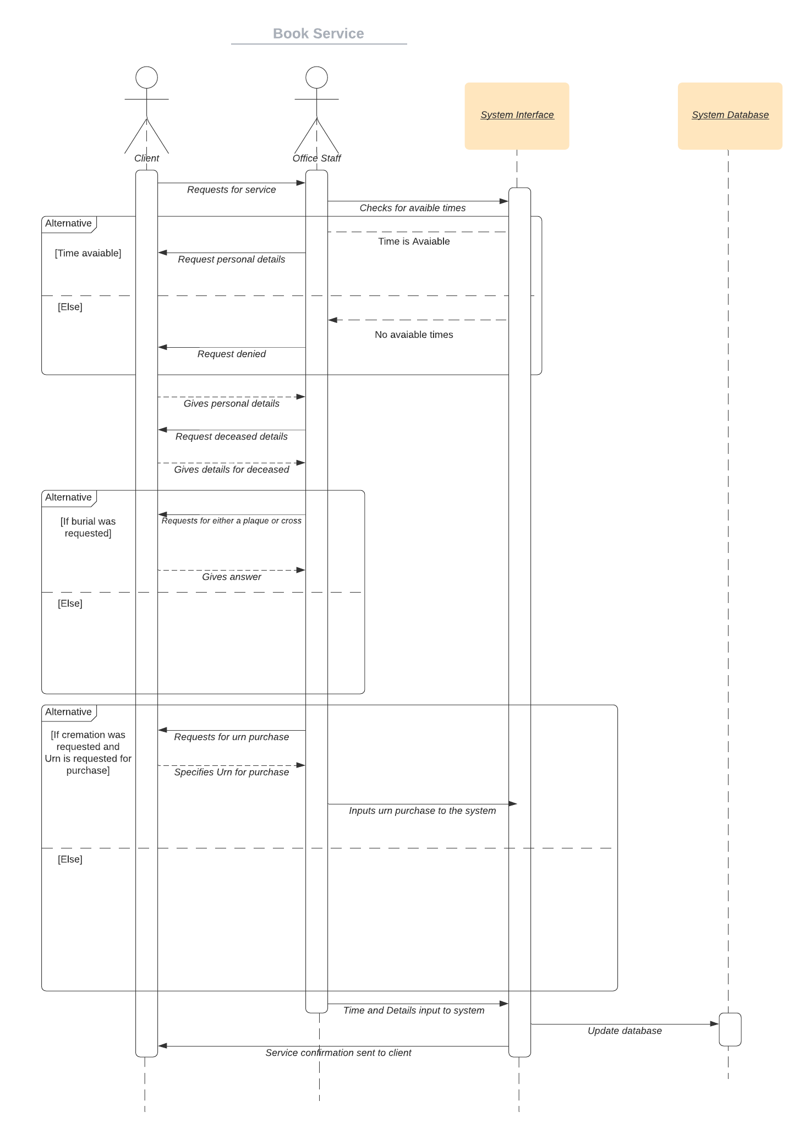

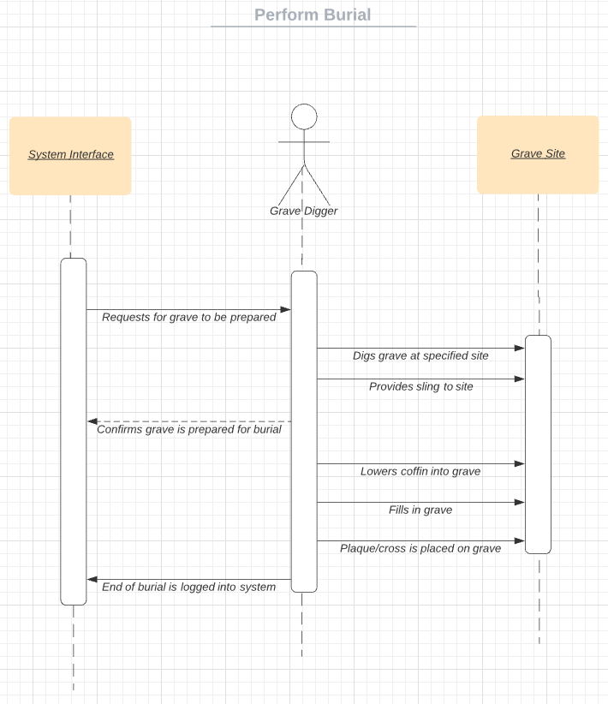

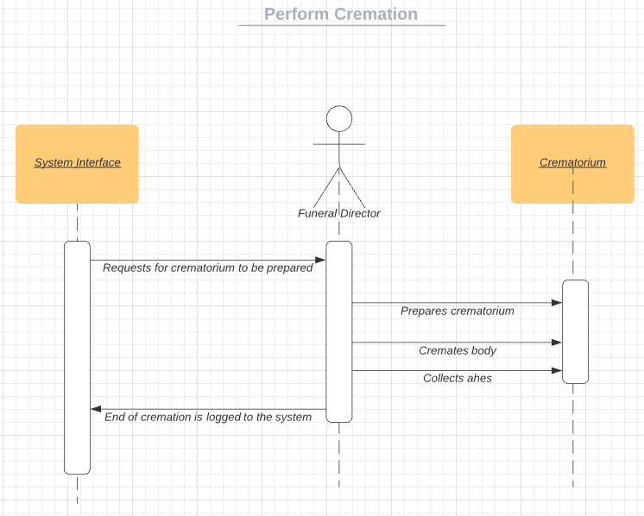

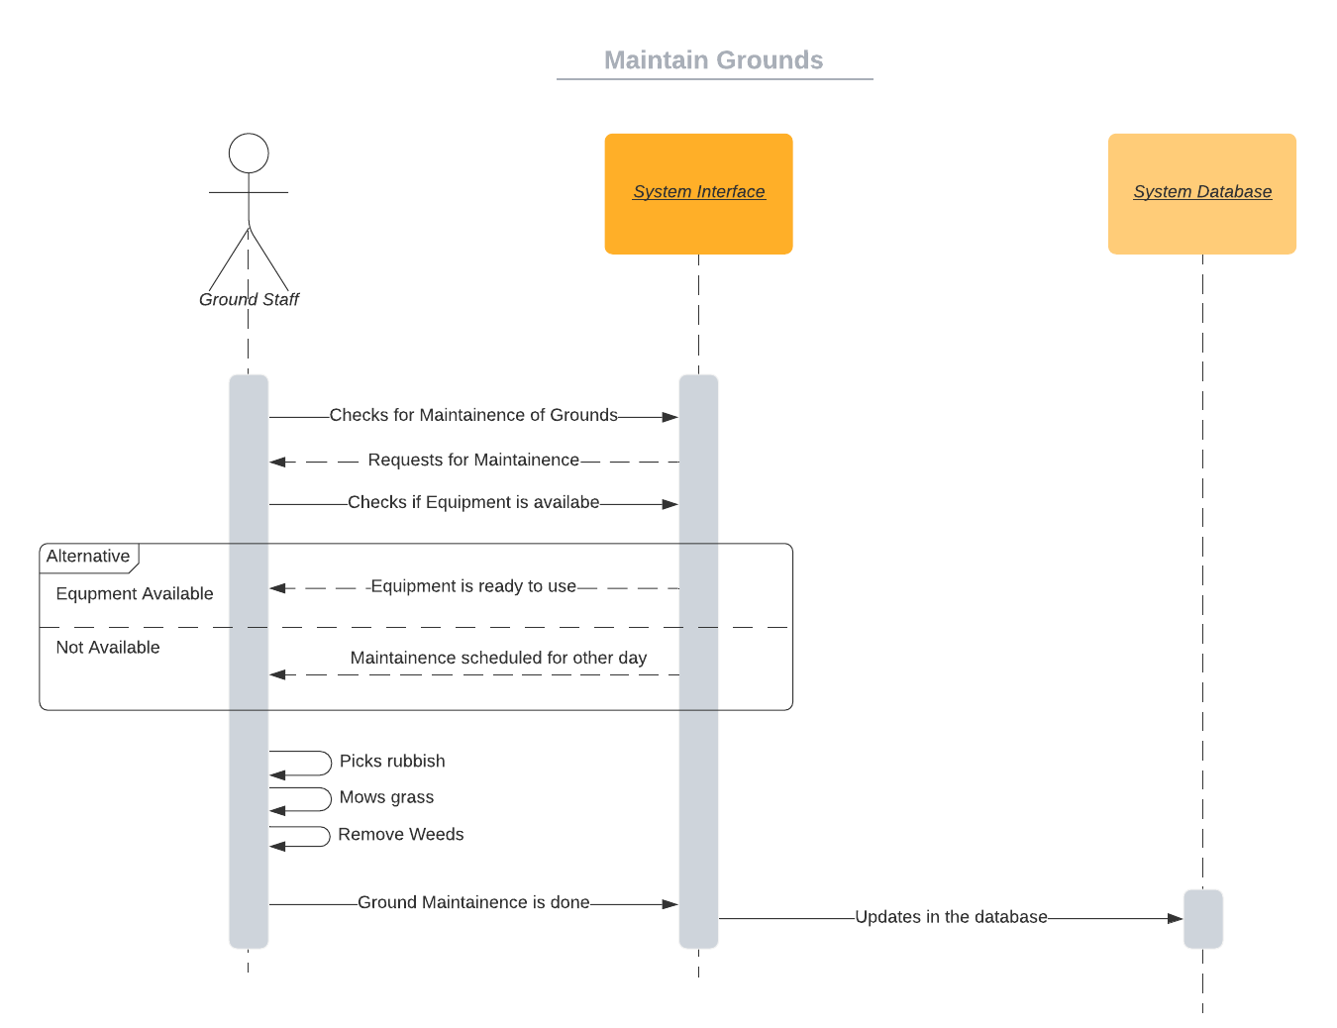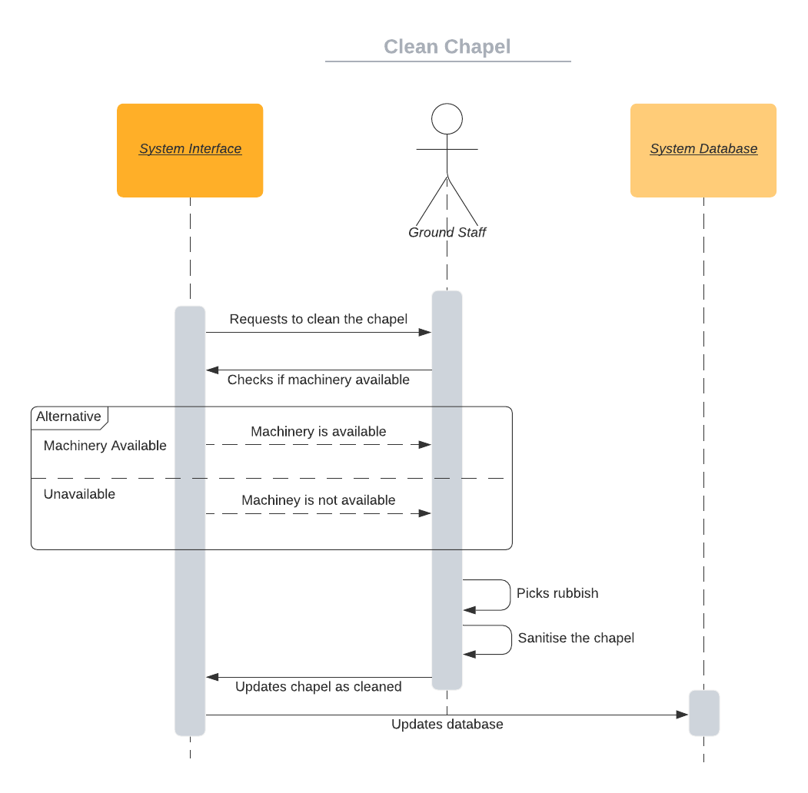

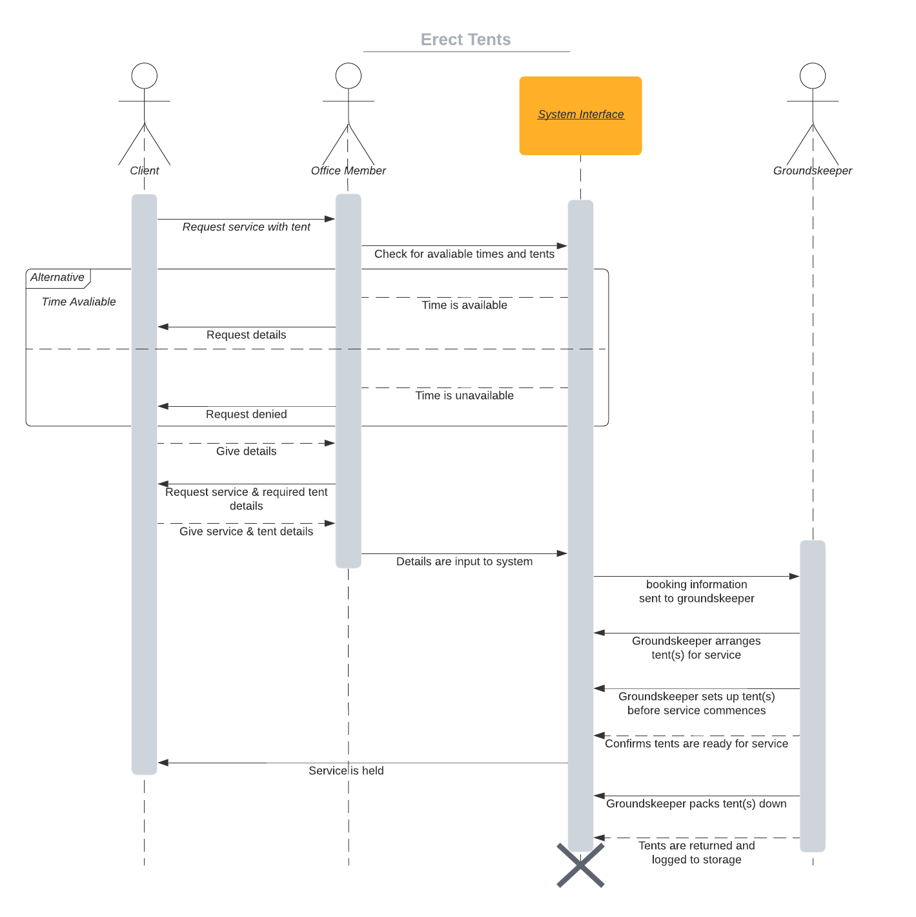

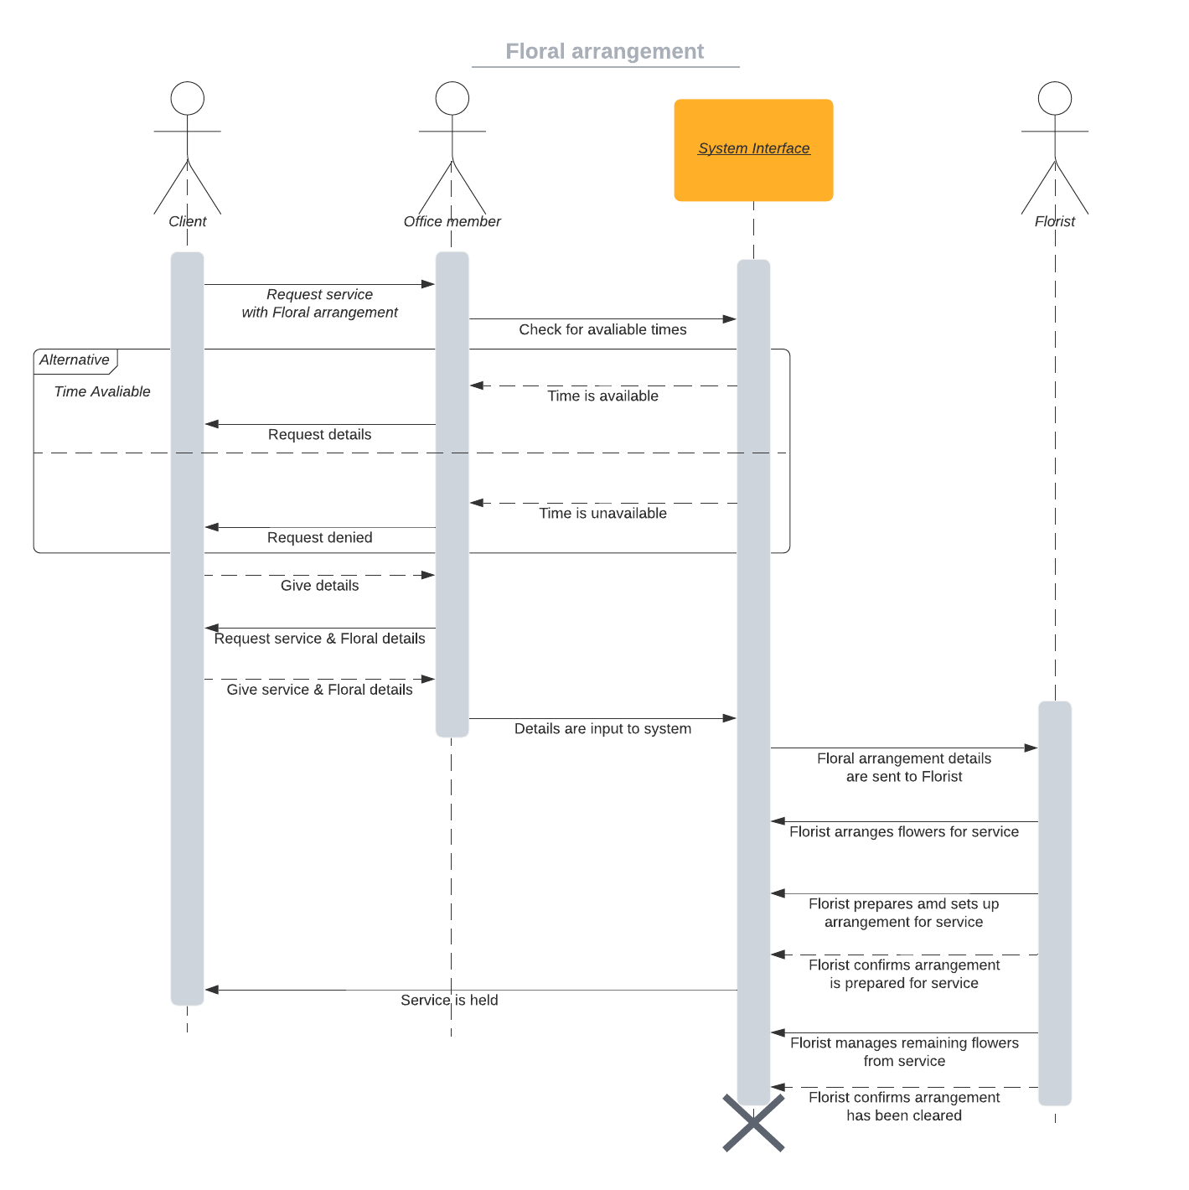

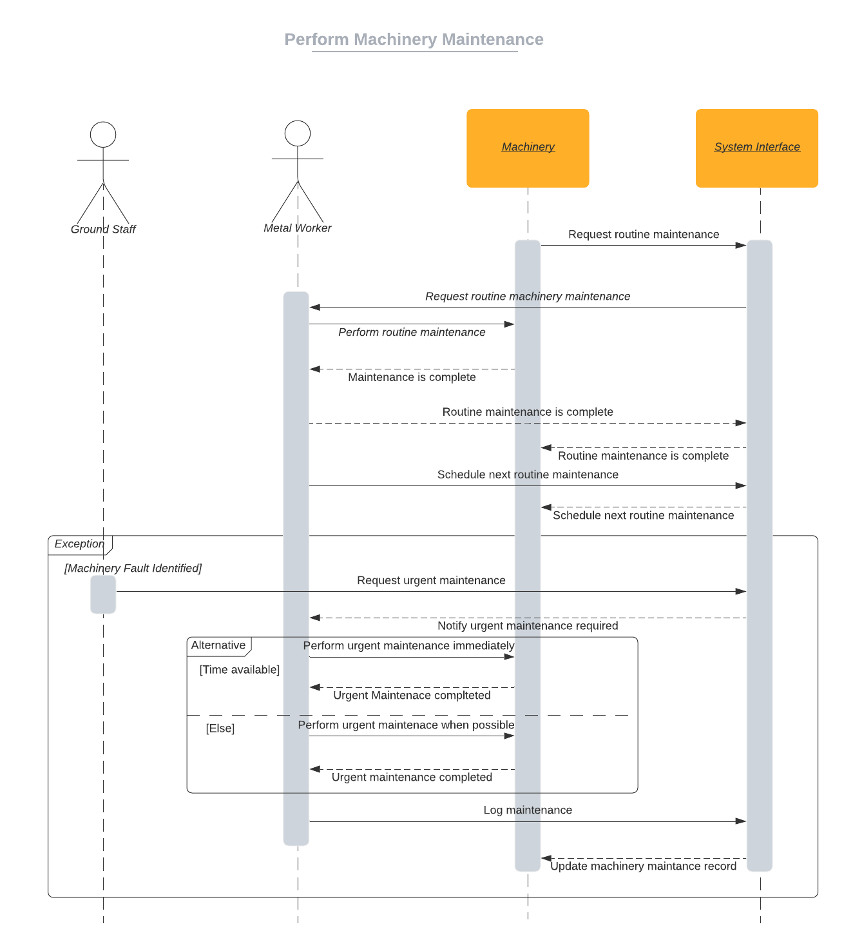

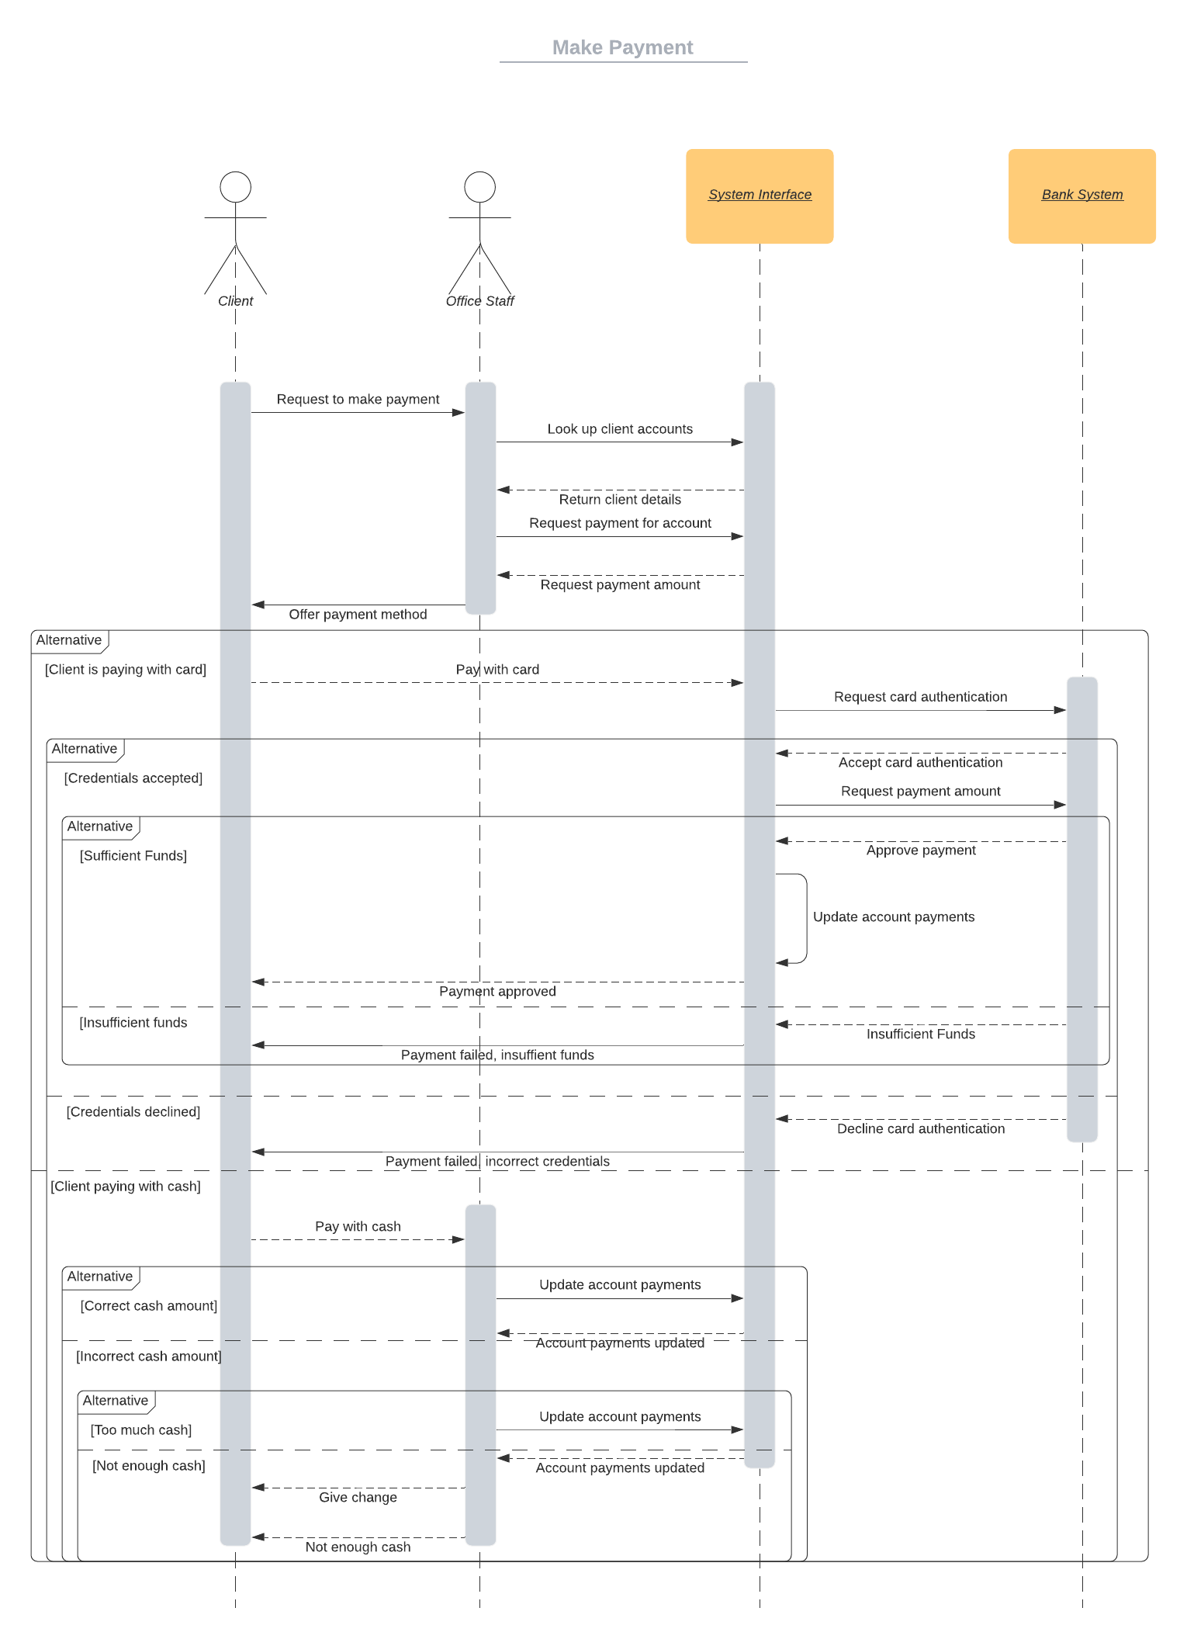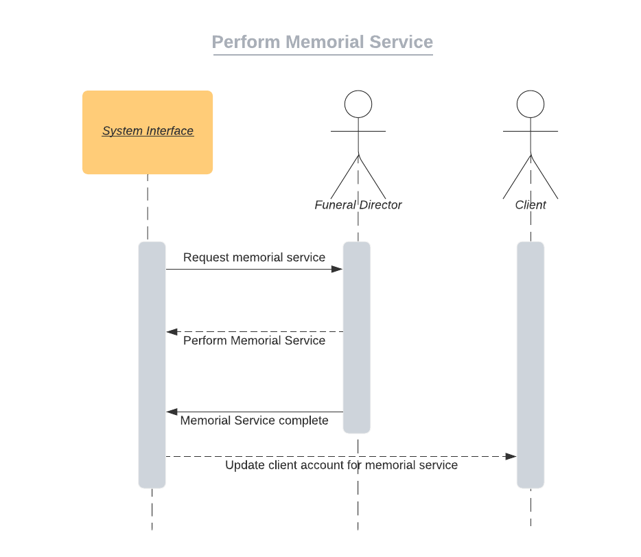

Deployment Strategy

We believe that we will use a Layered Architectural Style, as it seems to cater to our system’s needs. We believe that the best method for implementation of the new system would be a piolet implementation system. Where we will give access to the new system to a select few of the staff and over the course of a few weeks, they teach the other staff how to use the new system. By 3-4 weeks, the system should be fully functional and used throughout the business.

We will start the system with a handful of the grounds staff and the office staff, the developers will teach them how to use the system first, they will use the system to contact and plan services with each other. These staff, however, will have to keep a record of all new clients, deceased and other data entry points that need to be logged until all staff know how to use the system themselves.

User Interface Designs

