# Author

## Sharjil Khan

# GoDoc Documentation



The image will redirect to godocs documentation//https://go.dev/blog/godoc#

# Introduction

What is GoDocs?

GoDoc is an open-source documentation generation tool that provides a standardized way of creating and maintaining documentation specifically for Go (Golang) codebases. It automatically extracts comments written in Go code and generates accessible, web-based documentation for functions, methods, structs, and packages. GoDoc is popular for its simplicity, minimalistic approach, and seamless integration with the Go ecosystem, making it easy for developers to keep documentation in sync with code. It emphasizes readability and standardization, using concise, structured comments to provide clear, navigable documentation without additional formatting languages.

# Installation

## How to install GoDoc?

Click here. #here is a link to view installation process

https://youtu.be/Q7uh85_i0-M?si=gJ6ZR8HF70eoKQjV

## How to make GoDoc documentation?

Click here. ## will take to process video https://youtu.be/80VT3xexcWs?si=hUbyDsWCMOQPT_Nr

# Usage

Source Code

Here are some source codes of files we have created :

Screenshots

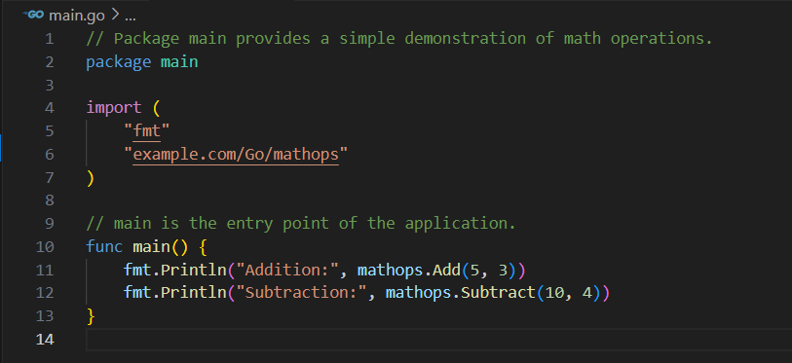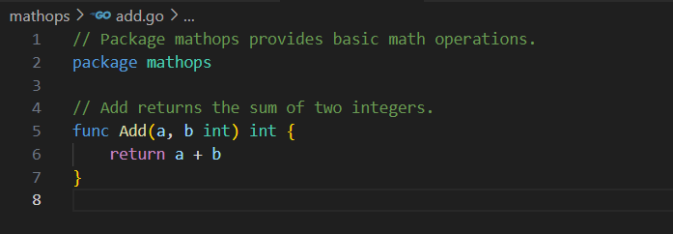

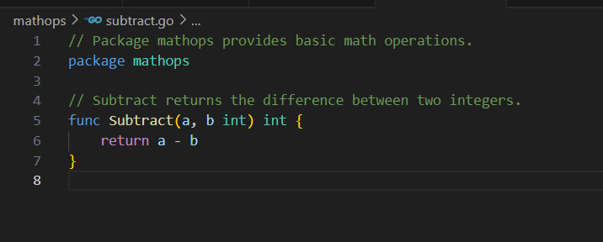

Produced Documentation

Screenshots

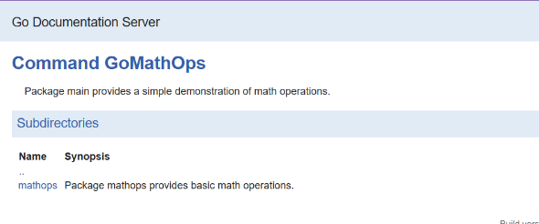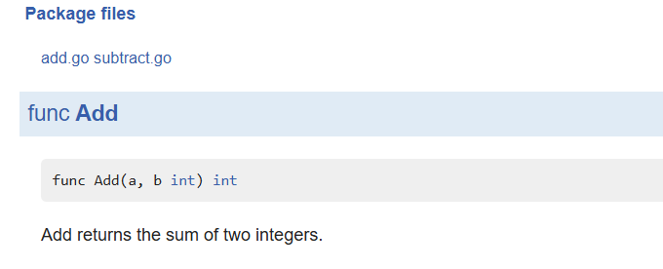

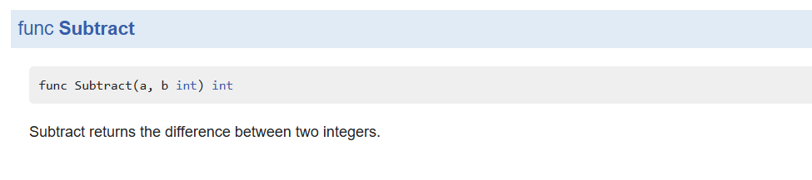

# Documentation for Test Files

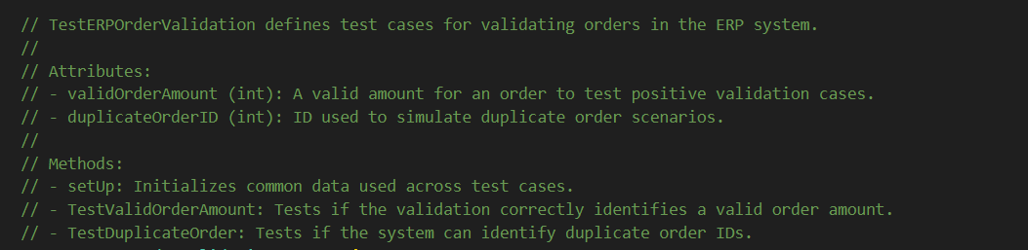

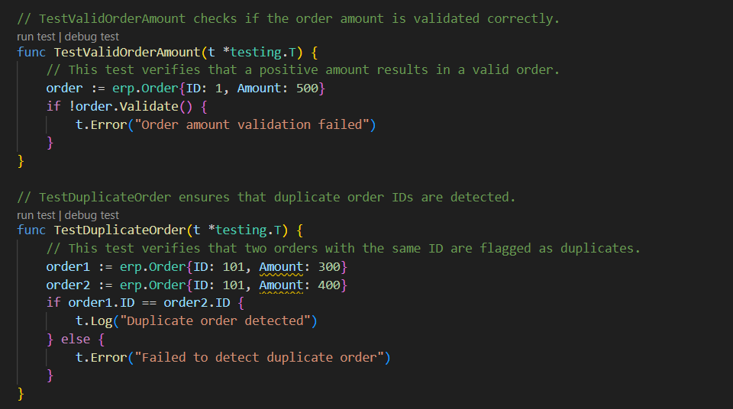

# Pros and Cons of GoDoc

## Why GoDoc?

* **Automatic Documentation Generation**: GoDoc automatically generates documentation from Go code comments, making it easy to create and update documentation as the code evolves.
* **Integrated with the Go Ecosystem**: GoDoc is built specifically for Go and integrates seamlessly with the Go toolchain, ensuring a consistent experience for Go developers.
* **Minimalistic and Standardized**: GoDoc enforces a simple, minimalistic documentation style that focuses on essential information, promoting concise, readable, and standardized documentation.
* **Web-accessible Documentation**: GoDoc allows developers to host documentation locally using godoc or via public services like pkg.go.dev, making it easy to share documentation across teams.
* **IDE Support**: Many Go-compatible IDEs and editors (like VS Code and GoLand) display GoDoc comments inline, aiding in code navigation and understanding without leaving the editor.

## Why not GoDoc?

• **Limited Formatting Capabilities**: GoDoc’s simplicity means it lacks support for complex formatting, such as tables, images, or custom styles, which might be useful for more detailed documentation.

• **Basic Syntax**: GoDoc comments need to follow a specific syntax to be rendered correctly, which may be restrictive for developers coming from other languages or documentation tools.

• **Requires Consistent Maintenance**: Because GoDoc relies on comments within the code, it requires developers to keep comments updated along with code changes. Outdated comments can lead to misleading documentation.

• **Less Suitable for Non-Go Projects**: GoDoc is designed specifically for Go projects and may not be suitable for documenting projects in other languages or multi-language projects.

• **No Runtime Validation**: Missing or incorrect comments do not affect runtime, so GoDoc won’t flag missing documentation. This can lead to incomplete documentation if developers don’t consistently follow documentation practices.

Overall, GoDoc is highly effective for Go projects but best suited to straightforward documentation needs within the Go ecosystem. Its simplicity and integration with Go tools make it an excellent choice for Go developers seeking a lightweight documentation solution.