Software Requirement Specifications
AI-Powered Resume Builder & Job Matching System

Submitted by
Shakira Jabeen (S23BINFT1M1042)

Submitted to
Suleman Javed

Department of Information Technology
Faculty of Computing
The Islamia University of Bahawalpur

Summary
This Software Requirement Specification (SRS) document describes the requirements, scope, user roles, functional behavior, non-functional constraints, and use case flows for the proposed Final Year Project titled AI-Powered Resume Builder & Job Matching System.
The proposed system is a responsive web-based platform designed to assist students, fresh graduates, and job seekers in creating professional resumes using Artificial Intelligence. The system will allow users to enter their academic, professional, and skill-related information, generate structured resume content, analyze job descriptions, compare resume content against job requirements, provide ATS-style scoring, and export the final resume as a PDF document.
The project uses a hybrid approach in which AI-based features are used for resume content generation, job description analysis, and feedback generation, while rule-based mechanisms are used for keyword matching, completeness validation, scoring support, and structured PDF generation. This document excludes the meeting details section from the original template and focuses on the academic SRS content required for project submission.

Table of Contents
1. Introduction | 4
1.1. Purpose | 4
1.2. Scope | 4
1.3. Product Perspective | 5
1.4. User Characteristics | 5
1.5. Similar Apps and Systems / Literature Review | 5
1.6. Proposed Technologies | 6
2. Requirements | 7
2.1. Functional Requirements | 7
2.2. Non-Functional Requirements | 9
3. Use Cases and Flow of Processes | 10
3.1. Use Case 1: User Registration and Login | 12
3.2. Use Case 2: Create Resume Profile | 13
3.3. Use Case 3: Generate AI Resume Content | 13
3.4. Use Case 4: Analyze Job Description | 13
3.5. Use Case 5: Tailor Resume for Job Description | 14
3.6. Use Case 6: Export Resume as PDF | 14
4. References | 16

1. Introduction
The AI-Powered Resume Builder & Job Matching System is a web-based academic software project intended to support users in preparing professional, job-specific, and ATS-compatible resumes. The system targets a common problem faced by students and fresh graduates: they often have relevant education, skills, and project experience but are unable to present that information in a structured and professional manner.
In many job application processes, resumes are first filtered by automated screening systems or reviewed quickly by recruiters. A resume that is incomplete, poorly structured, or missing important job-related keywords may reduce the candidate's chance of being shortlisted. The proposed system addresses this issue by combining guided resume input, AI-assisted writing, job description analysis, keyword matching, and feedback generation.
The project is not being developed for a specific organization. It is a general-purpose career support system that can be used by students, fresh graduates, and early-career professionals. The system will be implemented as a responsive web application, making it accessible through desktop and mobile browsers without requiring a separate mobile application.

1.1. Purpose
The purpose of this SRS document is to define the software requirements for the AI-Powered Resume Builder & Job Matching System. It provides a formal description of the system objectives, scope, users, functional requirements, non-functional requirements, use case flows, and technology choices.
The main goals of the project are:
- To develop a responsive web application that helps users create professional resumes.
- To use AI for generating resume summaries, experience bullet points, and improvement suggestions from structured user input.
- To analyze job descriptions and identify important skills, technologies, responsibilities, and keywords.
- To compare a user's resume content with a provided job description and generate an ATS-style matching score.
- To provide actionable feedback that helps users improve their resume for a specific job role.
- To allow users to export their final resume in a clean and professional PDF format.

1.2. Scope
The scope of this project is limited to the development of a web-based AI resume builder and job matching system. The system will include user authentication, resume profile creation, AI-assisted resume generation, job description analysis, resume-job matching, ATS-style scoring, improvement suggestions, and PDF export.
The system will include the following modules:
- User registration and login module
- Resume information input and management module
- AI resume content generation module
- Job description analysis module
- Resume-job matching and scoring module
- Resume tailoring and feedback module
- PDF export module
The following items are outside the scope of this FYP version:
- A dedicated Android or iOS mobile application
- Direct integration with external job portals
- Payment gateway or subscription billing system
- Real-time recruiter dashboard
- Voice-based resume creation
- Full career counseling chatbot
- Automatic job application submission

1.3. Product Perspective
The proposed system will be developed as an independent web application. It will not be a module of an already existing system. However, the architecture will be designed in a modular way so that the product can be extended in the future as a SaaS-based career platform.
The application will consist of a frontend interface, backend API server, database, AI service integration, and PDF generation service. The frontend will handle user interaction, forms, preview screens, and result presentation. The backend will handle authentication, data validation, resume processing, AI request handling, scoring logic, and PDF generation. The database will store user accounts, resume profiles, generated content, job descriptions, and analysis results.

1.4. User Characteristics
The system will primarily be used by the following users:
User Type | Description | Expected Skill Level
Student / Fresh Graduate | Creates resume using education, skills, internships, and academic projects. | Basic computer and internet usage
Job Seeker | Tailors resume according to a specific job description and downloads optimized resume. | Basic to intermediate web usage
System Administrator | Manages system configuration, monitors records, and may review system-level data if admin module is enabled. | Intermediate technical knowledge

1.5. Similar Apps and Systems / Literature Review
Existing resume builder systems generally provide templates where users manually enter information and export resumes. Some advanced platforms also provide AI-assisted writing and ATS scanning. However, many tools are either paid, generic, not localized for student needs, or focused on one feature only, such as resume formatting or keyword checking.
System Category | Common Features | Limitations | Proposed Improvement
Template-based resume builders | Pre-designed resume formats and PDF export | Limited intelligence and no deep job-specific analysis | AI-generated resume content and job tailoring
ATS scanning tools | Keyword comparison and resume score | Often paid and may not generate improved resume content | Hybrid scoring with AI-generated feedback
AI writing assistants | Can rewrite text and generate summaries | Not always structured around resume sections and ATS requirements | Resume-specific AI prompts and controlled output format
Manual resume services | Human-created resume improvements | Costly, slow, and not scalable for students | Instant web-based self-service system

1.6. Proposed Technologies
Layer | Technology | Purpose
Frontend | React.js with TypeScript | Build responsive user interface, forms, previews, and result dashboards
Styling | Tailwind CSS | Create modern, consistent, and mobile-responsive design
Backend | Node.js with Express.js | Develop REST APIs, business logic, AI orchestration, and PDF generation endpoints
Database | MongoDB | Store users, resume profiles, job descriptions, and analysis results
AI Integration | OpenAI API or equivalent LLM API | Generate resume content, analyze job descriptions, and produce feedback
PDF Generation | pdfmake or similar library | Generate ATS-friendly resume PDFs
Version Control | Git and GitHub | Maintain project source code and documentation

2. Requirements
The system will provide features for user account management, resume profile creation, AI-assisted content generation, job description analysis, resume-job matching, scoring, feedback generation, resume tailoring, and PDF export. The system will accept structured user inputs, process them using backend services and AI integration, and produce user-friendly outputs including generated resume sections, matching score, missing keywords, improvement suggestions, and downloadable resume documents.

2.1. Functional Requirements

2.1.1. User Registration
Name | FR001
Purpose | The registration process is required for a user to create an account and access the resume builder system.
User(s) | Student, Fresh Graduate, Job Seeker
Input | Full name, email address, password, and optional profile information.
Validation | Email must be unique and valid. Password must meet minimum length requirements.
Output | A new user account is created and the user becomes able to log in to the system.

2.1.2. User Login
Name | FR002
Purpose | The login process is required to authenticate existing users and allow access to saved resume data.
User(s) | Registered User
Input | Email address and password.
Validation | Credentials must match an existing user record.
Output | User is authenticated and redirected to the dashboard.

2.1.3. Create Resume Profile
Name | FR003
Purpose | The system shall allow users to enter and manage the information required to create a resume.
User(s) | Registered User
Input | Personal details, education, experience, projects, skills, certifications, languages, and contact information.
Validation | Required fields such as name, email, education, and skills must be validated before resume generation.
Output | Resume profile is saved and becomes available for AI-based resume generation.

2.1.4. Generate AI Resume Content
Name | FR004
Purpose | The system shall generate professional resume content from structured user input using AI.
User(s) | Registered User
Input | Resume profile data and selected role or career direction.
Processing | The backend sends a structured prompt to the AI service and receives formatted resume sections.
Output | Generated professional summary, improved skill presentation, and experience/project bullet points.

2.1.5. Edit and Preview Resume
Name | FR005
Purpose | The system shall allow users to review and edit generated resume content before final export.
User(s) | Registered User
Input | User edits in resume sections such as summary, skills, projects, and experience.
Validation | Text fields must not exceed configured limits and required sections must remain available.
Output | Updated resume preview is displayed to the user.

2.1.6. Analyze Job Description
Name | FR006
Purpose | The system shall analyze a pasted job description to identify important requirements.
User(s) | Registered User
Input | Job description text.
Processing | The system extracts skills, technologies, responsibilities, qualifications, and keywords.
Output | A structured list of job-specific keywords and requirements is generated.

2.1.7. Resume Matching and ATS Score
Name | FR007
Purpose | The system shall compare the user's resume with the job description and calculate an ATS-style match score.
User(s) | Registered User
Input | Resume content and analyzed job description data.
Processing | The system uses keyword matching, section completeness, and AI-based evaluation to generate a score.
Output | A score out of 100, matched keywords, missing keywords, and section-wise feedback are displayed.

2.1.8. Tailor Resume for Job Description
Name | FR008
Purpose | The system shall provide suggestions and generate an optimized version of the resume for a specific job description.
User(s) | Registered User
Input | Current resume content, job description, and identified missing requirements.
Processing | AI rewrites or suggests resume bullet points and summaries while preserving the user's actual profile information.
Output | Tailored resume content and improvement suggestions are displayed.

2.1.9. Export Resume as PDF
Name | FR009
Purpose | The system shall allow users to export the final resume in PDF format.
User(s) | Registered User
Input | Final resume content selected by the user.
Processing | The system formats the resume using a clean ATS-friendly layout and generates a PDF file.
Output | A downloadable PDF resume is produced.

2.2. Non-Functional Requirements
Requirement | Description
NFR001 - Usability | The system shall provide a simple, clean, and responsive interface that can be used by students and job seekers with basic web knowledge.
NFR002 - Performance | The system should generate normal rule-based analysis results within a few seconds. AI-based responses may take longer depending on the external AI service response time.
NFR003 - Security | User passwords shall be stored in hashed form. Backend APIs shall validate user identity before allowing access to private resume data.
NFR004 - Privacy | Resume data contains personal information; therefore, the system shall restrict each user's data access to their own account.
NFR005 - Reliability | The system should handle AI API failures gracefully by showing a meaningful error message and allowing the user to retry.
NFR006 - Maintainability | The codebase shall be modular, separating frontend, backend, AI service logic, database models, routes, controllers, and utilities.
NFR007 - Compatibility | The application shall work on modern web browsers and support mobile-responsive layouts.
NFR008 - Scalability | The system architecture should allow future addition of features such as cover letter generation, multiple templates, and job portal integration.
NFR009 - Data Validation | The system shall validate input fields such as email, password, required resume sections, and job description of text length.
NFR010 - AI Output Control | AI output should be structured, relevant, and based only on user-provided information to avoid generating misleading claims.

3. Use Cases and Flow of Processes
Use cases to formally describe how users interact with the system to achieve specific goals. The primary actor of the system is the registered user, which may be a student, fresh graduate, or job seeker. The system also interacts with external AI service APIs for generating resume content and feedback.
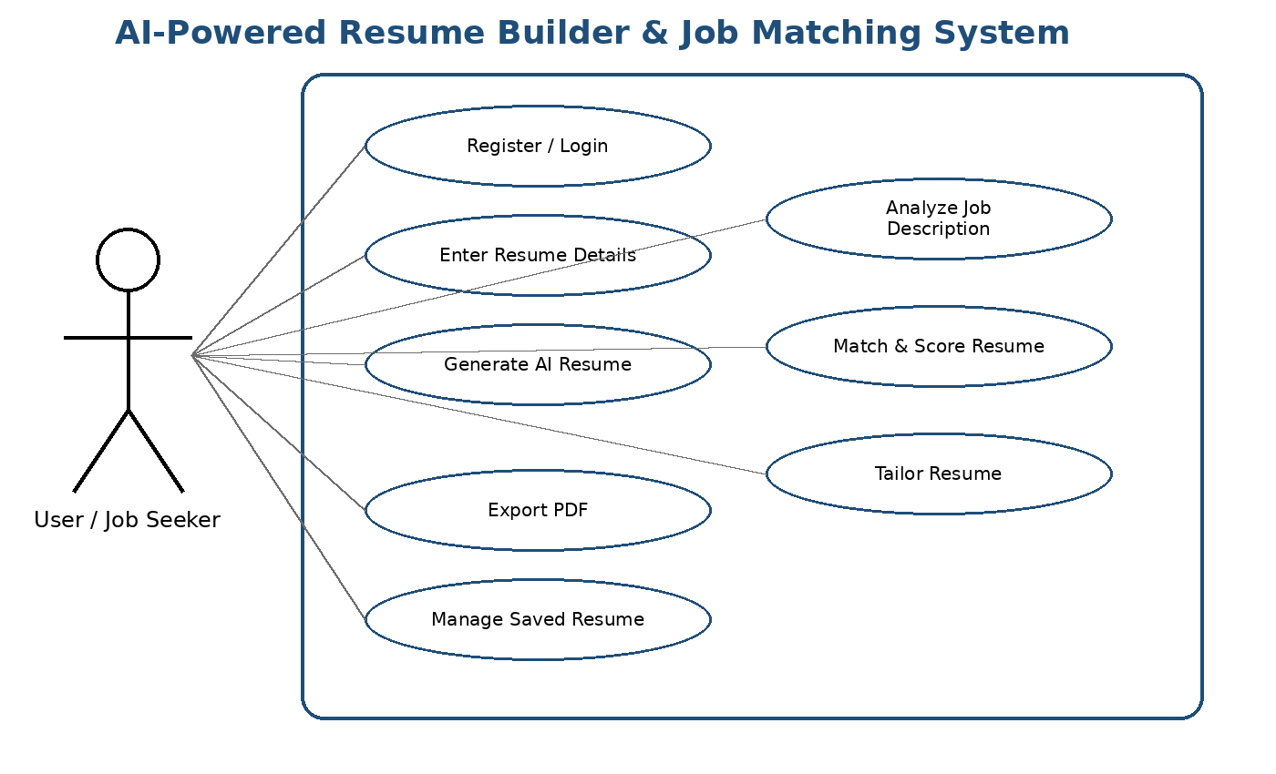
Figure 1: System Level Use Case Diagram
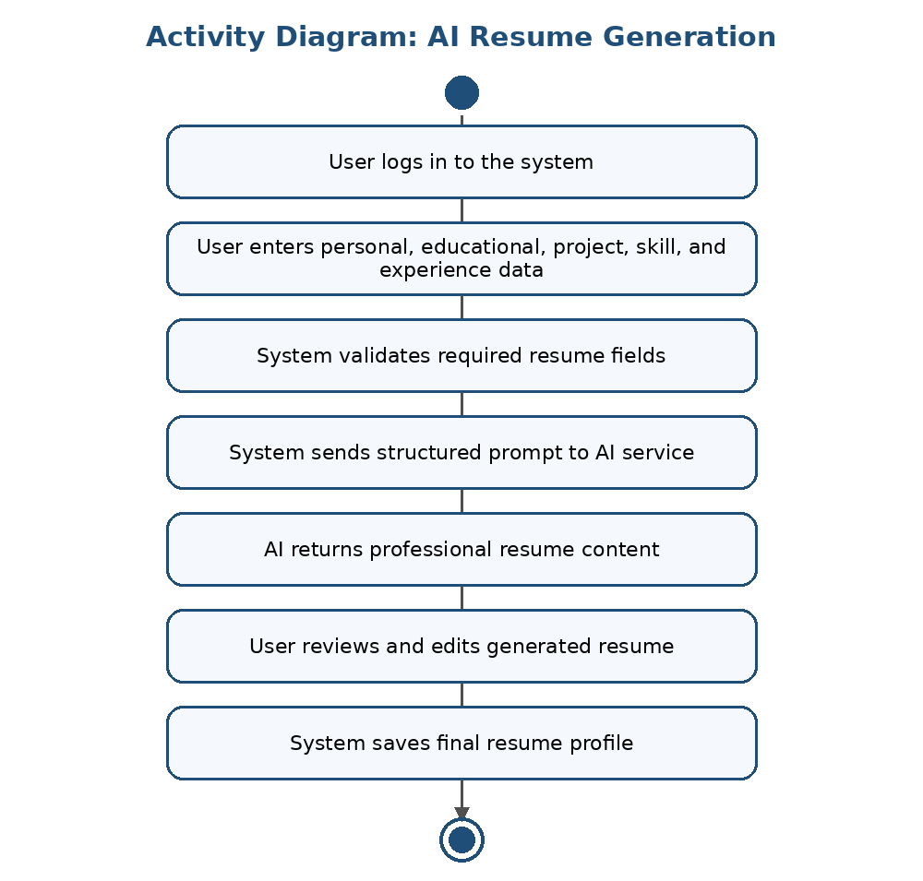
Figure 2: Activity Diagram for AI Resume Generation
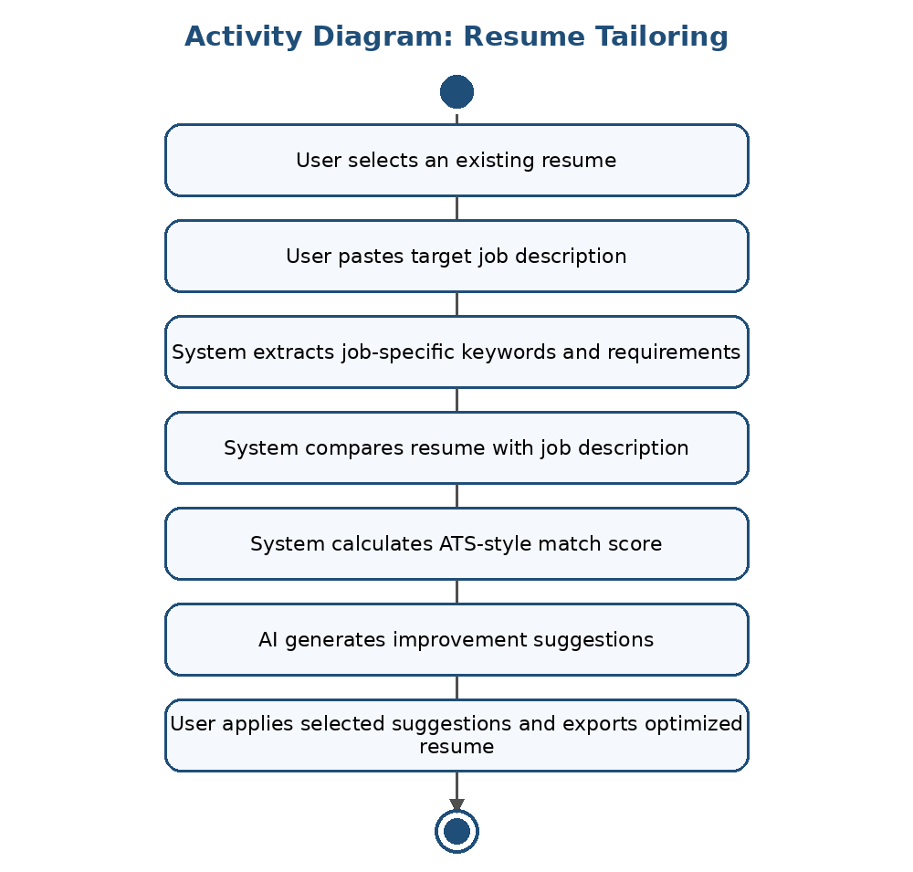
Figure 3: Activity Diagram for Resume Tailoring

3.1. User Registration and Login
ID | UC001
Name | User Registration and Login
Description | This use case describes how a user creates an account and logs in to access the system.
Requirement(s) | FR001, FR002
Actor(s) | Student, Fresh Graduate, Job Seeker
Precondition | The user must not already be logged in. For login, the user must already have a registered account.
Postcondition | The user is authenticated and can access the dashboard.
Basic Flow | 1. User opens the application.  2. User selects registration or login.  3. User enters required credentials.  4. System validates input fields.  5. System creates account or authenticates the user.  6. System redirects user to dashboard.
Alternative Flow | 1. User forgets password and requests reset.  2. System may provide a reset process if implemented.
Exceptions | Invalid email format, weak password, duplicate email, incorrect login credentials, server unavailable.

3.2. Create Resume Profile
ID | UC002
Name | Create Resume Profile
Description | This use case describes how a user enters resume information required for resume generation.
Requirement(s) | FR003
Actor(s) | Registered User
Precondition | User must be logged in.
Postcondition | Resume profile data is saved and ready for AI generation.
Basic Flow | 1. User opens the resume builder form.  2. User enters personal information.  3. User enters education, skills, projects, certifications, and experience.  4. System validates required fields.  5. User saves the resume profile.
Alternative Flow | 1. User may save the form as draft if all sections are not completed.  2. User may edit an existing resume profile.
Exceptions | Required field missing, invalid email or phone format, database save error.

3.3. Generate AI Resume Content
ID | UC003
Name | Generate AI Resume Content
Description | This use case describes how AI generates professional resume content from structured user input.
Requirement(s) | FR004, FR005
Actor(s) | Registered User, AI Service
Precondition | User must have entered sufficient resume profile data.
Postcondition | AI-generated resume content is displayed and may be saved after user approval.
Basic Flow | 1. User clicks Generate Resume.  2. System prepares a structured prompt using user profile data.  3. System sends request to AI service.  4. AI service returns professional summary and bullet points.  5. System displays generated content in resume preview.  6. User edits and saves final content.
Alternative Flow | 1. User may regenerate a specific section only.  2. User may manually edit AI-generated content.
Exceptions | AI API unavailable, prompt validation failure, response timeout, irrelevant AI response.

3.4. Analyze Job Description
ID | UC004
Name | Analyze Job Description
Description | This use case describes how the system analyzes a job description entered by the user.
Requirement(s) | FR006
Actor(s) | Registered User, AI Service
Precondition | User must be logged in and must provide a job description.
Postcondition | Extracted skills, keywords, responsibilities, and requirements are displayed.
Basic Flow | 1. User opens job matching screen.  2. User pastes job description.  3. System validates text length and content.  4. System extracts important keywords and skills.  5. System displays analyzed job requirements.
Alternative Flow | 1. User may edit job description and re-run analysis.
Exceptions | Empty job description, very short description, AI service failure, unsupported text format.

3.5. Tailor Resume for Job Description
ID | UC005
Name | Tailor Resume for Job Description
Description | This use case describes how the system compares the resume with a job description and generates tailoring suggestions.
Requirement(s) | FR007, FR008
Actor(s) | Registered User, AI Service
Precondition | User must have a resume profile and a valid job description analysis.
Postcondition | The system displays match score, missing keywords, and tailored resume suggestions.
Basic Flow | 1. User selects resume and job description.  2. System compares resume content with job requirements.  3. System calculates ATS-style match score.  4. System identifies matched and missing keywords.  5. AI generates improvement suggestions.  6. User reviews and applies selected improvements.
Alternative Flow | 1. User may only view score without applying suggestions.  2. User may keep original resume version.
Exceptions | Insufficient resume data, invalid job description, AI response failure, scoring service error.

3.6. Export Resume as PDF
ID | UC006
Name | Export Resume as PDF
Description | This use case describes how the user exports the final resume as a PDF document.
Requirement(s) | FR009
Actor(s) | Registered User
Precondition | User must have a completed resume.
Postcondition | A downloadable PDF resume is generated.
Basic Flow | 1. User reviews final resume preview.  2. User clicks Export PDF.  3. System formats resume content.  4. System generates PDF file.  5. User downloads the resume.
Alternative Flow | 1. User may return to edit resume before exporting.
Exceptions | PDF generation failure, incomplete resume fields, server error.

4. References
[1] I. Sommerville, Software Engineering, 10th ed. Pearson, 2015.
[2] R. S. Pressman and B. R. Maxim, Software Engineering: A Practitioner's Approach, 9th ed. McGraw-Hill, 2019.
[3] OpenAI, “OpenAI API Documentation,” OpenAI, 2026. [Online]. Available: https://platform.openai.com/docs/
[4] MongoDB, “MongoDB Documentation,” MongoDB, 2026. [Online]. Available: https://www.mongodb.com/docs/
[5] React, “React Documentation,” Meta Open Source, 2026. [Online]. Available: https://react.dev/
[6] Node.js, “Node.js Documentation,” OpenJS Foundation, 2026. [Online]. Available: https://nodejs.org/en/docs/

