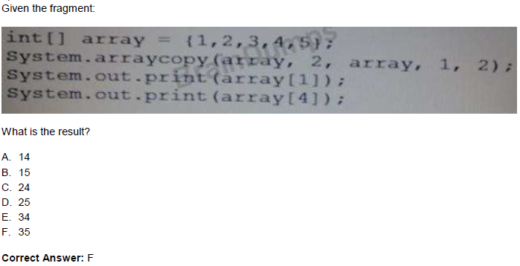

Explanation:

The two elements 3 and 4 (starting from position with index 2) are copied into position index 1 and 2 in the same array.

Afterthe arraycopy command the array looks like:

{1, 3, 4, 4, 5};