public class Test {

public static void main(String[] args) {

int ax = 10, az = 30;

int aw = 1, ay = 1; try {

aw = ax % 2; ay = az / aw;

}

catch (ArithmeticException e1){

System.out.println("Invalid Divisor");

}

catch (Exception e2) {

aw = 1;

System.out.println("Divisor Changed");

}

ay = az /aw; // Line 14 System.out.println("Succesful Division " + ay);

}

}

What is the result?

A. Invalid Divisor Divisor Changed Successful Division 30

B. Invalid Divisor Successful Division 30

C. Invalid Divisor

Exception in thread "main" java.lang.ArithmeticException: / by zero at test.Teagle.main(Teagle.java:14)

D. Invalid Divisor

Exception in thread "main" java.lang.ArithmeticException: / by zero at test.Teagle.main(Teagle.java:14)

Successful Division 1

**Answer:** C

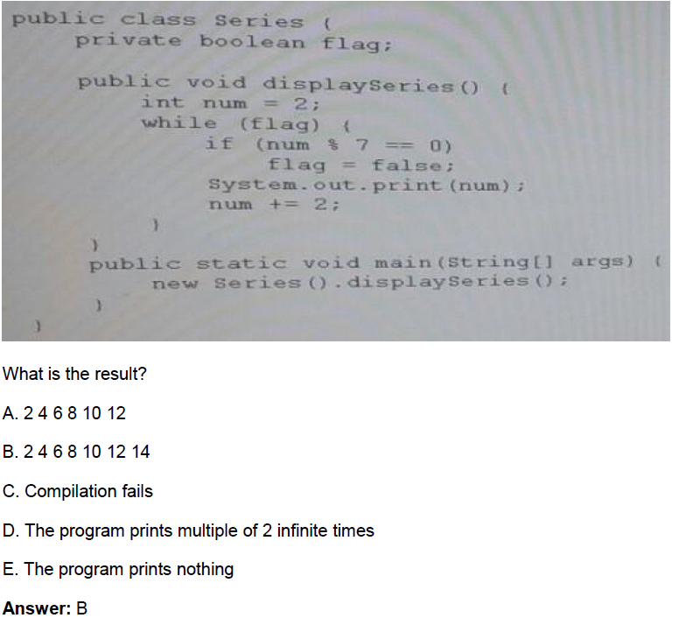

* **Ans：E**

public class App {

// Insert code here

System.out.print("Welcome to the world of Java");

}

}

Which two code fragments, when inserted independently at line // Insert code here, enable the program to

execute and print the welcome message on the screen?

A. static public void main (String [] args) {

B. static void main (String [] args) {

C. public static void Main (String [] args) {

D. public static void main (String [] args) {

E. public void main (String [] args) {

**Answer:** A,D

class Base {

public static void main(String[] args) { System.out.println("Base " + args[2]);

}

}

public class Sub extends Base{

public static void main(String[] args) { System.out.println("Overriden " + args[1]);

}

}

And the commands: javac Sub.java

java Sub 10 20 30 What is the result?

A. Base 30

B. Overridden 20

C. Overridden 20

Base 30

D. Base 30

Overridden 20

**Answer:** B

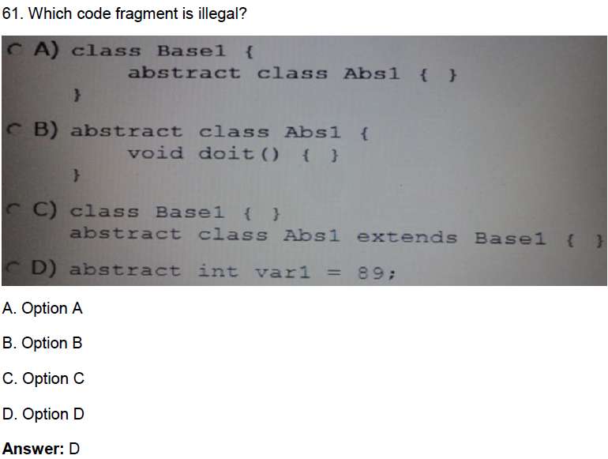

public class Natural { private int i;

void disp() { while (i <= 5) {

for (int i=1; i <=5;) { System.out.print(i + " "); i++;

} i++;

}

}

public static void main(String[] args) { new Natural().disp();

}

}

What is the result?

A. Prints 1 2 3 4 5 once

B. Prints 1 3 5 once

C. Prints 1 2 3 4 5 five times

D. Prints1 2 3 4 5 six times

E. Compilation fails

**Answer:** D

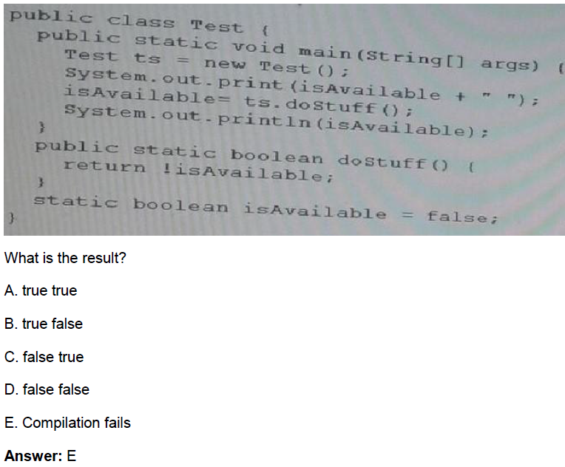

Which two will compile, and can be run successfully using the command:

java fred1 hello walls

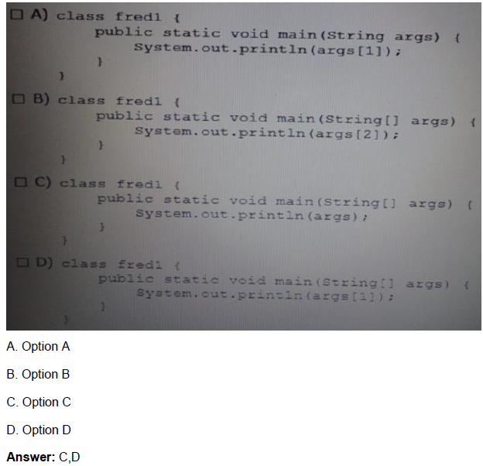

127. Given the fragment:

String[][] arra = new String[3][]; arra[0] = new String[]{"rose", "lily"};

arra[1] = new String[]{"apple", "berry","cherry","grapes"};

arra[0] = new String[]{"beans", "carrot","potato"};

// insert code fragment here

Which code fragment when inserted at line '// insert code fragment here', enables thecode to successfully

change arra elements to uppercase?

A. String[][] arra = new String[3][];

arra[0] = new String[]{"rose", "lily"};

arra[1] = new String[]{"apple", "berry","cherry","grapes"};

arra[0] = new String[]{"beans", "carrot","potato"}; for (int i = 0; i < arra.length; i++) {

for (int j=0; j < arra[i].length; j++) { arra[i][j] = arra[i][j].toUpperCase();

}

}

B. for (int i = 0; i < 3; i++) { for (int j=0; j< 4; j++) {

arra[i][j] = arra[i][j].toUpperCase();

}

}

C. for(String a[] : arra[][]){ // 錯

    for(String x : a[]){

        x.toUpperCase();

    }

}

D. for(int i : arra.length){

    for(String x : arra){

        arra[i].toUpperCase();

    }

}

**Answer: A**

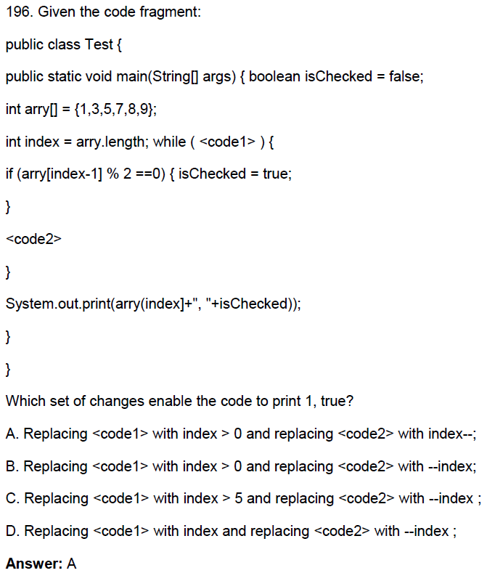

**B也可以**

193. Given:

interface Pet { }

class Dog implements Pet { } public class Beagle extends Dog{ }

Which three are valid?

A. Pet a = new Dog();

B. Pet b = new Pet();

C. Dog f = new Pet();

D. Dog d = new Beagle();

E. Pet e = new Beagle();

F. Beagle c = new Dog();

**Answer:** A,D,E

149. Given:

public class Test { static boolean bVar;

public static void main(String[] args) { boolean bVar1 = true;

int count =8; do {

System.out.println("Hello Java! " +count); if (count >= 7) {

bVar1 = false;

}

} while (bVar != bVar1 && count > 4); count -= 2;

}}

What isthe result?

A. Hello Java! 8 Hello Java! 6

Hello Java! 4

B. Hello Java! 8 Hello Java! 6

C. Hello Java! 8

D. Compilation fails

**Answer:** C

153. Given the code fragment:

Int [] [] array = {{0}, {0, 1}, {0, 2, 4}, {0, 3, 6, 9}, {0, 4, 8, 12, 16}};

Systemout.printIn(array [4] [1]);

System.out.printIn (array) [1] [4]); What is the result?

A. 4

Null

B. Null 4

C. An IllegalArgumentException is thrown at run time

D. 4

An ArrayIndexOutOfBoundException is thrown at run time

**Answer:** D

165. Given the code fragment:

//insert code here arr[0] = new int[3]; arr[0][0] = 1;

arr[0][1] = 2;

arr[0][2] = 3;

arr[1] = new int[4]; arr[1][0] = 10;

arr[1][1] = 20;

arr[1][2] = 30;

arr[1][3] = 40;

Whichtwo statements, when inserted independently at line // insert code here, enable the code to compile?

A. int [] [] arr = null;

B. int [] [] arr = new int [2];

C. int [] [] arr = new int [2] [ ];

D. int [] [] arr = new int [] [4];

E. int [] [] arr = new int [2] [0];

F. int [] [] arr=new int [0] [4];

**Answer:** C,E

178. Which three are valid types for switch?

A. int

B. float

C. double

D. integer

E. String

F. Float

**Answer:** A,D,E