**Software Installation Manual (SIM)**

*Document Number: SIM02*

*Date: Monday, May 1, 2017*

***MU GitHub Analyzer***

*Liam Innes*

*Swarna Muralidharan*

Professor Torres

Software Engineering Department

Monmouth University

West Long Branch, NJ 07764-1898

**Table of Contents**

**Scope** **3**

**Identification** **3**

**System Overview** **3**

**Document Overview** **3**

**References** **3**

**Software Summary** **3**

**Software Application** **3**

**Software Inventory** **3**

**Software Environment** **4**

**Software Organization and Overview of Operation** **4**

**Contingencies and Alternate States and Modes of Operation** **4**

**Access to the Software** **4**

**First-Time User of the Software** **4**

**Access Control** **4**

**Installation and Setup** **5**

**Initiating a Session** **5**

**Notes** **6**

# Scope

## Identification

This document applies to version 1.0 MU GitHub Analyzer.

## System Overview

The MU GitHub Analyzer (MUGHA) will list all open source projects using GitHub API, compile project attributes for each of those projects and build analytical functions to derive metrics like number of issues per contributor, number of issues per 1000 lines of code, number of lines of code per contributor. The concept is driven by Mike Bush and it is being developed by Liam Innes and Swarna Muralidharan in a Software Engineering Practicum course at Monmouth University.

## Document Overview

This document explains how to install the MUGHA software.

# References

N/A

# Software Summary

## Software Application

The MU GitHub Analyzer is intended to collect data about repositories pertaining to the User’s search terms so that data can be leveraged in statistics generated by other tools.

## Software Inventory

To use MUGHA, Users need the mugha.jar file.

## Software Environment

Users need to have installed JRE(Java Runtime Environment) version 8 update 121 and MySQL version 5.7.17 on their machine. MUGHA requires internet access to connect to GitHub repositories.

## Software Organization and Overview of Operation

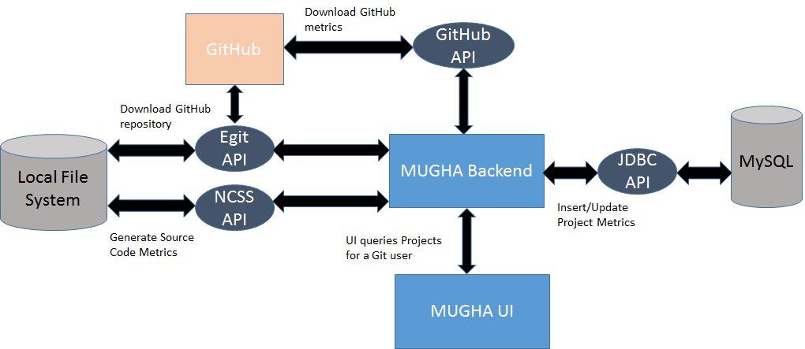

## Contingencies and Alternate States and Modes of Operation

N/A

# Access to the Software

## First-Time User of the Software

### Access Control

In order to access GitHub’s API, users will need the username (or e-mail address) and associated password a GitHub account which they can register and manage on [https://GitHub.com](https://github.com) .

### Installation and Setup

1. Make sure you have Java installed on your system. You can follow the instructions to do so here: <https://java.com/en/download/help/download_options.xml> .
2. Make sure you have MySQL installed on your system. You can follow the instructions to do so here: <https://dev.mysql.com/doc/refman/5.7/en/installing.html> .

MySql should have a userid configured as ‘root’ with password as ‘’.

Mugha software expects the MySql instance service to be available in the localhost at port number 3306.

1. Get the code from this repository <https://github.com/sharkfan/MU-GitHub-Analyzer>
2. Open the application by running the code as a Java application in Eclipse or exporting it as a Jar file which you can also do in Eclipse by clicking File → Export and select Runnable Jar File and inputting settings like these (MU22 should instead be the name of the project you imported into Eclipse)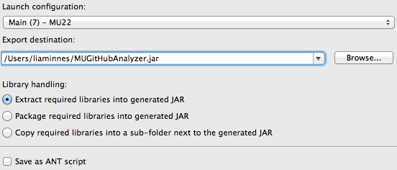

## Initiating a Session

If the user exported the Jar, they can just click it or they can open their Command Terminal program and enter the text “java -jar MUGitHubAnalyzer.jar” though they may have to specify the location of mugha in the file directory such as “java -jar Downloads/MUGitHubAnalyzer.jar”. This will open the jar file’s user interface.

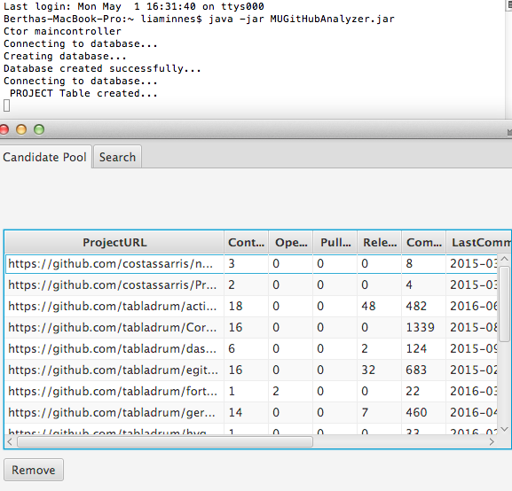

# Notes