**Software User Manual (SUM)**

*Document Number: SUM02*

*Date: Monday, May 1, 2017*

***MU GitHub Analyzer***

*Liam Innes*

*Swarna Muralidharan*

Professor Torres

Software Engineering Department

Monmouth University

West Long Branch, NJ 07764-1898

**Table of Contents**

**Scope** **3**

**Identification** **3**

**System Overview** **3**

**Document Overview** **3**

**References** **3**

**Software Summary** **3**

**Software Application** **3**

**Software Inventory** **4**

**Software Environment** **4**

**Software Organization and Overview of Operation** **4**

**Access to the Software** **4**

**Initiating a Session** **4**

**Stopping and Suspending Work** **5**

**Processing Reference Guide** **5**

**Capabilities** **5**

**Processing Procedures** **6**

**Searching For Repositories** **6**

**Recovery from Errors, Malfunctions, and Emergencies** **8**

**Messages** **8**

**Notes** **9**

# Scope

## Identification

This document applies to version 1.0 MU GitHub Analyzer released in May 2017.

## System Overview

The MU GitHub Analyzer (MUGHA) will list all open source projects using GitHub API, compile project attributes for each of those projects and build analytical functions to derive metrics like number of issues per contributor, number of issues per 1000 lines of code, number of lines of code per contributor. The concept is driven by Mike Bush and it is being developed by Liam Innes and Swarna Muralidharan in a Software Engineering Practicum course at Monmouth University.

## Document Overview

This document explains in detail the installation of the software, the features associated with the software and the usage of the software.

# References

N/A

# Software Summary

## Software Application

The MU GitHub Analyzer is intended to collect data about repositories pertaining to the User’s search terms so that data can be leveraged in statistics generated by other tools.

## Software Inventory

To use MUGHA, Users need the mugha.jar file.

## Software Environment

Users need to have installed JRE(Java Runtime Environment) and MySQL on their machine. MUGHA requires internet access to connect to GitHub repositories.

## Software Organization and Overview of Operation

N/A

# Access to the Software

## Initiating a Session

If the user has exported a Jar file of the project, they can just open it directly or open their Command Terminal program and enter the text “java -jar filename.jar” though they may have to specify the location of mugha in the file directory such as “java -jar Downloads/mugha.jar”. This will open the jar file’s user interface.

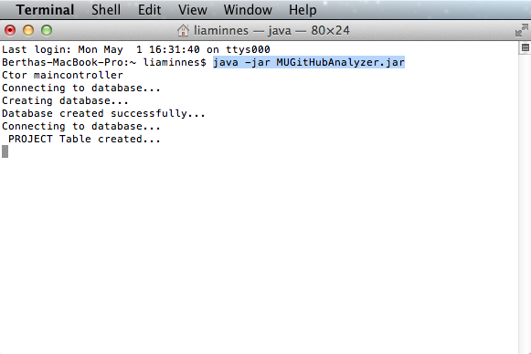

The following text is coded to appear if the jar file is working.

## Stopping and Suspending Work

All information from mugha is stored in the user’s MySQL database, so closing out of the application is okay at any time.

# Processing Reference Guide

## Capabilities

A summary of MUGHA’s capabilities as of May 2017

* Takes lists of GitHub usernames and a user’s login information.
* Retrieves all repositories from the users in the lists.
* Retrieves attributes about those repositories.
* Imports those repositories to the user’s machine.
* Can perform static analysis on those imported repositories if they’re in Java.
* Stores that information in a MySQL database.
* Shows the information from the database in the UI.
* Can delete that information from the database via the UI.

## Processing Procedures

### Searching For Repositories

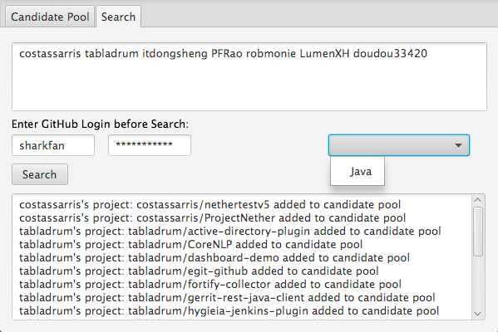

* + - 1. In order to search repositories on GitHub, first click the Search Tab near the top of the window.
      2. In the Search tab, you will see areas in which you can enter search parameters for limiting the repositories MUGHA returns:
         1. The upper text box is where you have to enter a list of GitHub usernames that mugha will retrieve repositories from. Usernames must be separated by spaces only.
         2. There is a drop down menu that you can open by clicking, and then select the programming language by clicking it from the menu. Clicking an item on the menu or elsewhere closes the menu. This drop down menu serves no purpose at this time.
         3. There are two text boxes where the user must enter a valid GitHub username and password to let MUGHA access GitHub’s API after they click the search button, otherwise the search button will do nothing.
      3. When you click the “Search” button, MUGHA will connect to GitHub retrieve repositories pertaining to the set parameters..
      4. MUGHA’s Search function currently entails that projects get imported from GitHub to a directory known as GitLandingDir so that methods can run on them to count the number of methods, classes, and lines of code. After getting this information, MUGHA deletes the files automatically.

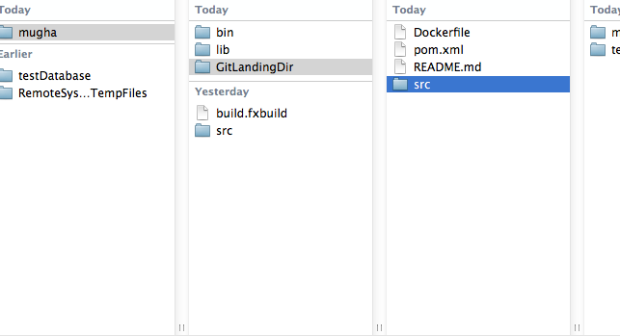

* + - 1. MUGHA will likely seem frozen until it finishes retrieving information. This can take a long time for more prolific users with bigger repositories.
    1. **Candidate Pool**

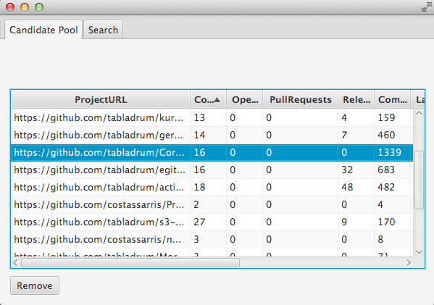

* + - 1. The rows in the table in the Candidate Pool Tab can be temporarily reordered by clicking the top of the columns and columns can also be temporarily reordered by dragging the tops of columns around.
      2. Users can click on rows in the database to select them and then click the button labeled “remove” which deletes the selected repository entries from the database and refreshes the table.

## Recovery from Errors, Malfunctions, and Emergencies

N/A

## Messages

TBD

# Notes