**A user guide to the GISMO toolbox**





**Revision Sheet**

|  |  |  |
| --- | --- | --- |
| **Release No.** | **Date** | **Revision Description** |
| Rev. 0 | 20/12/2010 | First version |
|  |  |  |
|  |  |  |

# General information

## Description

This document is a short introduction on how to use the GISMO toolbox. It is an application to manually perform quality control of in situ ocean data from different sampling types such as ferryboxes and fixed platforms. As of now it is setup to use the standard CMEMS data format. Functionalities include visual flagging of data, comparison between different data sources and interactive plot exports.

The GISMO toolbox software (available at https://github.com/sharksmhi/gismo_gui_tkinter) is distributed free of charge under the MIT license (https://opensource.org/licenses/MIT).

## Platform Requirements

The application is only tested on Windows. For requirements and guidance on how to install please see README.md in the application root directory.

## Contact

We would greatly appreciate any comments, suggestions or feedback, please contact [shark@smhi.se](mailto:shark@smhi.se).

# File setup

To import data, some settings must be linked corresponding to the data file/type of data. This is done in the lower area of the screen. Under **Get Data file**, click on the appropriate data file to find the file you want to import. Then select the matching settings file and sampling type in the drop down lists. Also specify **Platform depth** if you are importing a Fixed platform file. To add additional settings files se section “Advanced options”.

Click the green **Load file** button and GISMO uploads the file. This may take some time for large files; wait for the message **“File loaded! Please continue.”** at the bottom of the screen. After a successful load, **“Sampling type: <filename>”** is displayed under **Loaded files** in the lower right corner as well as in the banner under **Select data file** in the upper right corner of the time series page. It is possible to load both several data files of the same sampling type as well as data files of different sampling types.

# Time series management and plotting

To generate a time series plot, choose an uploaded file in the banner under **Select data file** in the upper right corner, then click **Update data file:**

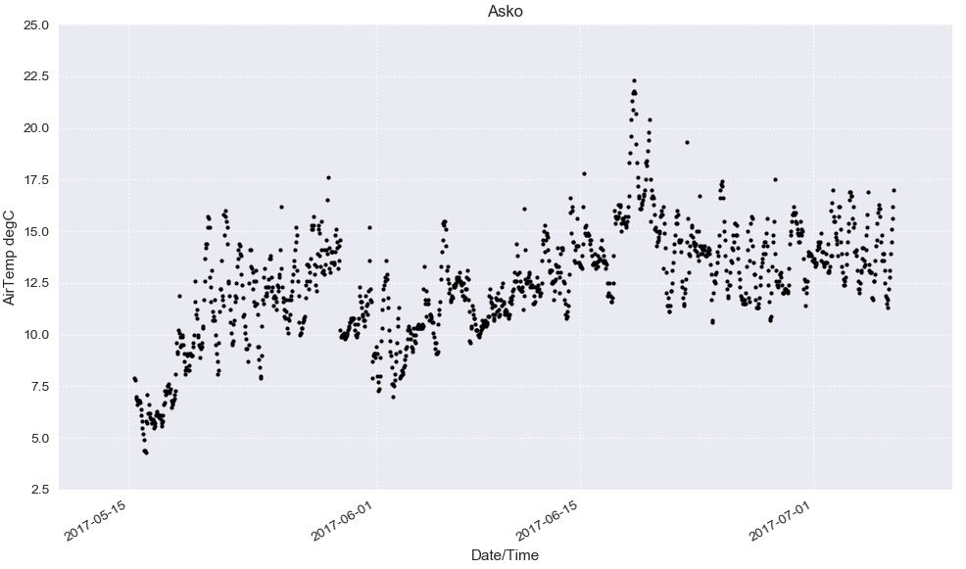

Only one parameter at a time can be plotted, the choice of parameter to display is made in the banner under **Parameter,** always with values on the y-axis and time on the x-axis**.** For large data files, updating the plot window may take some time. The message “Updating time series plot…please wait…” is displayed in the bottom of the screen. When the file is loaded you get a new message at the bottom of the screen saying “File updated: <filename>”. If the column header in the data file follows the standard CMEMS format, the corresponding parameter name will be written on the y-axis. If you have browsed to a different page you can access the time series page via **Goto** in the menu bar in the upper left corner.

The range of parameter values can be decided under **Set Range**. Enter values in the boxes and click **Set** range, you can also use Return to confirm**.** If the box **Show grid** is unticked, no horizontal grid lines will be shown.

The time range, data selection and quality control flagging, map and export options are accessed under the different tabs to the right.

**Time range** tab

The whole time range of the data (x-axis) is displayed by clicking **Zoom to full range.** It is also possible to set exact dates to display in the banners under **From** and **To.** If the box **Show grid** is unticked, no vertical grid lines will be shown.

**Map** tab

Here two maps are shown. The left map displays all data that is uploaded, highlighting the active data which is shown in the **Time series plot** window, while the right map displays a ferrybox track (if ferrybox file is active). The colored dots in the track correspond to the values of the currently chosen **Parameter**. By clicking **Map window**, a separate map window is generated. In this window it is possible to zoom and pan in the map and to save the desired outline in an image file format.

# Flagging data

**Select data to flag** tab

Here a subset of the displayed data can be selected for flagging. To pick out data, use the **Mark form** and **Mark to** buttons for time range and y-range respectively. You can then fine tune the selection by setting the banners under **From** and **To**. The range selected is highlighted in the map.

**Flag selected data** tab

Under this tab the quality flags are administrated. From the existing flags in the data file, it is possible to decide which ones to display by ticking and unticking the boxes and clicking **Update flags to show**. Color and size of the circles to be displayed for each flag can be set in the banners to the right.

It is also possible to set a set your own flag on a selected part of the data. To do this, first choose a subset under the **Select data to flag** tab. Then click the appropriate flag number and click **Flag selected data.** The appearance in the plot of the new flag can thereafter be set, tick/untick the box to show/hide, choose color and size and finally click **Update flags to show.**

Here follows an example on how to set and display flags, using the test file data/example_files/Asko_33022.txt. A zoom in on the first days on the Oxygen parameter from this file:

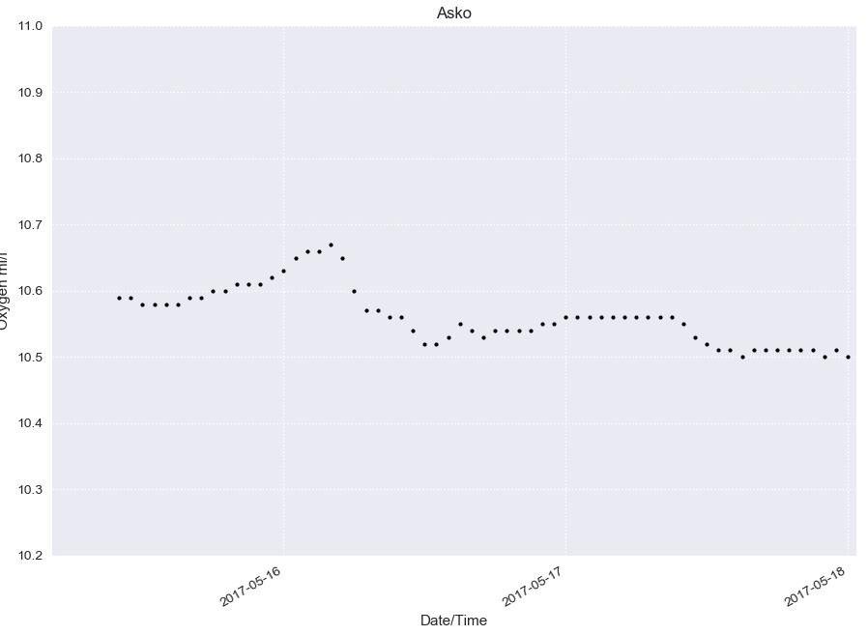

The data from March 15th - March 16th has a 0 flag and from the 17th the data is flagged with 1 in the original data file. All data is now displayed as black, size 6. To distinguish the data marked with 0, choose another color and size in the banners, for example “red” and “10”:

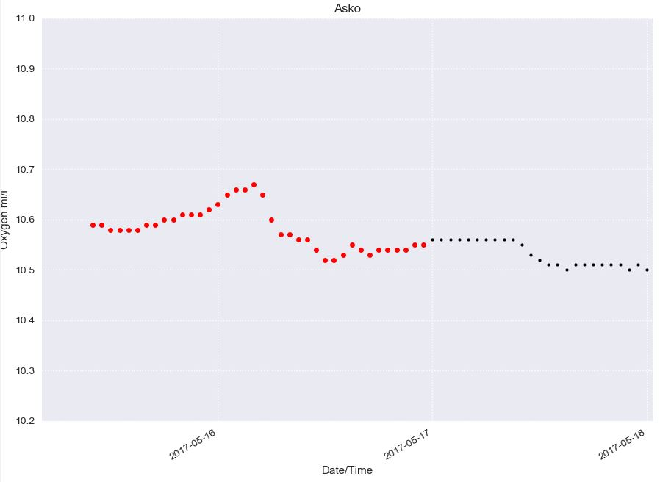

Now say we want to mark the data with the 0 flag as “bad”, to flag this data with 4. Go to the **Select data to flag** tab and select all data from March 15th to March 16th. To do this, click **Mark from**, move the cursor in the plot and click at the desired starting time:

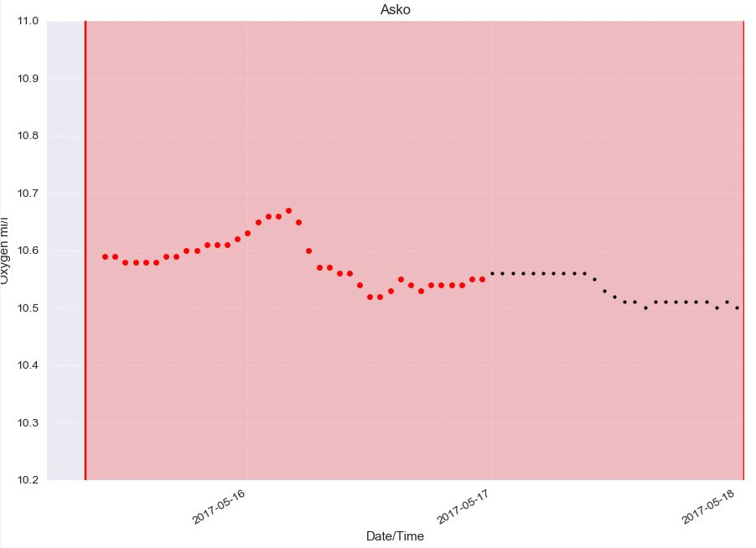

Then click **Mark to**, move in the plot and click where the end time should be:

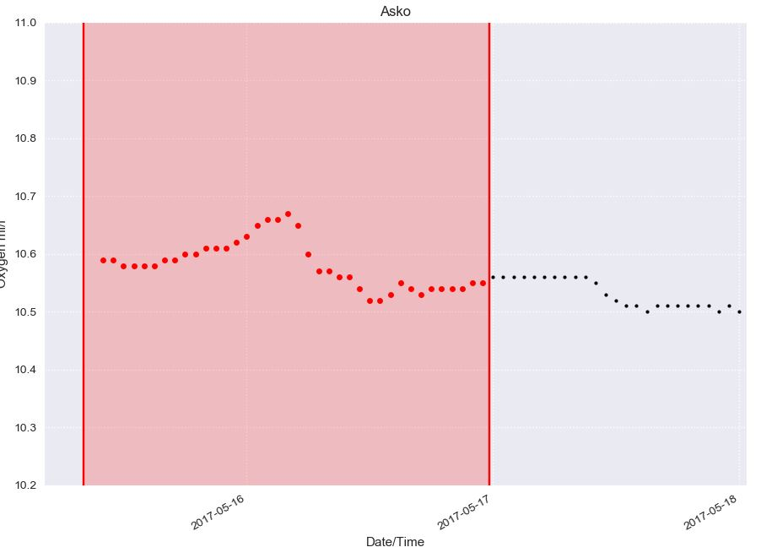

You can also fin tune your selection by using the banners or type values under “y-rang”.

Now the right time period is highlighted in the plot window. Go to the **Flag selected data** tab and click “4” in the left column to flag the selected data with 4, and then click **Flag selected data**. If desired, the display style of the new flags can now be changed, choose for example “blue” size “8“ in the banners:

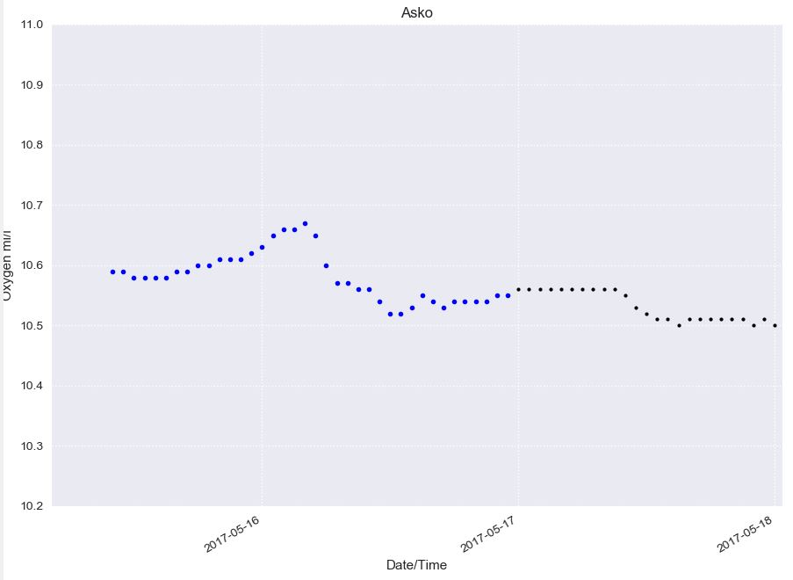

# 5. Correlating data

It is possible to upload data from an additional sensor type for comparison and correlation. Under **Get data file**, click **SHARKweb bottle data** and navigate to a SHARKweb-file. Then click the green **Load file** button. The application is setup to handle SMHI SHARKweb data which can be downloaded here: <https://www.smhi.se/klimatdata/oceanografi/havsmiljodata/marina-miljoovervakningsdata> as sampling data. (tab-separated column data with English header. Please contact [shark@smhi.se](mailto:shark@smhi.se) if you need help downloading data). To use other kinds of data, see chapter 8 Advanced Options.

Open the **Compare tab**, choose the right file in the banner under **Reference** file and then click **Load/update reference file**. Choose the parameter from the new comparison file under **Parameter**. This one will now be used together with the chosen parameter from the initial file.

For the correlation, it is possible to set limits in time, distance and depth for the comparison file to be valid. Enter values of **Max time diff [hours], Max distance [m] and Max depth diff [m]** in the boxes.

You can add matching data from you reference file in the time series plot by clicking **Plot in time series**.

Two types of correlation plots can be generated, plots with colors according to flag or colors according to depths. Click on one of the respective buttons and then click the **Correlation plot** tab in the plot window.

By clicking **Save correlation** **dataset,** a time series .txt asci file with corresponding data from the two active files will be saved in a default or chosen directory displayed under **Save directory**.

# 6. Exporting data and plots

The data with adjusted flags can be exported as a .txt asci file. Go to the **Save data** tab, choose a directory, enter a file name and then click **Save.**

To save the plots in a picture file format and also to generate and save interactive html-plots, go to the **Save plots** tab.

Picture files are exported by choosing a directory, choosing a file format and then clicking **Save time series plot** or **Save correlation plot.**

By clicking **Show and save correlation plot in HTML format**, an interactive plot is opened in a web browser. Under **Export time series html plots** it is possible to choose and plot several parameters in the same plot window. This choice can also be exported as a .html-file by clicking **Export**.

# 7. User settings

During a session in GISMO, all changes are saved automatically to the user displayed in the upper left corner (window header).

Under the **Users** banner in the menu bar, it is possible to select and add a user and to control settings for a specific user. Here map boundaries, different plot properties and show/hide popups can be set under **User settings**. The **Color maps** are from the cmocean package (https://matplotlib.org/cmocean/) while the **Plot style** choices follow the matplotlib style sheets (https://matplotlib.org/gallery/style_sheets/style_sheets_reference.html).

To leave the **User settings** page, use the **Goto banner**.

# 8. Advanced options

**Settings file**   
To be able to use a data file in GISMOtoolbox you need to specify a settings file that “explains” the structure of the data file. Settings files are located in the directory settings_files. Here follows an explanation on the settings file structure. You are free to add your own settings files and all files in the directory settings_files will be available in the application (if the file structure is correct). Note that lines starting with # are comment lines.

*Flags*   
Describe all flags possible in the data file. First column (QF) is the valid quality flags for the data file. Second column (Description) is the description of the flag that will be shown in the application.

*Dependent parameters*   
Here you can specify dependent parameters meaning that if you flag the first parameter in list, also the following will be flagged. If External parameter names are numbers you can specify the dependent variables as a range separated by :. Example: 8191; 8041:8188 means that if parameter 8191 is flagged all parameters from 8041 to 8188 are also flagged.

*Parameter mapping*   
Here you specify your which parameter mapping file you want to use for your data. Specify the “File name” (the file needs to be placed in directory “data/mapping_files”). “Internal column” is the column (or combined columns separated by ;) you want to use for the parameter names inside the application. “External column” is column describing the parameter names in your file. If you have a column for unit you can specify this under “Unit column”. If unit is in the external parameter name , for example “Oxygen (ml/l)” you can specify “unit starts with” as “(“ to distinguish where the unit can be found. Set “qf prefix” and “qf suffix” to find the matching quality flag column. Example: If you have parameters of the structure “Salinity” with qf-parameter “QF_Salinity” you should set “qf prefix” to “QF_”. Also specify file “encoding” of your parameter mapping file.

*Station mapping*   
Describe your station mapping file. Give the “File name”, “Internal column”, “External column” and “encoding” in the same way as for Parameter mapping. In “Header starts with” you can specify where the header starts in the file. Header is recognized if line starts with string specified for “Header starts with”.

*Column*   
Specify mandatory parameters: time, lat, lon and depth (if present). Can be specified by external parameter name or 0-based index (like “index=0”). In CMEMS files the station name is given in the first row, first column. So we set “station” to “index=0”.

*Info*   
Specify value for “Missing value” and “Number of decimals for float” that you have in your file.