class04.ex.R

sharl

2023-04-13

x <- 1:50  
plot (x, sin(x))

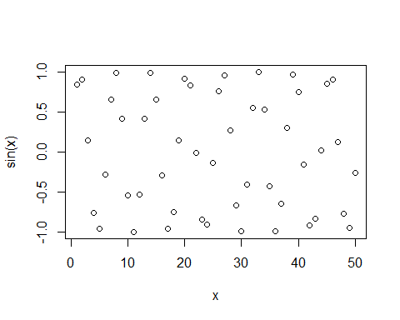

plot (x, sin(x), typ= "l", col= "blue", lwd= 3, xlab= "Hello there")

