**Hardware components requirements:**

1. Arduino
2. TCS 3200 Color sensor
3. Servo motor
4. Cardboard
5. Color candy
6. Seven segment display

**Block Diagram:**

**Circuit Diagram:** 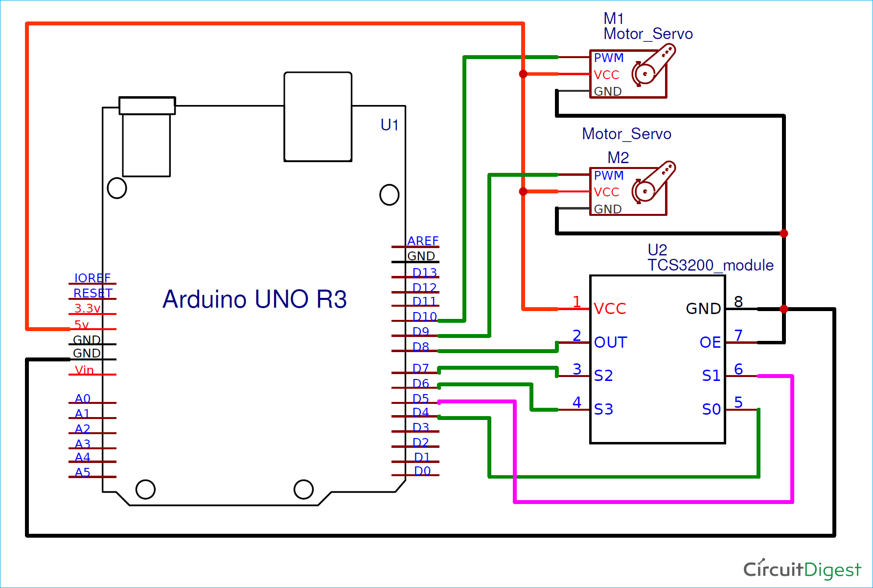

7 Segment Display

Arduino

Servo Motor

Color Sensor

Servo motor

IR Sensor