


High-Performing Agriculture
Company test
CONFIDENTIAL
INFORMATION MEMORANDUM
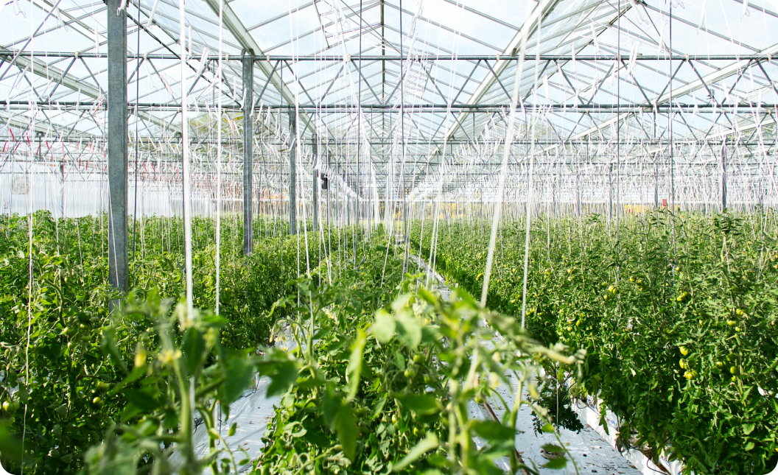
2025

Vikram Batra
Certified Business Intermediary  Merger and Acquisition Master Intermediary   | 2132423432  5vvzlsmto1@cmhvzylmfc.com  ewf,Florida

Introduction
Disclaimer
About the Brokerage
Next Steps & Additional Information
Executive Summary
Price & Terms
Business Overview
Business Location
Products & Services
Business History
Markets & Customers
Sales & Marketing
Facilities
Owner Function
Transition Period
Non-Compete
Reason for Sale
Team
Current Ownership and Structure
Employees
Staffing, Compensation, & Benefits
Financial Snapshot
Financial Highlights
Financial Performance
Tax Return
Operations Snapshot
Vendors & Supply Chain
Partnership Agreement
Facilities & Lease
Industry Overview & Competition
Industry Market and Trends
Competition
Growth Potential
Assets & Inventory
Hard Asset
Infrastructure & Tech Overview
Legal & License Requirements
Proprietary Technology & Intellectual Property
Legal Matters & Lease
Questions & Answers
Highlights & Lowlights
Attachments
Contact Information

1. Introduction

Disclaimer
This Confidential Information Memorandum is being provided exclusively to prospective parties who have specifically requested information regarding eeee in order to assess their interest in submitting an offer to acquire the company. All recipients must have executed a valid Confidentiality Agreement prior to receiving this memorandum. The document contains preliminary information about eeee and highlights the key factors that contribute to its value.  The contents of this memorandum are confidential and cannot be reproduced or shared without the explicit permission of eeee. This copy is electronically tagged to the recipient under the terms of the Confidentiality Agreement. Test 5.2 feature test with fixes has obtained the information from eeee. and does not guarantee the accuracy or completeness of the information, financial data, or projections. Test 5.2 feature test with fixes disclaims any liability for any information, projections, or representations (expressed or implied) contained herein, for any omissions from this Confidential Information Memorandum, or for any other written or oral communications provided during the evaluation of eeee. | Prospective investors should conduct their own due diligence. If you have not signed a Confidentiality Agreement, please notify us and delete this document. eeee reserves the right to negotiate, modify procedures, or end participation at any time without notice.

This Confidential Information Memorandum includes forward-looking statements about eeee and its industry. These statements reflect current assumptions by management and advisors, and results may differ significantly. No representation or warranty is made regarding the feasibility or accuracy of such projections.
NEITHER THIS CONFIDENTIAL INFORMATION MEMORANDUM NOR ITS DELIVERY TO YOU SHALL CONSTITUTE OR BE INTERPRETED AS AN OFFER TO SELL ANY SECURITIES OF eeee. THIS CONFIDENTIAL INFORMATION MEMORANDUM SHALL NOT BE CONSIDERED AN INDICATION OF THE COMPANY'S CURRENT STATE OR THAT THERE HAVE BEEN NO CHANGES IN THE BUSINESS OR AFFAIRS OF eeee.

About Test 5.2 feature test with fixes
Transaction Process & Next Steps
This Confidential Information Memorandum Offers An Initial Overview For Evaluating The Business Acquisition Opportunity. Detailed Information Will Be Provided After You Submit An Offer To Purchase Or A Letter Of Intent (LOI), Which Will Be Contingent On Successful Due Diligence And Final Agreement Terms.
If You Choose Not To Proceed, Please Inform Us And Return All Confidential Information According To The Signed Confidentiality Agreement (NDA). We Appreciate Your Interest And Hope To Work With You On This Opportunity
If you have further interest
If you choose to continue with this opportunity, please submit a comprehensive Offer to Purchase or Letter of Intent (LOI) to Test 5.2 feature test with fixes Your proposal should include:
- Transaction Value: Your proposed price for the business.
- Deal Proposal: The type and structure of the deal.
- Payment Details: Terms for payment including cash and notes.
- Seller Note Security: Collateral for any seller financing.
- Assumptions: Key assumptions used in your offer.
- Closing Timeline: Proposed schedule for closing and any specific requirements.
- Financing: Your financing sources, levels, and steps for obtaining funds.
- Discussion Points: Major assumptions and issues to discuss.
- Due Diligence: Additional due diligence is needed and estimated time.
- Financial Proof: Confidential documents proving your ability to complete the transaction.
Please note that your Offer to Purchase or LOI will be subject to due diligence and the negotiation of final terms before any formal agreements are made.

D.D And Purchase Agreement  If you choose to move forward, you will have the opportunity to carry out a thorough due diligence investigation of eeee. This involves working with your advisors to review the business details provided in the Offer to Purchase. This phase also includes negotiating and finalizing all necessary agreements to complete the transaction. | Fees  Both parties will be responsible for their own legal, accounting, and advisory costs associated with the due diligence review and preparation of the purchase agreement. These expenses are incurred regardless of whether the transaction is finalized.
Warning!
The information contained in this profile is strictly confidential and only for the intended recipient. Do not disclose to any parties whatsoever without written permission of the Seller and Broker. Broker and/or Seller will be happy to coordinate any information you may need. The seller should only be contacted through the Broker.
About The Company
##AboutCompany##

Contact Protocol
Please refrain from contacting any of eeee's officers, employees, clients, suppliers, or shareholders without explicit prior consent from Test 5.2 feature test with fixes. All inquiries and communications should be directed through Test 5.2 feature test with fixes

  Test 5.2 feature test with fixes  Vikram Batra  Certified Business Intermediary,  Merger and Acquisition Master Intermediary | ewfd, ewf, Florida, 23323  5vvzlsmto1@cmhvzylmfc.com  wed.wef  2132423432

2. Executive Summary - eeee
Price & Terms
Asking Price:  $ N/A | ddd
Business Overview
##Business Overview##
Business Location
 | 
wfwe, ewfwe, Florida, 32423  ##Address Info## | 
Products & Services
##Products & Services##

Business History
##Business History##

Markets & Customers
##Market & Competition##

Sales & Marketing
##Sales & Marketing##

Facilities
##Facilities##

Location Benefits
##Location Benefits##

Owner Function
##Owner Function##

Transition Period
##Transition Period##

Non-Compete
##Non-Compete##

Reason for Sale
Financial Gain
3. Team
Current Ownership & Structure
##Replace the Image Below##
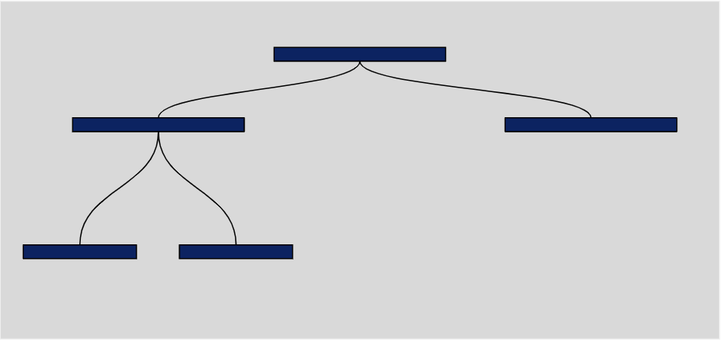
Employees
##Employees##

Title | Pay Rate | Weekly Hours | Years | Health Benefits | Vacation Pay | Staying
 |  |  |  |  |  | Yes/No
 |  |  |  |  |  | Yes/No
 |  |  |  |  |  | Yes/No
 |  |  |  |  |  | Yes/No
 |  |  |  |  |  | Yes/No
 |  |  |  |  |  | Yes/No
 |  |  |  |  |  | Yes/No

Staffing, Compensation, & Benefits
##Staffing, Compensation, & Benefits##
4. Financial Snapshot
Financial Highlights
Overview
##Financial Highlights Overview##

Financial Performance

Source Basis | ##PreviousYearStart##P/L  Statement Accrual | ##PreviousYearMid## P/L  Statement Accrual | ##PreviousYear## P/L  Statement Accrual | ##PreviousYearStart##-##PreviousYear##  3-yr Average
Revenue | asdasdas
COGS | sadasda
Gross Profit

Total Expenses
Adj. EBIT
Adj. EBITDA
Seller's Discretionary Earnings

Margins (Using Total Revenue)  Source | ##PreviousYearStart##P/L  Statement Accrual | ##PreviousYearMid## P/L  Statement Accrual | ##PreviousYear## P/L  Statement Accrual | ##PreviousYearStart##-##PreviousYear##  3-yr Average
COGS
Gross Profit
Adj. EBITDA
Seller's Discretionary Earnings

EBITDA Note
##Ebitda Note##

SDE Note
##Ebitda Note##
Financial Highlights
##Chart##
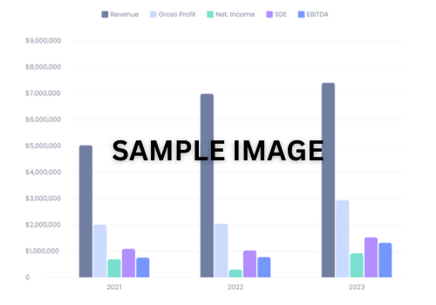

Year: ##Previous Year##
Source: P/L Statement

Revenue (Gross Sales) | Statements | Add Backs | Adjusted
Revenue
Total Revenue
Cost Of Goods Sold
Purchases
Cost Of Labor
Equipment Rental
Permit Fees
Subcontractors
Transportation
Other
Total Cost Of Goods Sold
Gross Profit
Expenses
Compensation Of Officers
Salaries And Wages
Repairs And Maintenance
Bad Debt
Rents
Taxes & Licenses
Interest
Accounting
Automobile And Truck Expenses
Bank Charges
Cleaning
Commissions
Computer Services And Supplies
Dues And Subscriptions
Gift
Insurance
Legal & Professional / Consulting
Meals
Miscellaneous
Postage
Printing
Supplies
Telephone
Training/Continuing Education
Travel
Uniforms
Utilities
Payroll Processing Fees
Total Cost Of Goods Sold
Total Expenses
Net Income
Seller's Discretionary Earnings
Year: ##Previous Year##
Source: Unadjusted Income Statement Summary

Revenue (Gross Sales) | ##PreviousYear -2##  P/L | ##PreviousYear-1##  P/L | ##PreviousYear##  P/L
Revenue
Total Revenue
Cost Of Goods Sold
Purchases
Cost Of Labor
Equipment Rental
Permit Fees
Subcontractors
Transportation
Other
Total Cost Of Goods Sold
Gross Profit

Expenses
Compensation Of Officers
Salaries And Wages
Repairs And Maintenance
Bad Debt
Rents
Taxes & Licenses
Interest
Accounting
Automobile And Truck Expenses
Bank Charges
Cleaning
Commissions
Computer Services And Supplies
Dues And Subscriptions
Gift
Insurance
Legal & Professional / Consulting
Total Expenses
Net Income

Year: ##Previous Year##
Source: Balance Sheet
Assets | {{PreviousYear}}
Current Assets
Cash
Accounts Receivable
Retentions receivable
Total
Total Fixed Asset
Other Assets
LIABILITIES
Current Liabilities
Accounts Payable
Bank - line of credit
Fixed Assets
Other Assets
Total Other Assets
Liabilities
Account Payable
Bank - Line of credit
Credit Cards
Total Current Liabilities
Long-Term Liabilities
SBA Loan
Total Long-Term Liabilities
Total

Tax Return
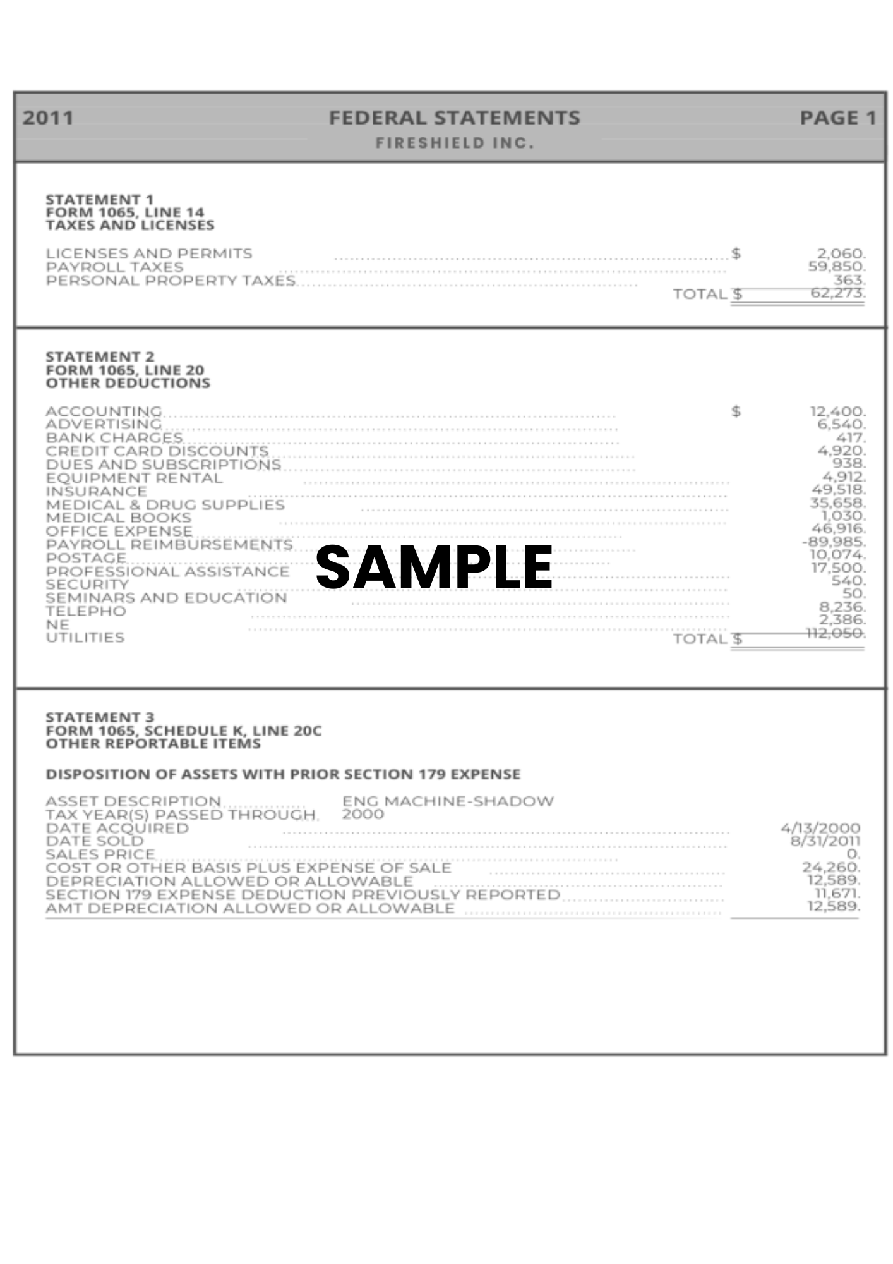
5. Operations Snapshot
Days and Hours of Operation
##Days And Hours Of Operation##

Insurance
##Insurance##

Partnership Agreement
##Partnership Agreement##

Facilities & Lease
##Facilities & Lease##

Vendors and Supply Chain
##Vendors And Supply Chain##

Information Systems
##Information Systems##
6. Industry Overview & Competition

Industry Market and Trends
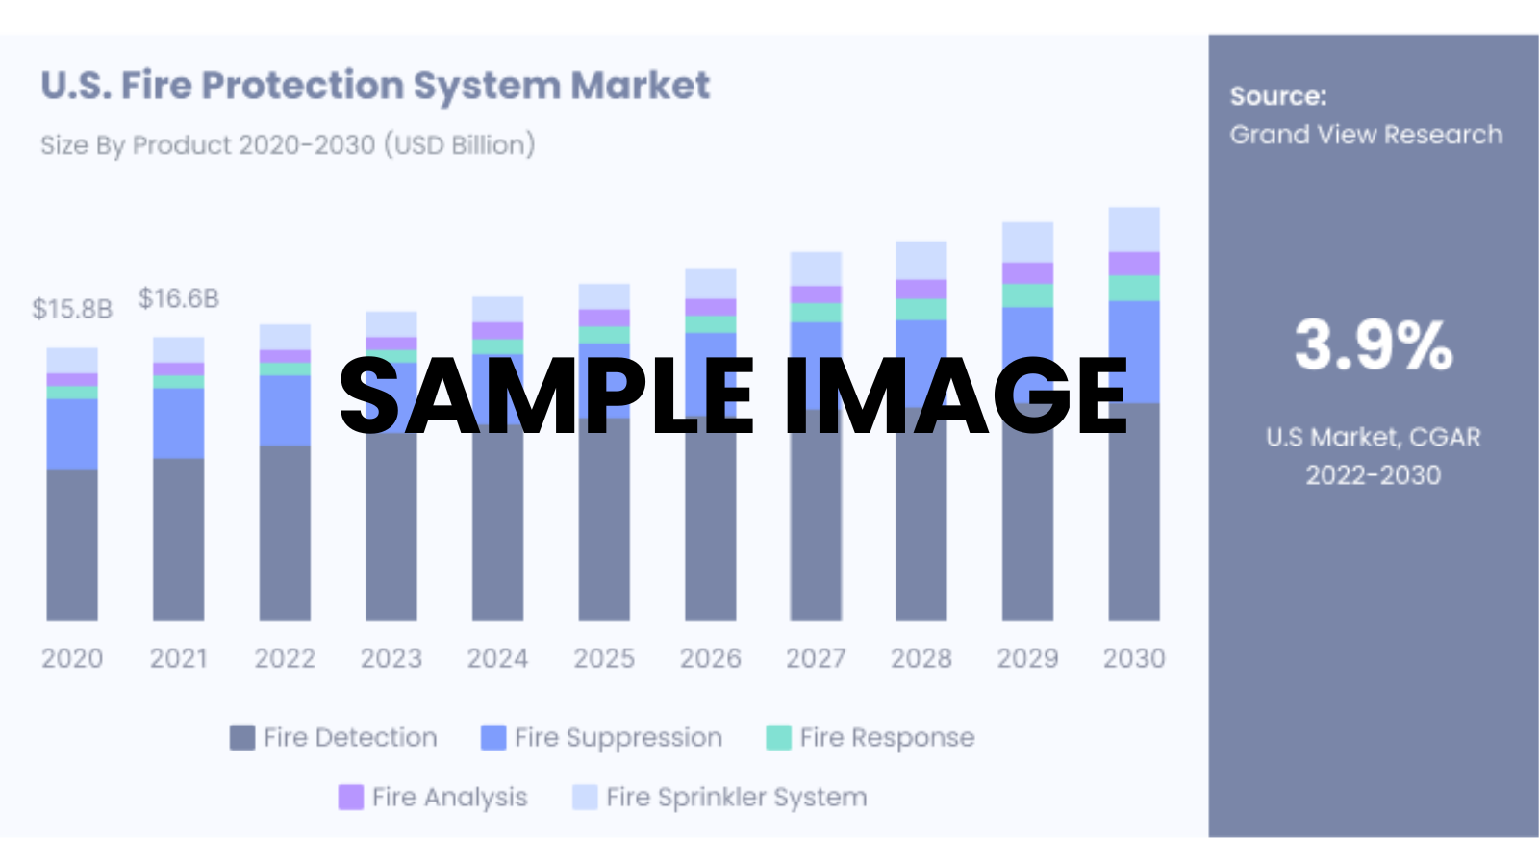

Systems Overview
##Systems Overview##

Adoption & Awareness
##Adoption & Awareness##

Market Growth & Opportunities
##Market Growth & Opportunities##

Competition
##Competition####

Opportunities to Increase Profit
##Opportunities To Increase Profit##

Growth Potential
##Growth Potential##
7. Assets & Inventory

Hard Asset

Quantity | Description | Year/Model | Year Acquired | Original Cost | Market Value | Name of Holder | Current Lien

Business Local Rating by Peers
##Business Local Rating By Peers##

Infrastructure & Tech Overview
##Infrastructure & Tech Overview##

Inventory
##Inventory##
8. Legal & License Requirements

Proprietary Technology & Intellectual Property
##Proprietary Technology##
##Intellectual Property##

Legal Matters
##ILegal Matters##

Trademarks
##Trademarks##

Lease
##Lease##
9. Questions and Answers

Question: How does your business differentiate itself from competitors?

Answer: ##Not Answered##

Question: What is the typical customer lifecycle, and how do you maintain customer loyalty?

Answer: ##Not Answered##

Question: Are there new products, services, or markets under consideration or in the pipeline?

Answer: ##Not Answered##

Question: Are there specific risks (e.g., market risks, regulatory risks) unique to your business?

Answer: ##Not Answered##

Question: Can you describe any exclusive contracts or longstanding relationships with suppliers or clients?

Answer: ##Not Answered##

10. Highlights & Lowlights

Highlights
##Highlights & Lowlights##

Lowlights
##Highlights & Lowlights##

11. Attachments
Additional Pictures

Client Reviews
##Client Reviews ##
##Client Reviews ##

##Client Reviews ##

##Client Reviews ##

12. Contact Information

Next Steps
##Next steps ##

About the Brokerage
##About the Brokerage##

Contact Information
##Contact information##

Test 5.2 feature test with fixes  Vikram Batra  Certified Business Intermediary,  Merger and Acquisition Master Intermediary | ewfd, ewf, Florida, 23323  5vvzlsmto1@cmhvzylmfc.com  wed.wef  2132423432

