Country – State – City API
A beginner's step-by-step guide to getting an API key, testing it in Postman, and using it to build a Country → State → City dropdown.

1. What This API Does
This is a free web service that gives you location data in three levels:
- Countries — e.g. India, USA, Afghanistan
- States — e.g. Maharashtra, Gujarat (inside a country)
- Cities — e.g. Yavatmal, Pune, Nagpur (inside a state)
It's most commonly used to build the 3-level cascading dropdown you see on almost every signup or address form: pick a Country, then a State, then a City.

2. Get Your Free API Key
Step 2.1 — Go to the website
Open https://countrystatecity.in/ in your browser. This is the homepage of the API provider.
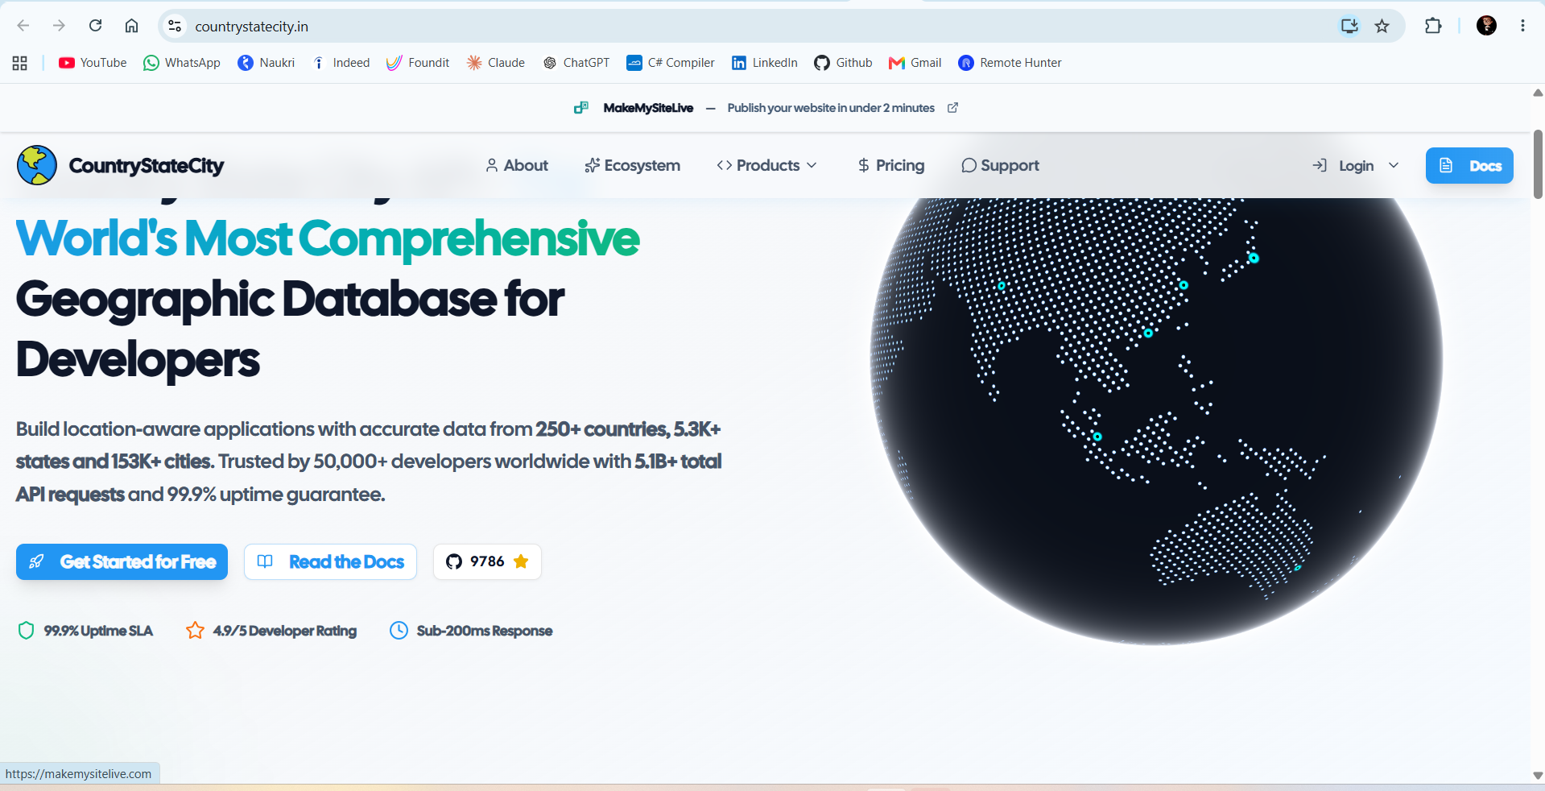
Fig 1 — CountryStateCity.in homepage
Step 2.2 — Sign up / Log in
Click Login at the top right, then choose the sign-up option. You can use a temporary email service (like a temp-mail site) if you just want to test it out quickly, or use your real email for long-term use.
Step 2.3 — Open the API Keys page
Once logged in, you'll land on a Developer Console. Click API Keys in the left-hand menu.
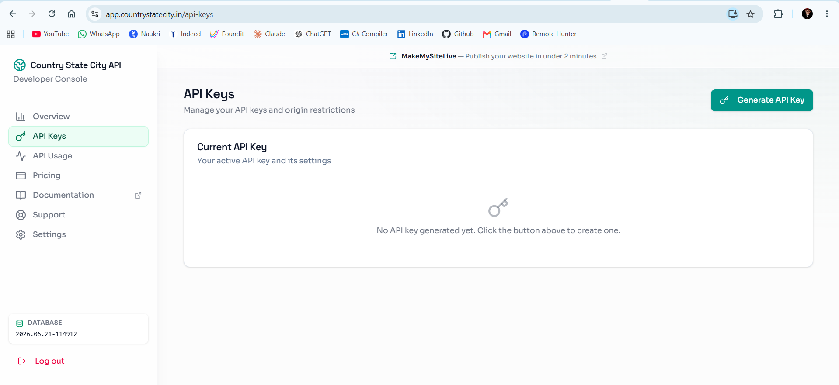
Fig 2 — API Keys page (before generating a key)
Step 2.4 — Generate the key
Click the Generate API Key button. A new key will appear on screen — a long string of letters and numbers.
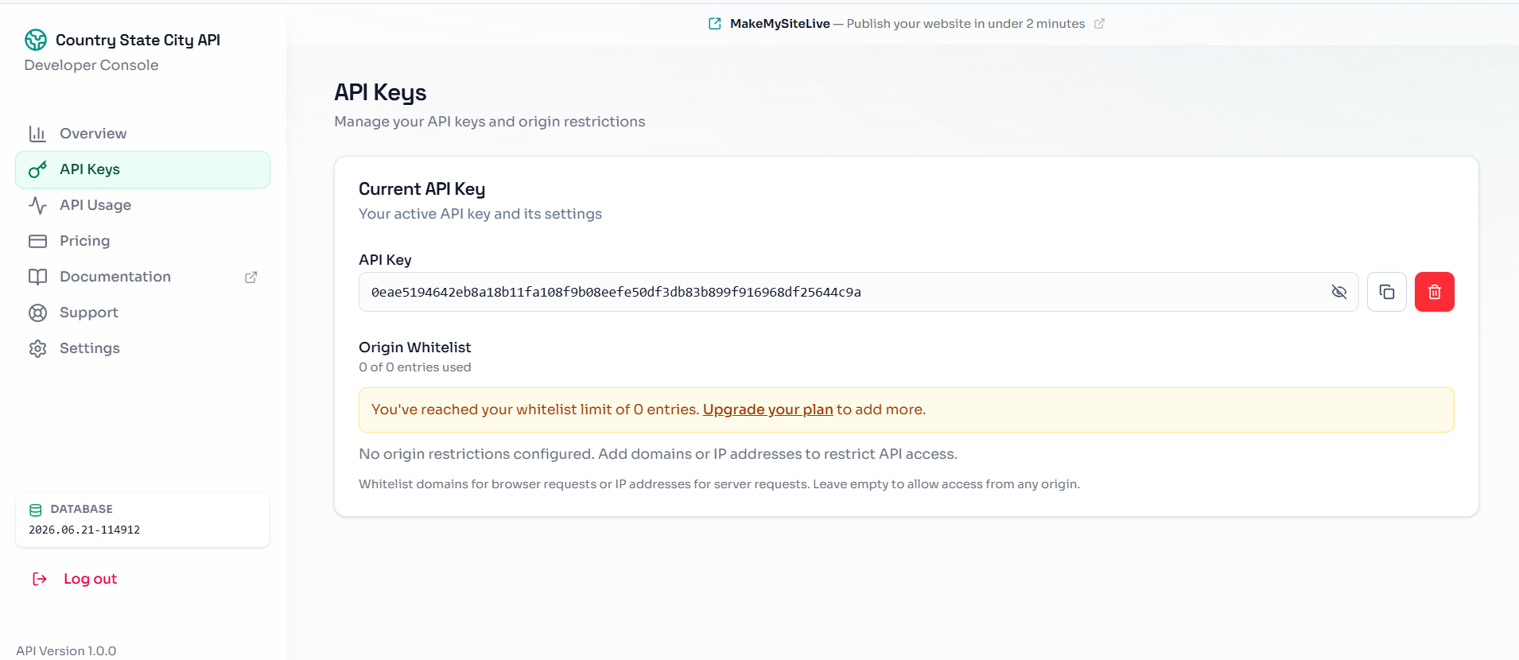
Fig 3 — API key generated
⚠️ Keep this key private. Anyone who has it can use your free quota. Don't post it publicly (GitHub, forums, WhatsApp groups, etc.). If it ever leaks, come back to this page and regenerate a new one.

3. Test the API in Postman (No Coding Needed)
Postman is a free tool that lets you send requests to an API and see the response, without writing any code. This is the easiest way to check the API works before using it in your own app.
Step 3.1 — Open Postman and Import the collection
In Postman, click the Import button (top left).
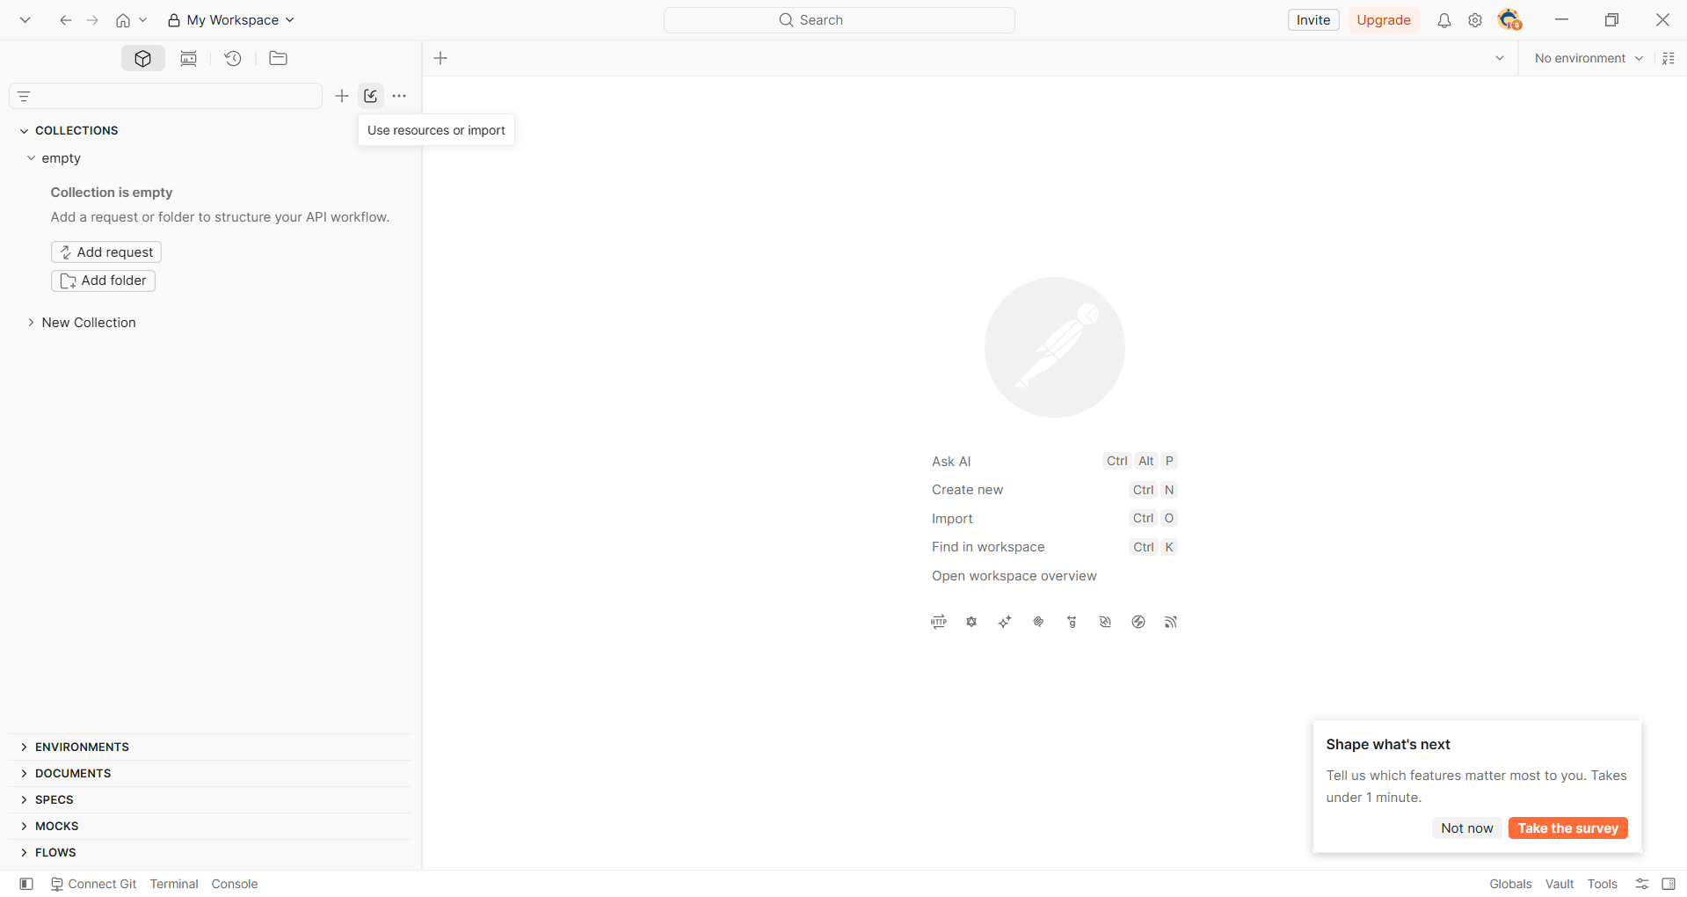
Fig 4 — Postman's empty workspace with the Import option
Select the file CountryStateCity_API.postman_collection.json (provided separately) or paste in the shared Google Drive link. This file already contains 6 ready-made requests — you don't need to build them yourself.
Step 3.2 — Add your API key
After importing, click on the collection name → Variables tab. Paste your API key into the api_key row. The other variables (base_url, country_code, state_code) are already filled in for India → Maharashtra.
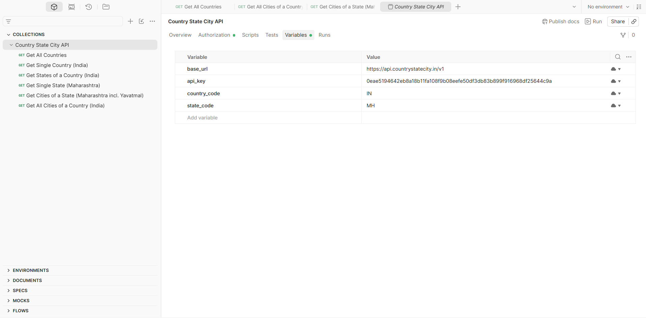
Fig 5 — Collection variables, including the api_key field
Step 3.3 — Send a request
Open any request (start with “Get All Countries”) and click Send. If everything is set up correctly, you'll get a 200 OK response with JSON data.
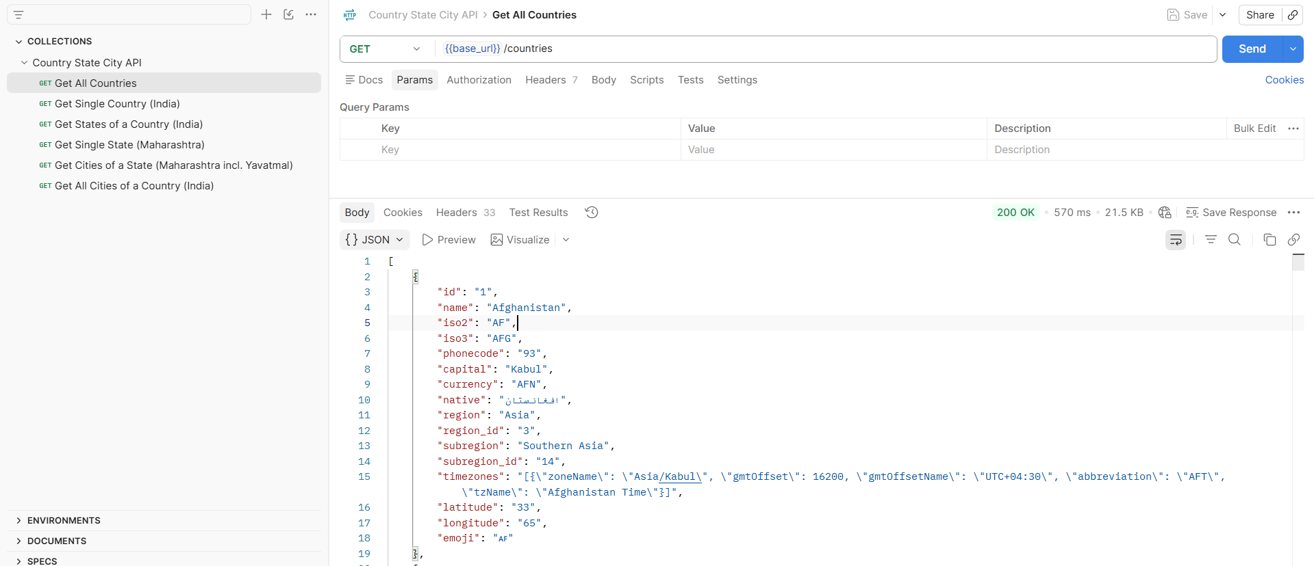
Fig 6 — Successful 200 OK response showing country data

4. API Reference
All requests use the GET method and need this header on every call:
X-CSCAPI-KEY: <your api key>

4.1 Get All Countries
Field | Value
HTTP VERB | GET
HTTP URL | https://api.countrystatecity.in/v1/countries
USE CASE | Fill the first dropdown — “Select Country”
HTTP RESPONSE | [{"id":"1","name":"Afghanistan","iso2":"AF","iso3":"AFG","phonecode":"93","capital":"Kabul","currency":"AFN","region":"Asia", ...}, ...]

4.2 Get Single Country
Field | Value
HTTP VERB | GET
HTTP URL | https://api.countrystatecity.in/v1/countries/{country_code}
PARAMETER | country_code — e.g. IN
USE CASE | Show extra details about one selected country
HTTP RESPONSE | {"id":"101","name":"India","iso2":"IN","iso3":"IND","capital":"New Delhi","currency":"INR", ...}

4.3 Get States of a Country
Field | Value
HTTP VERB | GET
HTTP URL | https://api.countrystatecity.in/v1/countries/{country_code}/states
PARAMETER | country_code — e.g. IN
USE CASE | Fill the second dropdown — “Select State” — after a country is chosen
HTTP RESPONSE | [{"id":"4017","name":"Andhra Pradesh","country_code":"IN","iso2":"AP", ...}, {"id":"4008","name":"Maharashtra","iso2":"MH", ...}, ...]

4.4 Get Single State
Field | Value
HTTP VERB | GET
HTTP URL | https://api.countrystatecity.in/v1/countries/{country_code}/states/{state_code}
PARAMETER | country_code — e.g. IN, state_code — e.g. MH
USE CASE | Show extra details about one selected state
HTTP RESPONSE | {"id":"4008","name":"Maharashtra","country_id":"101","country_code":"IN","iso2":"MH","latitude":"18.90...","longitude":"75.67...","timezone":"Asia/Kolkata"}

4.5 Get Cities of a State ⭐ (this is where Yavatmal shows up)
Field | Value
HTTP VERB | GET
HTTP URL | https://api.countrystatecity.in/v1/countries/{country_code}/states/{state_code}/cities
PARAMETER | country_code — e.g. IN, state_code — e.g. MH
USE CASE | Fill the third dropdown — “Select City” — after a state is chosen
HTTP RESPONSE | [{"id":"57589","name":"Achalpur"}, {"id":"147667","name":"Adawad"}, ..., {"name":"Yavatmal"}, ...]

4.6 Get All Cities of a Country — Not on the Free Plan
Field | Value
HTTP VERB | GET
HTTP URL | https://api.countrystatecity.in/v1/countries/{country_code}/cities
STATUS | ❌ Blocked on the free plan
HTTP RESPONSE | {"status":"error","message":"This feature is not available on your current plan.","details":{"feature":"citiesByCountry","upgradeUrl":"https://app.countrystatecity.in/pricing"}}
NOTE | Not required — request 4.5 (cities of a state) works fine on the free plan and covers the dropdown use case.

5. How This Powers a Country → State → City Dropdown
The three dropdowns on a form are linked. Each one only loads data once its parent has been picked:
- Page loads → call 4.1 (Get All Countries) → fill the Country dropdown
- User picks “India” → call 4.3 (Get States of India) → fill the State dropdown
- User picks “Maharashtra” → call 4.5 (Get Cities of Maharashtra) → fill the City dropdown → Yavatmal appears in this list
This is called a cascading dropdown, because each choice “cascades” down and filters the next list.

6. Quick Recap
- Sign up on countrystatecity.in and generate a free API key (Section 2)
- Test it in Postman using the ready-made collection (Section 3)
- Only 3 endpoints are needed for a working dropdown: Countries → States → Cities (4.1, 4.3, 4.5)
- Never share your API key publicly — treat it like a password

