**PIR Sensor**

|  |  |  |  |  |  |
| --- | --- | --- | --- | --- | --- |
| **S No** | **Name** | **Make/Model** | **Specs** | **Cost/500** | **Remarks** |
| 1. | PIR325 | Glolab | -- | 280/- per piece as per site | -additional lens required to improve FoV  -Used as the PIR sensor in various AppNotes  -lens separatly available |
| 2. | IR-S210ST01 | Murata | Responsivity:4.6 mV  FoV:  Distance: | 104/-  Source:Mouser | -additional lens required to improve FoV  -lens separatly available |
| 3. | IR-S410ST01 | Murata | Responsivity:7.0 mV  FoV:  Distance: | 113/-  Source:Mouser | -additional lens required to improve FoV  -lens separatly available |
| 4. | EKMC1600100 | Panasonic/PaPirs | Responsivity: Digital Output  FoV:  Distance: upto 5 m | 500/- (7.2$)  Source:Digikey | -additional lens required to improve FoV |
| 5. | EKMC1601111 | Panasonic/PaPirs | Responsivity: Digital Output  FoV: H 94 V 82  Distance: upto 5 m | 500/-(7.4$)  Source:Digikey | -Lens Built-in |
| 6. | LHI968-ND | Excelitas | Responsivity: 3.3 kV/W  FoV: H 100 V 100  Distance: | 350/-(4.5$)  Source:Digikey | -additional lens required to improve FoV |
| 7. | LHi778 | Excelitas | Responsivity: 3.3 kV/W  FoV: H 71--95 V 71--87  Distance: | 220/-(3.2$)  Source:Digikey | -additional lens required to improve FoV |
| 8. | PYD1788  -PYD1798 | Excelitas | Responsivity:3.3 kV/W/ Digital  FoV: H 95-110 V 110-90  Distance: | 420/-(5.8$)  Source:Digikey | -additional lens required to improve FoV |
| 9. | PYD1588 | Excelitas | Responsivity:3.3 kV/W/ Digital  FoV: H 95-110 V 110-90  Distance: | 450/-(6.4$)  Source:Digikey | -additional lens required to improve FoV  -advanced tech |
| 10. | ZRE200GE | Zylog | Responsivity:  FoV: H 138 V 125  Distance: | 75/-(1.24$)/100  Source:Digikey | -additional lens required to improve FoV  -lens separatly available |
| 11. | ZSBG323671 | Zylog | Responsivity:3.3 kV/W/ Digital  FoV: H 134 V 120  Distance: | 150/-(2.3$)/100  Source:Digikey | -additional lens required to improve FoV  -upgrade to #10  -lens separatly available |
| 12. | RE200B | Shanghai-Nicera | Responsivity:  FoV: H 138 V 125  Distance: | 30/-(0.46$)/100  Source:lcsc.co | -additional lens required to improve FoV |

**PIR sensor components**:

--5um cut-on long pass filter as an optical filter:

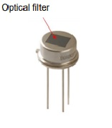

PIR sensor equivalent ckt. (ANALOG Output):

--Three-terminal sensor with source follower

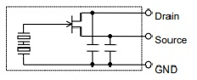 source: Murata

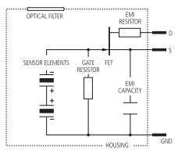

source: Excellitas

**Algorithms for interfacing to Ucontroller:**

1. Source TI

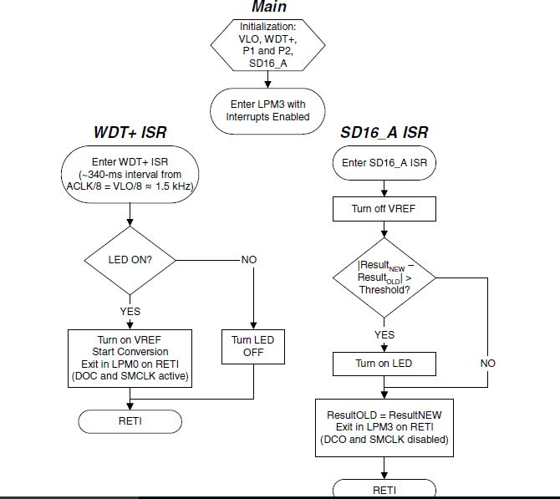

1. Source NXP

