**Introduction:** An interactive graphical user interface (GUI). Applications of the project are given below:

1. Select the learning ( either supervised or unsupervised)
2. Select the particular model
3. Upload the dataset or use available datasets
4. Set the parameters and hyper parameters
5. Train the model
6. Interactively analyze the model by varying parameters

**Features:**

The web application consists of following machine learning models

**Learning Type**

**Unsupervised Learning**

**Supervised learning**

**K means clustering**

**Naïve Bayes**

**Classification**

**Regression**

**Linear Regression**

**KNN**

**Logistic Regression**

**Multilayer Perceptron**

**System Requirements:**

* Python with version higher than 3.0
* Import Libraries: Streamlit, Numpy, Pandas, Seaborn, Matplotlib

**User Manual:**

To run the app: type command “**streamlit run <filename>**” in command prompt

XOR GATE Implementation using Multilayer perceptron model:

**Step 1:** Select following options as it is.

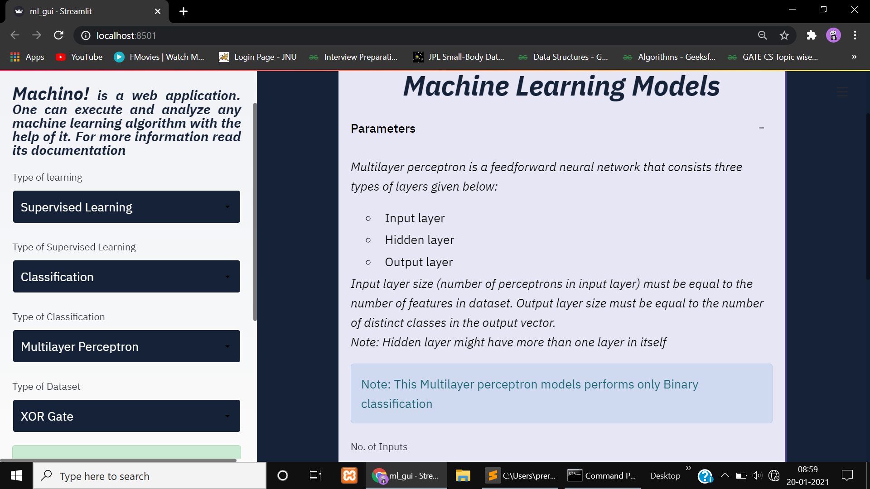

**Step 2:** Set the number of inputs in XOR Gate. Give input for number of hidden layers, and size of respective layers (here is just number of neurons in a particular layer). Choose the activation function for the first n-1 layers (including input layer and hidden layers) and for the output layer.

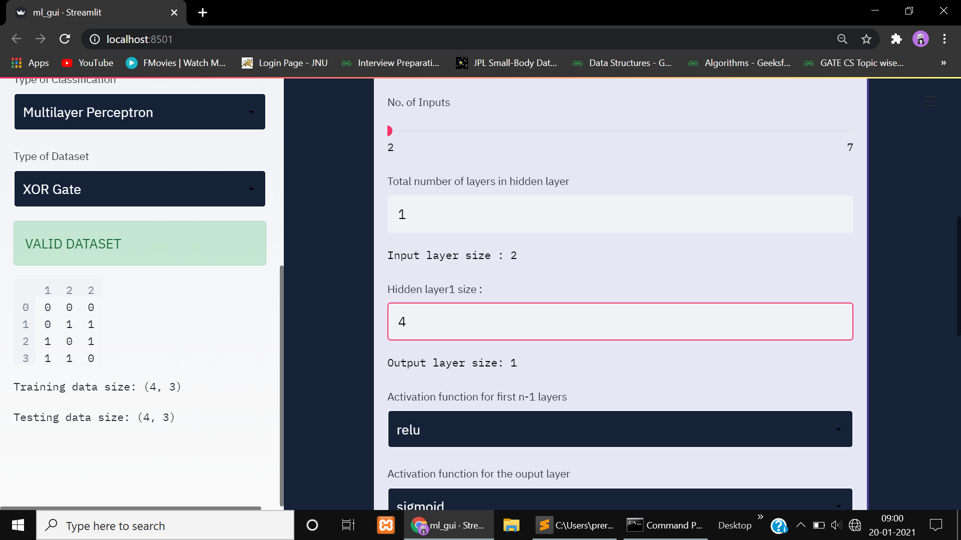

**Step 3:** Press the train button and you are done☺.

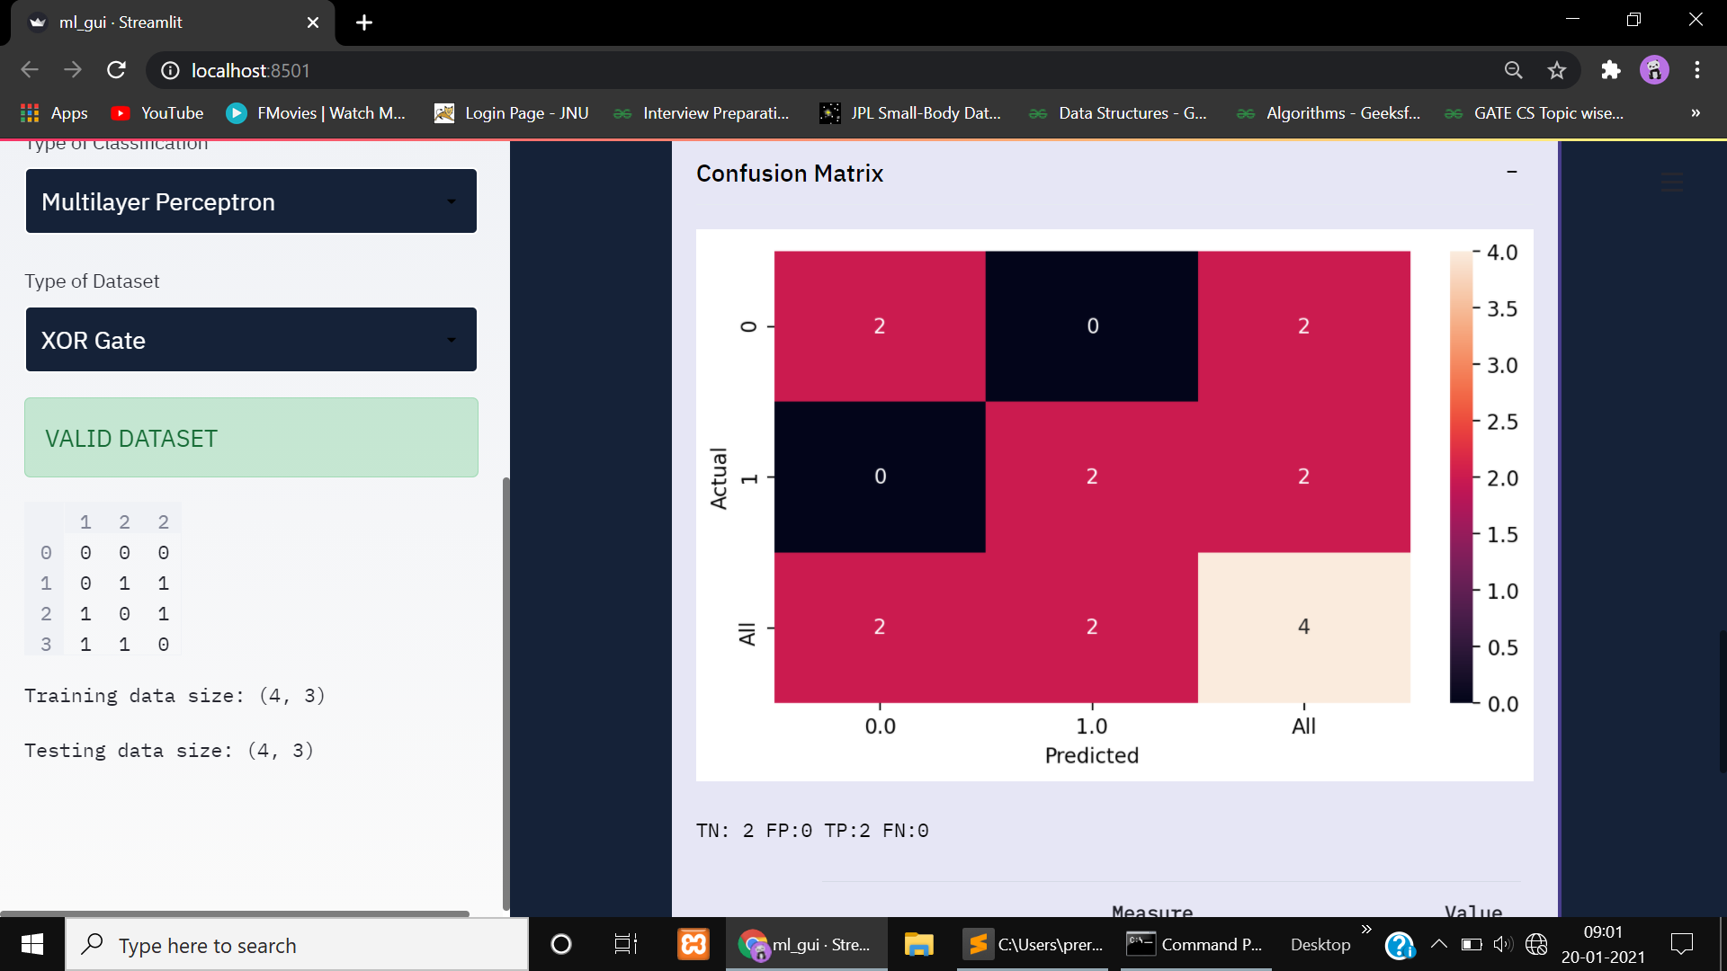

**Step 5:** Cost Reduction Graph

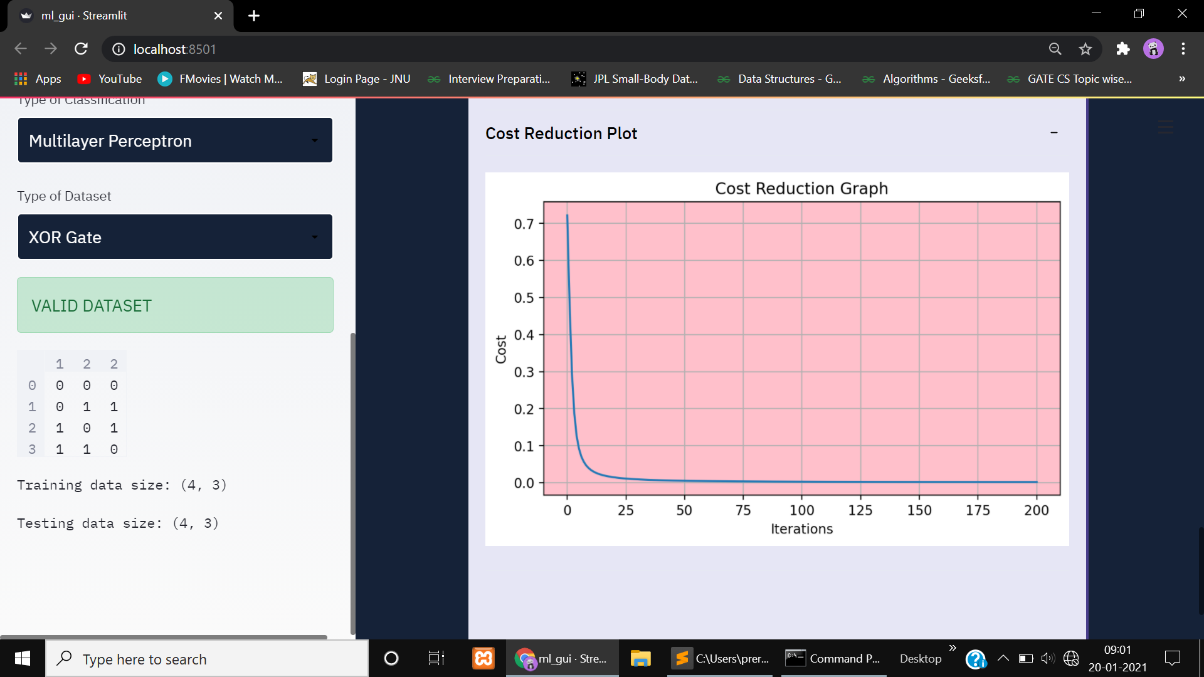

**For other datsets**: Also provide split percentage to split testing data and training data for example 10 or 20 (ranging 1 to 100)

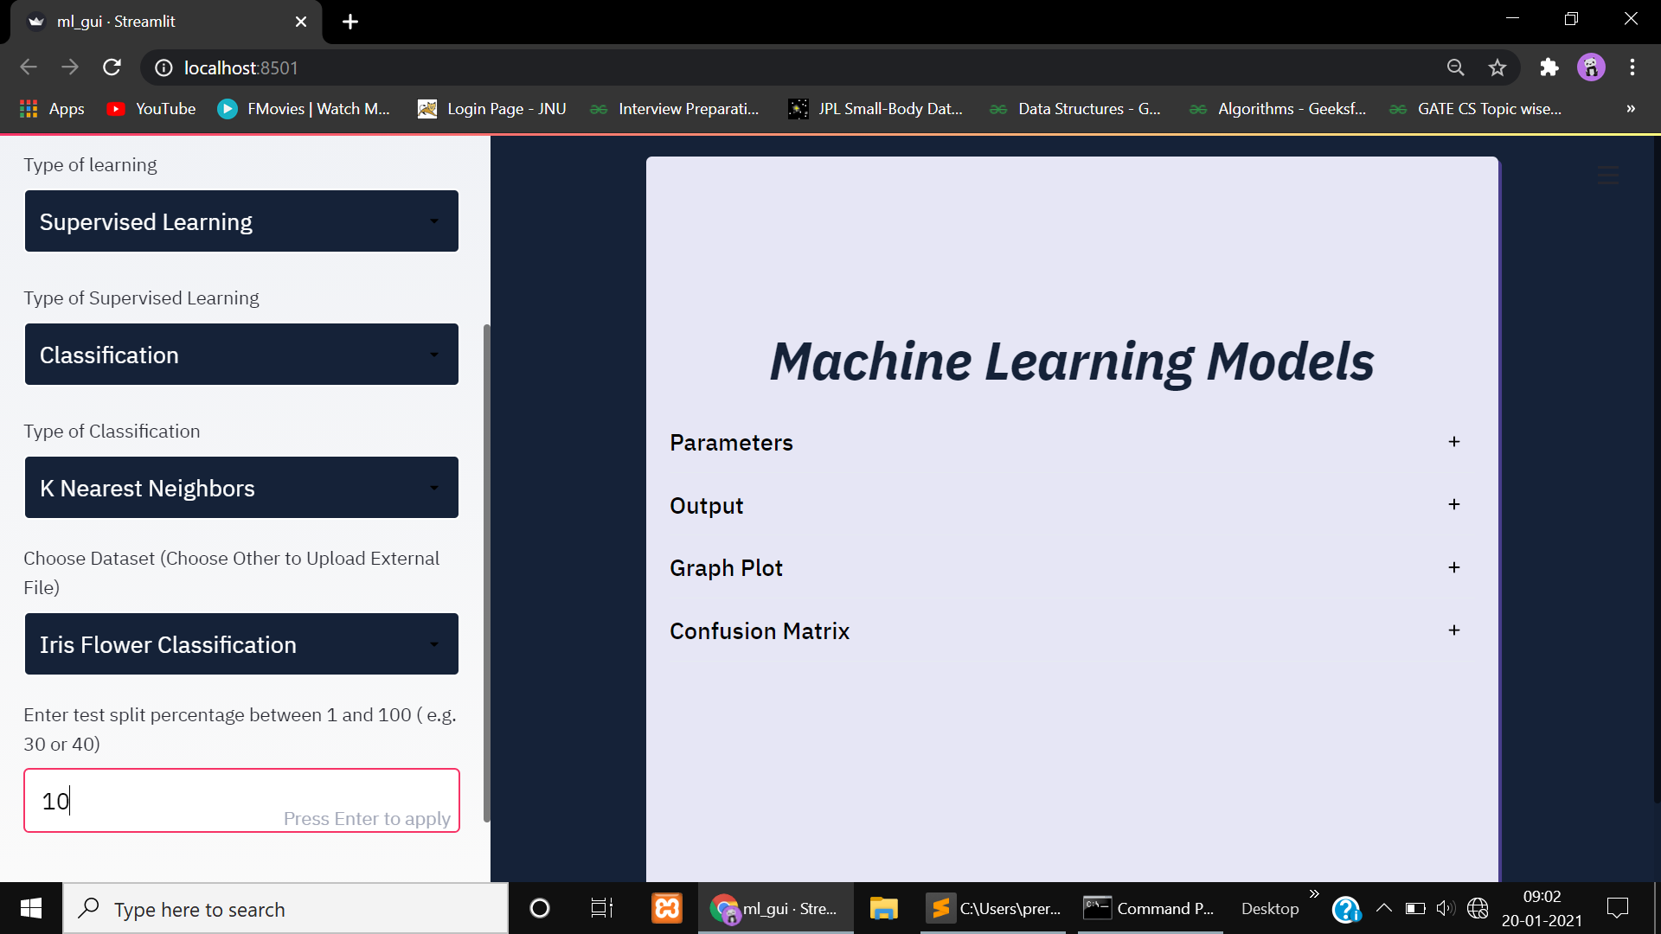

Explore the application to know more.

**=======================THANK YOU=====================**