No.: GA Digital/HR/22 Dt.21/09/2021
Dear Prerna Sharma
We welcome you to GA Digital Web Word (P) Ltd.
We are glad to have you in our team of “CDAC” as “Software Developer ” from 23-09-2021 for AIIMS Project in DDPM Division on purely contractual basis at our esteemed client’s Office of CDAC (Noida).
You hereby agree to abide by the following terms and conditions:
- Fully perform the services, in a professional manner, at the Client’s location until the completion of the term of the work assignment.

- During the term of the work assignment, render services exclusively to the Client and such performance shall not be inconsistent with any obligation you may have to other third parties.

- Not to engage in any conduct which is detrimental to the interest of the Client or GAD.

- Not to receive any payments of any nature directly or indirectly from the Client unless agreed to by GAD.

- Neither directly nor indirectly offers you for employment with the Client or its affiliates during the period of the work assignment without prior permission of GAD.

- Extend all cooperation to the Client’s employees, consultants, representatives, etc, and do all such things as may be necessary and comply with all terms of the Appointment letter so as to effectively undertake the work.

- Report and be present at the designated location during the working hours mentioned herein and abide by the rules and regulations as required by the Client.

- Comply with the safety, health and other rules and regulations of GAD and the GAD Client that you have been made aware of.

- During the course of your contract, you can be transferred to any location within the territory of India as and when required by GAD/Client for executing the services provided herein.

- Your engagement with us and deployment at our esteemed client’s site is governed by our Policies, which include Code of Conduct Policy, Non-Disclosure and Confidentiality Policy, IT Security Policy, Non-Competence & Non-Solicitation Policy, Sexual Harassment Policy, Anti Bribery Policy, Company Stationary, Assets, Phone, Computers & Internet Use Policy & Health Safety Policy. You shall be required to sign all the policies and abide by the same.

- The contract of employment between you and the company may be terminated in the following conditions:-

- By the CDAC without giving any notice period.
- By the employee by giving one month’s advance notice in writing.
- However for any breach of Company's Policy or insubordination or any adverse reporting from our client or on the happening of any of the event enumerated in above Clause, the Company shall be at liberty to terminate the contract of employment without any notice and without any liability.
.
- You agree to defend, indemnify and hold GAD or the Client harmless from any and all claims, damages, liability, attorney fees and expenses on account of your failure to satisfy any of your obligations under this work assignment letter or for misconduct or for violation of any law or creation of any legal liability by you.

- Any dispute between you and GAD shall be referred to a sole arbitrator appointed by GAD. The arbitration shall be conducted in English language, in accordance with the Arbitration and Conciliation Act 1996, at Delhi India. This Engagement Letter shall be governed by the laws of India.

- Salary will be as per the rate fix by client i.e. Rs. 30000 Gross per month. Statutory Obligation if any under the Contract shall be deducted and paid to you.

- The salary payout will be made latest by 07th of the following month.

We at GAD would like to create an environment and culture committed to co­operation, quality and responsiveness that permeates every activity. As a new entrant we would like you to add value to this process. Please return the copy of the Offer Letter enclosed after affixing your signature at the appropriate place on the Office Copy as the token of your having read, agreed, fully understood and accepted the terms and conditions of appointment. Please send across the copy to GAD Delhi/Indirapuram address which is mentioned below. In case we do not receive your acknowledgement copy within a period of 15 days from the date of joining, your assignment at GAD with the acceptance of your first salary from GAD will be conclusive proof of your acceptance in accordance of terms and conditions.
GAD neither accepts any consideration in the form of any cash or kind nor supports any policy of accepting such consideration by any third party for providing employment to prospective candidates. In the event you have paid any such amount to any employee, Officer , representative of GAD kindly bring the same to the immediate notice of your superior or report the same to GAD through email or through the toll free number which is provide to you.
After the acceptance of your appointment letter you will be issued GAD code through which you can download the GAD App on your Mobile and can have access to the facilities like salaryslip and other statutory deductions every month.

ENDORSEMENT
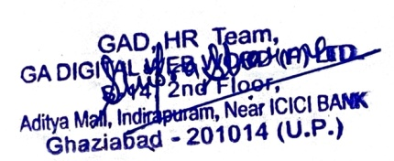
I hereby confirm acceptance of the above assignment, on the terms and conditions stipulated therein.
For GA Digital Web Word Private Limited Accepted and Agreed

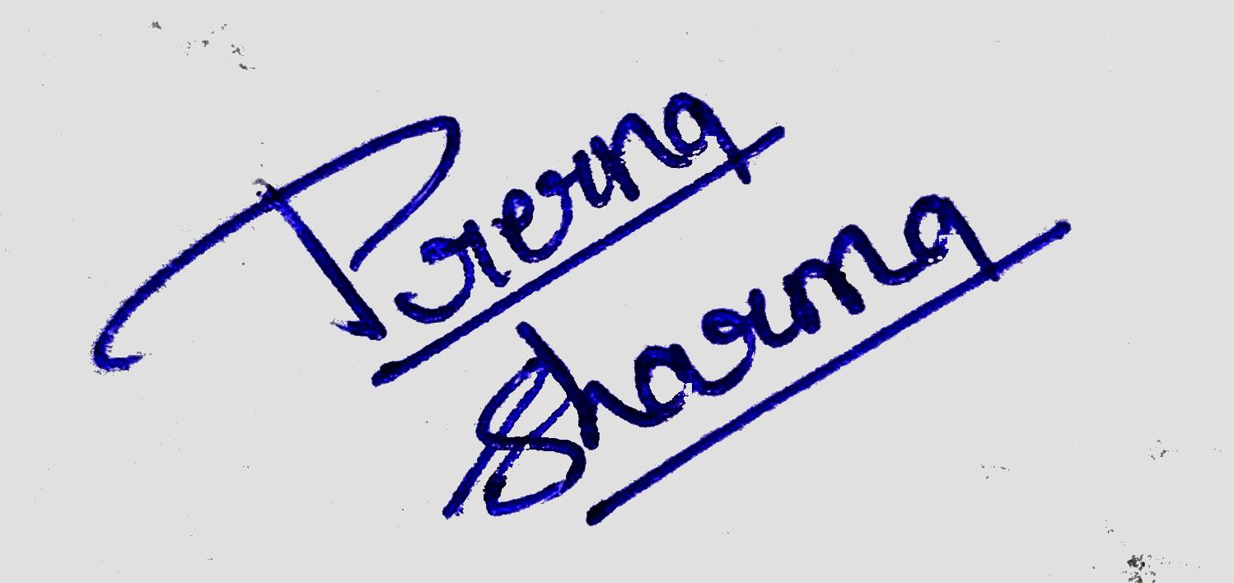
Shipra Sharma Signature and Date: 22-09-2021
(HR Executive) Name Ms . Prerna Sharma

