Bug 1.  
The Page header for analysis report page has incorrect spelling  
  
Steps:

1. Navigate to "https://applications.eu-1.celonis.cloud/ui/login"
2. Enter the login credentials and click on sign in
3. On the left side panel hower on the three dots ( more)
4. Click on more
5. Click on process Analytics
6. Check the Page header of analysis reports.

Actual result:  
Analyses is the page header  
  
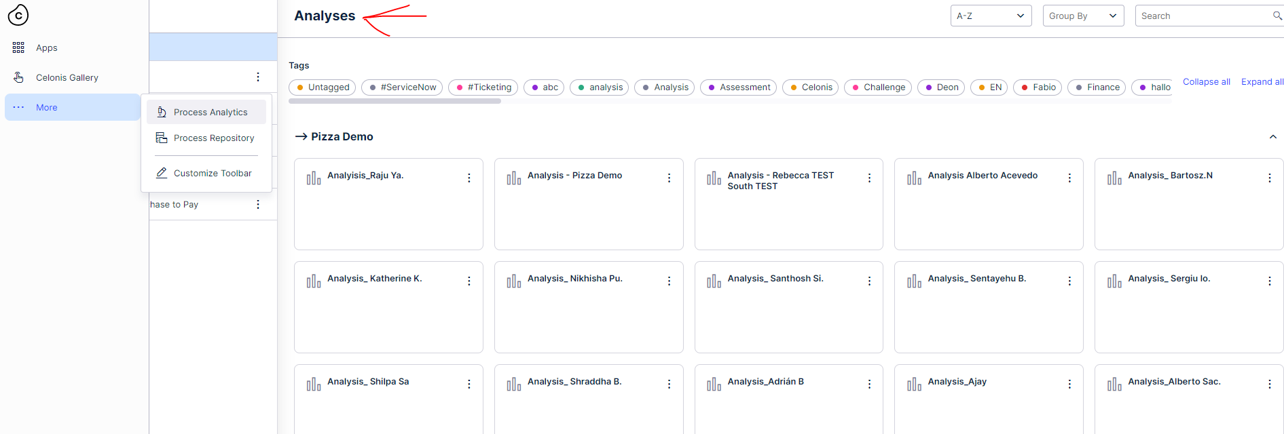

Expected result:  
the page header should be Analysis

Bug 2.  
The Analysis report generated not following the same pattern.  
  
Steps:

1. Navigate to "https://applications.eu-1.celonis.cloud/ui/login"
2. Enter the login credentials and click on sign in
3. On the left side panel hower on the three dots ( more)
4. Click on more
5. Click on process Analytics
6. Click on Pizza demo in workspace.
7. Check analysis section for the report called “Analysis_raju ya.”
8. Notice that the spelling of analysis is incorrect.
9. Check the analysis report “Analysis - Rebecca TEST South TEST”
10. Notice that it does not follow the naming convention.

Actual result:  
The individual analysis report is called “Analysis_Raju Ya.”

Expected result:  
The naming connection of analysis reports should be followed.

Bug 3:

The tags displayed on the analysis page are not updated according to the selected workspace.  
  
Steps:

1. Navigate to "https://applications.eu-1.celonis.cloud/ui/login"
2. Enter the login credentials and click on sign in
3. On the left side panel hower on the three dots ( more)
4. Click on more
5. Click on process Analytics
6. Click on „Pizza Demo“ in workspaces and notice the tags displayed in the tag section
7. Now change the workspace to some other workspace.

Actual result:  
The tags displayed in tag section are not change when we switch workspaces

Expected result:  
The tags selection should be updated according to workspace selection.

Bug 4:

The tags selection does not differentiate between capital letters and small letters..  
  
Steps:

1. Navigate to "https://applications.eu-1.celonis.cloud/ui/login"
2. Enter the login credentials and click on sign in
3. On the left side panel hower on the three dots ( more)
4. Click on more
5. Click on process Analytics
6. Click on the tag called “analysis” notice the analysis report which is shown and the tags that are highlighted.
7. Now deselect the tags by clicking “analysis”
8. Click on “Analysis” tag and notice that both tags are highlighted but a different analysis report is shown.

Actual result:  
The tags “Analysis” and “analysis” both get selected. But they both are actually used in different analysis reports. And only one report is shown.

Expected result:  
The tags selection should because sensitive.  
  
 Bug 5:

The older tags are lost when new tags are applied.  
  
Steps:

1. Navigate to "https://applications.eu-1.celonis.cloud/ui/login"
2. Enter the login credentials and click on sign in
3. On the left side panel hower on the three dots ( more)
4. Click on more
5. Click on process Analytics
6. Click on „Pizza Demo“ in workspaces.
7. On the analysis page select order by tag in the tag section.
8. Click on the three dots shown for the analysis report shown and click on tags.
9. Now add a new tag to the old existing tags. Note: do not remove the old tag

Actual result:  
The old tag is lost and is now replaced with new tag.

Expected result:  
The tags should be updated and a new one should be added along with the old one.

Bug 6:

The tag name “untagged” is not in sync in the tag section and analysis page.  
  
Steps:

1. Navigate to "https://applications.eu-1.celonis.cloud/ui/login"
2. Enter the login credentials and click on sign in
3. On the left side panel hower on the three dots ( more)
4. Click on more
5. Click on process Analytics
6. Click on „Pizza Demo“ in workspaces.
7. Check the tag name called “untagged”.
8. Click on group by drop down and select “tag”
9. Scroll to the last tag grouping in the page
10. Notice the tag name for untagged analysis reports is called “no tagging” and the “untagged” tag is not shown.

Actual result:  
The Untagged tag is not in sync in tag section and analysis page after grouping.

Expected result:  
The tags names should be in sync on both places i.e. tag section and analysis page.

Bug 7:

The Alignment of data model button is incorrect for analysis page.  
  
Steps:

1. Navigate to "https://applications.eu-1.celonis.cloud/ui/login"
2. Enter the login credentials and click on sign in
3. On the left side panel hower on the three dots ( more)
4. Click on more
5. Click on process Analytics
6. Click on „Pizza Demo“ in workspaces.
7. Check the alignment show data model button on the right side of analysis page.

Actual result:  
The show data model button is not centred in the div

Expected result:  
The show data model button should be centred in the div.

Improvement idea:   
The analysis key page has a save button which does not make any sense as no values can be changed there which will need saving. SO we end up having save , close and “X” all three button doing the same job. This redundancy can be reduced and a more simpler UI could be made.