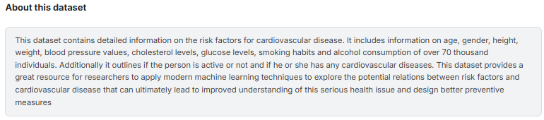

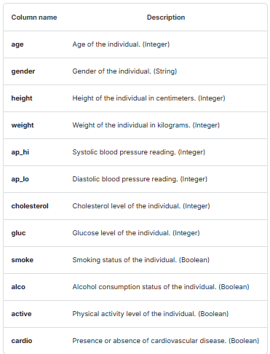

Data source:

<https://www.kaggle.com/datasets/thedevastator/exploring-risk-factors-for-cardiovascular-diseas?resource=download>