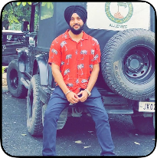

Field Supervision, IT software, Testing, MS office

Ramandeep Singh

Village Chohala Tehsil Rspura Distt Jammu J&K [deeparmanG54@gmail.com](mailto:deeparmanG54@gmail.com) | +U18803553237

Professional Experience

Harjas Enterprises Field Supervisor

Worked as field supervisor by efficiently supervison of the field work

* line transmission
* Tower maintenance
* Survey

11/17 - 01/20

Fusion Tech Partners Junior Software Developer

Java, Testing

* Backend developer
* Frontend developer
* Automation testing

04/20 - 04/21

Education

Jammu University BE(ECE)

Key Skills

* MS Tools
* Project Supervision
* Automation Testing
* API testing

Projects

Crityk

* Online Food delivery app

04/20 - 04/21

Tower Transmission

* Electice tower including boady parts, cross arms and cage

11/17 - 01/20

Interests

* Cricket
* Gyming
* Riding