1. **Design a Calculator**

**Program:**

import java.util.Scanner;

public class Main{

public static void main(String[] args) {

double num1;

double num2;

double ans;

char op;

Scanner reader = new Scanner(System.in);

System.out.print("Enter two numbers: ");

num1 = reader.nextDouble();

num2 = reader.nextDouble();

System.out.print("\nEnter an operator (+, -, *, /): ");

op = reader.next().charAt(0);

switch(op) {

case '+': ans = num1 + num2;

break;

case '-': ans = num1 - num2;

break;

case '*': ans = num1 * num2;

break;

case '/': ans = num1 / num2;

break;

default: System.out.printf("Error! Enter correct operator");

return;

}

System.out.print("\nThe result is given as follows:\n");

System.out.printf(num1 + " " + op + " " + num2 + " = " + ans);

}

}

**Output:**

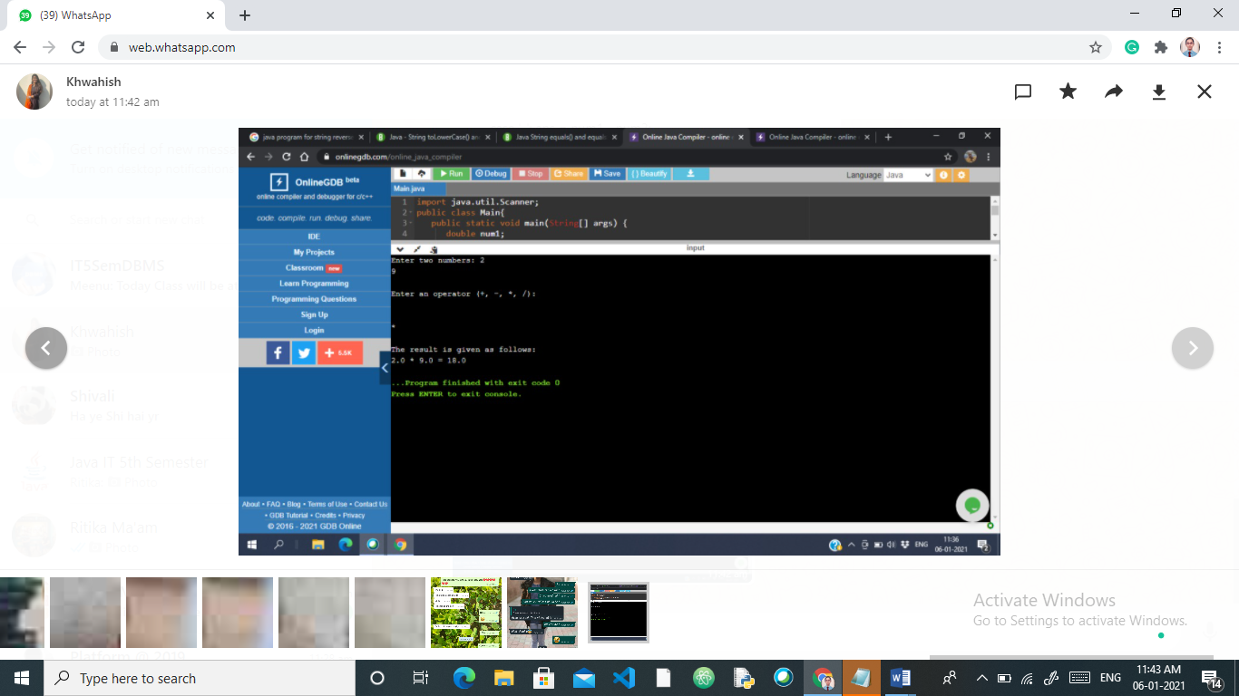

1. **Abstract classes and methods:**

**Program :**

abstract class Animal {

abstract void breed();

}

class Dog extends Animal {

public void breed() {

System.out.println("GOLDEN RETRIEVER");

}

}

class Cat extends Animal {

public void breed() {

System.out.println("Persian Cat");

}

}

class abstractclass{

public static void main(String[] args) {

Dog d1 = new Dog();

d1.breed();

Cat c1 = new Cat();

c1.breed();

}

}

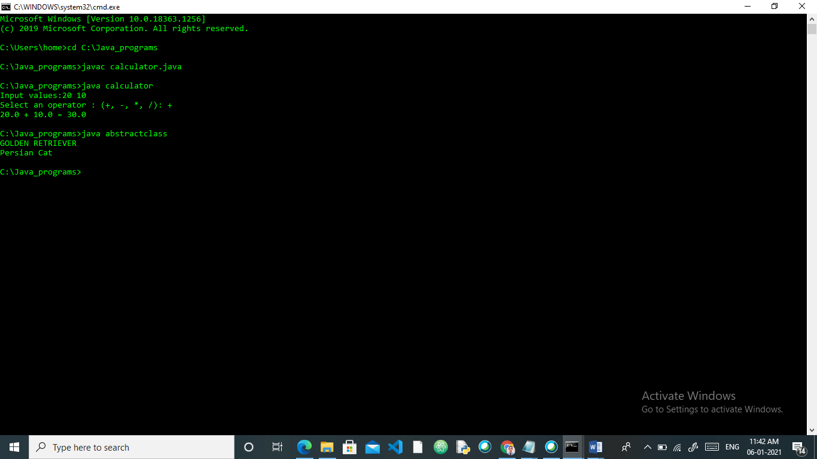

1. **Reverse Strings**

**Program :**

public class Main{

public static void main(String args[]){

String str1= new String("Hello");

String str2= new String("Hi");

String str3= new String("Hello");

System.out.println("str1 equals to str2:"+str1.equals(str2));

System.out.println(str1.toLowerCase());

System.out.println(str2.toUpperCase());

}

}

**Output:**

