1. **Design a Calculator.**

**Program:**

import java.util.Scanner;

public class calculator{

public static void main(String[] args) {

Scanner reader = new Scanner(System.in);

System.out.print("Input values:");

double first = reader.nextDouble();

double second = reader.nextDouble();

System.out.print("Select an operator : (+, -, *, /): ");

char operator = reader.next().charAt(0);

double result;

switch (operator) {

case '+':

result = first + second;

break;

case '-':

result = first - second;

break;

case '*':

result = first * second;

break;

case '/':

result = first / second;

break;

default:

System.out.printf("Error! operator is not correct");

return;

}

System.out.println(first + " " + operator + " " + second + " = " + result);

}}

**Output:**

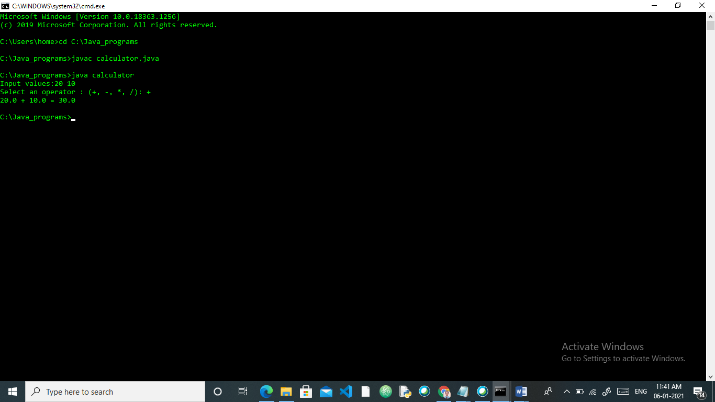

1. **Abstract classes and methods:**

**Program:**

abstract class Animal {

abstract void breed();

}

class Dog extends Animal {

public void breed() {

System.out.println("GOLDEN RETRIEVER");

}

}

class Cat extends Animal {

public void breed() {

System.out.println("Persian Cat");

}

}

class abstractclass{

public static void main(String[] args) {

Dog d1 = new Dog();

d1.breed();

Cat c1 = new Cat();

c1.breed();

}

}

**Output:**

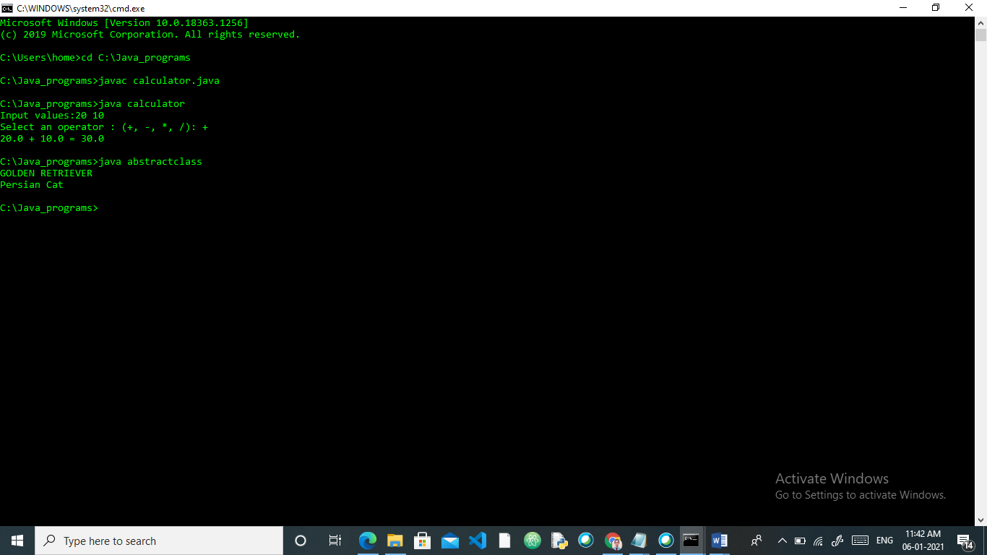

1. **Reverse String**

**Program:**  
public class Main{

public static void main(String args[]){

String str1= new String("Hello");

String str2= new String("Hi");

String str3= new String("Hello");

System.out.println("str1 equals to str2:"+str1.equals(str2));

System.out.println(str1.toLowerCase());

System.out.println(str2.toUpperCase());

}

}

**Output:**

