Name: Vidya Sharma

Roll no.: SG18821

Subject: Java Programming

1. Write a program to print “Hello World”

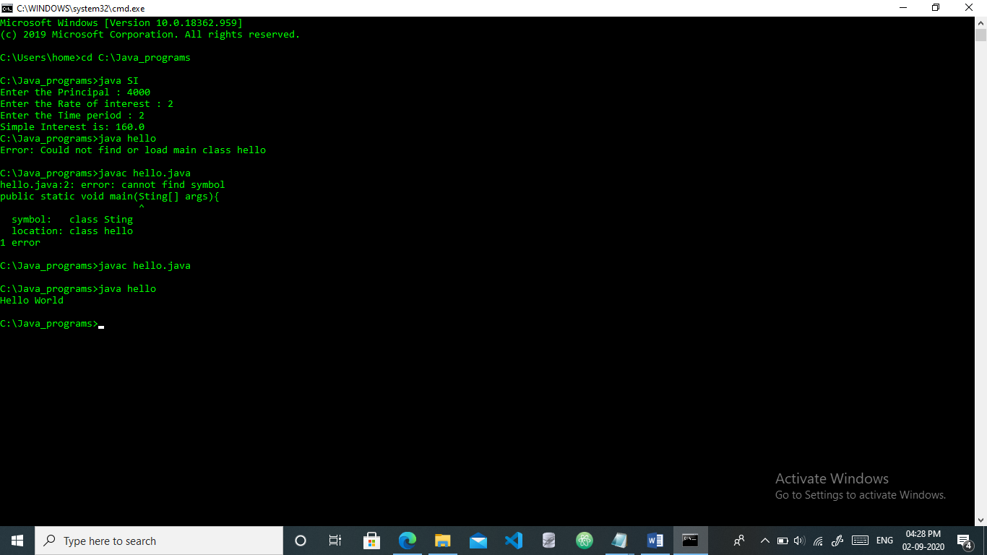

1. Write a program to add two integer numbers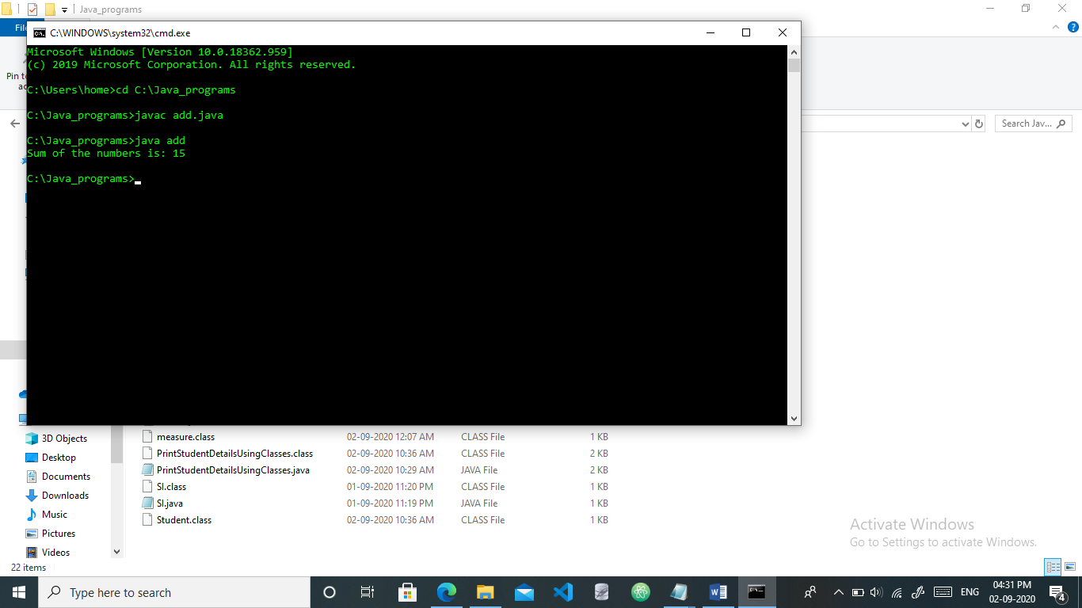
2. Write a program to obtain the product of two float numbers

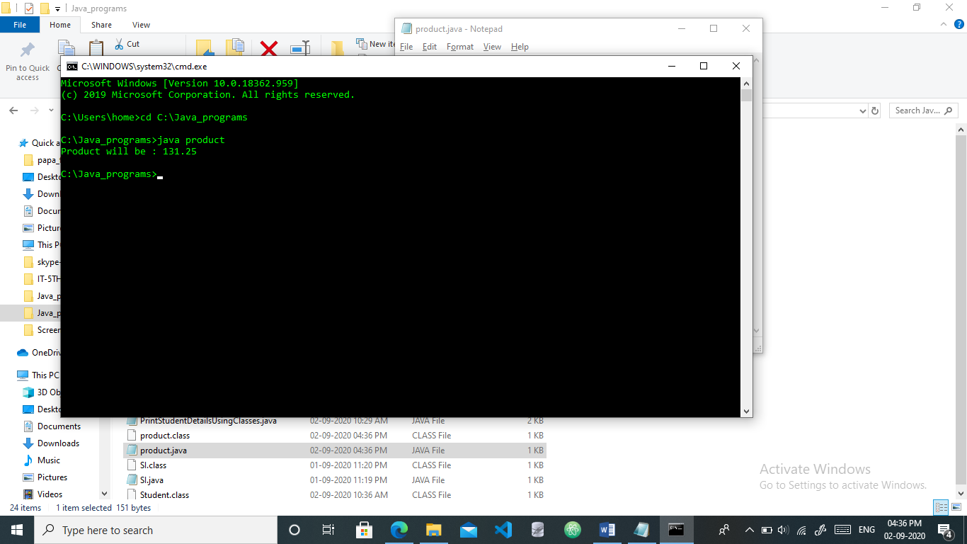

1. Write a Program to design a class using abstract methods and classes.

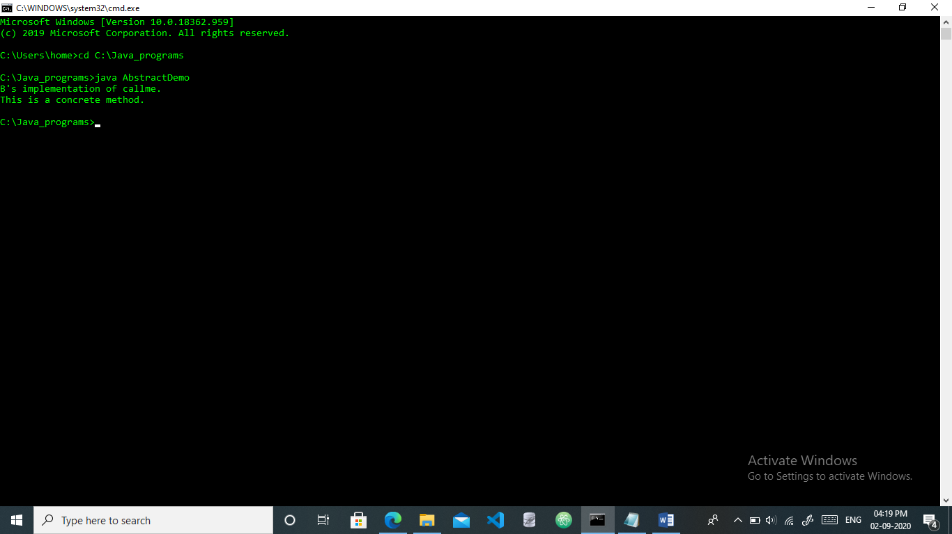

1. Write a program to calculate simple interest and taking input from the user

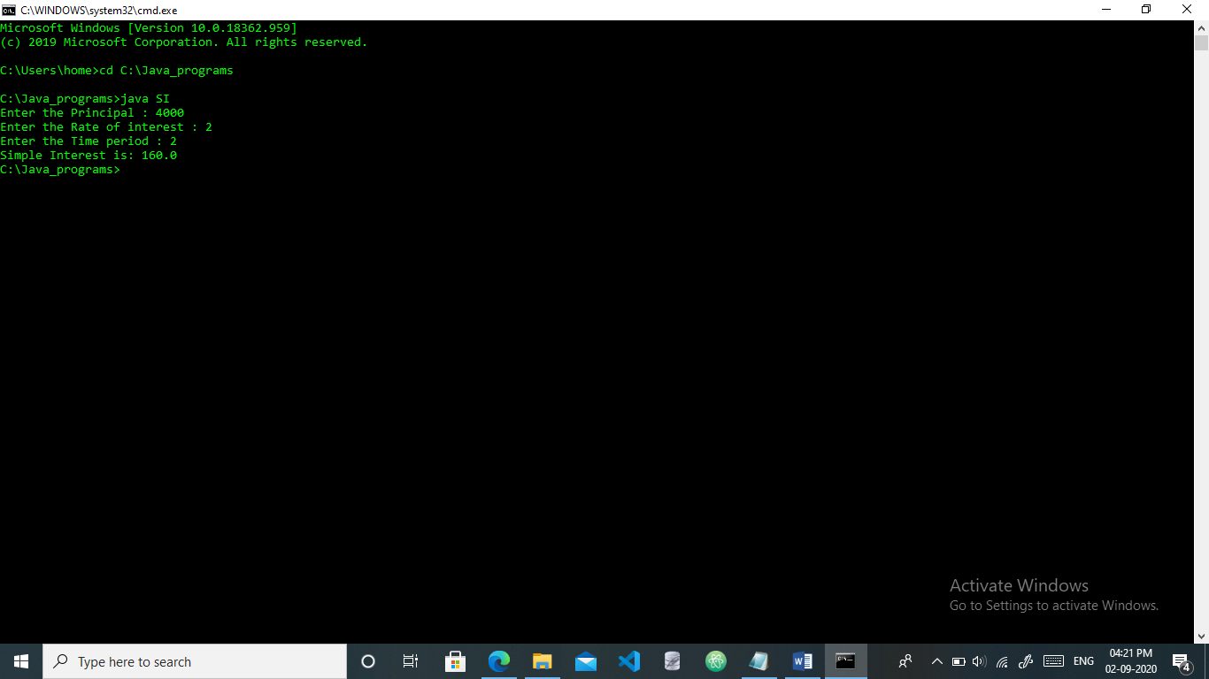

1. Write a program to calculate area and perimeter of rectangle and box using super and this keyword

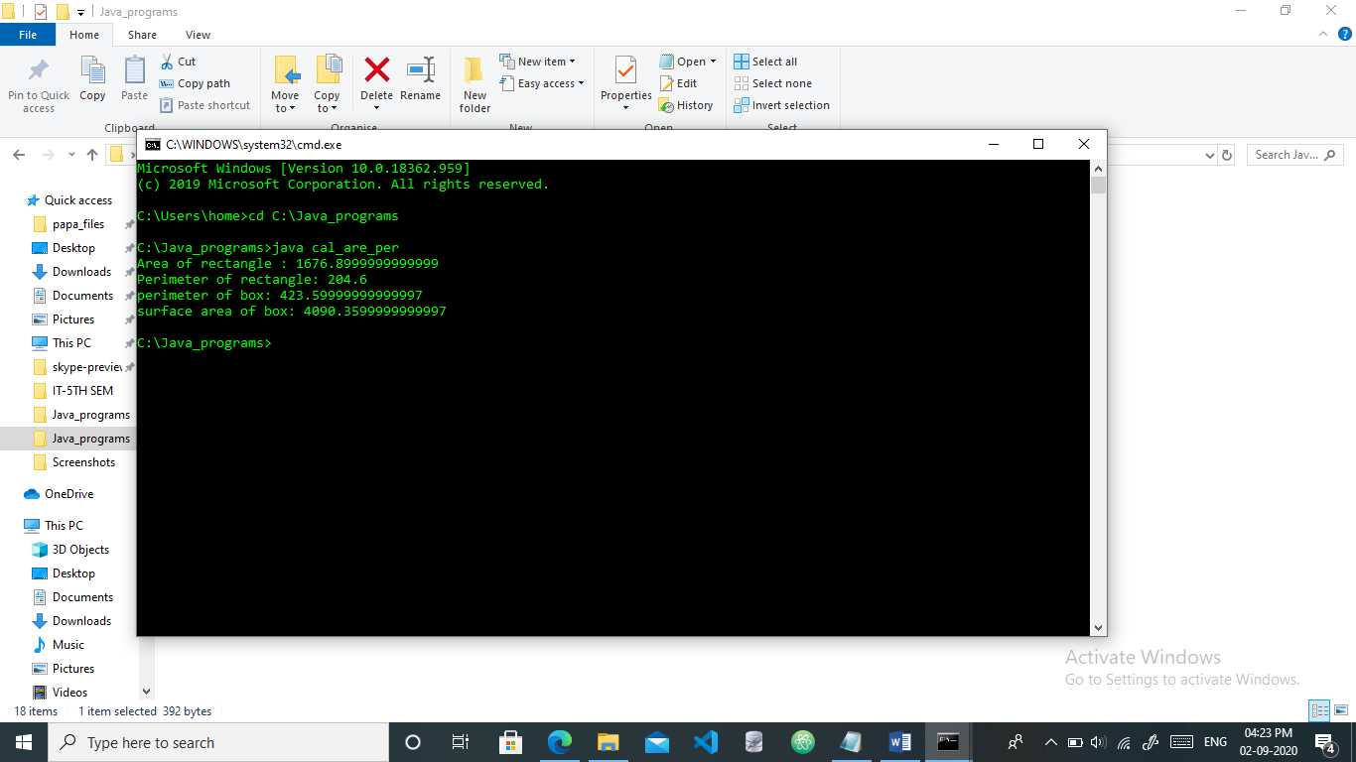

1. Write a program to display the details of student using classes and objects

