**Q1: What does the dollar($) sign do?**

Ans: The dollar sign fixes the reference of given cell so that it remain unchanged which is called as absolute cell referencing.

**Q2: How to Change the Reference from Relative to Absolute (or Mixed)?**

Ans: We can change relative to absolute reference by $ sign assign .In case of mixed referencing , either the column is made constant or the row is made constant .Example :

$F1 : column F is constant ; F$2 : row 1 is constant

**Q3: Explain the order of operations in excel?**

Ans: Excel’s order of operations follows BODMAS (bracket , order , division , Multiplication ,addition and subtraction).

**Q4: What, according to you, are the top 5 functions in excel and write a basic syntax**

**for any of two?**

Ans: Ctrl+N

**Q5: What are the things that we can notice after opening the Excel interface?**

Ans: Ribbon, formula bar, name box, worksheet window, sheet tabs, cells.

**Q6: When to use a relative cell reference in excel?**

Ans:

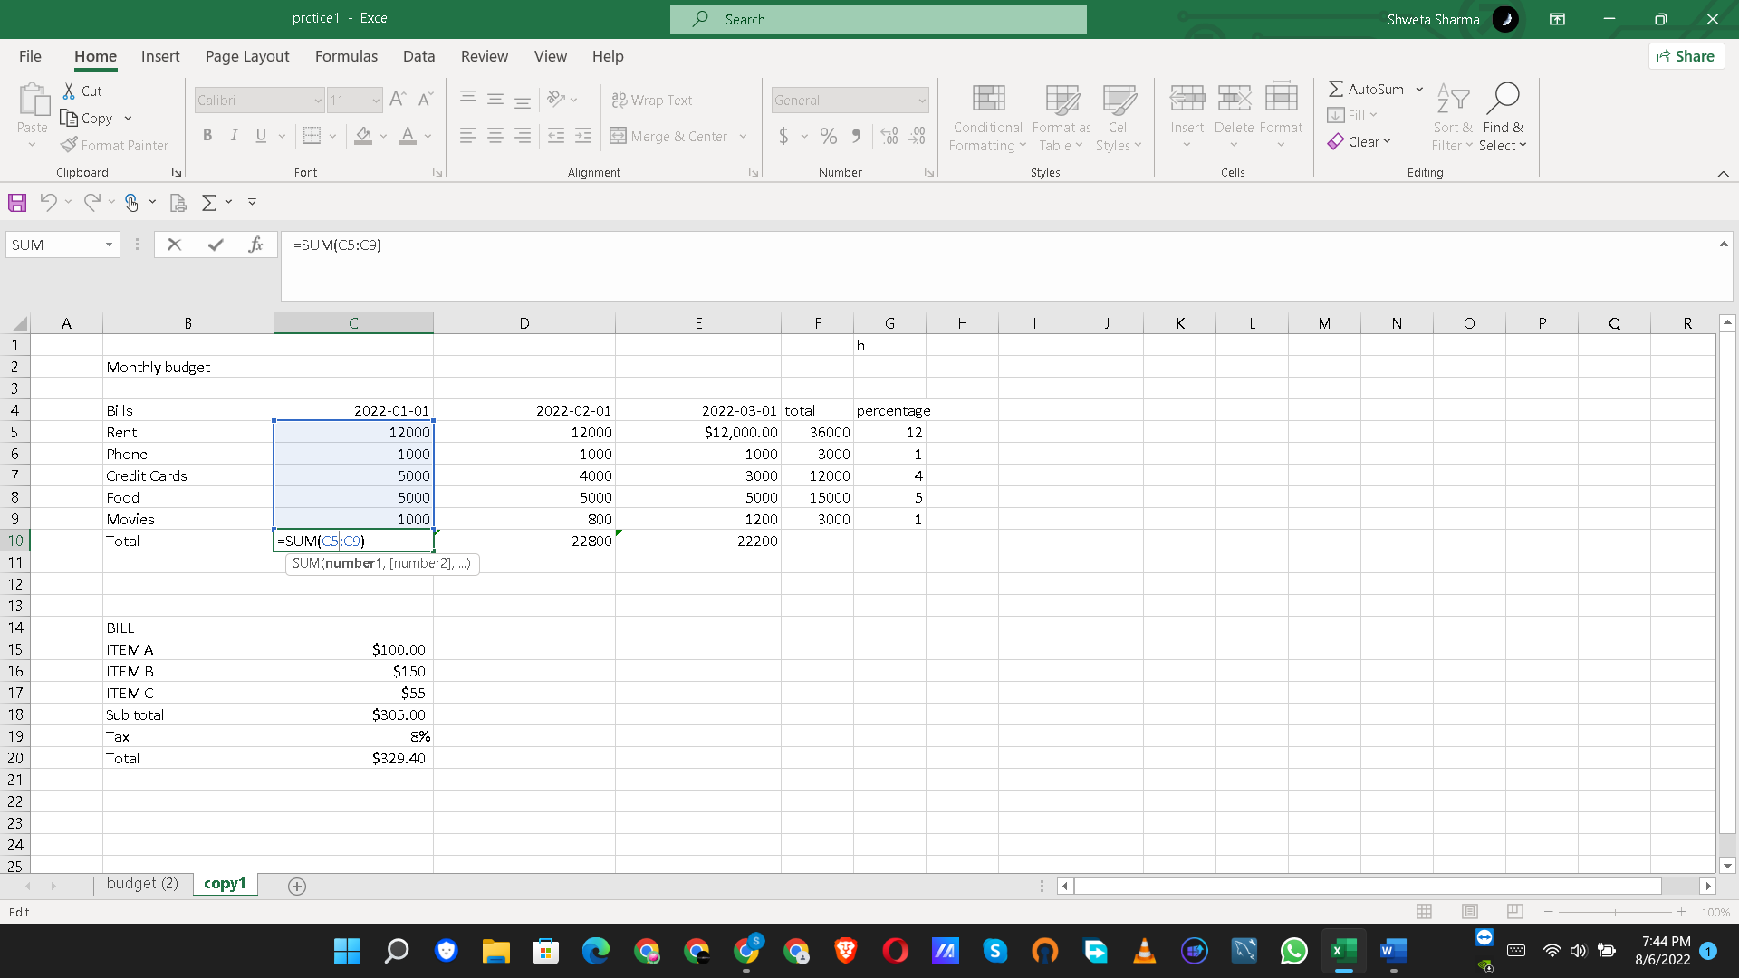

We use relative cell reference whenever we need to repeat the same calculation across multiple rows or columns.