Create amazon linux server with open 8080 port and 22 port

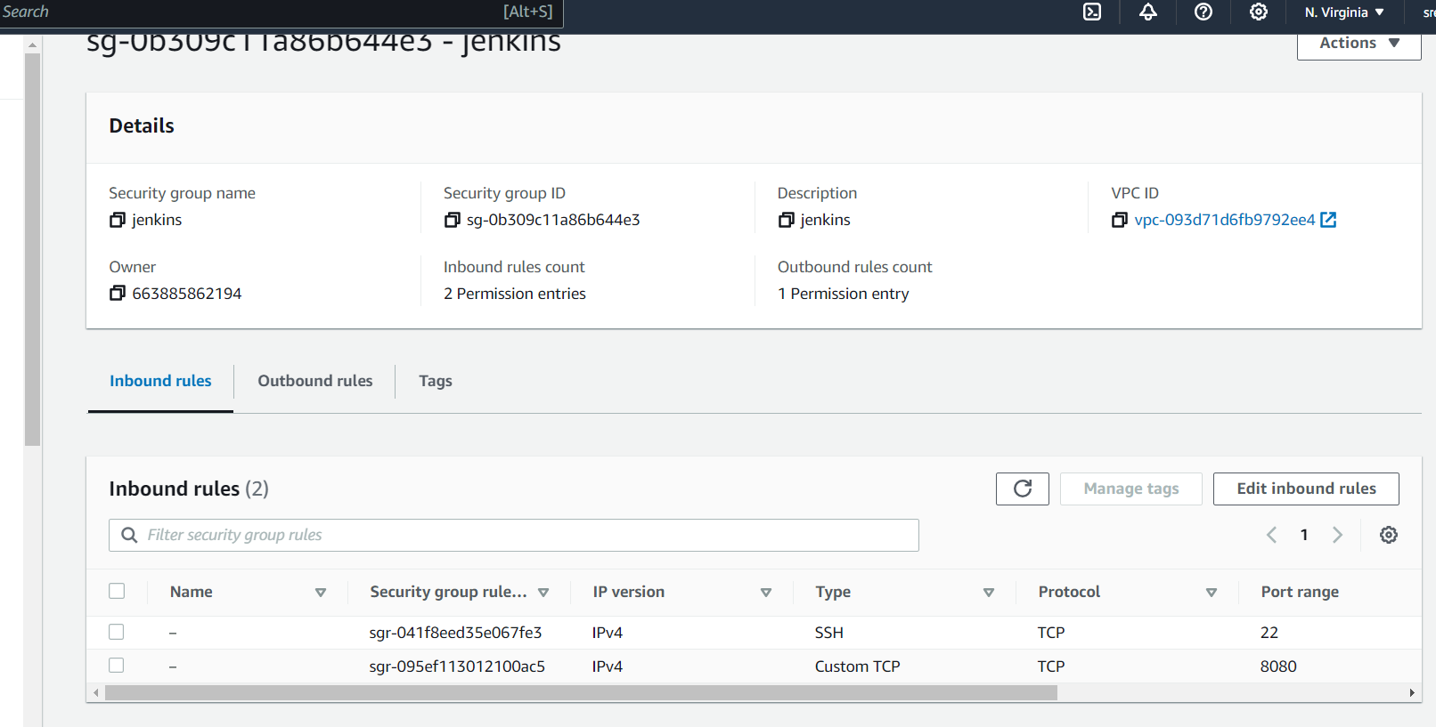

ssh into jenkins server

ssh -i c:/jenkins.pem [ec2-user@44.212.43.104](mailto:ec2-user@44.212.43.104)

sudo su –

#installing jenkins

sudo wget -O /etc/yum.repos.d/jenkins.repo https://pkg.jenkins.io/redhat-stable/jenkins.repo

sudo rpm --import <https://pkg.jenkins.io/redhat-stable/jenkins.io-2023.key>

sudo amazon-linux-extras install epel

amazon-linux-extras install java-openjdk11

#yum install fontconfig java-11-openjdk

yum install jenkins

service jenkins start

server-public-ip:8080

44.212.43.104:8080

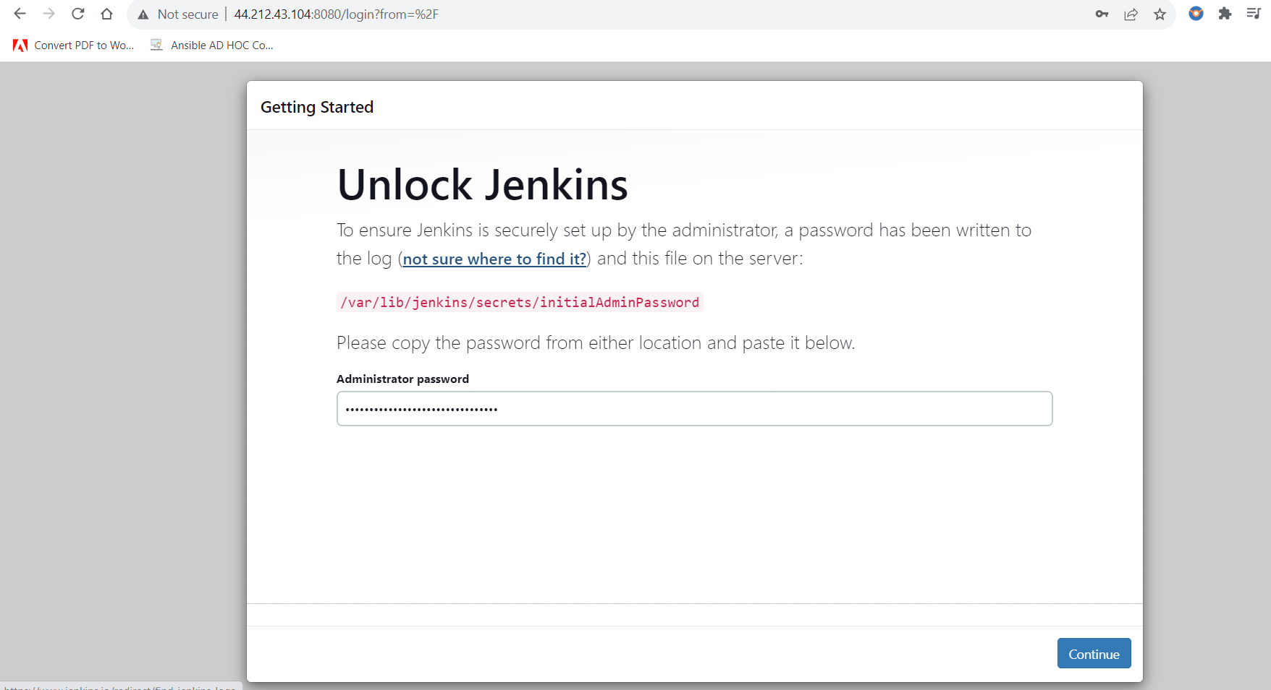

#create jenkins slave server with security group 22 port only for jenkins master security group redirected

in master server add pem key

vi jenkins.pem

chmod 400 jenkins.pem

ssh into slave server from master server

ssh -i "jenkins.pem" [ec2-user@ec2-54-172-195-24.compute-1.amazonaws.com](mailto:ec2-user@ec2-54-172-195-24.compute-1.amazonaws.com)

sudo yum update -y

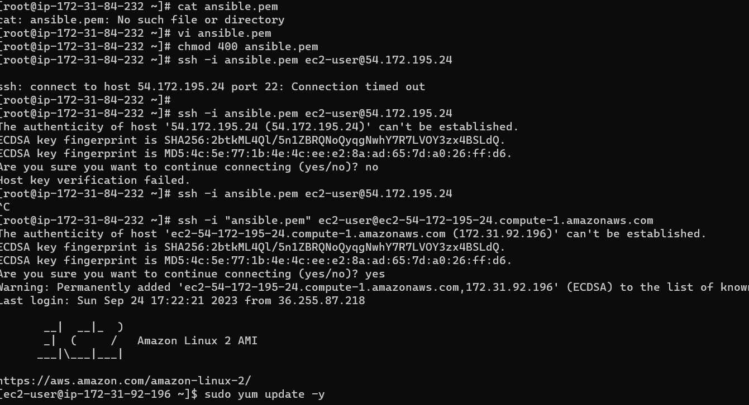

sudo amazon-linux-extras install epel

sudo amazon-linux-extras install java-openjdk11

sudo yum install jenkins

#integrating it with git