Implementation and Analysis of various Page Ranking Algorithms

Sakshi Hooda#
sakshi.hooda@gmail.com
Ankur Goel#
ankurgoel@acm.org
Nitish Sharma#
sharma1nitish@gmail.com

Pratik Gupta#
pratikgupta1992@gmail.com
Akansha Agarwal#
akansha.agg12@gmail.com

#Department of Computer Science and Engineering
Maharaja Surajmal Institute of Technology
Delhi, India

Abstract— In this article, we work with different algorithms and techniques for better estimations of page ranking. Rank of a web page plays the most crucial role in retrieval of information as it assigns a priority to it. This priority may be defined differently on the basis of numerous factors which different Page Ranking algorithms take into consideration. Thus different ranking algorithms return different results. This paper analyzes various Page Ranking algorithms : Google's PageRank, Frequency Ranking, Location Ranking, Distance Ranking and Merged Ranking. We compare these algorithms by building a complete search engine consisting of crawling, indexing, ranking and querying components and analyzing the results of each algorithm against the other.
Keywords— pagerank, rank, pages, crawler, spider, index, parser, stemming
I. Introduction
Tim Berners-Lee, a British scientist at CERN, invented the World Wide Web (WWW) in 1989. The web was originally conceived and developed to meet the demand for automatic information-sharing between scientists in universities and institutes around the world.
Since its birth the World Wide Web has become the foremost and most popular way of communication and information dissemination. It serves as a platform for exchanging various kinds of information, ranging from research papers, and educational content, to multimedia content, software and personal logs. Every day, the web grows by roughly a million electronic pages, adding to the hundreds of millions pages already on-line. So with the rapidgrowth of information sources available on the World Wide Web, it has become increasingly necessary for users to use automated tools to find the desired information resources, and to track and analyze their usage patterns. These factors give rise to the requisite of creating server side and client side intelligent systems that can effectively mine for knowledge. Web mining can be broadly defined as the extraction and mining of useful information from the World Wide Web.
Thus the Internet is an infinite source of information which includes massive collection of web pages and countless hyperlinks. These hyperlinks contain a huge amount of concealed human explanation that can be extremely valuable for automatically inferring concept of authority. Thus the structure of a typical Web graph (Fig. 1.) consists of web pages as nodes, and hyperlinks as edges connecting two related pages.

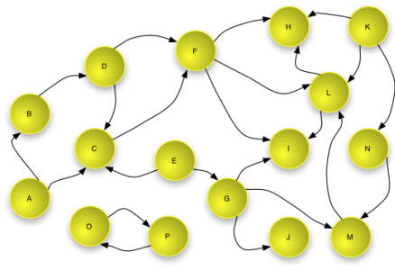

Fig. 1. The Web Graph

The rest of this paper is organized as follows: Section II introduces components of a Search Engine; Section III describes Google's Page Rank Algorithm; Section IV describes Frequency, Location and Distance Ranking Algorithm; Section V discusses the detailed overview of Analysis and Experimental Results. Section VI summarizes the Conclusion and prospect. Finally references are given.
II. SEARCH ENGINE
Search engine is the popular term for an information retrieval (IR) system. While researchers and developers take a broader view of IR systems, consumers think of them more in terms of what they want the systems to do — namely search the Web, or an intranet, or a database. Actually consumers would really prefer a finding engine, rather than a search engine.
Search engines match queries against an index that they create. The index consists of the words in each document, plus pointers to their locations within the documents. This is called an inverted file. Our search engine or IR system comprises four essential components:

- Crawler : A crawler is a program that visits Web sites and reads their pages and other information in order to create entries for a search engine index. The major search engines on the Web all have such a program, which is also known as a "spider" or a "bot". Crawlers are typically programmed to visit sites that have been submitted by their owners as new orupdated.
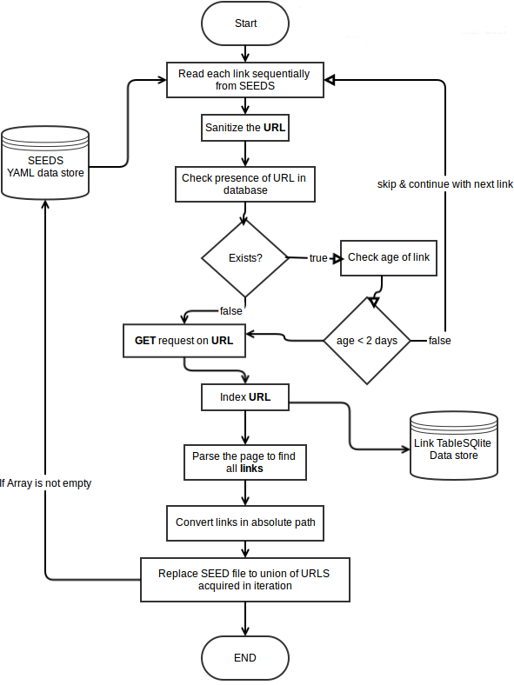
Fig. 2. Crawling mechanism
Entire sites or specific pages can be selectively visited and indexed. Crawlers apparently gained the name because they crawl through a site a page at a time, following the links to other pages on the site until all pages have been read.The crawler adheres to the rules of politeness for Web crawlers that are specified in the Standard for Robot Exclusion (SRE). It asks each server which files should be excluded from being indexed. It does not (or can not) go through firewalls. And it uses a special algorithm for waiting between successive server requests so that it doesn't affect response time for other users.
- Indexer : The index or inverted file is the internal data structure that stores the index information and that will be searched for each query. Indexing of links and words consists of execution of a lot of steps involving normalization of the document, deletion of stop words and stemming of words before they can be indexed. While essential and potentially important in affecting the outcome of a search, normalization simply standardizes the multiple formats encountered when deriving documents from various providers or handling various web sites and serves to merge all the data into a single consistent data structure that all the downstream processes can handle. The need for a well-formed, consistent format is of relative importance in direct proportion to the sophistication of later steps of document processing. The pointers stored in the inverted file will enable a system to retrieve various sized units — either site, page, document, section, paragraph, or sentence. A stop word list typically consists of those word classes known to convey little substantive meaning, such as articles (a, the), conjunctions (and, but), interjections (oh, but), prepositions (in, over), pronouns (he, it), and forms of the "to be" verb (is, are). To delete stop words, an algorithm compares index term candidates in the documents against a stop word list and eliminates certain terms from inclusion in the index for searching. Stemming removes word suffixes, perhaps recursively in layer after layer of processing. The process has two goals. In terms of efficiency, stemming reduces the number of unique words in the index, which in turn reduces the storage space required for the index and speeds up the search process. In terms of effectiveness, stemming improves recall by reducing all forms of the word to a base or stemmed form. For example, if a user asks for analyze, they may also want documents which contain analysis, analyzing, analyzer, analyzes, and analyzed. Therefore, the document processor stems document terms to analy- so that documents which include various forms of analy- will have equal likelihood of being retrieved; this would not occur if the engine only indexed variant forms separately and required the user to enter all. After completing all these steps the remaining entries are extracted from the original document, which is now standardized, and then inserted and stored in an inverted file that lists the index entries and an indication of their position and frequency of occurrence.
- Ranking Algorithm : We rank the webpages to assign them a attribute of importance, a certain priority over other web pages on the basis of various factors. Nowadays searching on the internet is most widely used operation on the World Wide Web. The amount of information is increasing day by day rapidly that creates the challenge for information retrieval. There are so many tools to perform efficient searching. Due to the size of web and requirements of users creates the challenge for search engine page ranking. Ranking is the main part of any information retrieval system Today’s search engines may return million of pages for a certain query It is not possible for a user to preview all the returned results So, page ranking is helpful in web searching. Rankers are classified into two groups: Content-based rankers and Connectivity-based rankers. Content-based rankers works on the basis of number of frequency of terms, location of terms, and distance between terms. Connectivity-based rankers work on the basis of link analysis technique, links are edges that point to different web pages such as Google's PageRank.
- Querying Component : Query processing has numerous possible steps, though a system can cut these steps short and proceed to match the query to the inverted file at any of a number of places during the processing. Document processing during indexing shares many steps with query processing. More steps and more documents make the process more expensive for processing in terms of computational resources and responsiveness. However, the longer the wait for results, the higher the quality of results. Thus, search we must choose what is most important to the users — time or quality. As soon as a user inputs a query, our search engine tokenizes the query stream, i.e., breaks it down into understandable segments. Usually a token is defined as an alpha-numeric string that occurs between white space and/or punctuation. We go further and stop-list and stem the query, similar to the processes described above in the indexing section. The stop list contains commonly used words from commonly occurring querying phrases. The the final normalized query is used for retrieval of the results: Having determined which subset of documents or pages matches the query requirements to some degree, a similarity score is computed between the query and each document/page based on the scoring algorithm used by the system. Scoring algorithms rankings are based on the presence/absence of query term(s), term frequency, term location, distance between terms, on relations among documents. After computing the similarity of each document in the subset of documents, the system presents an ordered list to the user. The sophistication of the ordering of the documents again depends on the model the system uses, as well as the richness of the document and query weighting mechanisms. For example, search engines that only require the presence of any alpha-numeric string from the query occurring anywhere, in any order, in a document would produce a very different ranking than one by a search engine that performed linguistically correct phrasing for both document and query representation. However our search engine determines rank, the ranked results list goes to the user, who can then simply click and follow the system's internal pointers to the selected document/page.

Shown in the figure given below is the model used in our search engine. Using this model the processes of indexing, document processing and querying are executed efficiently.

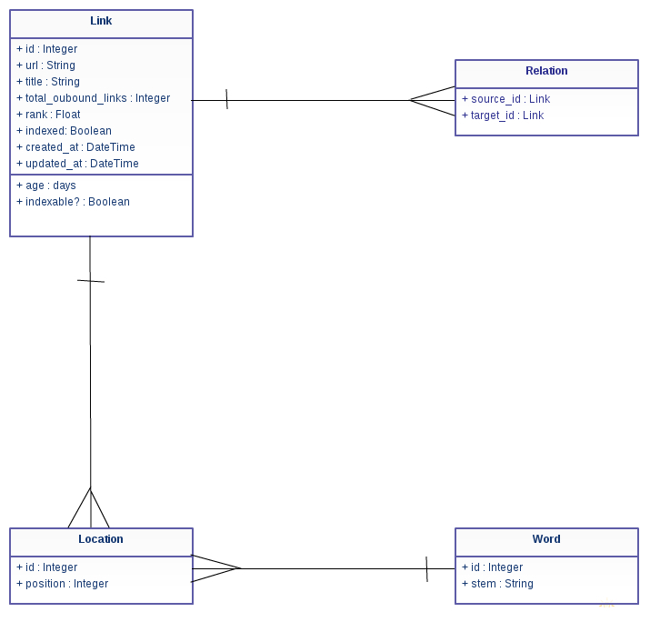

Fig. 3. Search Engine Model

III. FREQUENCY, LOCATION AND DISTANCE RANKING ALGORITHMS
Content-based page ranking algorithms work on the policy of assign priority to a web page on the basis of the text content contained in it i.e. the query processor retrieves web pages on the basis of the the text (words, phrases, numbers, alpha-numerics, etc) present in the query input by the user, by matching this query content with the textual content contained in the web page
We implemented 3 kinds of content-based algorithms:

- Frequency Ranking Algorithm : This algorithm focuses on the number of times the query terms appear on a web page. The page that has more of the search words is given priority thus assigned a higher rank.
This is implemented as a method in the querying component which gets converted into a MySQL query like this :
SELECT loc0.link_id, count(loc0.link_id) as count FROM locations loc0, locations loc1
WHERE loc0.link_id = loc1.link_id AND
loc0.word_id = 1296
AND
loc1.word_id = 8839
GROUP BY loc0.link_id ORDER BY count DESC

- Location Ranking Algorithm : This algorithm focuses on the positioning of the query terms and their location as they appear on a web page. If a page has the query terms closer to the top of the page then it will be given priority thus assigned a higher rank.
This is implemented as a method in the querying component which gets converted into a MySQL query like this :
SELECT loc0.link_id, (loc0.position + 1 + loc1.position + 1) as total FROM locations loc0, locations loc1
WHERE loc0.link_id = loc1.link_id AND
loc0.word_id = 1296
AND
loc1.word_id = 8839
GROUP BY loc0.link_id ORDER BY total ASC

- Distance Ranking Algorithm : This algorithm focuses on the spacing or the distance between the query terms as they appear on a web page. The page that has search words nearer to each other is given priority thus assigned a higher rank. For just 1 search term, this is a non-event as there is no distance. For 2 search terms, it ranks on the basis of the distance between 2 words. For 4 terms, it will be the distance between word 1 and word 2, then word 2 and word 3 and finally word 3 and word 4. The growth in processing then becomes a linear growth.
This is implemented as a method in the querying component which gets converted into a MySQL query like this :
SELECT loc0.page_id, (abs(loc0.position - loc1.position) + abs(loc1.position - loc2.position)) as dist
FROM locations loc0, locations loc1, locations loc2
WHERE loc0.page_id = loc1.page_id AND
loc1.page_id = loc2.page_id
AND
loc0.word_id = 1296
AND
loc1.word_id = 8839
AND
loc2.word_id = 8870
GROUP BY loc0.page_id ORDER BY
dist ASC

The search engine produces distinct results as it has been made capable of retrieving web pages on the basis of each of these ranking algorithms.
In order to improve the ranking efficiency the search engine has been made capable of ranking the webpages on the basis of the merge of the frequency, location and distance ranking algorithms. This is implemented by adding the individual ranks computed by each algorithm.

This allows us to broaden the scope of analysis of the ranking algorithms as the results of each of the above mentioned algorithms can be compared againsts the merged ranks as well.

IV. GOOGLE'S PAGERANK ALGORITHM

Within the past few years, Google has become the far most utilized search engine worldwide. A decisive factor therefore was, besides high performance and ease of use, the superior quality of search results compared to other search engines. This quality of search results is substantially based on PageRank, a sophisticated method to rank web documents.
The aim of these pages is to provide a broad survey of all aspects of PageRank. The contents of these pages primarily rest upon papers by Google founders Lawrence Page and Sergey Brin from their time as graduate students at Stanford University.
It is often argued that, especially considering the dynamic of the internet, too much time has passed since the scientific work on PageRank, as that it still could be the basis for the ranking methods of the Google search engine. There is no doubt that within the past years most likely many changes, adjustments and modifications regarding the ranking methods of Google have taken place, but PageRank was absolutely crucial for Google's success, so that at least the fundamental concept behind PageRank should still be constitutive.
Since the early stages of the world wide web, search engines have developed different methods to rank web pages. Until today, the occurence of a search phrase within a document is one major factor within ranking techniques of virtually any search engine. The occurence of a search phrase can thereby be weighted by the length of a document (ranking by keyword density) or by its accentuation within a document by HTML tags.
For the purpose of better search results and especially to make search engines resistant against automatically generated web pages based upon the analysis of content specific ranking criteria (doorway pages), the concept of link popularity was developed. Following this concept, the number of inbound links for a document measures its general importance. Hence, a web page is generally more important, if many other web pages link to it. The concept of link popularity often avoids good rankings for pages which are only created to deceive search engines and which don't have any significance within the web, but numerous webmasters elude it by creating masses of inbound links for doorway pages from just as insignificant other web pages.
Contrary to the concept of link popularity, PageRank is not simply based upon the total number of inbound links. The basic approach of PageRank is that a document is in fact considered the more important the more other documents link to it, but those inbound links do not count equally. First of all, a document ranks high in terms of PageRank, if other high ranking documents link to it.
So, within the PageRank concept, the rank of a document is given by the rank of those documents which link to it. Their rank again is given by the rank of documents which link to them. Hence, the PageRank of a document is always determined recursively by the PageRank of other documents. Since - even if marginal and via many links - the rank of any document influences the rank of any other, PageRank is, in the end, based on the linking structure of the whole web. Although this approach seems to be very broad and complex, Page and Brin were able to put it into practice by a relatively trivial algorithm.
The original PageRank algorithm was described by Lawrence Page and Sergey Brin in several publications. It is given by
PR(A) = (1-d) + d (PR(T1)/C(T1) + ... +PR(Tn)/C(Tn))
where
- PR(A) is the PageRank of page A,
- PR(Ti) is the PageRank of pages Ti which link to page A,
- C(Ti) is the number of outbound links on page Ti
- d is the damping factor which can be set between 0 and 1

The characteristics of PageRank shall be illustrated by a small example.

We regard a small web consisting of three pages A, B and C, whereby page A links to the pages B and C, page B links to page C and page C links to page A. According to Page and Brin, the damping factor d is usually set to 0.85, but to keep the calculation simple we set it to 0.5. The exact value of the damping factor d admittedly has effects on PageRank, but it does not influence the fundamental principles of PageRank. So, we get the following equations for the PageRank calculation:
PR(A) = 0.5 + 0.5 PR(C)
PR(B) = 0.5 + 0.5 (PR(A) / 2)
PR(C) = 0.5 + 0.5 (PR(A) / 2 + PR(B))
These equations can easily be solved. We get the following PageRank values for the single pages:
PR(A) = 14/13 = 1.07692308
PR(B) = 10/13 = 0.76923077
PR(C) = 15/13 = 1.15384615
It is obvious that the sum of all pages' PageRanks is 3 and thus equals the total number of web pages. As shown above this is not a specific result for our simple example.
For our simple three-page example it is easy to solve the according equation system to determine PageRank values. In practice, the web consists of billions of documents and it is not possible to find a solution by inspection.
Because of the size of the actual web, we use an approximative, iterative computation of PageRank values. This means that each page is assigned an initial starting value and the PageRanks of all pages are then calculated in several computation circles based on the equations determined by the PageRank algorithm. The iterative calculation shall again be illustrated by our three-page example, whereby each page is assigned a starting PageRank value of 1.
Iteration | PR(A) | PR(B) | PR(C)
0 | 1 | 1 | 1
1 | 1 | 0.75 | 1.125
2 | 1.0625 | 0.765625 | 1.1484375
3 | 1.07421875 | 0.76855469 | 1.15283203
4 | 1.07641602 | 0.76910400 | 1.15365601
5 | 1.07682800 | 0.76920700 | 1.15381050
6 | 1.07690525 | 0.76922631 | 1.15383947
7 | 1.07691973 | 0.76922993 | 1.15384490
8 | 1.07692245 | 0.76923061 | 1.15384592
9 | 1.07692296 | 0.76923074 | 1.15384611
10 | 1.07692305 | 0.76923076 | 1.15384615
11 | 1.07692307 | 0.76923077 | 1.15384615
12 | 1.07692308 | 0.76923077 | 1.15384615
We see that we get a good approximation of the real PageRank values after only a few iterations. According to publications of Lawrence Page and Sergey Brin, about 100 iterations are necessary to get a good approximation of the PageRank values of the whole web.
Also, by means of the iterative calculation, the sum of all pages' PageRanks still converges to the total number of web pages. So the average PageRank of a web page is 1. The minimum PageRank of a page is given by (1-d). Therefore, there is a maximum PageRank for a page which is given by dN+(1-d), where N is total number of web pages. This maximum can theoretically occur, if all web pages solely link to one page, and this page also solely links to itself.

