1. Introduction
This report presents a comprehensive analysis of an employee dataset using R. The project integrates the data cleaning and preparation techniques completed in Week 1, data visualization and insight communication performed in Week 2, and statistical analysis and predictive modeling conducted in Week 3.
The main objective of this final analysis is to transform raw employee data into meaningful information that can support data-driven understanding and decision-making. The analysis examines employee characteristics, departmental and city-wise distribution, salary patterns, relationships between variables, and the performance of a predictive regression model.
Different analytical techniques were applied throughout the project, including data cleaning, descriptive statistics, data visualization, correlation analysis, hypothesis testing, linear regression, and model diagnostics. The findings from these techniques are combined in this report to provide a clear and structured view of the dataset.
Overall, this project demonstrates how R can be used throughout the data analysis process, from preparing raw data to communicating insights and evaluating predictive models. It also highlights the importance of combining statistical analysis and visualization to understand business-related employee data effectively.

2. Data Preparation and Cleaning
Week 1 focused on preparing the employee dataset for further analysis. The dataset contained 19 employee records with variables including employee ID, name, department, city, salary, and joining date.
The data was examined for consistency, completeness, and appropriate data types. The dataset was organized into a structured format so that categorical and numerical variables could be analyzed correctly. Salary was treated as a numerical variable, while department and city were treated as categorical variables. Joining Date was converted into an appropriate date format for time-based analysis.
Basic data-cleaning and preparation techniques were applied to make the dataset suitable for visualization and statistical analysis. The cleaned dataset was then used as the foundation for the analyses performed in Weeks 2 and 3.
The prepared data enabled further exploration of employee distribution, salary patterns, departmental differences, relationships between variables, and predictive modeling.

2.1 Dataset Before Cleaning
- Raw dataset ka screenshot
- Agar Week 1 mein liya tha, wahi use kar sakte ho.

2.2 Data Cleaning Process
Yahan ye points likh sakte hain:
- Missing values check kiye
- Duplicate records check kiye
- Data types verify/convert kiye
- Salary ko numeric format mein rakha
- Joining Date ko Date format mein convert kiya
- Categorical columns (Department, City) ko verify kiya

2.3 Cleaned Dataset

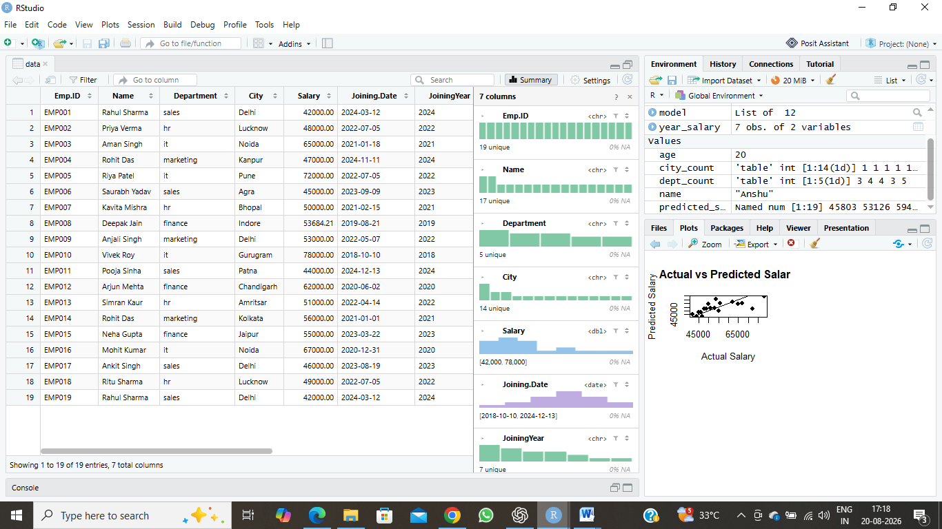

3. Data Visualization and Analysis

3.1 Employees by Department
The department-wise analysis shows the distribution of employees across different departments. The Sales department has the highest number of employees, followed by the HR and IT departments. Finance and Marketing have comparatively fewer employees.
This visualization helps identify how the workforce is distributed across departments and provides a quick overview of the organizational structure.

.

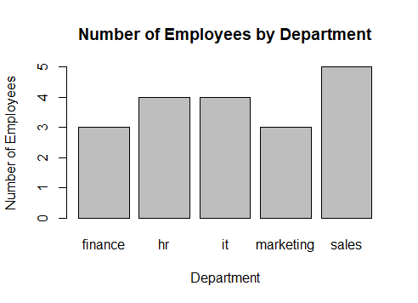

3.2 Employees by City
The city-wise analysis shows that employees are distributed across several cities. Gurugram has the highest number of employees, while other cities have fewer employees. This indicates that the workforce is spread across multiple locations, with Gurugram having a comparatively higher representation.
The visualization provides a clear view of the geographical distribution of employees and helps identify cities with greater employee concentration.

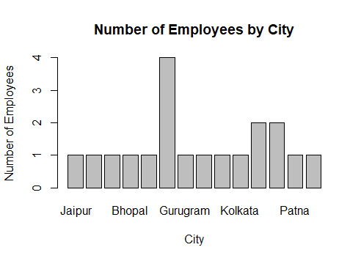

3.3 Average Salary by Department
The analysis of average salary by department shows clear differences in salary levels across departments. The IT department has the highest average salary, while the Sales department has the lowest average salary. Finance, HR, and Marketing fall between these two groups.
This comparison highlights differences in salary levels across departments and helps identify departments with relatively higher and lower average compensation.

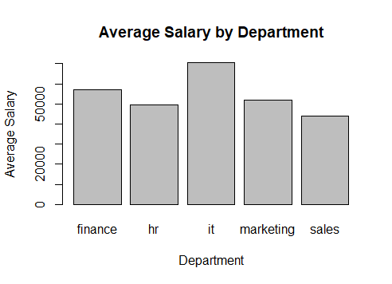

3.4 Salary Distribution by Department
The salary distribution across departments shows differences in both salary levels and salary ranges. The boxplot indicates that employees in the IT department generally have higher salaries, while the Sales department has comparatively lower salaries. The other departments show salary ranges between these two groups.
The visualization helps compare the spread, central tendency, and variation of salaries across departments. It also shows that salary levels are not uniform across the organization.

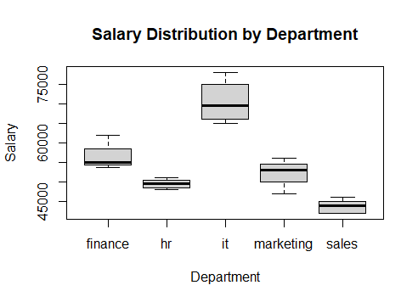

3.5 Salary Distribution
The salary distribution was analyzed using a histogram to understand how employee salaries are spread across different salary ranges. The analysis shows that most employees have salaries concentrated in the lower and middle salary ranges, while fewer employees receive comparatively higher salaries.
The histogram provides a simple overview of the overall salary distribution and helps identify the concentration and spread of salary values within the dataset.
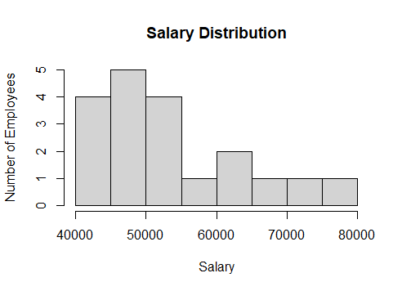

3.6 Salary vs Joining Date
The scatter plot was used to examine the relationship between employee salary and joining date. The analysis shows a negative relationship between the two variables, which is consistent with the correlation analysis performed in Week 3.
Employees with earlier joining dates generally have higher salaries in this dataset, while employees with more recent joining dates tend to have comparatively lower salaries. However, the relationship does not mean that joining date alone determines salary, as other factors may also influence employee compensation.
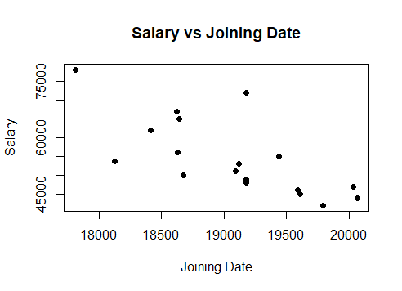

3.7 Average Salary Trend by Joining Year
The line chart shows the variation in average employee salary across different joining years. The analysis indicates that the highest average salary was observed for employees who joined in 2018, while average salary generally decreased for later joining years, with some variation between individual years.
This trend provides a useful overview of how average salary levels differ across employee joining cohorts. It also supports the regression and correlation findings that showed a negative relationship between joining date and salary in this particular dataset.
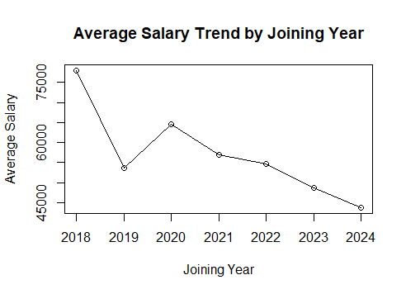

4. Statistical Analysis and Predictive Modeling
The statistical analysis and predictive modeling performed in Week 3 were integrated into the final analysis to identify relationships and patterns within the employee dataset. Descriptive statistics, correlation analysis, hypothesis testing, linear regression, model diagnostics, and actual-versus-predicted analysis were used to evaluate salary-related patterns.
The analysis showed that the average employee salary was approximately ₹53,983, with salaries ranging from ₹42,000 to ₹78,000. The correlation between salary and joining date was approximately -0.732, indicating a relatively strong negative relationship.
A Welch Two Sample t-test showed a statistically significant difference between the average salaries of IT and Sales employees, with a p-value of 0.001691. The linear regression model produced an R-squared value of 0.5361, indicating that approximately 53.61% of the variation in salary was explained by joining date.
Model diagnostic plots were also examined to evaluate the regression assumptions, and an actual-versus-predicted salary plot was used to assess the model's predictive behavior.

4.1 Descriptive Statistics
The descriptive statistics provide an overview of the salary distribution. The average salary was approximately ₹53,983, while the median salary was ₹51,000. Salaries ranged from ₹42,000 to ₹78,000, with a standard deviation of approximately ₹10,350.
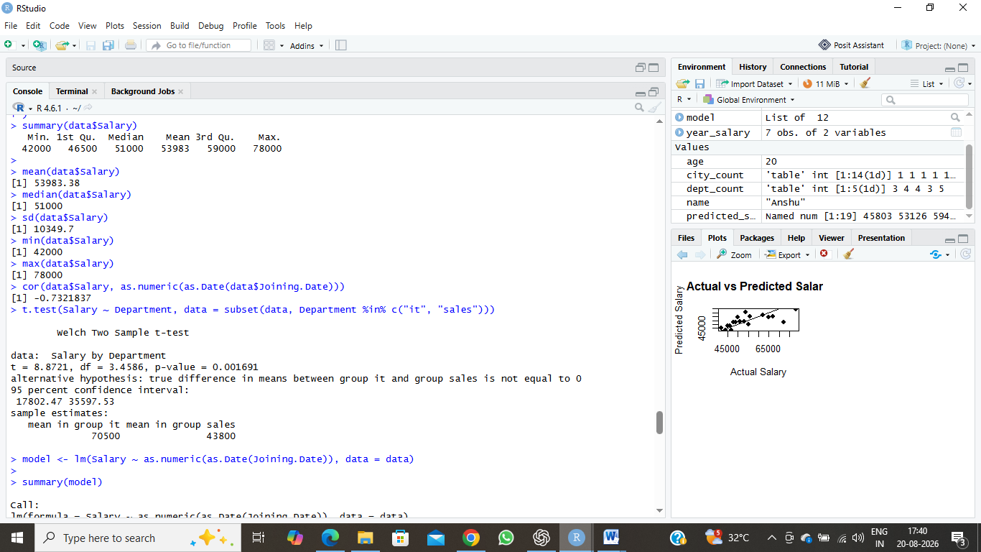

4.2 Correlation Analysis
The correlation analysis produced a coefficient of approximately -0.732, indicating a relatively strong negative relationship between joining date and salary. This suggests that employees with earlier joining dates generally tend to have higher salaries in this dataset. However, correlation does not establish a direct cause-and-effect relationship.

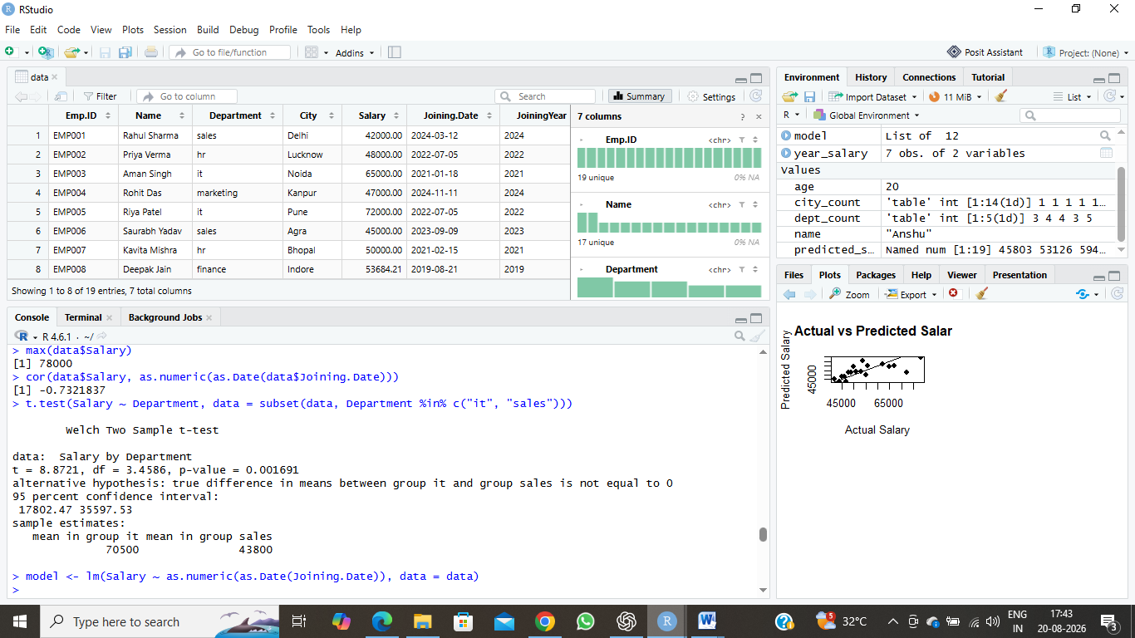

4.3 Hypothesis Testing
The Welch Two Sample t-test was performed to determine whether there was a statistically significant difference in average salary between employees in the IT and Sales departments.
The test produced a t-value of 8.872 and a p-value of 0.001691. Since the p-value is less than the 0.05 significance level, the null hypothesis was rejected. This indicates that there is a statistically significant difference between the average salaries of IT and Sales employees.
The mean salary for the IT group was ₹70,500, while the mean salary for the Sales group was ₹43,800. Therefore, IT employees had a substantially higher average salary than Sales employees in this dataset.

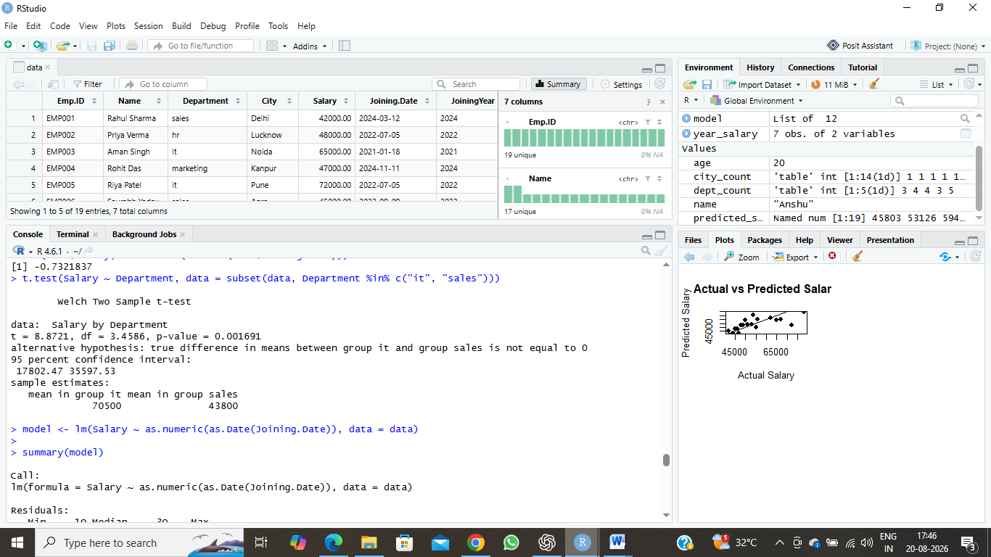

4.4 Linear Regression
A simple linear regression model was developed to examine whether joining date could be used to predict employee salary. Salary was treated as the dependent variable, while joining date was used as the explanatory variable.
The regression model produced an R-squared value of 0.5361, indicating that approximately 53.61% of the variation in salary is explained by joining date. The coefficient for joining date was approximately -11.887, showing a negative relationship between joining date and salary.
The overall model was statistically significant, with a p-value of 0.000365, which is below the 0.05 significance level. This suggests that joining date has a statistically significant relationship with salary in this dataset.
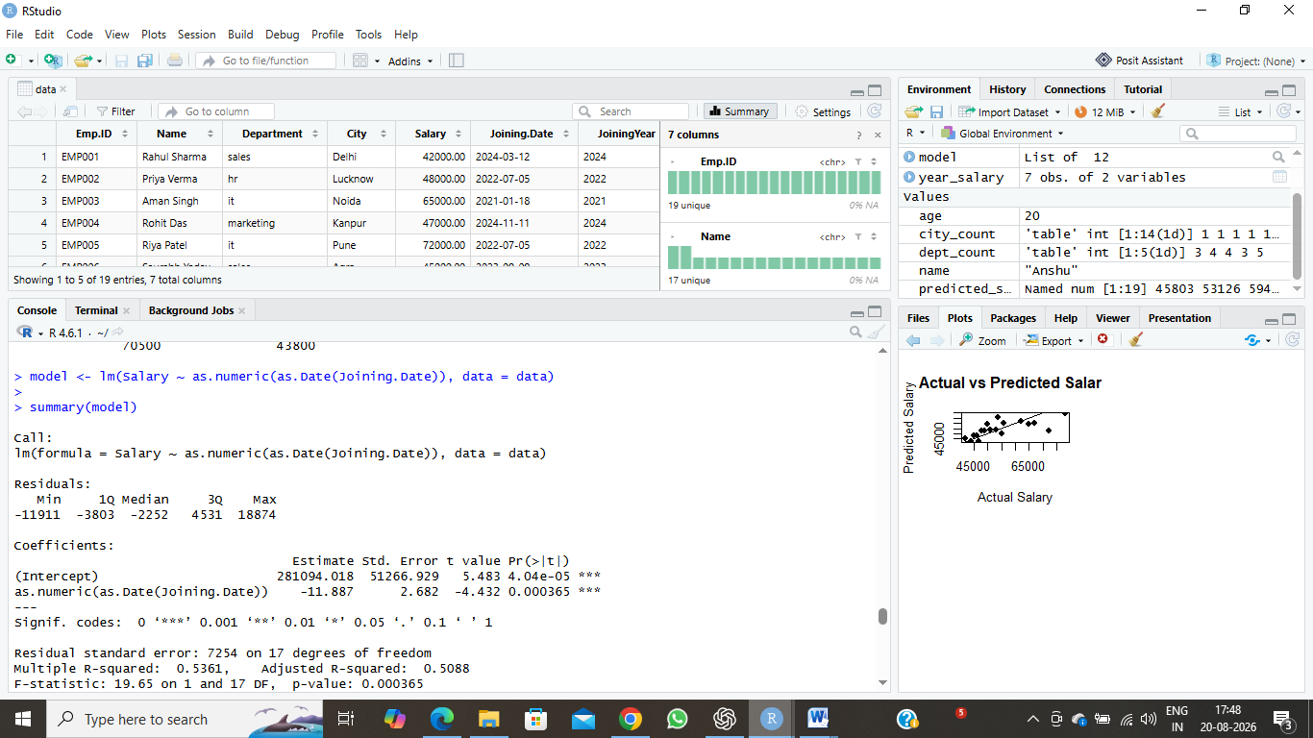

4.5 Model Diagnostics
Model diagnostic plots were used to evaluate the assumptions and overall fit of the linear regression model. Four diagnostic plots were examined: Residuals vs Fitted, Normal Q-Q, Scale-Location, and Residuals vs Leverage.
The Residuals vs Fitted plot was used to identify patterns in the residuals, while the Normal Q-Q plot helped assess the normality of the residuals. The Scale-Location plot was used to examine the consistency of residual variance, and the Residuals vs Leverage plot helped identify potentially influential observations.
These diagnostic plots provide a better understanding of the strengths and limitations of the regression model and help determine whether the model provides a reasonable representation of the observed data.

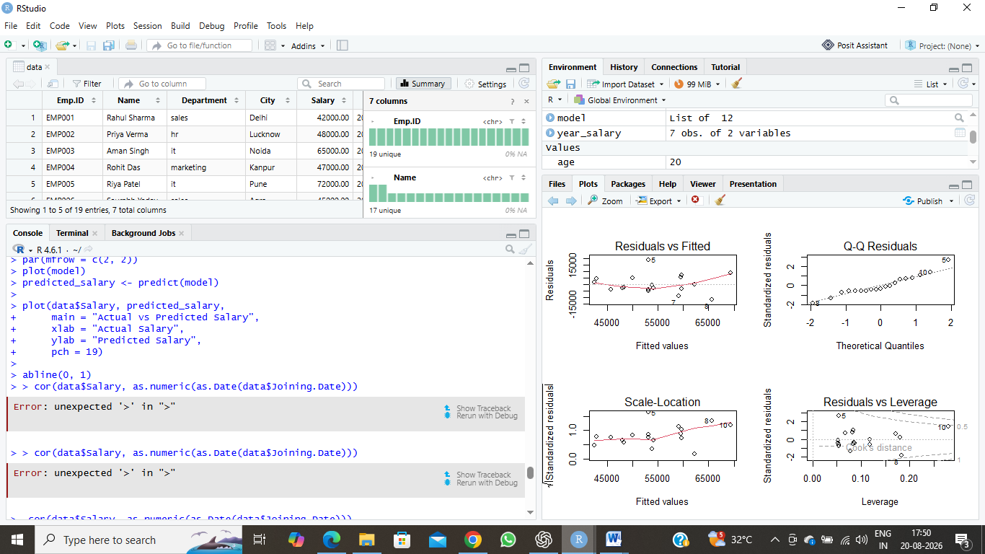

4.6 Actual vs Predicted Salary
The regression model was used to generate predicted salary values for each employee. The actual salary values were then compared with the predicted values to evaluate the model's predictive performance.
The actual-versus-predicted salary plot shows a positive pattern between the observed and predicted values. Several points are relatively close to the reference line, indicating that the model captures an important part of the salary variation. However, some differences between actual and predicted values remain, suggesting that other factors may also influence employee salary.
Overall, the comparison provides a visual assessment of how well the regression model represents the observed salary data.
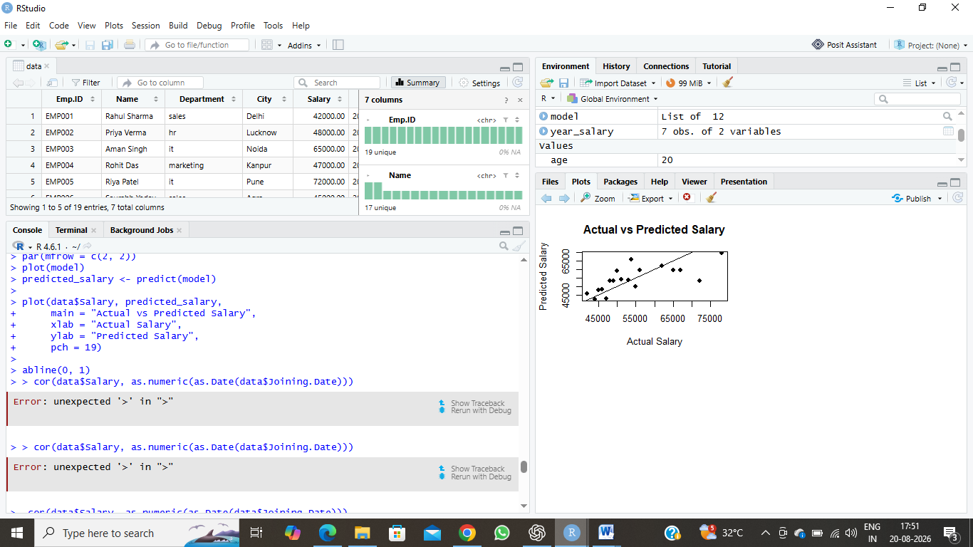

5. Integrated Insights and Business Findings
The integrated analysis of the employee dataset provides several useful insights. The data preparation process ensured that the dataset was structured and suitable for further analysis. The visualization analysis showed differences in employee distribution across departments and cities, as well as clear variations in salary levels.
The Sales department had the highest number of employees, while the IT department had the highest average salary. The city-wise analysis showed that Gurugram had the highest employee representation. Salary distribution analysis indicated that most employees were concentrated within the lower and middle salary ranges.
Statistical analysis revealed a correlation coefficient of approximately -0.732 between joining date and salary, indicating a relatively strong negative relationship in this dataset. The hypothesis test also showed a statistically significant difference between IT and Sales salaries.
The regression model explained approximately 53.61% of salary variation based on joining date. However, the remaining unexplained variation indicates that salary is influenced by other factors as well. Factors such as department, experience, skills, job role, and other employee characteristics could potentially improve future salary prediction models.
Overall, combining data cleaning, visualization, statistical analysis, and predictive modeling provided a more complete understanding of the employee dataset and demonstrated how different analytical techniques can work together to support data-driven decision-making.

6. Conclusion and Future Directions
The final analysis combined data preparation, visualization, statistical analysis, and predictive modeling to develop a comprehensive understanding of the employee dataset. The project demonstrated how R can be used throughout the complete data analysis process, from cleaning and organizing raw data to identifying patterns and communicating meaningful insights.
The analysis highlighted important differences in employee distribution and salary levels across departments and cities. Statistical techniques further helped identify relationships between joining date and salary and confirmed a significant salary difference between the IT and Sales departments. The regression model provided a useful starting point for salary prediction, although its results also showed that additional factors are required for more accurate predictions.
In future analysis, additional variables such as experience, job role, skills, education, and performance could be included in the predictive model. More advanced machine-learning techniques could also be explored to improve prediction accuracy. Regular analysis of updated employee data could further help organizations understand workforce and salary trends.
Overall, this project strengthened practical skills in data cleaning, visualization, statistical analysis, hypothesis testing, regression modeling, and data interpretation using R. It provided valuable experience in converting raw employee data into meaningful, data-driven insights.

