1. Introduction
This week focuses on statistical analysis and predictive modeling using R. The main objective is to apply statistical techniques to understand relationships and patterns within the employee dataset. Descriptive statistics, correlation analysis, hypothesis testing, and regression modeling were performed to analyze employee salary data.
The analysis also includes model evaluation and diagnostic techniques to understand how well the predictive model explains salary variation. The results help identify important relationships between salary and joining date and provide a practical understanding of how R can be used for statistical analysis and prediction.

2. Dataset Overview
The dataset used for this analysis contains employee information from a company. It includes 19 employee records with variables such as employee ID, employee name, department, city, salary, and joining date. These variables provide useful information for examining employee characteristics and salary-related patterns.
The main variables used in the statistical analysis are:
- Emp.ID – Unique identification number of each employee
- Name – Name of the employee
- Department – Department in which the employee works
- City – City where the employee is located
- Salary – Salary of the employee
- Joining.Date – Date on which the employee joined the company
For predictive modeling, Salary was considered the dependent variable, while Joining Date was used as the main explanatory variable. The dataset was analyzed using R to calculate descriptive statistics, examine correlations, perform hypothesis testing, and build a linear regression model.

Descriptive statistics were calculated to understand the overall distribution of employee salaries. The summary() function in R was used to obtain the minimum, first quartile, median, mean, third quartile, and maximum salary values.

3. Statistical Analysis and Modeling

3.1 Descriptive Statistics
The results showed that the minimum salary was ₹42,000, while the maximum salary was ₹78,000. The average salary was approximately ₹53,983, and the median salary was ₹51,000. The standard deviation was approximately ₹10,350, indicating noticeable variation in salaries among employees.
These statistics provide a basic understanding of the salary distribution and help identify the central tendency and spread of the data.

3.2 Correlation Analysis
Correlation analysis was performed to examine the relationship between employee salary and joining date. The correlation coefficient was calculated using the cor() function in R.
The correlation coefficient was approximately -0.732, indicating a moderately strong negative relationship between joining date and salary in this dataset. This means that employees with earlier joining dates generally tend to have higher salaries, while employees with later joining dates tend to have lower salaries.
The negative correlation suggests that salary and joining date move in opposite directions. However, correlation alone does not prove that joining date directly causes changes in salary.

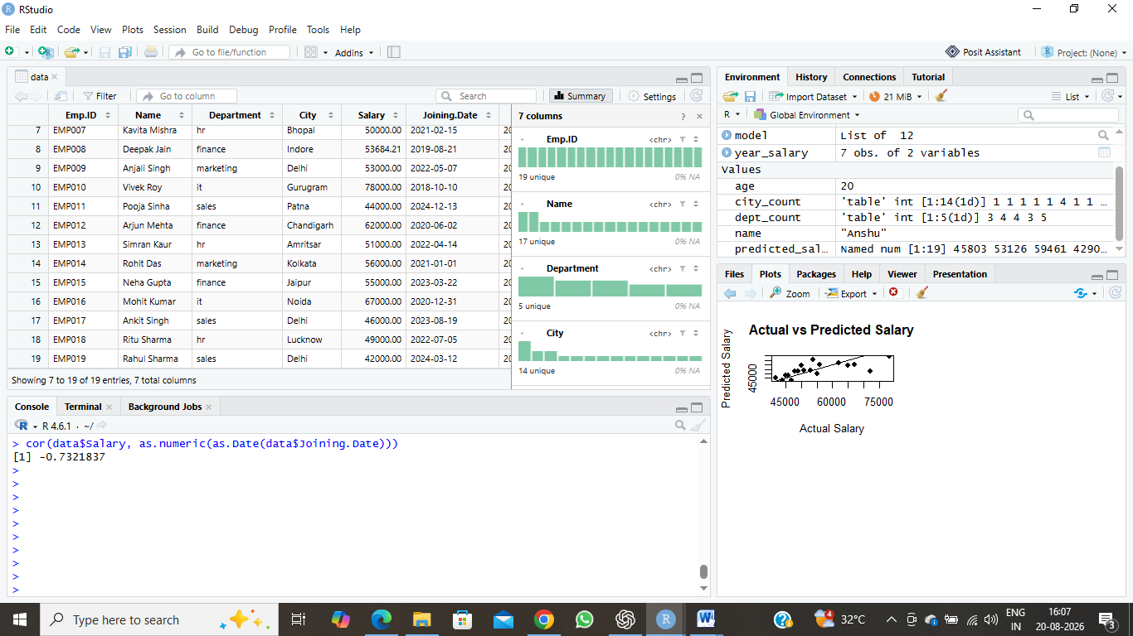

3.3 Hypothesis Testing
Hypothesis testing was performed to determine whether there is a statistically significant difference in average salary between employees from the IT and Sales departments. A Welch Two Sample t-test was conducted using R.
The null hypothesis states that there is no significant difference between the mean salaries of the IT and Sales departments. The alternative hypothesis states that a significant difference exists between the two group means.
The test produced a t-value of 8.872, with a p-value of 0.001691. Since the p-value is less than 0.05, the null hypothesis is rejected. Therefore, the analysis indicates a statistically significant difference in average salary between the IT and Sales departments.
The mean salary was ₹70,500 for IT employees and ₹43,800 for Sales employees.
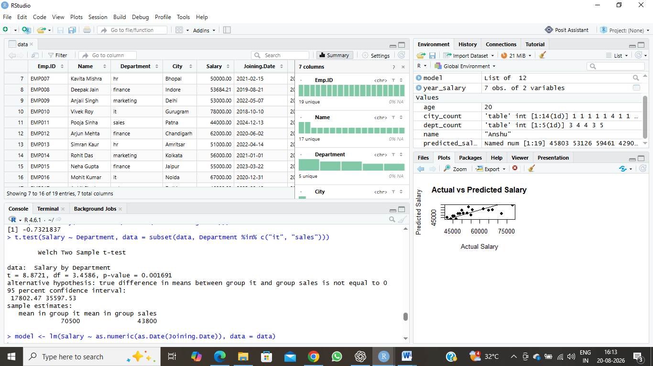

3.4 Linear Regression Model
Regression analysis was performed to examine whether joining date can be used to predict employee salary. A simple linear regression model was created in R, with Salary as the dependent variable and Joining Date as the explanatory variable.
The regression model showed a negative relationship between joining date and salary. The estimated coefficient for joining date was approximately -11.887, indicating that salary tends to decrease as the joining date increases.
The model produced an R-squared value of 0.5361, meaning that approximately 53.61% of the variation in salary is explained by the model. The p-value of the model was approximately 0.000365, which is below 0.05. This indicates that the relationship between joining date and salary is statistically significant in this dataset.
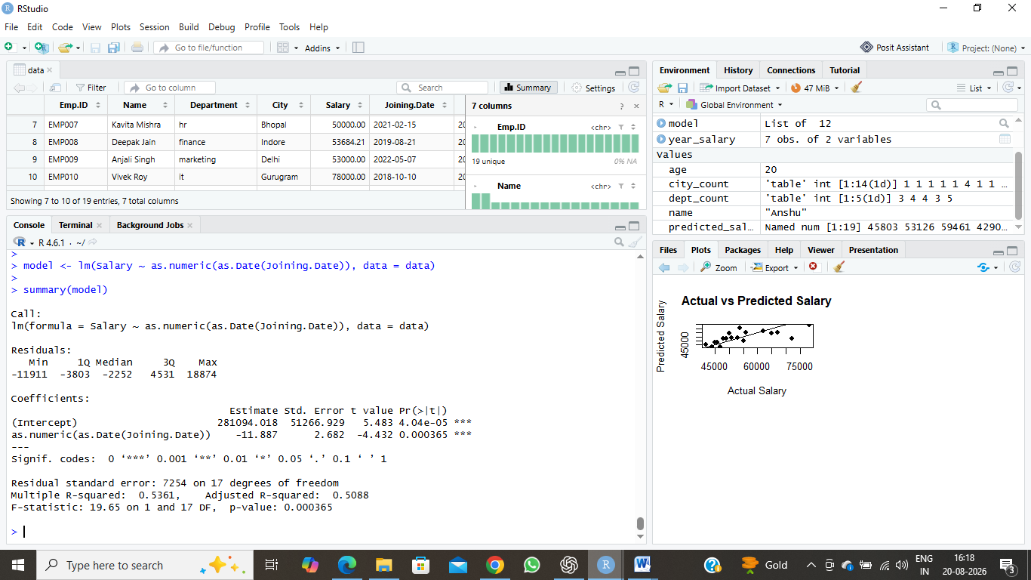

3.5 Model Diagnostics
Model diagnostics were performed to evaluate the assumptions and overall reliability of the linear regression model. Diagnostic plots were generated in R to examine residuals, normality, scale-location, and influential observations.
The diagnostic analysis helps determine whether the regression model provides a reasonable fit to the data. The residual plots were examined for patterns, while the Q-Q plot was used to assess the normality of residuals. The scale-location plot was used to examine the consistency of residual variance, and the residuals-versus-leverage plot helped identify potentially influential observations.
Overall, these diagnostic plots provide useful information about the strengths and limitations of the regression model.

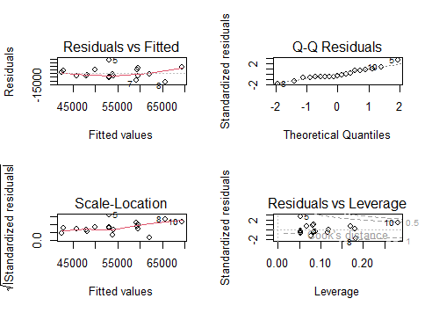

3.6 Actual vs Predicted Salary
The regression model was used to generate predicted salary values for each employee. The actual salary values were then compared with the predicted values to evaluate how closely the model estimates employee salaries.
The comparison was visualized using a scatter plot, where actual salary values were placed on the x-axis and predicted salary values on the y-axis. The points generally follow an upward pattern, indicating that the model captures an important part of the variation in employee salaries.
This visualization provides a simple way to assess the predictive performance of the regression model and identify differences between actual and predicted salary values.

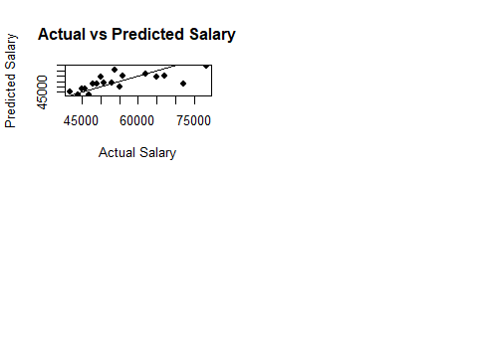

3.7 Model Performance Summary
The performance of the linear regression model was evaluated using the R-squared value, statistical significance, and comparison between actual and predicted salary values. The model achieved an R-squared value of 0.5361, indicating that approximately 53.61% of the variation in employee salary is explained by joining date.
The regression coefficient for joining date was negative, showing that salary tends to decrease as the joining date becomes later. The overall model was statistically significant, with a p-value of approximately 0.000365.
The actual-versus-predicted salary comparison also shows that the model captures a meaningful pattern in the salary data. However, some differences between actual and predicted values remain, indicating that other factors may also influence employee salaries.

3.7 Model Performance Summary
The performance of the linear regression model was evaluated using the R-squared value, statistical significance, and comparison between actual and predicted salary values. The model achieved an R-squared value of 0.5361, indicating that approximately 53.61% of the variation in employee salary is explained by joining date.
The regression coefficient for joining date was negative, showing that salary tends to decrease as the joining date becomes later. The overall model was statistically significant, with a p-value of approximately 0.000365.
The actual-versus-predicted salary comparison also shows that the model captures a meaningful pattern in the salary data. However, some differences between actual and predicted values remain, indicating that other factors may also influence employee salaries.

4. Interpretation and Key Findings
The statistical analysis provided several important insights into the employee salary dataset. The descriptive statistics showed that the average employee salary was approximately ₹53,983, with salaries ranging from ₹42,000 to ₹78,000.
The correlation analysis produced a coefficient of approximately -0.732, indicating a relatively strong negative relationship between joining date and salary in this dataset. This suggests that employees with earlier joining dates generally tend to have higher salaries.
The hypothesis test comparing IT and Sales salaries produced a p-value of 0.001691, which is below the 0.05 significance level. Therefore, there is a statistically significant difference between the average salaries of employees in the IT and Sales departments.
The linear regression model produced an R-squared value of 0.5361, meaning that approximately 53.61% of the variation in salary is explained by joining date in this dataset. The model was statistically significant, with a p-value of approximately 0.000365.
The diagnostic plots helped evaluate the assumptions and limitations of the regression model. The actual-versus-predicted salary plot showed that the model captures part of the salary variation, although some differences remain between actual and predicted values.
Overall, the analysis demonstrates how statistical methods and predictive modeling can be used to identify relationships, test differences, and understand patterns within employee data.

5. Conclusion
The Week 3 project provided practical experience in statistical analysis and predictive modeling using R. Descriptive statistics were used to understand the overall salary distribution, while correlation analysis helped identify the relationship between joining date and salary.
Hypothesis testing showed a statistically significant difference between the average salaries of IT and Sales employees. A linear regression model was then developed to examine whether joining date could be used to predict salary. The model explained approximately 53.61% of the variation in salary, demonstrating a meaningful relationship within the dataset.
Model diagnostic plots and the actual-versus-predicted salary comparison were also used to evaluate the model and understand its limitations. The analysis demonstrated that statistical techniques can provide useful insights from employee data, while also showing that salary may depend on several factors beyond joining date.
Overall, this project improved practical skills in descriptive statistics, correlation analysis, hypothesis testing, regression modeling, model diagnostics, and interpretation of analytical results using R.

