WEEK 2: DATA VISUALIZATION AND INSIGHT COMMUNICATION USING R
Virtual R Data Analyst Internship
Week 2 Report
Submitted by: Anshu Sharma

1. Introduction
This week focuses on data visualization and insight communication using R. The objective was to transform employee data into meaningful visualizations that make patterns, comparisons, and trends easier to understand. Using R, different types of charts and graphs were created to analyze employee distribution, salary patterns, departmental differences, city-wise employee counts, and salary trends over joining years. The visualizations help communicate important findings from the dataset in a clear and understandable manner.

2. Dataset Overview
The dataset used for this analysis contains employee information from a company. The dataset includes 19 employee records and variables related to employee identification, name, department, city, salary, and joining date. A joining year variable was also created from the joining date to analyze salary trends over time.
The main variables used in the analysis are:
- Emp.ID
- Name
- Department
- City
- Salary
- Joining.Date
- JoiningYear
The dataset contains both categorical and numerical information. Department and City are categorical variables, while Salary is a numerical variable. The dataset was analyzed using R to create different visualizations and identify useful patterns.

3. Visualization and Analysis

3.1 Employees by Department
barplot(
table(data$Department),
main = "Employees by Department",
xlab = "Department",
ylab = "Number of Employees"
)
Interpretation:
The bar chart shows the number of employees working in each department. The sales department has the highest number of employees, followed by the HR and IT departments. Finance and marketing have comparatively fewer employees. This visualization provides a clear comparison of employee distribution across departments.
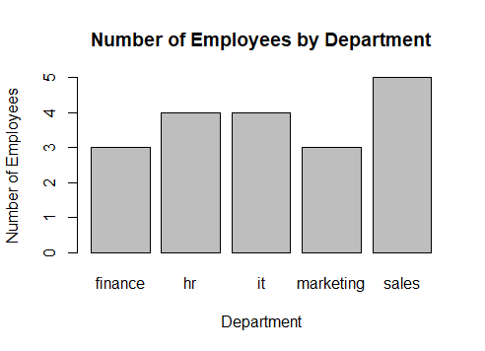

3.2 Employees by City
city_count <- table(data$City)

barplot(
city_count,
main = "Number of Employees by City",
xlab = "City",
ylab = "Number of Employees"
)
Interpretation:
The chart shows the distribution of employees across different cities. Gurugram has the highest number of employees in the dataset, while several other cities have one or two employees. This indicates that the employees are distributed across multiple locations, with Gurugram having a comparatively larger representation.
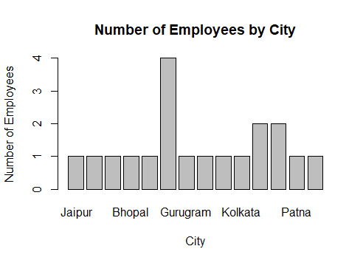

3.3 Average Salary by Department
avg_salary <- aggregate(
Salary ~ Department,
data = data,
FUN = mean
)

barplot(
avg_salary$Salary,
names.arg = avg_salary$Department,
main = "Average Salary by Department",
xlab = "Department",
ylab = "Average Salary"
)
Interpretation:
The chart compares the average salary of employees across different departments. The IT department has the highest average salary among the departments, while the sales department has the lowest average salary. Finance, marketing, and HR fall between these two groups.
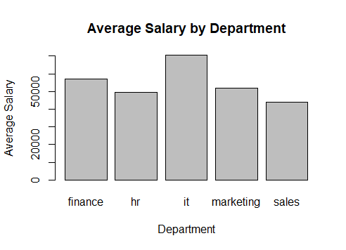

3.4 Salary Distribution
hist(
data$Salary,
main = "Salary Distribution",
xlab = "Salary",
ylab = "Number of Employees"
)
Interpretation:
The histogram shows how employee salaries are distributed. Most employees have salaries concentrated in the lower and middle salary ranges, while fewer employees have salaries above 60,000. The distribution also shows that the dataset contains some relatively high salary values.
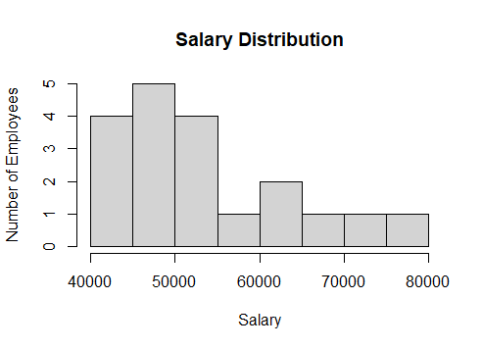

3.5 Salary Distribution by Department
boxplot(
Salary ~ Department,
data = data,
main = "Salary Distribution by Department",
xlab = "Department",
ylab = "Salary"
)
Interpretation:
The boxplot compares salary ranges across departments. The IT department has the highest salary range and median salary, while the sales department has the lowest salary range. The boxplot also helps identify differences in salary variation among departments.
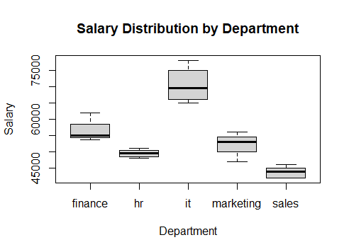

3.6 Salary vs Joining Date
plot(
as.numeric(as.Date(data$Joining.Date)),
data$Salary,
main = "Salary vs Joining Date",
xlab = "Joining Date",
ylab = "Salary",
pch = 19
)
Interpretation:
The scatter plot shows the relationship between employee joining dates and salaries. The visualization indicates that employees who joined earlier do not necessarily have lower salaries. Salary values vary across different joining dates, suggesting that factors other than joining date may influence salary levels.
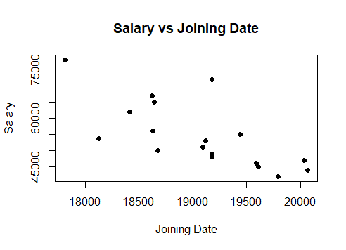

3.7 Average Salary Trend by Joining Year
data$JoiningYear <- format(
as.Date(data$Joining.Date),
"%Y"
)

year_salary <- aggregate(
Salary ~ JoiningYear,
data = data,
FUN = mean
)

plot(
year_salary$JoiningYear,
year_salary$Salary,
type = "o",
main = "Average Salary Trend by Joining Year",
xlab = "Joining Year",
ylab = "Average Salary"
)
Interpretation:
The line chart shows changes in average salary according to the employee joining year. The highest average salary is observed for employees who joined in 2018. After 2018, the average salary generally decreases, with some variation between individual years. The lowest average salary in this dataset is observed for the 2024 joining year.
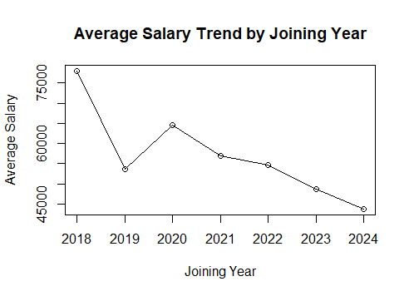

4. Key Insights
The visualizations provide several important insights from the employee dataset. The sales department has the largest number of employees, whereas finance and marketing have fewer employees. The IT department has the highest average salary among the departments, while sales has the lowest average salary.
The city-wise analysis shows that employees are distributed across several cities, with Gurugram having the highest representation. The salary histogram indicates that most salaries are concentrated around the lower and middle ranges, while only a smaller number of employees receive higher salaries.
The department-wise boxplot shows clear differences in salary levels and ranges between departments. The scatter plot indicates that joining date alone does not determine salary. The joining-year analysis shows that average salary varies considerably across different years, with the highest average observed for the 2018 group.

The visualizations provide several useful insights from the employee dataset:
- The Sales department has the highest number of employees, followed by the HR and IT departments.
- The IT department has the highest average salary, while the Sales department has the lowest average salary among the departments.
- The salary boxplot shows that salary levels vary across departments, with IT employees generally receiving higher salaries than employees in other departments.
- The city-wise analysis shows that employees are distributed across several cities. Gurugram has the highest number of employees in the dataset.
- The salary histogram indicates that most employees have salaries concentrated in the ₹40,000–₹55,000 range, while fewer employees have salaries above ₹60,000.
- The joining-year trend shows a decline in average salary from 2018 to 2024, with the highest average salary observed among employees who joined in 2018.
- The salary-versus-joining-date scatter plot suggests that the employees who joined earlier generally have higher salaries in this particular dataset.

5. Conclusion
This week provided practical experience in creating and interpreting data visualizations using R. Different visualization techniques, including bar charts, histograms, boxplots, scatter plots, and line charts, were used to analyze employee data from multiple perspectives. The analysis helped identify patterns in employee distribution, salary levels, departmental differences, city-wise distribution, and salary trends over joining years.
The project improved understanding of how data visualization can convert raw data into meaningful information. It also demonstrated how R can be used to create clear and informative visualizations for communicating analytical findings. These visualizations make complex data easier to understand and support better interpretation of business-related information.

