Grade 6 Logical Reasoning Practice Set

Page - 1/16
Q.1
Choose the correct continuation: 3, 8, 15, 24, ?
A. 30
B. 35
C. 40
D. 45
Q.2
Find the missing term in the pattern: 4, 6, 9, 13, , 24, 30
A. 18
B. 13
C. 20
D. 12
Q.3
If David is Sarah's husband and Sarah is your daughter, what is David to you?
A. Son
B. Nephew
C. Son-in-law
D. Grandson
Q.4
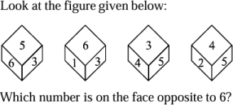
A. 4
B. 2
C. 3
D. 5
Q.5
Select the figure which will come next in the following series.
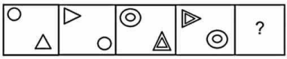
Page - 2/16
A. 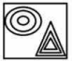
B. 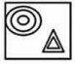
C. 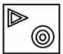
D. 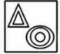
Q.6
Which term in the given code language signifies 'weather' if 'oka peru' translates to 'fine cloth', 'meta lisa' stands for 'clear water', and 'dona lisa peru' corresponds to 'fine clear weather'? A. peru
B. Oka
C. meta
D. Dona
Q.7
Select the number which can be placed at the sign of the question mark (?) from the given alternatives: 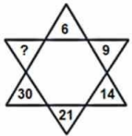
A. 44
B. 46
C. 42
D. 41
Page - 3/16
Q.8
Select the related figure from the given alternatives.
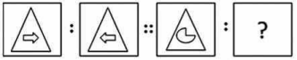
A. 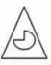
B. 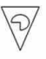
C. 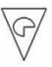
D. 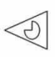
Q.9
In a code language where "SAND" is coded as "191144", what would be the code for "BLUR"?
A. 2122118
B. 2132219
C. 3122118
D. 3132219
Q.10
Select the related figure from the given alternatives.
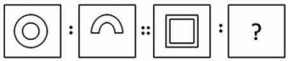
Page - 4/16
A.
B.
C.
D.
Q.11
What is the direction of the ray starting from point L and points in the direction of point M? 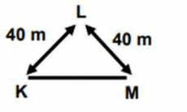
A. South
B. South-West
C. South-East
D. West
Q.12
If you are facing north and you turn 135 degrees clockwise, which direction are you facing now?
A. South-West
B. North - East
C. North - West
D. South - East
Q.13
In the following figure, the rectangle represents house, circle represents blue, triangle represents duplex and hexagon represents garage. Which of the following represents those houses that are duplex of blue color with a garage?
Page - 5/16
A. H
B. E
C. D
D. B
Q.14
Sunny is standing in the middle and facing Hospital. If he takes a 225° counterclockwise turn, where will he face now?
A. Hotel
B. Library
C. Home
D. Garage
Q.15 If a toy starts facing North and rotates counterclockwise 135°, followed by a 90° clockwise rotation, what direction is it facing now?
A. North
B. West
C. North-West
D. North-East
Q.16
How many consonants in the given arrangement are immediately after and before a vowel? Y U T R H Q A H P L V X E EE U D B A W O J L O J O C A T
A. Two
B. Three
C. Four
D. Five
Page - 6/16
Q.17
Select the option that correctly represents the relationship among the following: Summer, Winter and Season
A.
B.
C.
D.
Q.18
What is the second element to the left of the sixth element from the right in the series within quotation marks: 'B * 5 9 I T & E @ # U 1 &'
A. &
B. 9
C. E
D. T
Q.19
Group the given figures into three classes using each figure only once.
Page - 7/16
A. 1, 5, 9; 2, 6, 8; 3, 4, 7
B. 1, 5, 8; 2, 6, 9; 3, 4, 7
C. 1, 4, 8; 2, 6, 9; 3, 5, 7
D. 1, 5, 9; 2, 7, 8; 3, 4, 6
Q.20
Find the missing term in the number series: 10, 11, 13, 16, ?, 25, 31
A. 20
B. 21
C. 23
D. 15
Q.21
If a car is placed as the twenty-seventh from either end in a line of cars, what is the total number of cars in the row?
A. Fifty-five
B. Fifty-three
C. Fifty-four
D. Fifty-six
Q.22
Three of the following four numbers are alike in a certain way and one is different. Pick the odd word out.
A. 81
B. 28
C. 196
D. 121
Q.23
Select the correct option that represents the image of the image after it is mirrored under the line.
A.
B.
C.
D. None of these
Page - 8/16
Q.24
How many circles are present in the figure given below?
A. 6
B. 5
C. 4
D. 7
Q.25
If the word SPIN is related to NIPS in the same way as FARM is related to MRAF, what word would be related to GLOW?
A. WOLG
B. WLOG
C. LGWO
D. WOGW
Q.26
Among the given words, three are similar in a certain way, and one is different. Identify the odd word out.
A. Mercury
B. Venus
C. Mars
D. Saturn
Q.27 Select the correct option that represents the image of the image after it is mirrored under the line.
Page - 9/16
A.
B.
C.
D.
Q.28
If the relationship between 4 and 60 is the same as the relationship between 6 and one of the given options, which option completes the analogy?
A. 100
B. 90
C. 80
D. 110
Q.29 Select three figures out of the following five figures which when fitted into each other would form a triangle.
A. 1, 2, 4
B. 1, 2, 5
C. 5, 3, 1
D. 1, 3, 4
Q.30
Count the number of cubes in the filled figure given below.
Page - 10/16
A. 6
B. 12
C. 10
D. 14
Q.31
From the options, select the figure which dots are in the same shapes as the dots in the provided image:
A.
B.
C.
D.
Page - 11/16
Q.32
From the given answer figures, select the one in which the question figure is hidden/embedded (Rotation not allowed):
A.
B.
C.
D.
Page - 12/16

