***Ex 1 LED CHASER***

**Circuit Diagram**

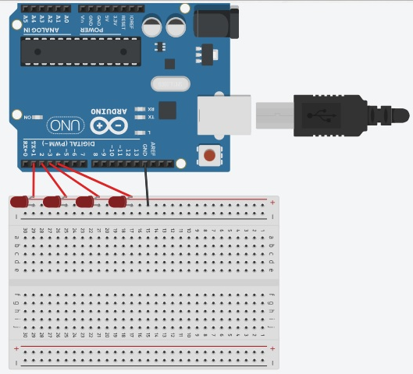

**Theory**

Concept Used:

Concept used in this is

1. Arduino UNO board coding
2. Arduino UNO board using
3. Breadboard using
4. For loop using
5. LED using LED diode junctions.

Learning & Observations:

1. I learned to make a LED chaser.
2. Using basic code in Arduino UNO IDE.
3. I observed use of for loop in Arduino Uno coding for manipulation.

Problems & Troubleshooting:

I had to change delay time several times in order to gain the required results.

Precautions

1. Do not directly connect the LED otherwise it will get fused.
2. Make sure all connections are tight and secure.
3. Ensure that the code is not only verified or compiled but is also uploaded on the board.
4. Check all the pin modes required are correct or not.
5. Make sure you are connecting the LED the right way.
6. Dry run your loop code if any problem occurs in the pattern.

Learning Outcomes

We learn to code and how to manipulate leds using for loops in circuit using Arduino board.