**Conestoga College SET**

**Project Report**

**Final Project**

**By**

**Arindm Sharma**

**Zivojin Pecin**

**Jody Markic**

**Sean Moulton**

**Date of Submission: 2018-01-05**

**Network Application Development**

**(PROG – 2030)**

Table of Contents

1. As-Built System Architecture 3

2. Implemented Feature List 6

2.1 User Input Validation: 6

2.2 Login/Logout users: 6

2.3 Signup: 6

2.4 Password Recovery: 6

2.5 Hashed And Salted Password: 6

2.6 Restrict users groups to certain functionality: 6

2.7 Create New Posts: 6

2.8 Browse Posts: 6

2.9 Contact The Poster: 6

2.10 Institute admin add books: 7

2.11 Adding new books to database: 7

2.12 Creating institutions/institution admins: 7

3. Planned but Not Implemented Feature List 7

3.1 Institute admin add new books: 7

3.2 Adding New Courses: 7

3.3 Smart Search 7

3.4 Custom images 7

3.5 Institution admin association 7

3.6 Add pagination: 8

4. Project Next Steps 8

5. Known Bug List 8

6. Team Member Work Estimate 8

Evaluation Form: 9

# As-Built System Architecture

The purpose of this application is to have an online College Used Book Sales System which can be accessed through the public internet. This application enables the users to buy and sell used books online. It is designed in order to simplify the task of buying and selling books for students of different schools/colleges by letting them seamlessly post and reply to advertisements on the website.

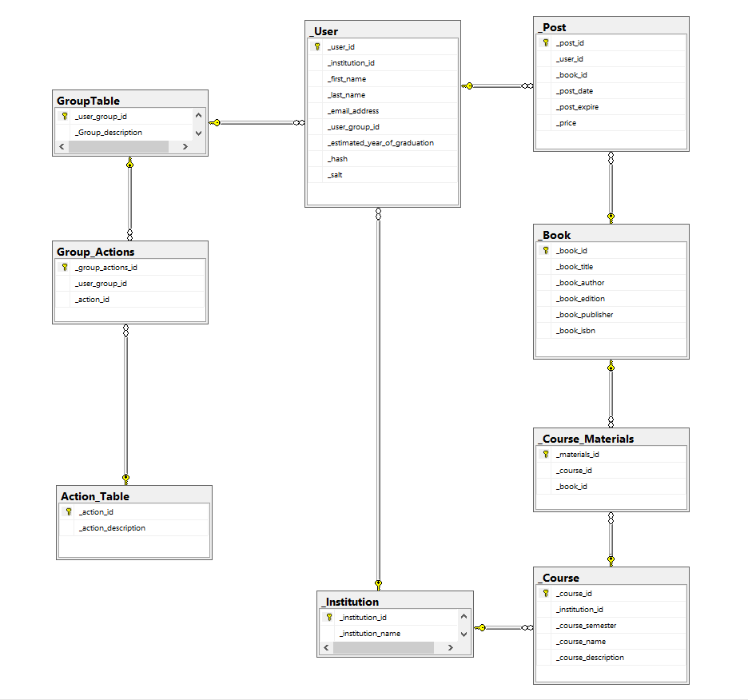

Figure 1. Database schema for the system

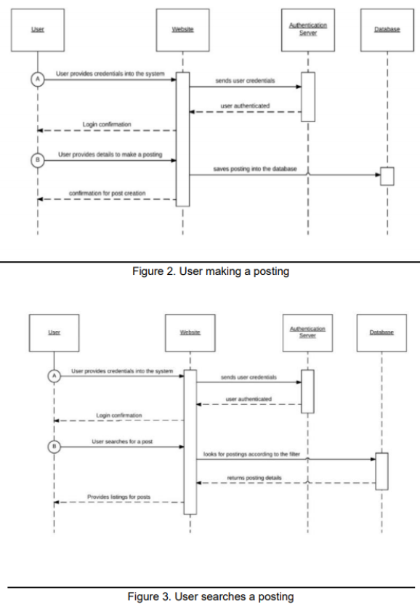

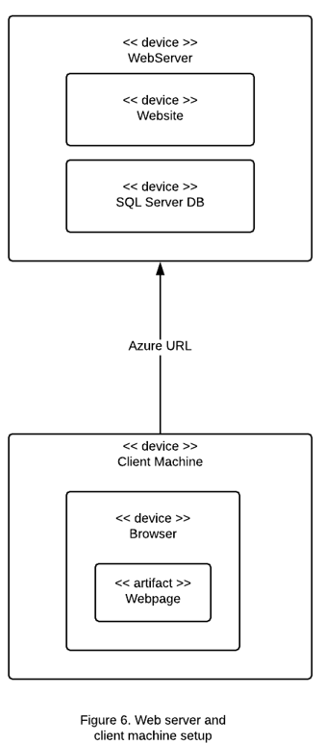

# 2. Implemented Feature List

Provide a list of implemented features and descriptions of each.

Features implemented in Textbook Trader are:

## 2.1 User Input Validation:

User input validation is done on the client side and feedback is provided accordingly.

## 2.2 Login/Logout users:

The ability to authenticate users.

## 2.3 Signup:

The ability to create new student users.

## 2.4 Password Recovery:

Sends an email to the user's email address with the recovery code.

## 2.5 Hashed And Salted Password:

Password is hashed and salted and the hash/salt values are stored in the database so that the system is never actually storing the user’s actual password.

## 2.6 Restrict users groups to certain functionality:

Depending on the group the users belong to, they are restricted/presented with certain pages.

## 2.7 Create New Posts:

Student users can create their own posts tailored to the specifics of their books.

## 2.8 Browse Posts:

Any user can browse posts freely but when it comes to viewing the details of the post only logged in users can do that. Browsing can be one through author, title and ISBN of the books.

## 2.9 Contact The Poster:

Any signed in user can contact any poster through their email without actually know it. And hence make a link with them.

## 2.10 Institute admin add books:

The institute admins can associate existing books with courses in order to officialize them according to the institute.

## 2.11 Adding new books to database:

Depending on the books ISBN number when a student user makes a post of a books that not already in the system it is added to the database.

## 2.12 Creating institutions/institution admins:

System admins can successfully create institutions and their admins.

# 3. Planned but Not Implemented Feature List

A list of features that were planned but not implemented:

## 3.1 Institute admin add new books:

The institute admins cannot add new books to the system, the logic was implemented for student users but not for institute admins.

## 3.2 Adding New Courses:

Institute admins currently cannot add new courses, the team plans to implement in a later release.

## 3.3 Smart Search

Wildcard search needs to be implemented in the brows page.

## 3.4 Custom images

Currently all the books have default images, the team plans to implement feature in order to upload custom images.

## 3.5 Institution admin association

Even though the website database has the logic for supporting an institution admin belonging to multiple institutions it is not actually implemented in business logic. The team plans to implement that in a future release.

## 3.6 Add pagination:

All the list views need to implement pagination.

# 4. Project Next Steps

The team plans to put this project on a hold for the duration of the next semester in order to focus more or the Capstone project.

If the team start on this project again sometime later in the year, we would wish to start by implementing all the features in the planned but not implemented feature list.

# 5. Known Bug List

* Being a system admin a user can add an institute admin without a valid email but, since it has an invalid email the input validation on the login page disables them to login with that ID. Hence creating an account that cannot be accessed.
* When the system admin tries to removing an institution that has records associated with it the system throws an unhandled exception and crashes.
* When the user tries to add a new post, list view displays same details for all the posts, but when they try editing posts it displays them distinctly.

# 6. Team Member Work Estimate

The estimated total number of hours per person which estimates the amount of work that into the creation of the textbook trader is about 84 hours per person.

Task breakdown for Textbook Trader:

Arindm Sharma - Stored Procedures, UI, Business Logic

Jody Markic - Stored Procedures, UI, Business Logic

Zivojin Pecin - Deployment, Business logic

Sean Moulton - Logging, UI, Business Logic

# Evaluation Form:

|  |  |  |  |
| --- | --- | --- | --- |
| Document | | Self Evaluation | Score |
|  | Completeness | 4/ 5 | / 5 |
|  | Feature Lists /Next Steps | 5/ 5 | / 5 |
|  | Known Bugs / Work Breakdown | 4/ 5 | / 5 |
| Document Total | | | / 15 |
| Demonstration | | Self Evaluation | Score |
|  | Readiness | 5/ 5 | / 5 |
|  | Functionality | 5/ 5 | / 5 |
|  | UI Quality | 4/ 5 | / 5 |
|  | Bug Free Operation | 4/ 5 | / 5 |
|  | SET Coding Standards | 5/ 5 | / 5 |
| Demonstration Subtotal | | | / 25 |
|  | Completeness Scale Factor | 5/ 5 | / 5 |
| Demonstration Total (Demonstration Subtotal * Completeness / 5) | | | / 25 |
| Reflection | | Self Evaluation | Score |
|  | Self Evaluation Accuracy | 5/ 5 | / 5 |
| Assignment Total | | | / 45 |