**Output screen shots**

**Project Title: -**

**Set Up and Monitor a WordPress Instance for Your Organization**

**Task 1. Create a Cloud Formation stack**

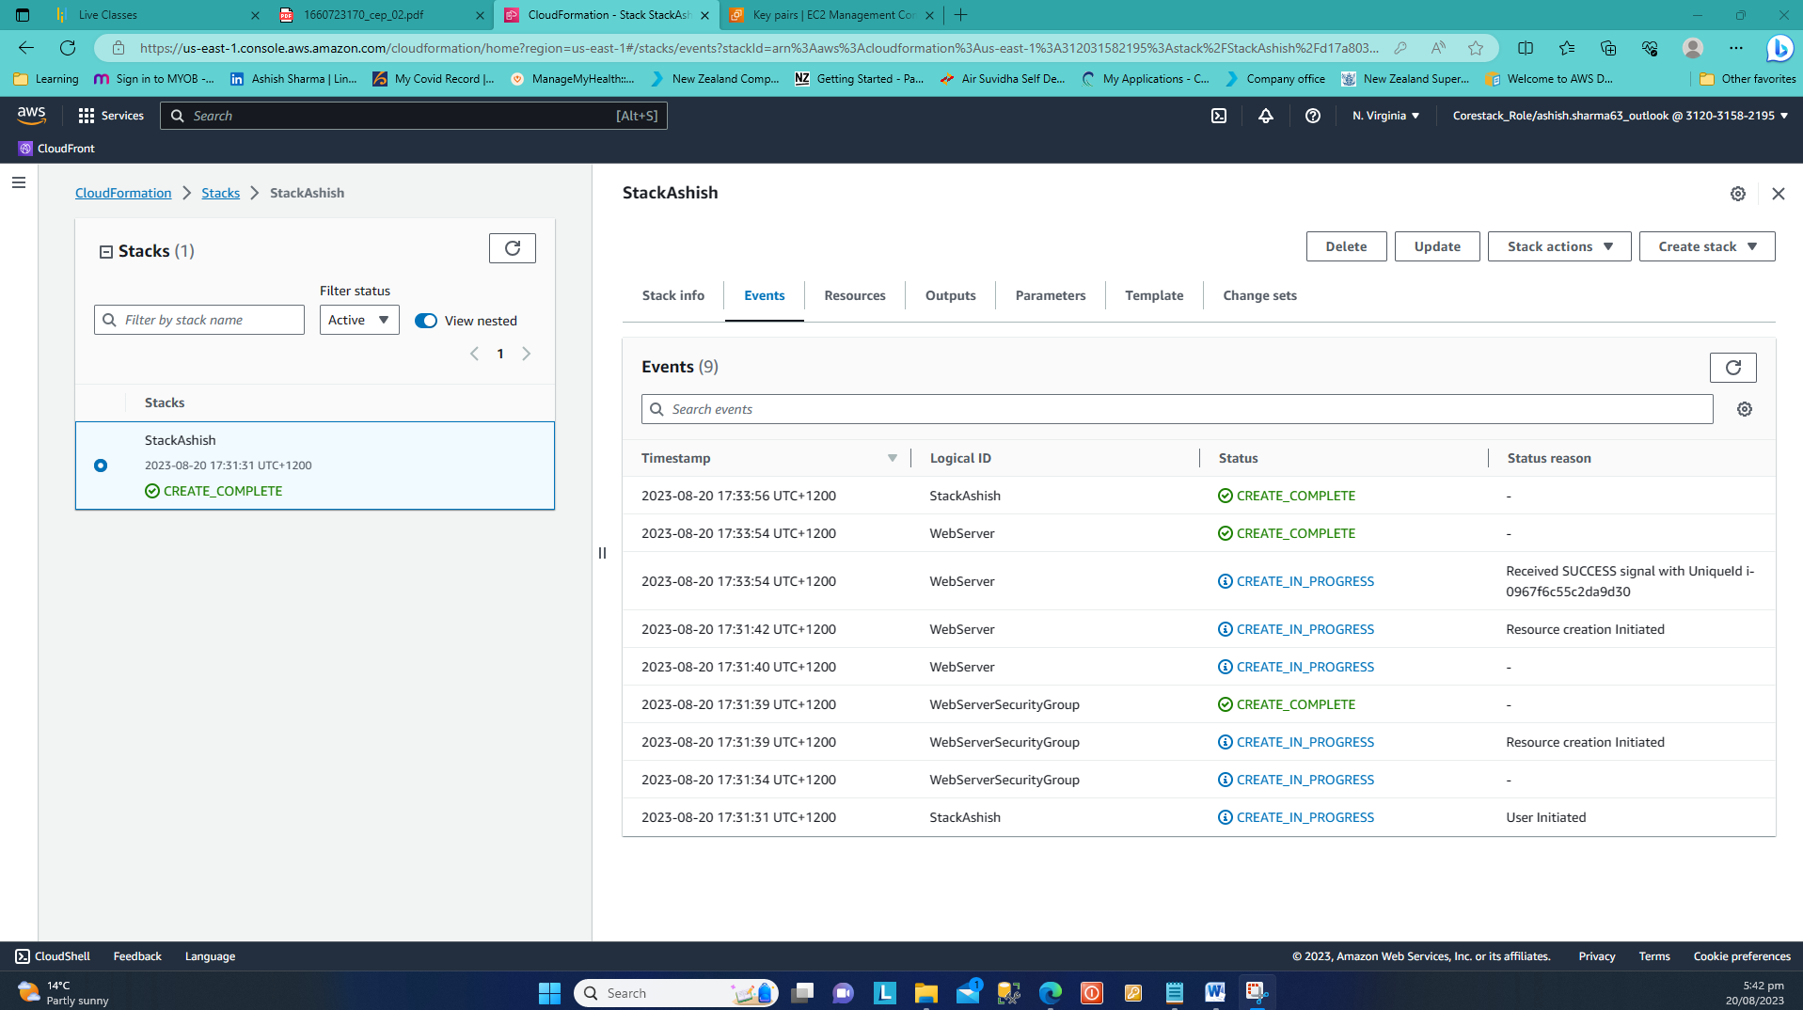

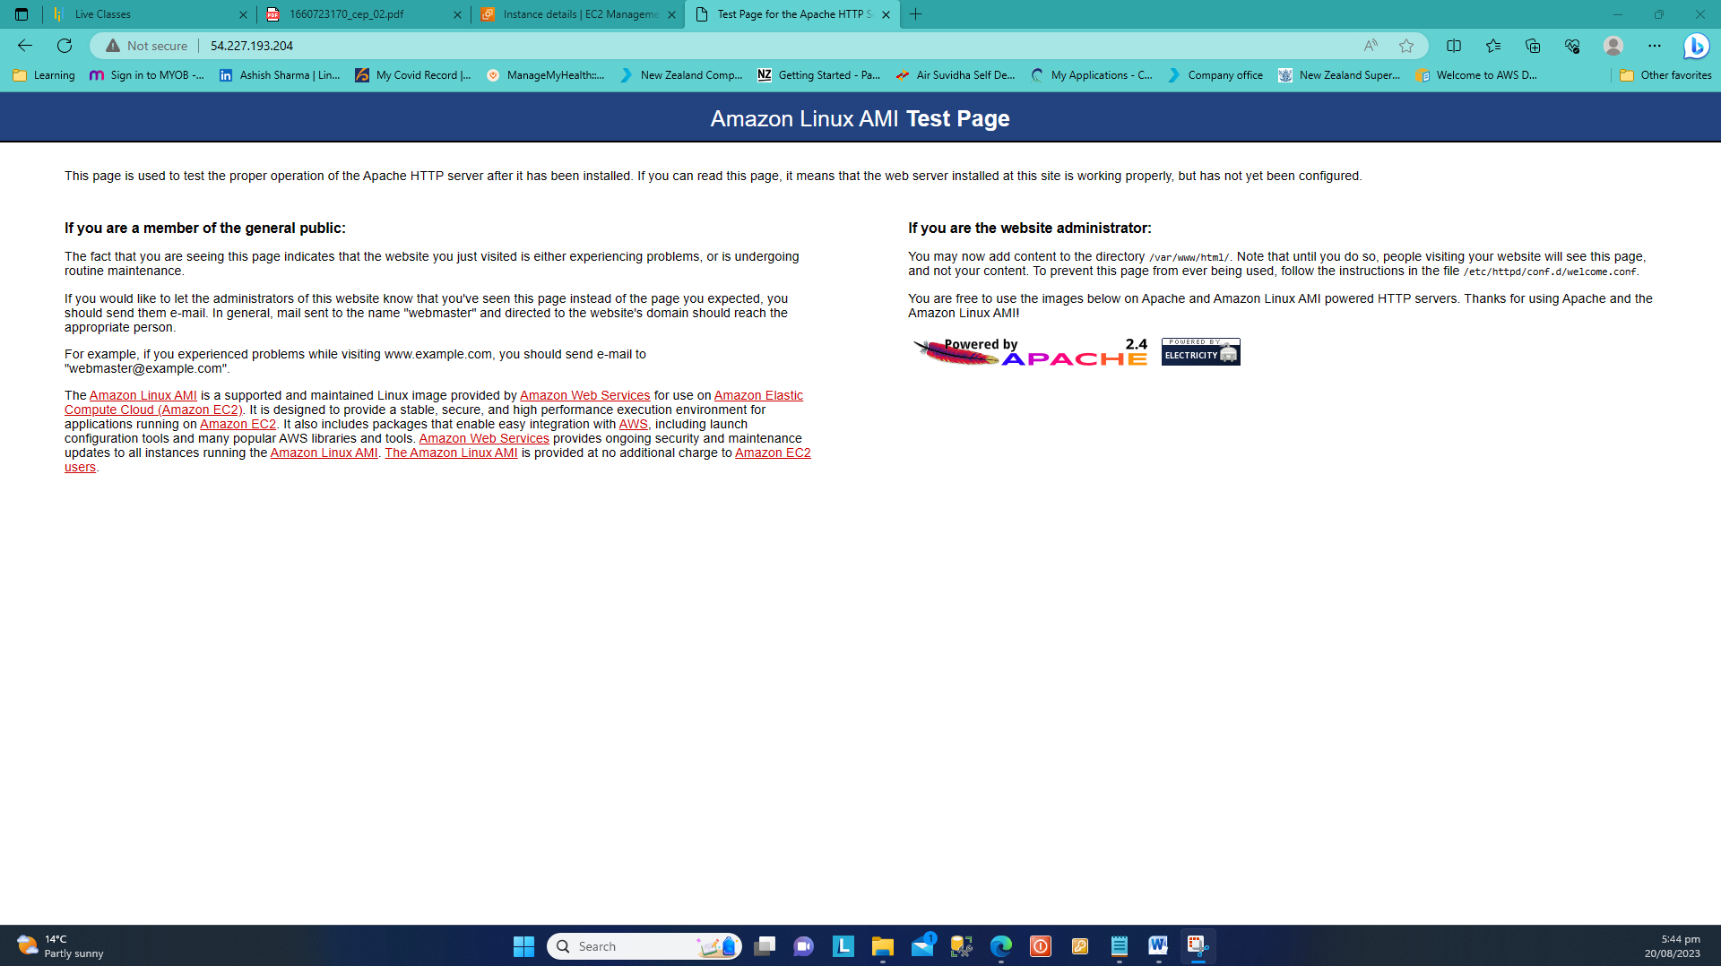

**Task 2. Create an AMI of the WordPress instance**

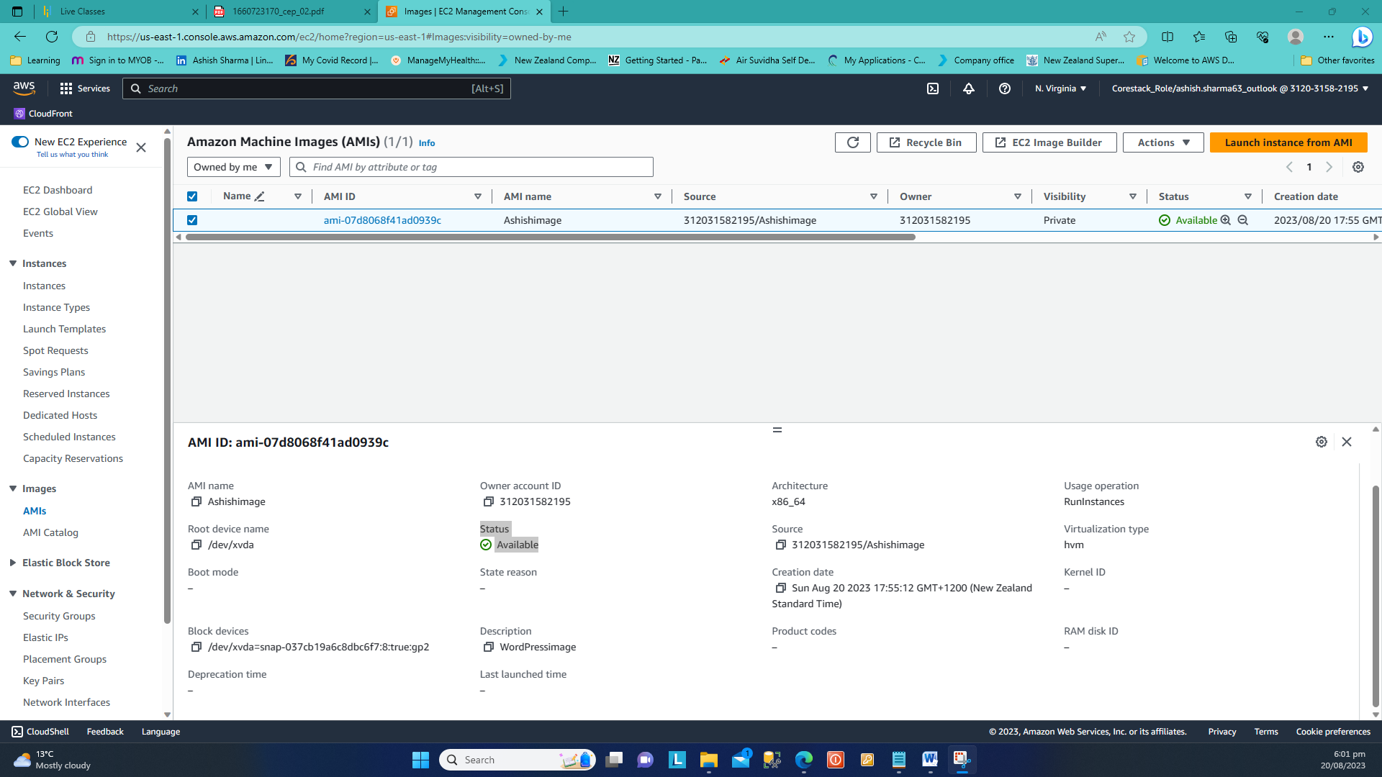

**Task 3. Configure Auto Scaling to launch a new WordPress instance**

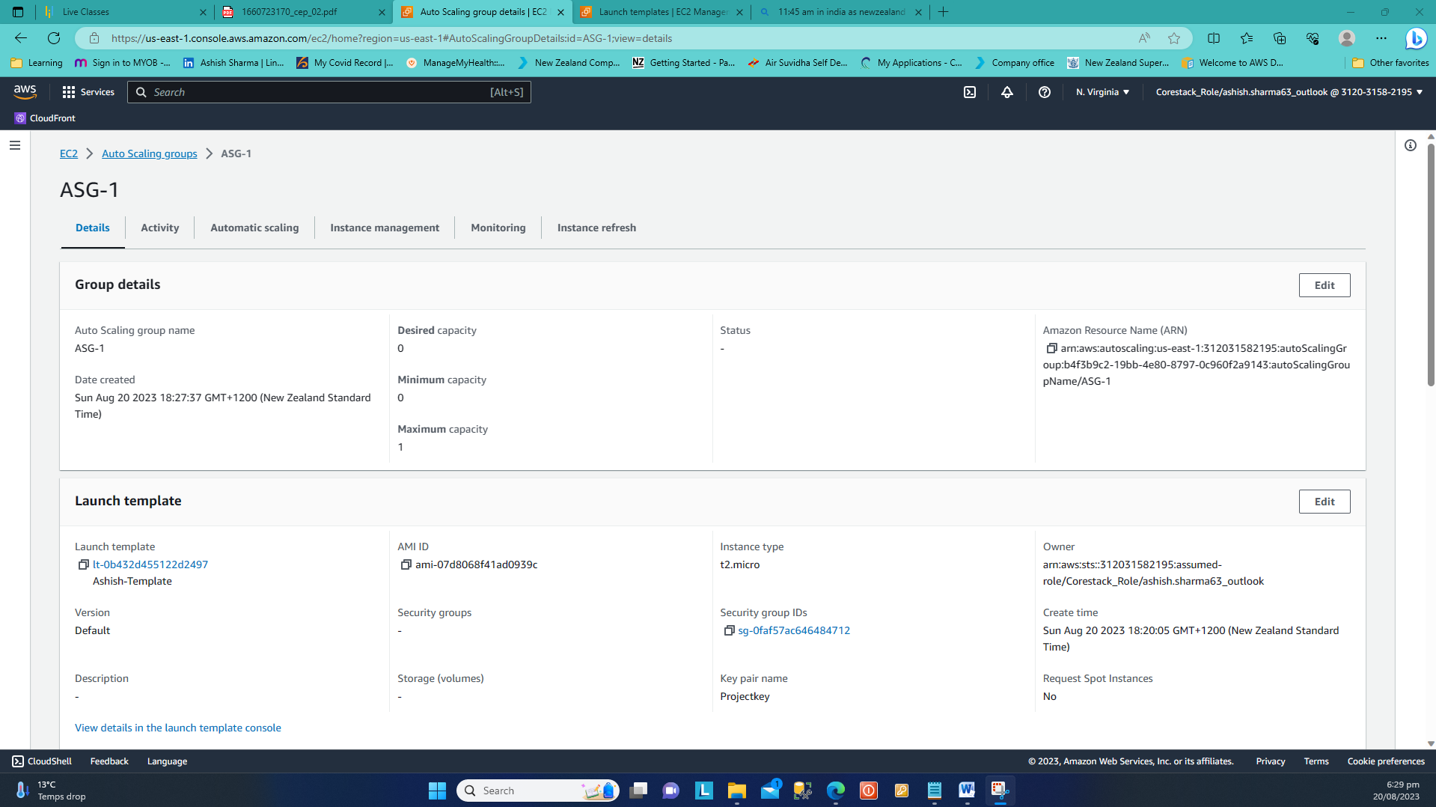

**Task 4. Configure the new WordPress instance to shut down automatically**

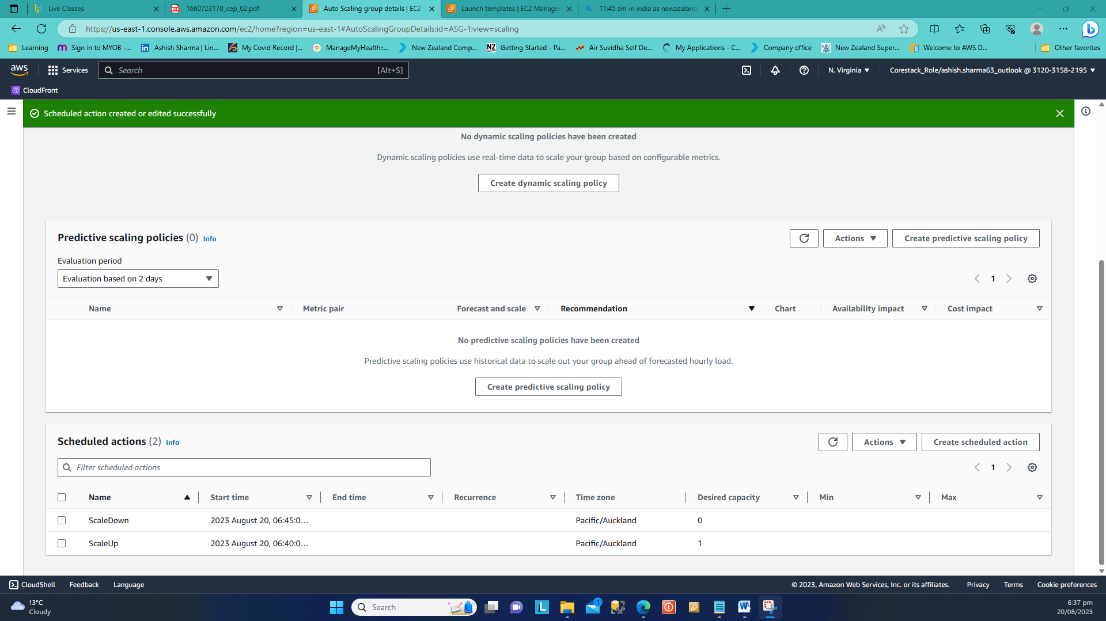

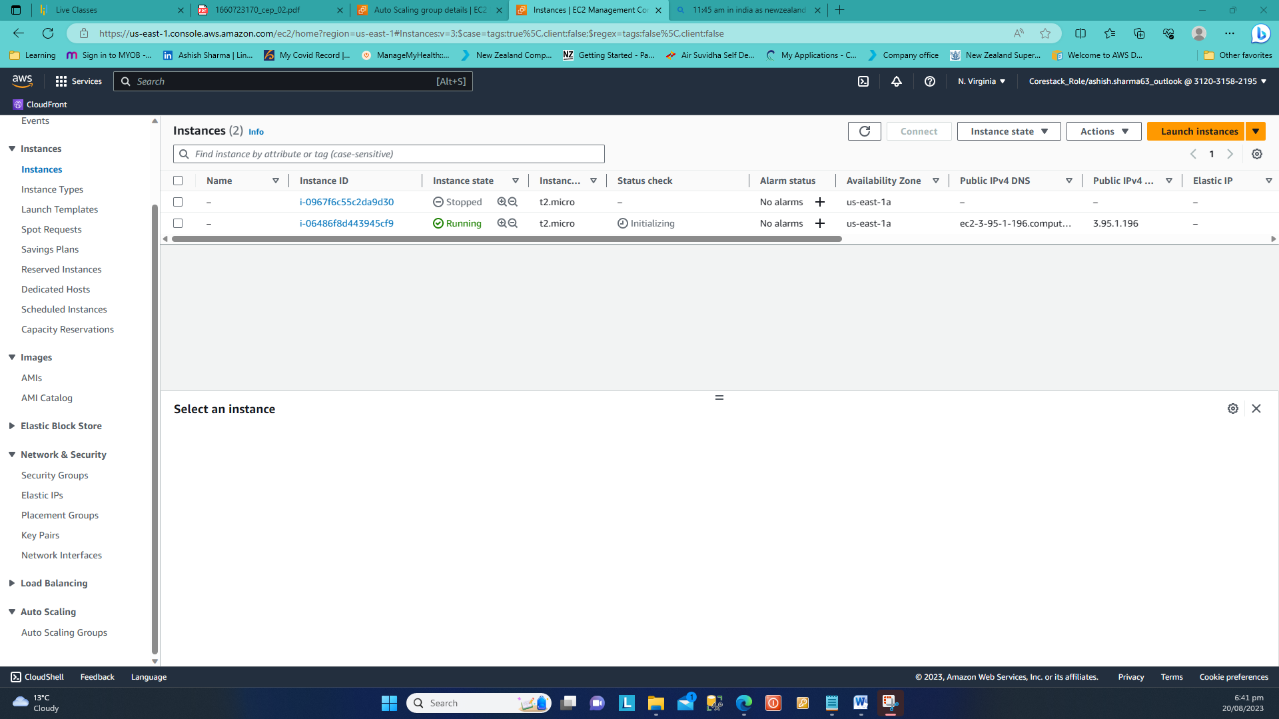

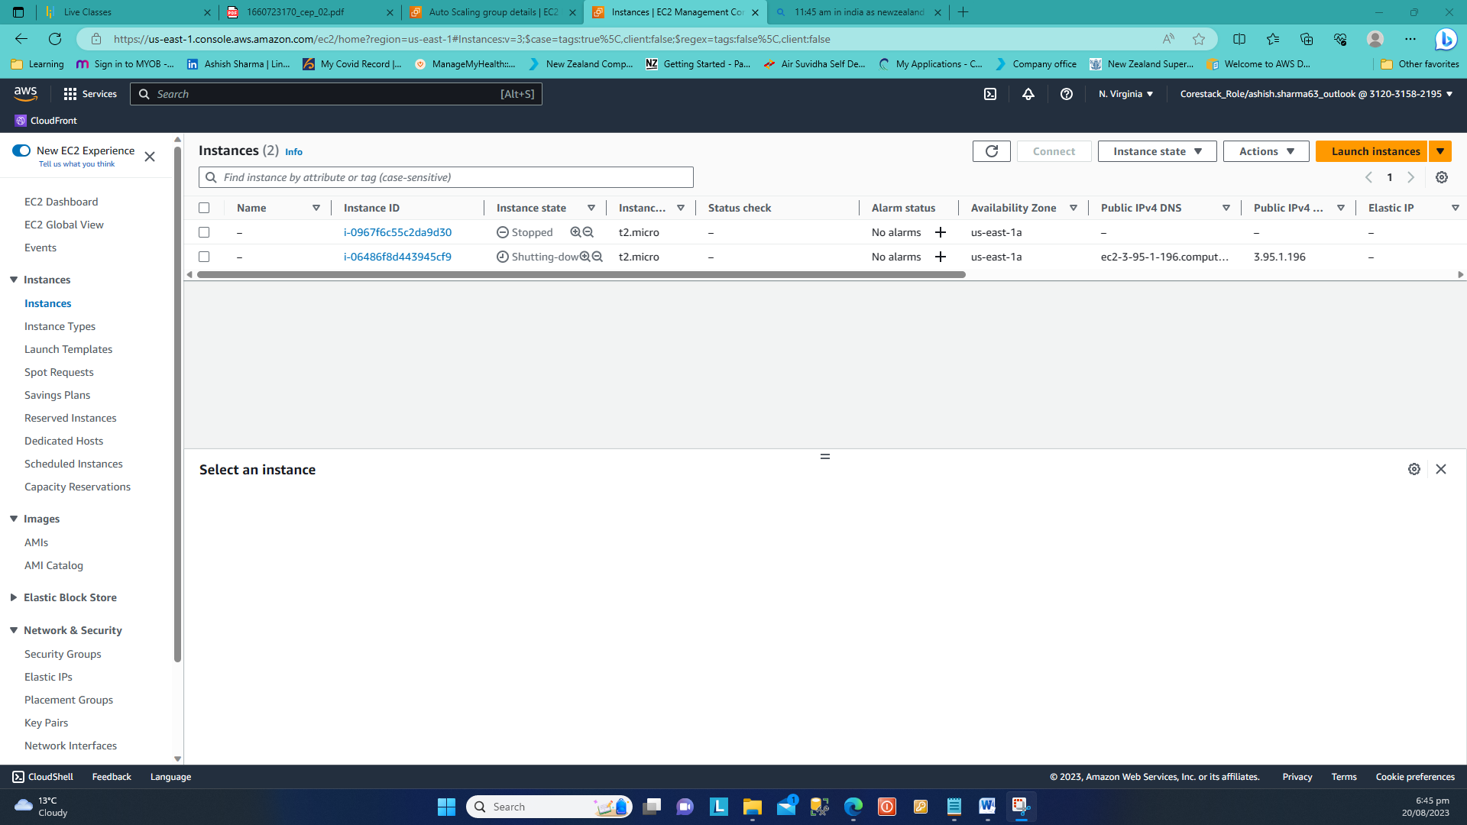

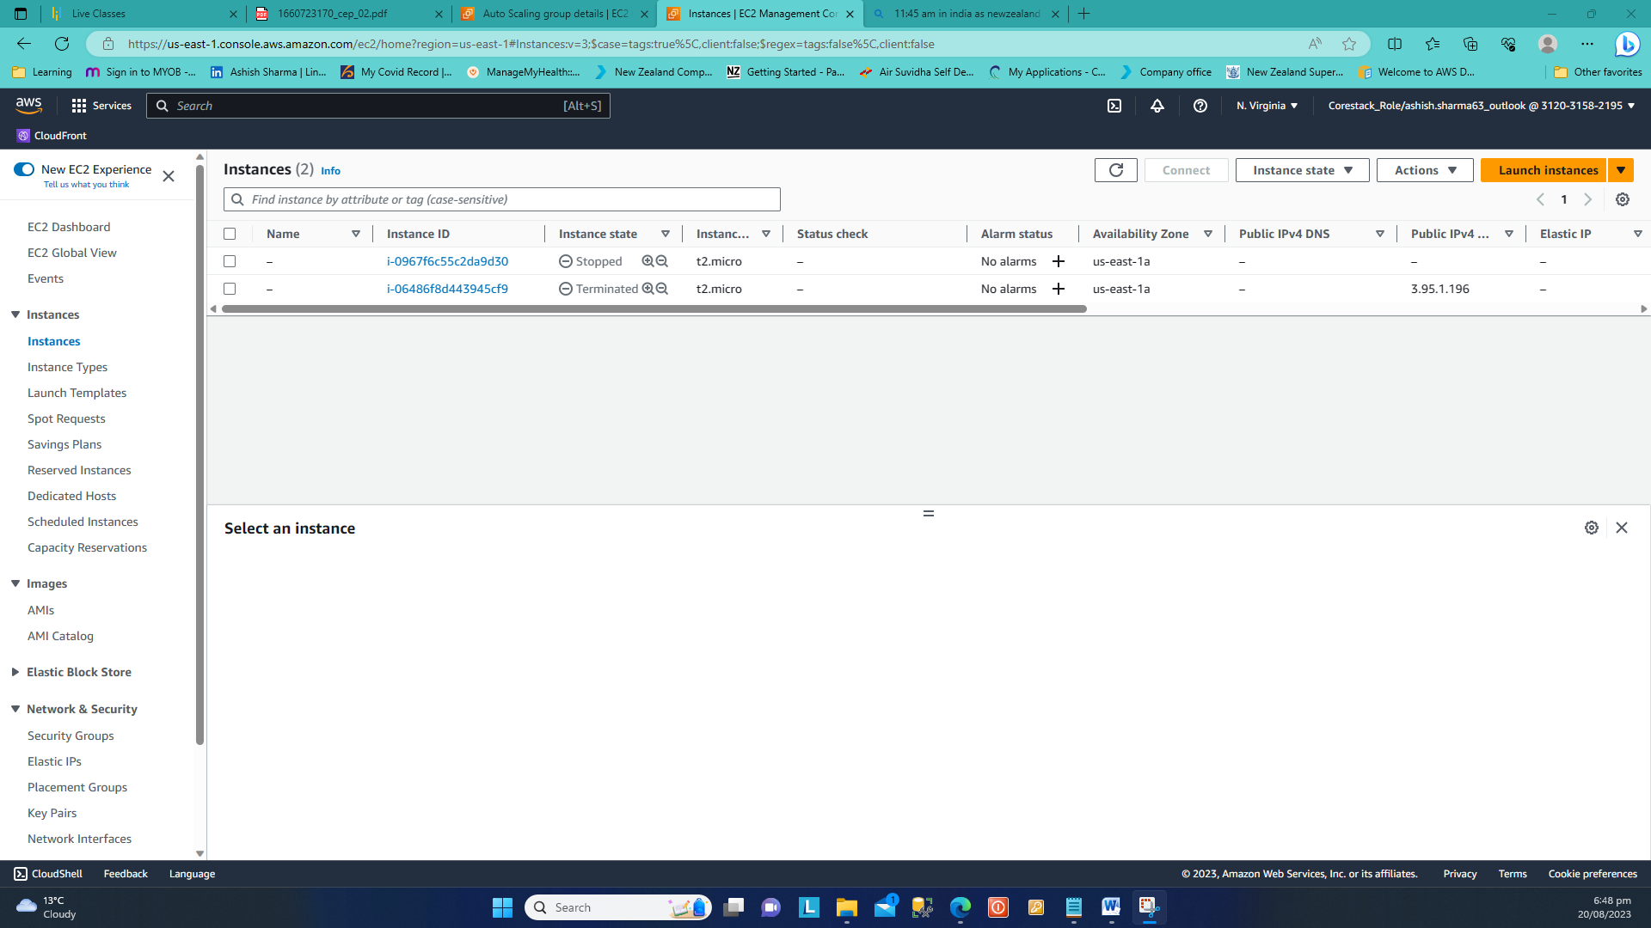

**Task 5. Monitor the instance using Availability Monitoring feature of the R53**

