**Basic Linux command:-**

1. **ls** - Lists a directory’s content

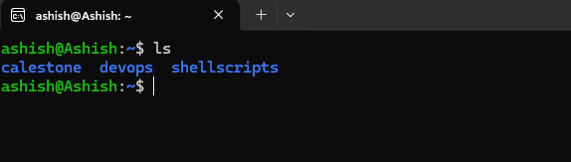

**pwd - Shows the current present working directory’s path**

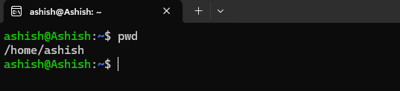

1. **cd** - Changes the working directory

**Example: cd devops will change directory to devops**

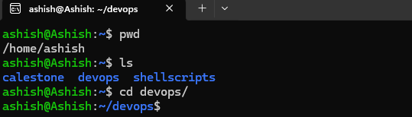

1. **mkdir** - Creates a new directory

**Example: mkdir dir1 will create a new directory as dir1**

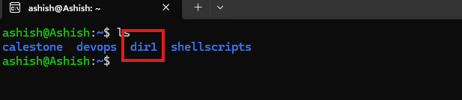

1. **rm**  - Deletes a file

**Example: rm –r dir will remove the directory dir. In this command we have used –r flag which mean recursive**

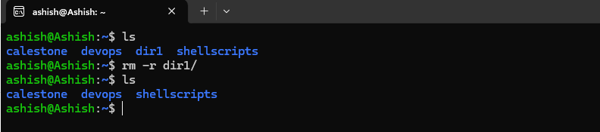

1. **cp** - Copies files and directories, including their content

**Example: cp –r shellscripts devops will copy shellscripts directory along with the file in shellscripts directory**

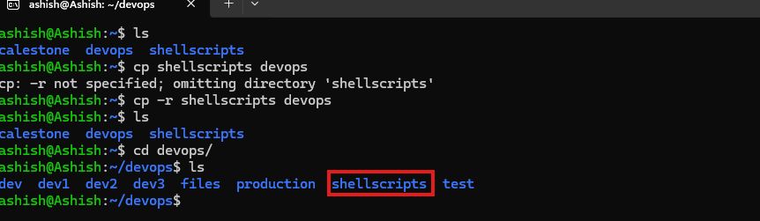

1. mv - Moves or renames files and directories

**Example: mv shellscripts scripts will rename shellscripts to scripts**

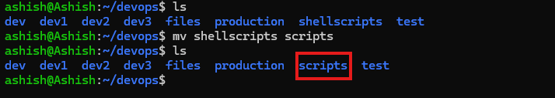

1. touch - Creates a new empty file

**Example: touch test.txt**

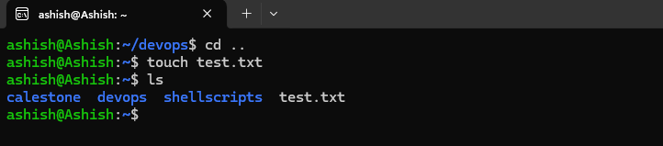

1. **zip and unzip** - Creates and extracts a ZIP archive

**Example: zip –r files.zip files, will create a zip file. Also we need to make sure we have zip installed on your system if not “run sudo apt install zip” then run that zip command**

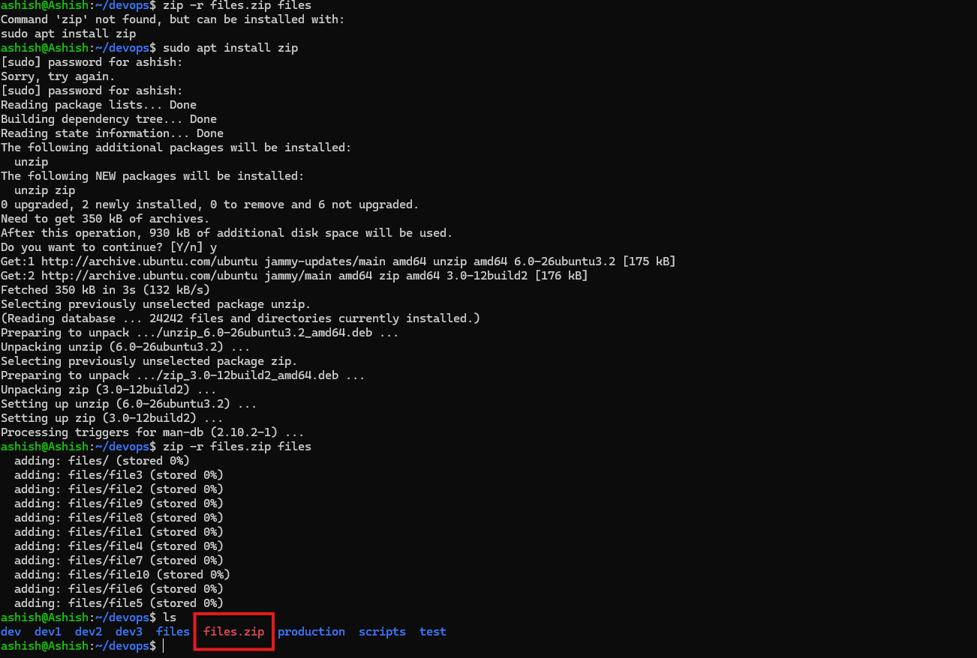

1. tar - Archives files without compression in a TAR format

**Example: tar -cvf files.tar /home/ashish/devops/files**

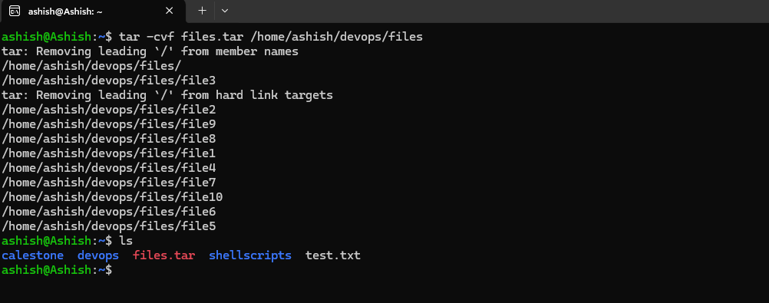

1. nano, vi, and jed- Edits a file with a text editor

**Example: vi test.txt**

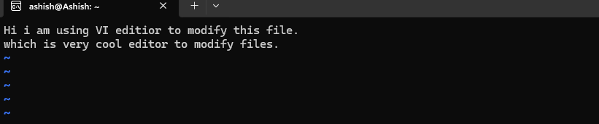

1. **cat** - Lists, combines, and writes a file’s content as a standard output

**Example: cat test.txt**

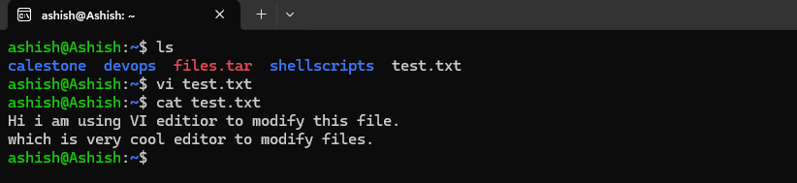

1. head - Displays a file’s first ten lines

**Example: head test.txt .This command will print first 10 line of file**

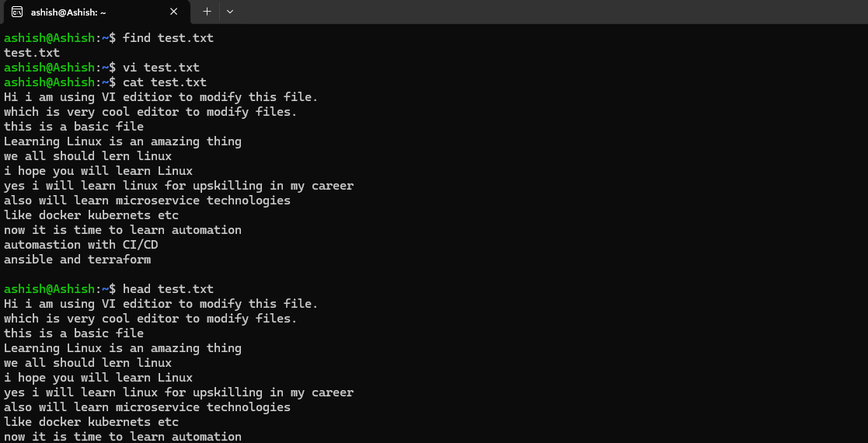

1. tail - Prints a file’s last ten lines

**Example: tail test.txt This command will print the bottom 10 line from the test.txt file**

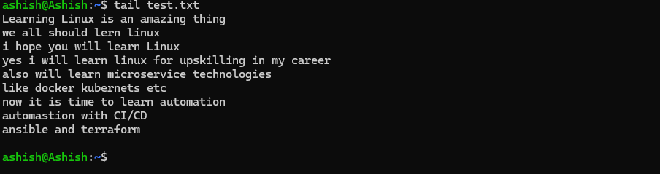

1. sudo - Runs a command as a superuser

**Example: sudo apt install zip. This command will install zip with sudo permission**

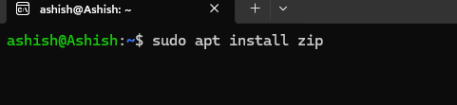

1. su - Runs programs in the current shell as another user

**Example: sudo su aryan . This command will switch user from ashish to aryan**

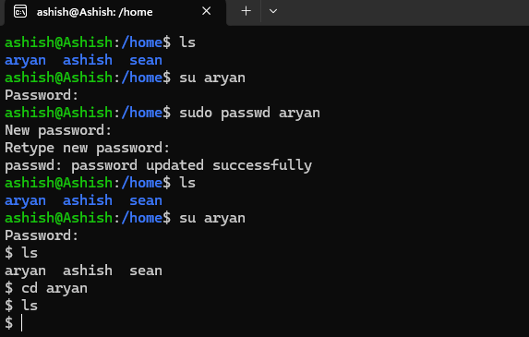

1. chmod - Modifies a file’s read, write, and execute permissions

**Example: sudo chmod 770 test.txt this command will change the permissions to rwxrwx---**

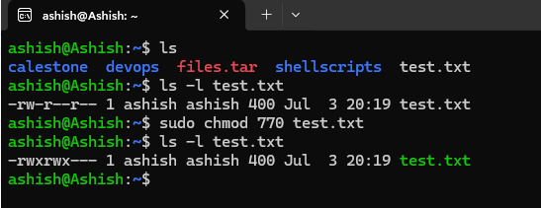

1. **df - Displays the system’s overall disk space usage**

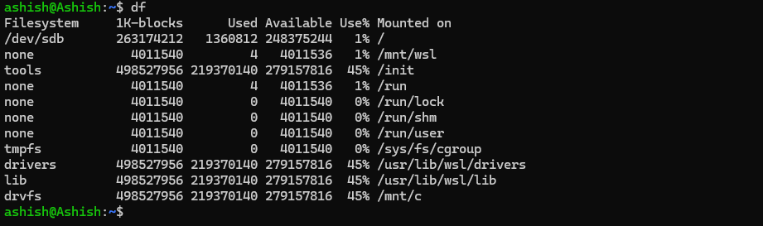

1. **du - Checks a file or directory’s storage consumption**

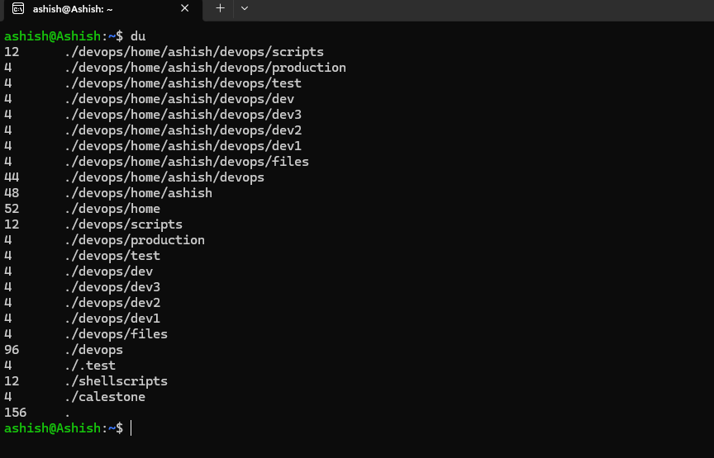

1. **top - Displays running processes and the system’s resource usage**

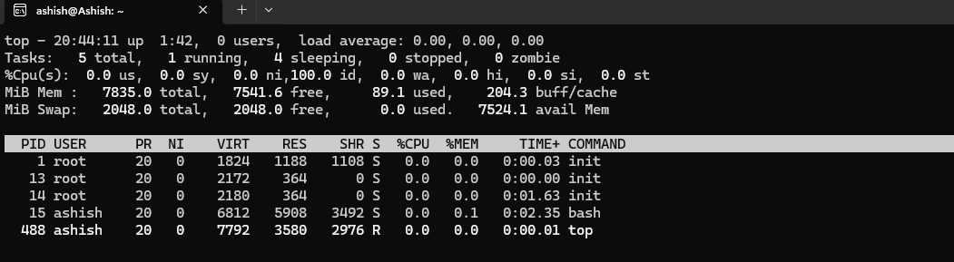

1. **ps - Creates a snapshot of all running processes**

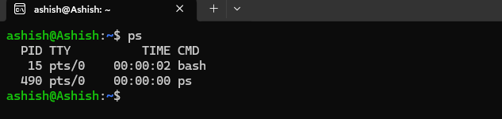

1. **uname - Prints information about your machine’s kernel, name, and hardware**

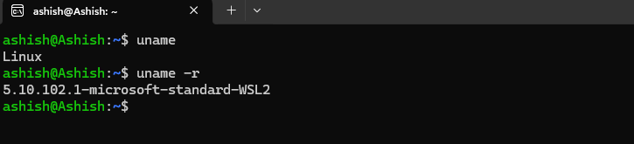

1. **hostname - Shows your system’s hostname**

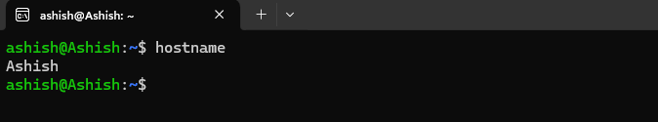

1. **time - Calculates commands’ execution time**

