**AIM** : The project is to analyse the bank data and to predict if the client will subscribe to fixed deposit term. It represents the use of various Machine Learning Algorithms and Python Programming.

**INTRODUCTION** : The bank has given a fixed deposit term to the clients in order to have a good interest and in order to do that we have a “train” file which tells us the number of people who supposedly tell us they have subscribed to the terms and on the other hand we have “test” file which tells us that we have to find out the exact number of people who have actually subscribed the terms of the deposit. We are going to extract the information, tranform the particular information which is given in string into numeric value. After that we are going to scale the data into a particular range and then apply various algorithms into this data and after that we are going to predict the outcome that is how many people have subcribed to the term deposit and then load it into a seprate file.

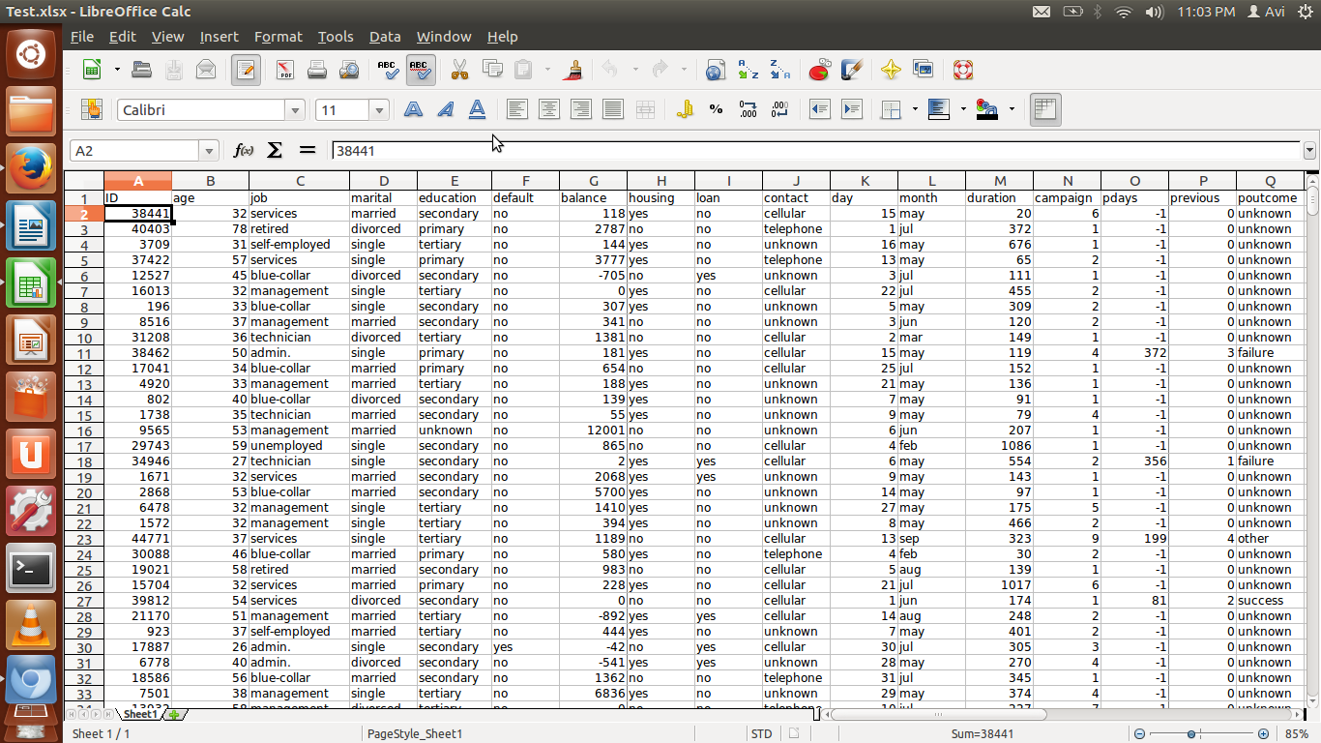

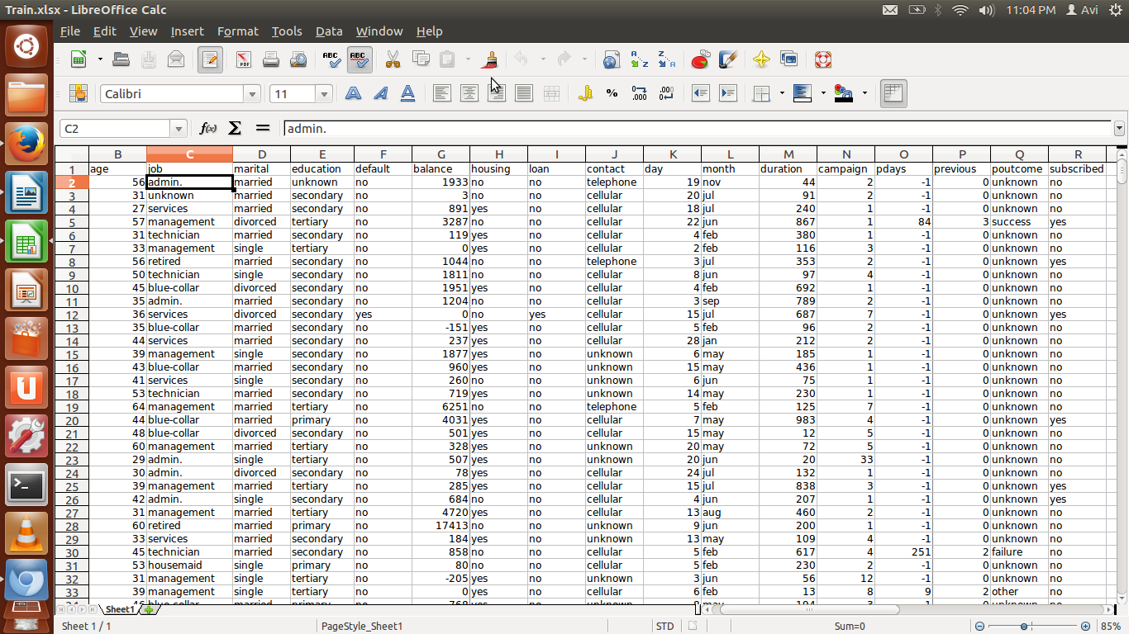

**PROGRAMMING LANGUAGES** : The following languages are used in order to execute the project,

* PYTHON PROGRAMMING
* SCIKIT
* PANDAS

**SHORT CODE SNIPPER** :

X,Y = split(x, y, test_size = )

scaler.fit(x)

KNeighborsClassifier()

Accuracy = accuracy_score()

RandomForestClassifier()

predict()

**INSTALLATIONS** : Any python programming platform for instance pycharm in order to install pycharm directly google the platform and click on the first link which represents for the windows edition and just follow the instructions and then you have download it in no time. Once you are done, we need to import some particular packages and they are :

* import pandas
* import accuracy
* from sklearn.preprocessing import StandardScaler
* from sklearn.preprocessing import KneighborClassifier

Once every installations have been done and the packages have been loaded up, we take our data from www.kaggle.com this is the reference “ ” and save it and afterwards we upload our csv file in the code which we are going to present.

**CONFIGURATION** : Once the installation has been done you need to configure the software with all the important packages which are important for the project we have to work on with and the packages are :

* import pandas
* import accuracy
* from sklearn.preprocessing import StandardScaler
* from sklearn.preprocessing import KneighborClassifier

**CREDITS** :

**CONTACT** : ##we need to insert the url of [www.kaggle.com](http://www.kaggle.com/) from where we found the dataset and the information that is all of it.

**LICENSE** : ##we need to specify the certain license of the project.

Such as “the project is licensed under [insert the license number]”

**CONCLUSION** : The final conclusion of this project is that as soon as we get our results the actual number of people who have subcribed to the term deposit will be predicted in a numeric value in 1 or 0 form depecting that 1 being a person who has subscribed and 0 being the person who has not subcribed it at all.