A project I proposal on

**“Inventory Management System”**

Submitted in partial fulfillment of the requirements for

the degree of “Bachelor of Computer Engineering”

under IOE, Tribhuvan University

Submitted by

Name: **Bibash Kumar Thakur**

Subject: C – Programming

Roll. No: **081BCT024**

Group : **A**

Under the supervision of:

**Bibash Kumar Thakur**

Date:

Feb 19,2025

**TRIBHUVAN UNIVERSITY**

**IOE, PULCHOWK CAMPUS**

# 

# Abstract

The Inventory Management System is a comprehensive software application designed to streamline and optimize inventory control processes for businesses. This project focuses on providing an efficient solution for managing inventory data, ensuring accurate record-keeping, and facilitating seamless operations. The system is developed in the C programming language and utilizes CSV files for data storage, offering a robust and portable method for handling large datasets.

Key features of the Inventory Management System include:

1. Company Information Storage: Administrators can store and manage their company’s information in a structured CSV file format, ensuring all essential details are easily accessible and up to date.

2. Insert Items: This functionality allows administrators to add new products to the inventory, including details such as quantity, price, name, and supplier information. All entries are saved in a CSV file, ensuring a reliable and persistent record.

3. Modify Items: The system provides an option to update existing product details, enabling administrators to maintain accurate and current inventory records.

4. Generate Invoice: Administrators can create invoices capturing customer details and sales transactions, stored in CSV files for tracking. An HTML version of the invoice is also generated for easy sharing. Additionally, the system updates a CSV customer database for future reference.

5. Generate Report: This feature allows administrators to generate comprehensive reports on sales information, including daily sales, profits, and other key metrics etc. These reports assist in making informed business decisions and evaluating performance.

The implementation of this system aims to improve the efficiency of inventory management, reduce errors associated with manual record-keeping, and provide valuable insights into business operations. By leveraging the capabilities of the C programming language and the simplicity of CSV file handling, the Inventory Management System offers a reliable and scalable solution for businesses of all sizes.

Table of Contents

Abstract 1

1. Company Information Storage: 1

2. Insert Items: 1

3. Modify Items: 1

4. Generate Invoice: 1

5. Generate Report: 1

Problem Statement 4

1. Inaccurate Record-Keeping: 4

2. Difficulty in Modifying Records: 4

3. Complex Invoice Generation: 4

4. Lack of Sales Reports: 4

5. Data Fragmentation: 4

6. Lack of Storing Customer Database: 4

Objective 5

Significance of Study 6

1. Improved Accuracy: 6

2. Time Savings: 6

3. Enhanced Efficiency: 6

4. Better Decision-Making: 6

5. Cost Reduction: 6

Scope 7

Limitations 8

1. Scalability: 8

2. File-Based Storage: 8

3. Concurrency: 8

4. Data Security: 8

5. User Interface: 8

Literature Study/Review 9

1. Traditional Inventory Management: 9

2. Automated Inventory Systems: 9

3. CSV File Utilization: 9

4. C Programming in Inventory Systems: 9

5. Automating Invoice Generation: 10

6. Challenges in Inventory Management: 10

7. Small to Medium-Sized Enterprises (SMEs): 10

Technical Description of the Project 11

Proposed Deliverable/Output 12

Gantt Chart 13

References 14

# Problem Statement

Effective inventory management is vital for business efficiency and profitability. Many small and medium-sized enterprises (SMEs) struggle with manual record-keeping, leading to errors, inefficiencies, and data loss. Key issues include:

1. Inaccurate Record-Keeping: Manual data entry is time-consuming and error prone.

2. Difficulty in Modifying Records: Updating inventory records is complex and often inconsistent.

3. Complex Invoice Generation:Manually creating invoices is labor-intensive and error prone.

4. Lack of Sales Reports: Generating detailed sales reports manually is challenging and unreliable.

5. Data Fragmentation:When information is scattered in different places and formats, it makes it hard to find and understand everything easily.

6. Lack of Storing Customer Database: Customer information is not systematically stored, complicating future reference and communication.

To address these issues, this project proposes an automated Inventory Management System using C programming and CSV files. The system will streamline data entry, allow easy record modifications, automate invoice generation (including customer details and HTML invoices), and provide comprehensive sales reports. This solution aims to enhance inventory accuracy, reduce errors, and improve overall business efficiency.

# Objective

The objective of this project is to develop an automated Inventory Management System using the C programming language and CSV file storage to streamline inventory control processes for businesses. The system aims to address the challenges of manual record-keeping, inefficient data management, and complex invoice generation by providing a user-friendly interface for adding, modifying, and tracking inventory items. The goal is to enhance inventory accuracy, reduce errors, and improve overall business efficiency by centralizing data management and automating key tasks such as invoice generation and sales reporting.

# Significance of Study

This study is significant for businesses, particularly small and medium-sized enterprises (SMEs), as it addresses critical challenges in inventory management. By developing an automated Inventory Management System, businesses can streamline their operations, reduce errors, and improve efficiency. The system's ability to centralize inventory data, automate tasks such as invoice generation, and provide comprehensive sales reports offers tangible benefits such as:

1. Improved Accuracy: Automation reduces the risk of errors associated with manual data entry and modification, leading to more accurate inventory records.

2. Time Savings: By automating tasks such as invoice generation and sales reporting, the system frees up valuable time for administrators, allowing them to focus on core business activities.

3. Enhanced Efficiency: Centralizing inventory data and providing a user-friendly interface simplifies the inventory management process, making it more efficient and less prone to bottlenecks.

4. Better Decision-Making: Access to comprehensive sales reports enables businesses to make informed decisions regarding inventory stocking, pricing strategies, and overall business performance.

5. Cost Reduction: By minimizing manual labor and reducing errors, the system helps businesses save on operational costs associated with inventory management.

Overall, the implementation of an automated Inventory Management System has the potential to significantly impact businesses by improving accuracy, efficiency, and decision-making processes, ultimately leading to increased competitiveness and profitability.

# Scope

The project aims to develop an Inventory Management System tailored for small to medium-sized enterprises (SMEs) utilizing the C programming language and CSV file storage. This system will encompass several key functionalities to streamline business operations.

Firstly, it will store and manage detailed company information in a CSV file, ensuring easy access and organization of crucial data. Users will be able to insert new inventory items, capturing product names, quantities, prices, and supplier information, all of which will be stored in a CSV format for efficient tracking.

The system will also allow modification of existing inventory records, enabling users to update item details as needed. Additionally, the system will facilitate invoice generation, capturing customer information and sales transactions, with data stored in CSV files and HTML invoices generated for record-keeping and customer distribution. This feature will include updating a customer database stored in a CSV file.

To support business analysis, the system will generate comprehensive sales reports, detailing daily sales and profit calculations, providing valuable insights into business performance. Emphasizing reliability, accuracy, and user-friendliness, the system is designed to enhance inventory management efficiency and support the growth of SMEs.

# Limitations

1. Scalability: The system is designed for small to medium-sized enterprises and may not handle the needs of larger organizations with very large inventories or complex operations.

2. File-Based Storage: Using CSV files for data storage limits the system's performance and efficiency compared to using a database management system (DBMS). This can result in slower data access and potential issues with data integrity.

3. Concurrency: The system may not effectively handle multiple users simultaneously making changes to the inventory, as CSV files do not support concurrent access and modifications well.

4. Data Security: CSV files do not provide robust security features such as encryption or user authentication, making the system less secure for storing sensitive information.

5. User Interface: The project focuses on core functionality and may not have a highly polished or advanced graphical user interface (GUI), potentially affecting user experience.

These limitations outline the potential constraints of the Inventory Management System, helping set realistic expectations for its capabilities and areas for future improvement.

# Literature Study/Review

Effective inventory management is essential for businesses to maintain operational efficiency, reduce costs, and meet customer demands. Various studies and existing systems highlight the importance of automation and accurate data management in achieving these goals.

## 1. Traditional Inventory Management:

Traditional methods of inventory management, such as paper records and spreadsheets, are still used by many small and medium-sized enterprises (SMEs). While these methods are straightforward, they are often prone to human error, time-consuming, and inefficient, especially as the volume of inventory increases. The manual nature of these systems can lead to discrepancies in inventory levels, loss of data, and delays in information retrieval.

## 2. Automated Inventory Systems:

Modern inventory management systems leverage software to automate data entry, track inventory levels in real-time, and generate reports. These systems significantly reduce errors, improve accuracy, and enhance decision-making processes. Automation helps in maintaining consistent inventory records, which is crucial for efficient supply chain management and customer satisfaction.

## 3. CSV File Utilization:

CSV (Comma-Separated Values) files are a simple and widely used format for storing tabular data. They are easy to implement, understand, and manipulate, making them suitable for SMEs that do not require complex database functionalities. CSV files provide an effective way to manage data without the overhead of more complex systems.

## 4. C Programming in Inventory Systems:

The C programming language is known for its performance and control over system resources, making it a suitable choice for system-level applications. C allows for efficient file manipulation and memory management, which are critical for developing lightweight inventory management systems that need to handle large datasets and perform quickly.

## 5. Automating Invoice Generation:

Automating the invoice generation process reduces administrative workload and ensures consistency in billing practices. Integrating customer information directly into the invoice process and generating HTML invoices can enhance professionalism and streamline communication with clients. Automating these tasks helps in maintaining accurate sales records and improves the overall customer experience.

## 6. Challenges in Inventory Management:

Despite the advantages of automated systems, challenges remain in their implementation. Issues such as data security, concurrent data access, and scalability need to be addressed to ensure the system's effectiveness. Ensuring data integrity and preventing unauthorized access are critical for maintaining trust and reliability in the system.

## 7. Small to Medium-Sized Enterprises (SMEs):

SMEs often lack the resources to implement sophisticated inventory management solutions. Therefore, a lightweight, cost-effective system using CSV files and basic automation can provide significant benefits without the complexity and expense of larger systems. This approach offers a practical solution for improving inventory accuracy and operational efficiency in smaller business environments.

This literature review indicates that while there are advanced systems available, there is a significant need for simple, efficient, and affordable inventory management solutions for SMEs. The proposed Inventory Management System aims to fill this gap by leveraging the C programming language and CSV file storage to deliver a robust, user-friendly tool that improves accuracy, efficiency, and decision-making in inventory management.

# Technical Description of the Project

The Inventory Management System project will be developed as a standalone desktop application using the C programming language. The system will feature a modular architecture to ensure flexibility and scalability, allowing for easy integration of new functionalities in the future.

In terms of user interface, a simple yet intuitive command-line interface (CLI) will be implemented, prioritizing ease of navigation and user-friendly interaction. Input validation mechanisms will be incorporated to maintain data integrity and enhance the user experience.

For data storage and management, CSV files will be utilized to store inventory, customer, and sales data. File input/output (I/O) operations will facilitate efficient data handling, enabling seamless manipulation and retrieval of information.

Key functionalities of the system will include the ability to add, modify, and manage inventory items, as well as generate invoices and reports based on stored data. Rigorous testing procedures will be conducted throughout the development process to ensure functionality and reliability, with a focus on unit and integration testing.

Comprehensive documentation, including user manuals and guides, will be provided to support users in understanding and utilizing the system effectively. Additionally, training sessions will be conducted to familiarize users with the features and functionalities of the Inventory Management System.

This concise description outlines the technical approach and methodologies for developing the Inventory Management System project.

# 

# Proposed Deliverable/Output

The Inventory Management System project aims to deliver a comprehensive solution tailored for small to medium-sized enterprises (SMEs) to effectively manage their inventory and streamline business operations. The proposed deliverables include a fully functional standalone desktop application developed using the C programming language, providing administrators with intuitive tools to manage inventory, generate invoices, and produce reports.

Additionally, the software package will include an executable file for easy installation and deployment on compatible desktop systems, enabling users to quickly set up and start using the system without complex installation procedures. The source code will be made available to facilitate further customization and development, allowing developers to modify the system to meet specific business requirements or integrate additional features.

To ensure continuous improvement, a feedback mechanism will be implemented to gather user input on their experiences with the system, helping to identify areas for enhancement in future updates. These proposed deliverables aim to offer a comprehensive and user-friendly solution for effective inventory management, empowering businesses to optimize their operations and drive growth.

# Gantt Chart

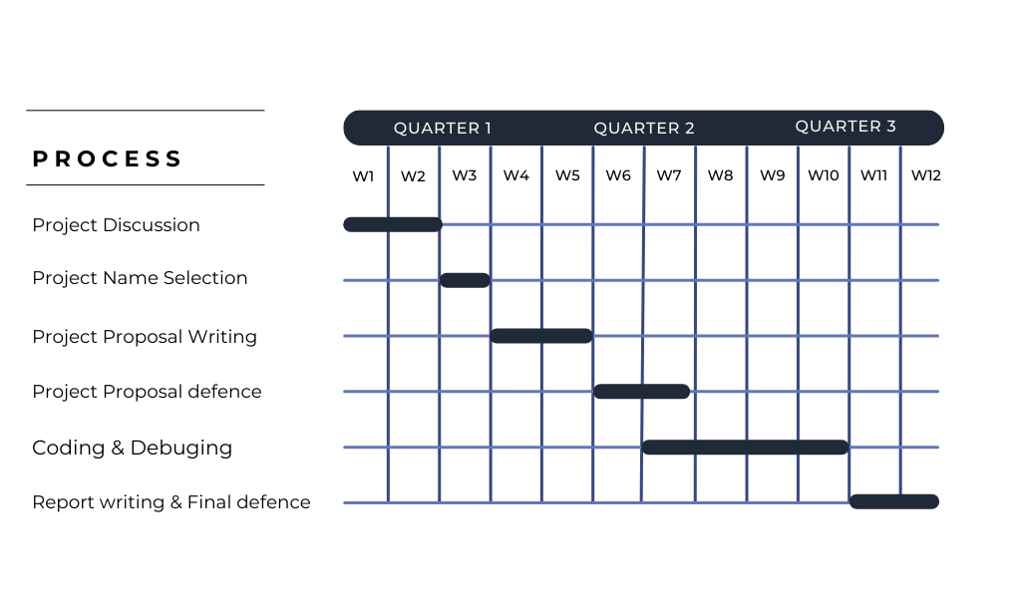

# References

1. Chopra, S., & Meindl, P. (2016). *Supply Chain Management: Strategy, Planning, and Operation*. Pearson.
2. Gupta, S., & Gupta, H. (2019). Automating Inventory Management Systems: Benefits and Challenges. *Journal of Business Systems*.
3. Kernighan, B. W., & Ritchie, D. M. (1988). *The C Programming Language*. Prentice Hall.
4. O'Regan, N. (2020). *Small Business Management: Theory and Practice*. Cengage Learning.
5. Patel, R. (2020). Efficient Billing Practices: Automating Invoice Generation. *Business Technology Journal*.
6. Smith, J., & Thomas, L. (2018). Data Management with CSV Files. *Data Science Journal*.
7. Wild, T. (2017). *Best Practice in Inventory Management*. Routledge.