LOW-LEVEL DESIGN · VERSION 2.0

Automated India Trending Topics to YouTube Shorts and Instagram Reels
Comprehensive Low-Level Design (LLD), Security Architecture and Master Implementation Guide
Attribute | Value
System architecture | Event-driven, queue-decoupled content pipeline on Azure Container Apps
Target platforms | YouTube Shorts (@chansharma870) and Instagram Reels (@Sharmac_870)
Document version | 2.0 (production-hardened revision of v1.0)
Date | 7 November 2026
Status | Approved for build: baseline for implementation
Audience | Engineers and AI coding agents building the solution; the channel operator

NOTE: Platform limits, quotas and API versions quoted in this document reflect public documentation at the time of writing and change often. Section 2 lists every such value; each must be re-verified against the official documentation during Step 0 of the build guide, and all of them are held in configuration, never hard-coded.
Contents

Document Control and Revision Summary
Version 2.0 keeps the purpose of v1.0 (find what is trending in India, write an original short script, render a 9:16 video, publish to both channels) and rebuilds the design around production engineering and security practice. The table below lists every material change and why it was made.
Area | v1.0 | v2.0 change | Reason
Trend discovery | Apify YouTube scraper and transcript extraction | Official YouTube Data API videos.list (chart=mostPopular, regionCode=IN). No transcript scraping of third-party videos. | YouTube Terms of Service prohibit automated access outside the API; transcripts of others' videos are their copyrighted work.
Content model | Script derived from trending video transcript | Original commentary on the trending topic; only licensed or generated visuals and audio | Copyright, reused-content demonetisation, and Content ID claims.
Orchestration | Single sequential controller run by cron | Staged workers connected by Azure Service Bus queues, persisted state machine, transactional outbox | A single process loses work on crash, cannot retry one stage, and blocks on 20-minute renders.
Idempotency | Not specified | Keys at every stage; resumable uploads; reconciliation before any retry of a publish | A retried upload must never create a duplicate post.
Secrets | Environment variables in docker-compose | Azure Key Vault + managed identities; no secrets in images, env files, logs or CI | Leaked OAuth refresh tokens give full channel control.
Instagram media | Public HTTP URL required | Resumable upload (upload_type=resumable) from private storage; short-lived SAS URL only as fallback | Removes the need for publicly reachable media.
OpenShorts | :latest image, port 8000 published on host | Digest-pinned image, internal ingress only, non-root, resource limits | Supply-chain and exposure risk.
LLM | Claude 3.5 Sonnet (claude-3-5-sonnet-20241022) | Current Claude model via config (default claude-sonnet-5-5), structured output, prompt-injection controls | The v1 model is retired; trending titles are untrusted input.
Governance | Auto-publish everything as public | Policy gate + human approval by default; AI-content disclosure; kill switch | Brand safety, platform policy and Indian regulatory exposure.
Observability | "Structured logging" | OpenTelemetry traces, metrics, alerts, SLOs, audit log, runbooks | Operability of an unattended system.
Diagrams | ASCII only | Nine rendered architecture diagrams | Clarity for build and review.

1. Executive Summary and System Goals
This document specifies the architecture, data model, security controls and build plan for an automated media pipeline that identifies topics trending in India, writes an original short-form script about each with a large language model, renders a captioned 9:16 vertical video, and publishes it to YouTube Shorts (@chansharma870) and Instagram Reels (@Sharmac_870).

1.1 Goals
ID | Goal | Measure
G1 | Publish timely, original short videos on topics trending in India | ≥ 3 published items per day per platform at steady state
G2 | Never publish a duplicate or a half-finished post | 0 duplicate posts; every publish attempt reconciled
G3 | Stay inside platform terms, quotas and Indian law | 0 policy strikes; quota usage < 80 % of daily budget
G4 | Protect channel credentials | Tokens only in Key Vault; 0 secrets in code, images or logs
G5 | Recover automatically from transient failures | ≥ 98 % of approved items published within 2 hours
G6 | Be operable by one person | Every alert links to a runbook entry; one-click approve, retry and kill switch

1.2 Non-goals
- Re-uploading, clipping or remixing other creators' videos, audio or thumbnails.
- Scraping YouTube, Instagram or any site whose terms do not allow automated access.
- Engagement manipulation (bulk likes, comments, follows, or cross-posting identical content across many accounts).
- Fully unattended public publishing before the quality gate has been proven (see Section 11.3).

1.3 Key design decisions
# | Decision | Alternatives considered | Rationale
D1 | Discover trends through the official YouTube Data API | Apify scraper; Google Trends scraping | Terms-compliant, stable schema, 1 quota unit per call
D2 | Queue-decoupled stages with a Postgres state machine | Single cron script; Durable Functions | Independent retries and scaling; renders run for minutes; state is queryable
D3 | Azure Container Apps (jobs + apps) | Azure Functions consumption plan | Renders need ffmpeg, large memory and long timeouts; KEDA scales on queue depth
D4 | Human approval by default, auto-approve by policy later | Always auto-publish | Brand and legal risk of LLM-written news commentary
D5 | Instagram resumable upload from private storage | Public bucket URL | No public media exposure
D6 | Secrets in Key Vault, accessed by managed identity | .env files; CI secrets | No long-lived secret ever leaves the vault boundary
D7 | Model, API versions and limits held in configuration | Hard-coded constants | Platform values change; upgrades become config changes

2. Platform Constraints, Terms and Compliance
These constraints drive the design. Every number here is a configuration value with the source noted, and must be re-checked in Step 0 of the build guide.

2.1 YouTube Data API v3
Constraint | Value (verify) | Design impact
Daily quota per Cloud project | 10,000 units by default | Quota ledger in DB; publishing stops at 80 % and alerts; request an extension through the YouTube API audit form when volume grows
Cost of videos.list | 1 unit | Discovery every 4 hours costs < 50 units/day
Cost of videos.insert | 1,600 units historically (check current quota calculator) | Budget assumes ~5 uploads/day on the default quota
Unverified API projects | Uploads from unaudited projects are locked to private | Complete the YouTube API Services compliance audit before go-live; staging uses private uploads by design
OAuth app in "Testing" status | Refresh tokens expire after 7 days | Set the consent screen to "In production"; youtube.upload is a sensitive scope that needs Google verification
Shorts format | Vertical or square, up to 3 minutes | Target 30–60 s, 1080×1920, H.264 + AAC
Synthetic content disclosure | status.containsSyntheticMedia on videos.insert | Set to true for all pipeline output (AI narration and AI-assisted visuals); conservative default
Audience declaration | status.selfDeclaredMadeForKids required | Always set explicitly to false
Metadata limits | Title ≤ 100 chars; description ≤ 5,000 bytes; tags ≤ 500 chars total | Enforced in the ScriptJSON schema

2.2 Instagram Graph API (Content Publishing)
Constraint | Value (verify) | Design impact
Account type | Instagram Professional (Business or Creator) account | Business account linked to a Facebook Page, or "Instagram API with Instagram Login"
Publishing limit | 50 API-published posts per rolling 24 h | Read GET /{ig-user-id}/content_publishing_limit before each publish
Permissions | instagram_basic, instagram_content_publish, pages_read_engagement (Facebook Login) or instagram_business_basic, instagram_business_content_publish (Instagram Login) | Standard access is enough while every account is owned by people with a role on the app; anything wider needs App Review and Business Verification
Container lifecycle | Status IN_PROGRESS → FINISHED / ERROR; containers expire after 24 h | Persist container_id; reuse within 24 h; never create a second container blindly
Media transfer | Resumable upload via rupload.facebook.com, or a public video_url | Default to resumable upload; SAS URL (≤ 15 min, read-only, single blob) only as fallback
Reels spec | MP4/MOV, H.264 or HEVC, AAC ≤ 48 kHz, 9:16, ≤ 300 MB, 23–60 fps | MediaQAService checks with ffprobe before enqueueing publish
Caption | ≤ 2,200 chars, ≤ 30 hashtags | Enforced in schema; target 3–8 hashtags
API version lifecycle | About 2 years per Graph API version; v19.0 (used in v1.0) is at or past end of life | Version is a config value; quarterly upgrade review

2.3 Content rights and third-party services
- No third-party footage, audio or thumbnails. Trending videos are used only as a topic signal. Visuals come from Pexels (Pexels License) or are generated; music only from a licensed library. Each asset's source and licence is stored in media_asset.licence_ref.
- Pexels API has default rate limits (about 200 requests/hour and 20,000/month); cache search results and follow its attribution guidelines.
- ElevenLabs: commercial use of generated speech needs a paid plan; use stock voices only, never clones of real people.
- Anthropic: follow the Usage Policy; commercial API inputs and outputs are not used for model training by default.

2.4 Indian legal and regulatory considerations
- IT (Intermediary Guidelines and Digital Media Ethics Code) Rules, 2021 and amendments: track MeitY rules on labelling synthetically generated content and apply on-screen and metadata labels when they apply.
- Digital Personal Data Protection Act, 2023 and DPDP Rules: the system processes almost no personal data (operator identities, public channel names). Do not put private individuals in scripts; keep operator data in India region (Central India).
- Defamation, elections and communal content: the policy gate blocks content naming private individuals, making unverified allegations, or covering elections, communal incidents and tragedies without human review (Section 11).
- ASCI influencer guidelines: any sponsored or affiliate content must carry a disclosure label; the pipeline does not create sponsored content by default.
CRITICAL: Go-live is blocked until: (1) the Google OAuth consent screen is in production and verified for youtube.upload; (2) the YouTube API compliance audit has passed (otherwise every upload is private); (3) the Meta app has instagram_content_publish access for the target account; (4) the operator has signed off the content policy in Section 11.

3. Architecture Overview

3.1 Architecture principles
Principle | How it is applied
Staged and decoupled | Each stage is a stateless worker reading from its own queue; a failure in one stage never loses work done by earlier stages.
Idempotent by construction | Every message carries an idempotency key; every external side effect is recorded before and after it happens (Section 5.4).
Fail closed on publishing | If policy, QA, quota or credential state is unknown, nothing is published.
Least privilege | One managed identity per workload, scoped to the specific secrets, queues and containers it needs.
Secure by default | Private networking, no public data plane, encryption in transit and at rest, signed images.
Observable | One trace per content item across all stages; every state transition is an audit event.
Configuration over code | Models, API versions, limits, schedules and policy lists are configuration.
Cost bounded | Daily budgets per vendor; the pipeline pauses when a budget is reached.

3.2 System context
The pipeline is the only system that holds channel credentials. The operator interacts only through the Review Console and alerts. All external services are called over TLS from a static egress IP.
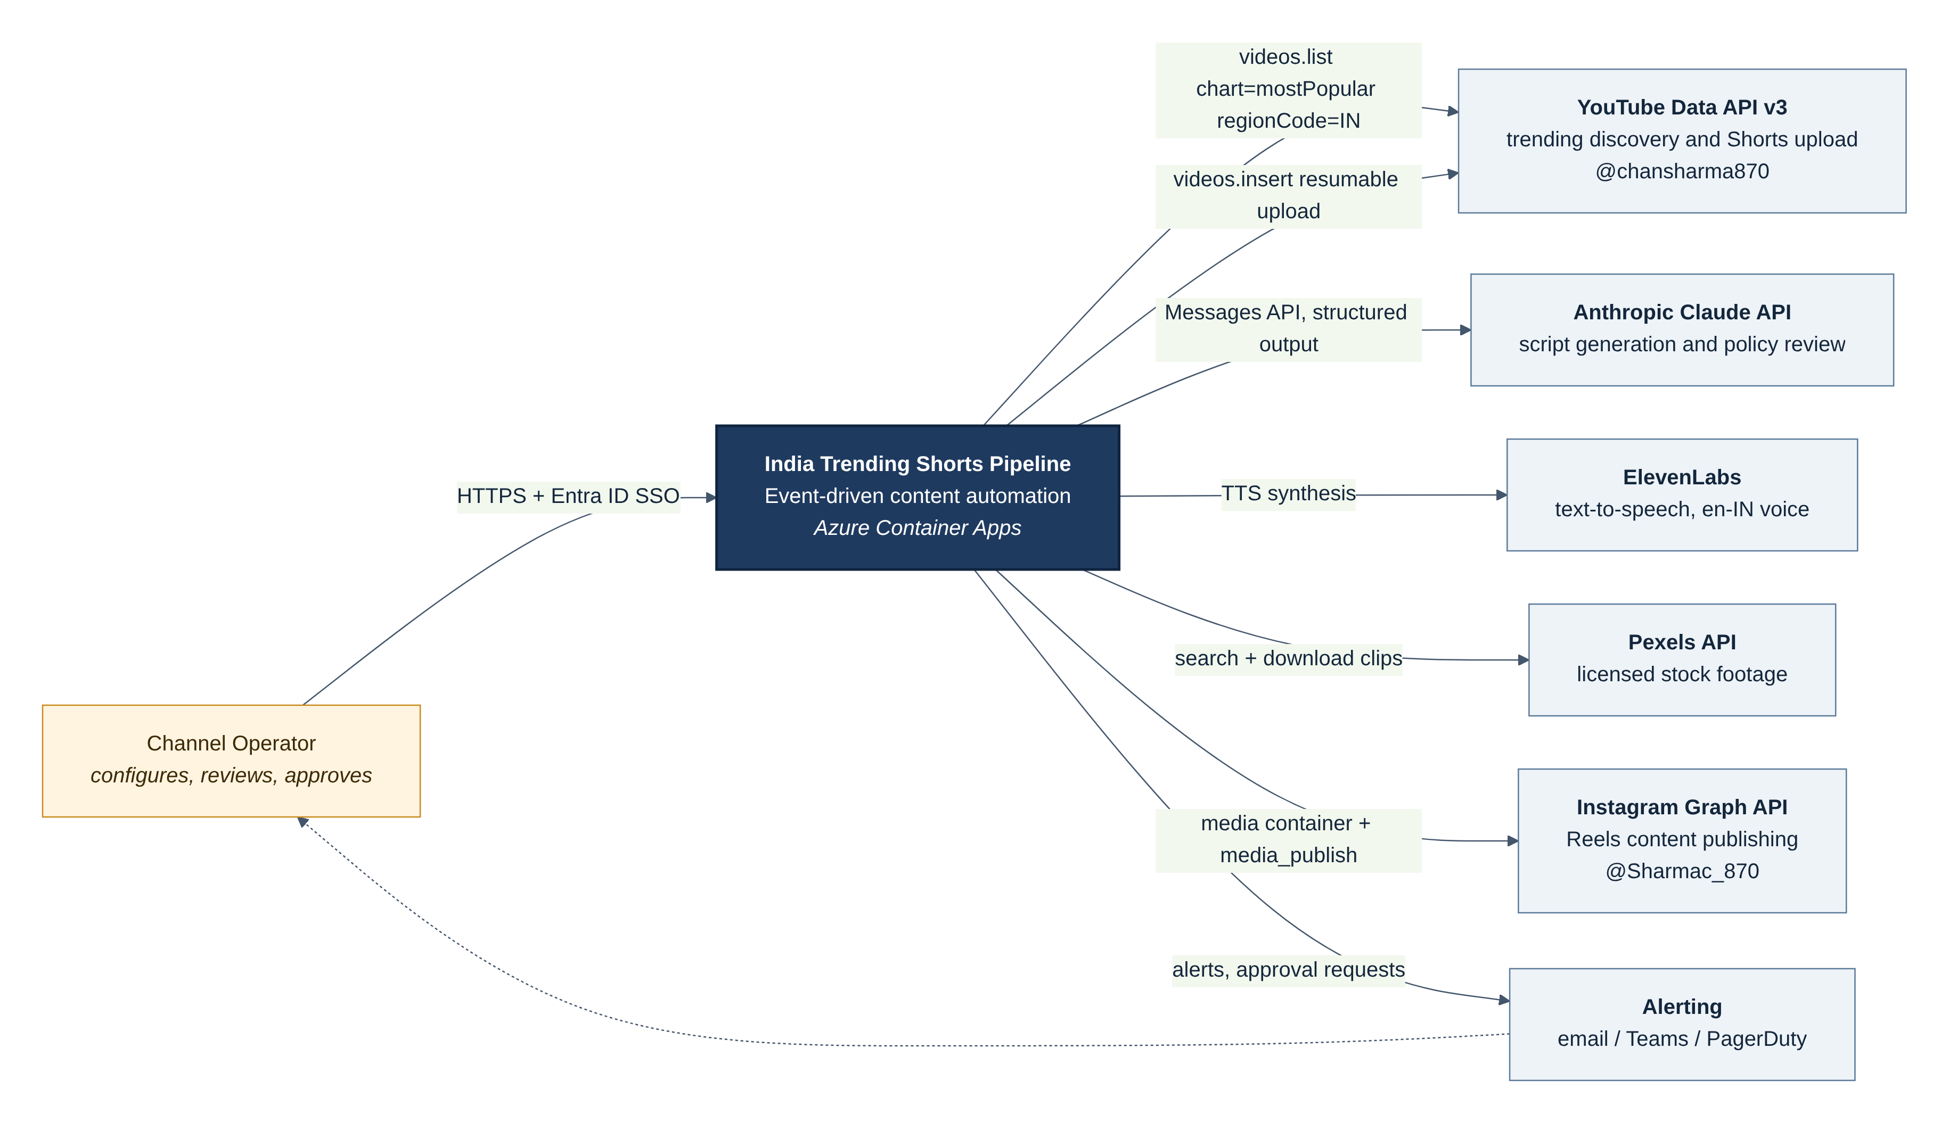
Figure 1. System context: the pipeline, its operator and the external services it depends on

4. Component Architecture
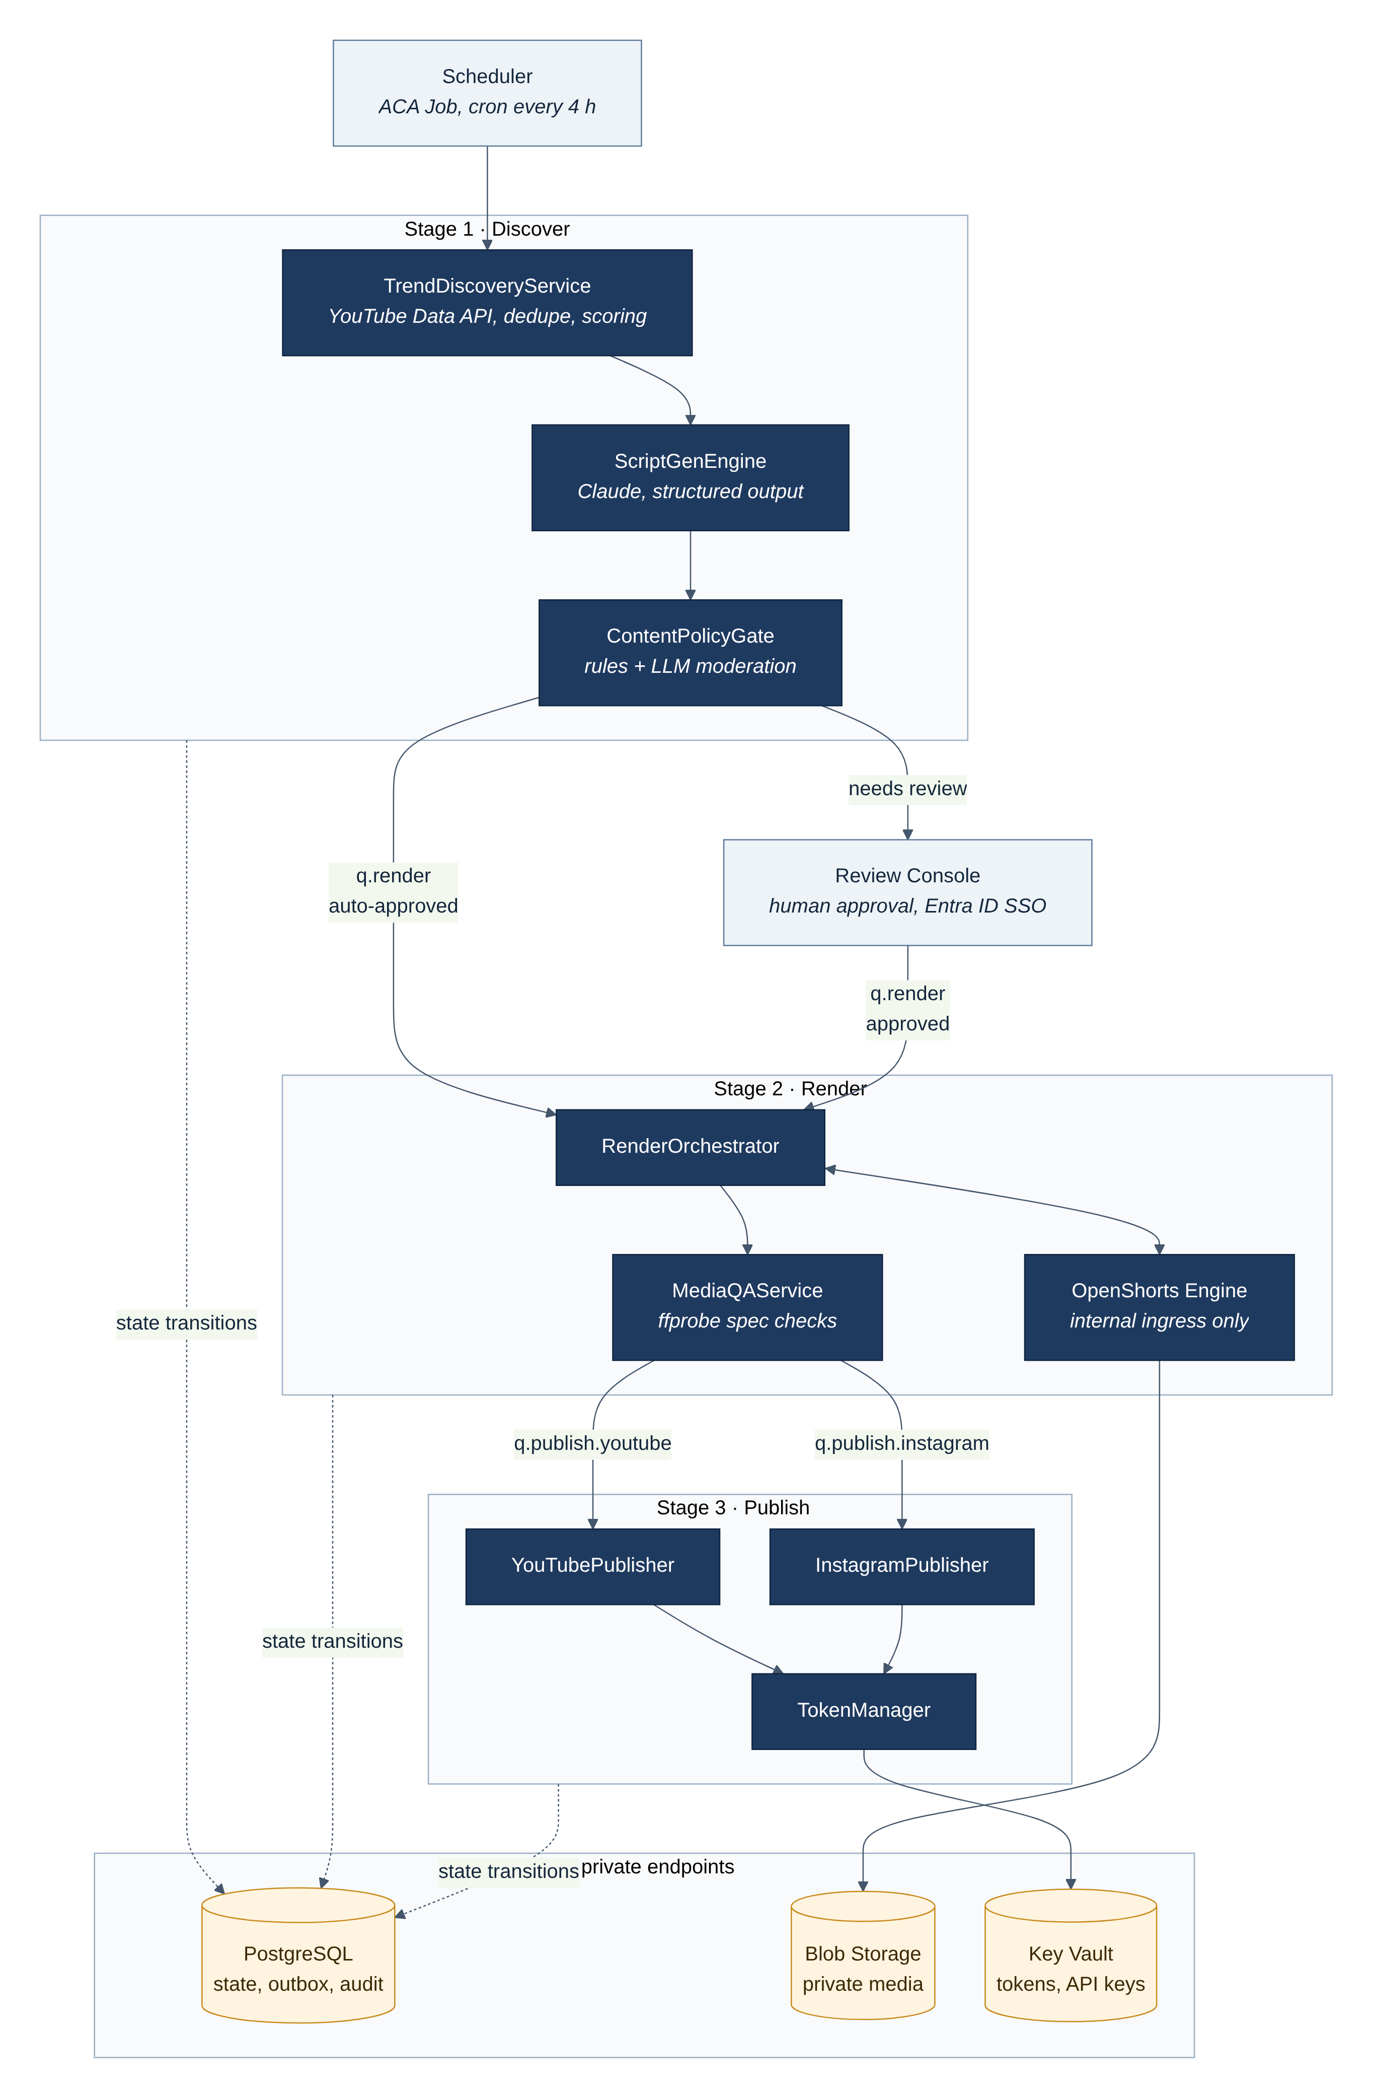
Figure 2. Component diagram: stages, queues and data stores
The system is split into three stages connected by queues. Workers are stateless and scale independently with KEDA on queue depth. All state lives in PostgreSQL; all media lives in private Blob Storage; all secrets live in Key Vault.

4.1 Component responsibilities
Component | Responsibility | Inputs / outputs | Scaling and failure behaviour
Scheduler (ACA Job) | Starts a discovery run every 4 hours (configurable) | Cron → run record | Run key YYYY-MM-DD-slot makes double triggers harmless
TrendDiscoveryService | Calls videos.list (mostPopular, IN, categories allow-list), scores by view velocity, dedupes topics over 7 days | API → trend_candidate rows, q.script messages | Single replica; on API error the run is marked FAILED and retried next slot
ScriptGenEngine | Builds a sanitised prompt, calls Claude with a strict output schema, validates the result | q.script → script_version | 0–3 replicas; 2 retries on schema failure, then REJECTED
ContentPolicyGate | Deterministic rules plus an LLM moderation pass; decides reject, review or auto-approve | Script → state change, outbox q.render | Fails closed: any error → AWAITING_APPROVAL
Review Console | Shows script, sources and risk flags; approve, edit, reject, kill switch | HTTPS (Entra ID) → state change | 1–2 replicas behind Front Door WAF
RenderOrchestrator | Submits render jobs, polls with backoff, stores output, triggers QA | q.render → render_job, media_asset | 0–2 replicas; render timeout 20 min, 2 retries
OpenShorts Engine | TTS, stock footage, captions, ffmpeg composition | Internal REST → MP4 in Blob | Internal ingress only; CPU/memory limits; restart on health failure
MediaQAService | ffprobe checks: codec, resolution, fps, duration, loudness, size, black frames | MP4 → PASS/FAIL | Fails closed
YouTubePublisher | Resumable videos.insert, quota ledger, reconciliation | q.publish.youtube → publication | 1 replica (serialised per channel)
InstagramPublisher | Container create, resumable upload, status poll, media_publish, limit check | q.publish.instagram → publication | 1 replica (serialised per account)
TokenManager | Loads secrets with managed identity, refreshes access tokens, caches in memory, detects revocation | Key Vault → bearer token | In-process library, not a service
Outbox Relay | Moves committed outbox rows to Service Bus | DB → queues | Runs inside each worker; duplicate detection on Service Bus

4.2 Module interfaces (Python)
These interfaces replace the ASCII class diagram of v1.0. Each worker depends only on these protocols, so external services can be replaced with fakes in tests.
from typing import Protocol
from uuid import UUID

class TrendSource(Protocol):
def fetch_trending(self, region: str, max_results: int) -> list[TrendPayload]: ...

class ScriptGenerator(Protocol):
def generate(self, trend: TrendPayload, *, idempotency_key: str) -> ScriptJSON: ...

class PolicyGate(Protocol):
def evaluate(self, script: ScriptJSON) -> PolicyDecision: ... # REJECT | REVIEW | APPROVE

class RenderEngine(Protocol):
def submit(self, req: RenderJobRequest, *, idempotency_key: str) -> str: ... # engine job id
def status(self, engine_job_id: str) -> RenderStatus: ...

class Publisher(Protocol):
platform: Platform # YOUTUBE | INSTAGRAM
def publish(self, item: PublishRequest) -> PublishResult: ... # must be idempotent
def reconcile(self, content_id: UUID) -> PublishResult | None: ... # find an existing post

class TokenProvider(Protocol):
def bearer(self, account: PlatformAccount) -> str: ... # never logged

5. Runtime Behaviour

5.1 Discovery, scripting and approval
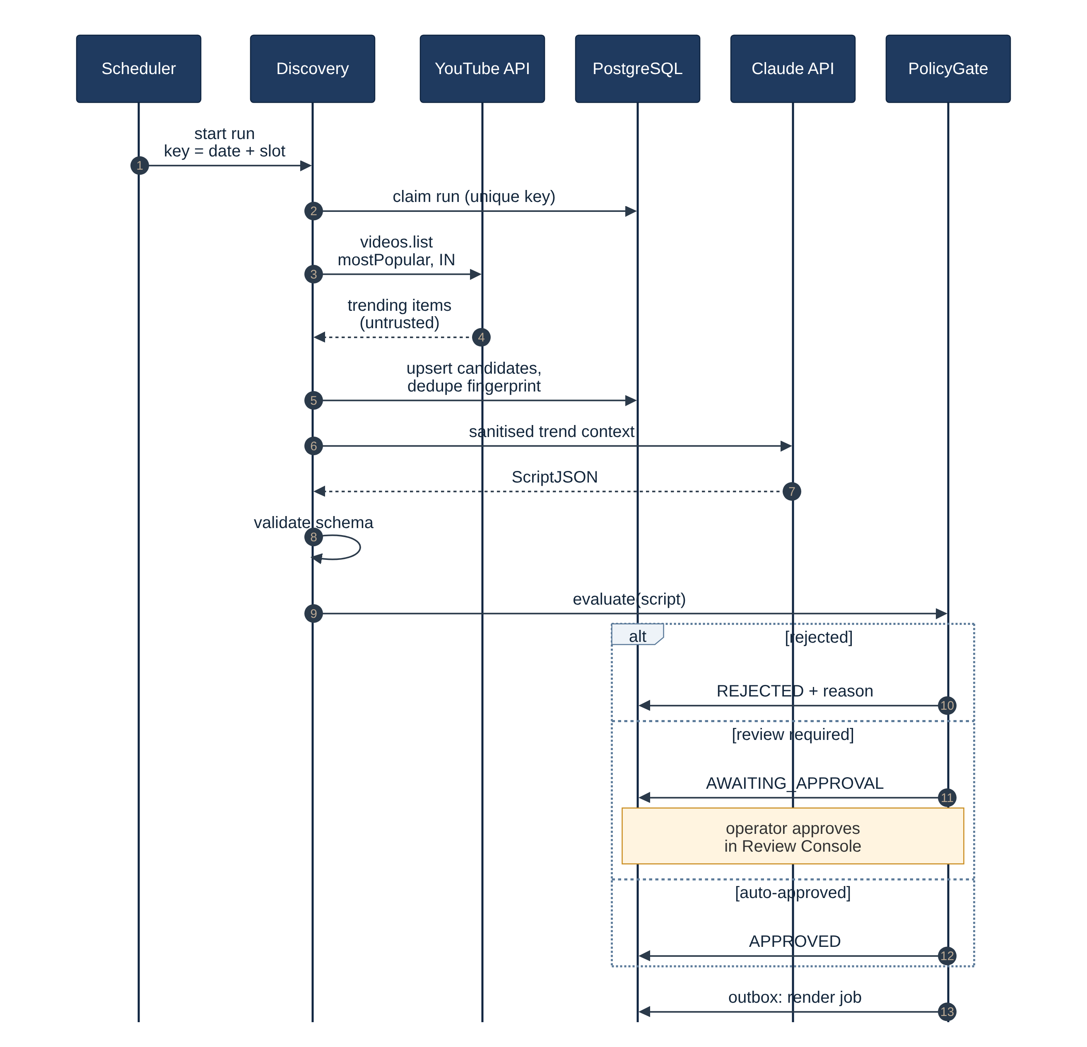
Figure 3. Sequence: discovery, script generation and policy decision
- The scheduler starts a run. Discovery claims it by inserting pipeline_run with a unique idempotency_key; a second trigger for the same slot exits.
- Discovery calls videos.list?part=snippet,statistics&chart=mostPopular&regionCode=IN&maxResults=50 and scores candidates by views per hour since publishedAt, excluding deny-listed categories.
- Candidates are normalised into a topic fingerprint (SHA-256 of normalised key phrases); topics seen in the last 7 days are SKIPPED.
- For the top N (default 5) topics, the sanitised metadata is sent to Claude inside clearly delimited data blocks; the response must match the ScriptJSON schema.
- The policy gate applies rules then an LLM moderation pass. The state change and the outbox row for q.render commit in one transaction.

5.2 Rendering and publishing
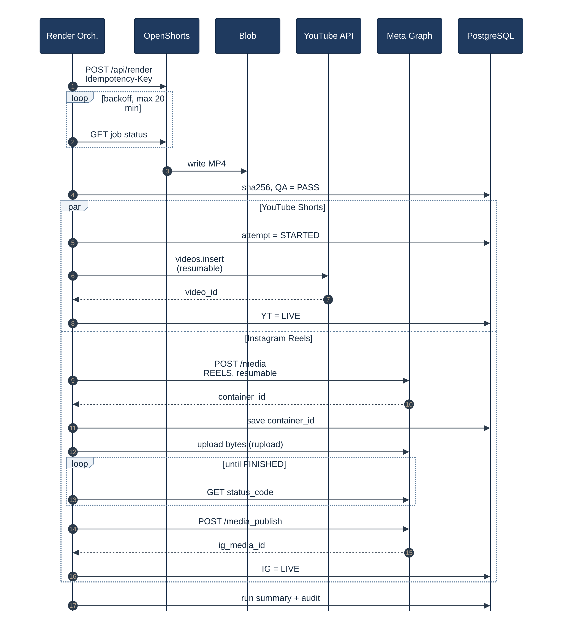
Figure 4. Sequence: render, quality check and parallel publishing with idempotency checkpoints
YouTube and Instagram publishing run as separate messages on separate queues, so one platform's outage never blocks the other. Each publisher writes an attempt row before any side effect and records the platform identifiers as soon as it receives them.

5.3 Content item state machine
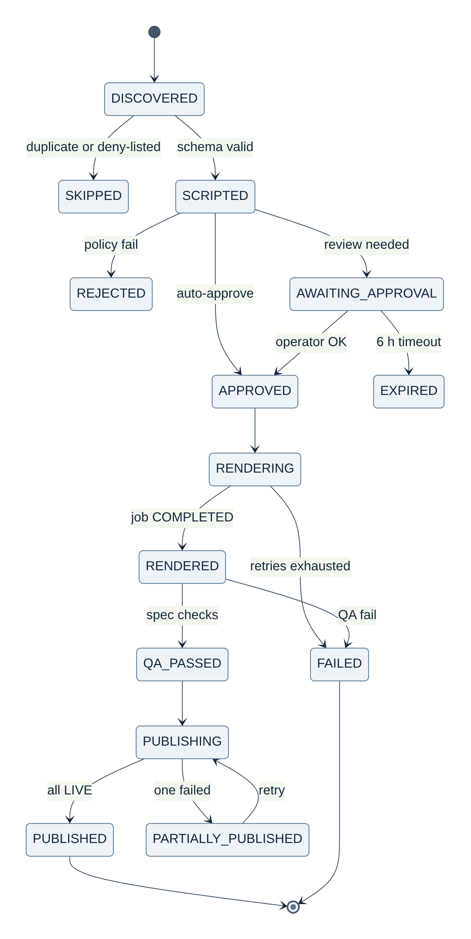
Figure 5. State machine for a content item; publication has its own per-platform sub-state
Transition rule | Enforcement
Only legal transitions are allowed | UPDATE content_item SET state=$new WHERE content_id=$id AND state=$expected (optimistic concurrency); 0 rows updated means another worker won
A message for an item in a later state is acknowledged and dropped | Consumers check the state before acting, which makes redelivery harmless
AWAITING_APPROVAL expires after 6 hours | Trends go stale; expired items can be re-approved manually
PARTIALLY_PUBLISHED needs operator action | Auto-retry is limited to transient errors; the console offers "retry platform"

5.4 Idempotency and exactly-once publishing
Message delivery is at-least-once. Exactly-once effects come from idempotency keys plus reconciliation before every retry.
Step | Idempotency key | Mechanism
Run | YYYY-MM-DD-slot | Unique constraint on pipeline_run.idempotency_key
Topic | topic_fingerprint | Unique within a 7-day window; duplicates SKIPPED
Queue messages | content_id:stage:version | Service Bus duplicate detection (10-minute window) + state check in consumer
Render | content_id:version | Idempotency-Key header; if the engine does not support it, reuse a stored engine_job_id that is not FAILED
YouTube upload | content_id | Write attempt row → open resumable session and persist the session URI → upload. After a crash, resume the session. If the outcome is unknown, reconcile by listing the channel's uploads playlist for the tag ref-<content_id short hash> before any new insert
Instagram publish | content_id | Persist container_id immediately. Before retrying, read container status_code: PUBLISHED means done (fetch the media id); FINISHED means only media_publish is needed; EXPIRED or ERROR means create a new container
CRITICAL: videos.insert and media_publish are not idempotent on the platform side. A publisher must never retry them without first running reconcile(). This rule is covered by a mandatory integration test (Section 13).

6. Data Model
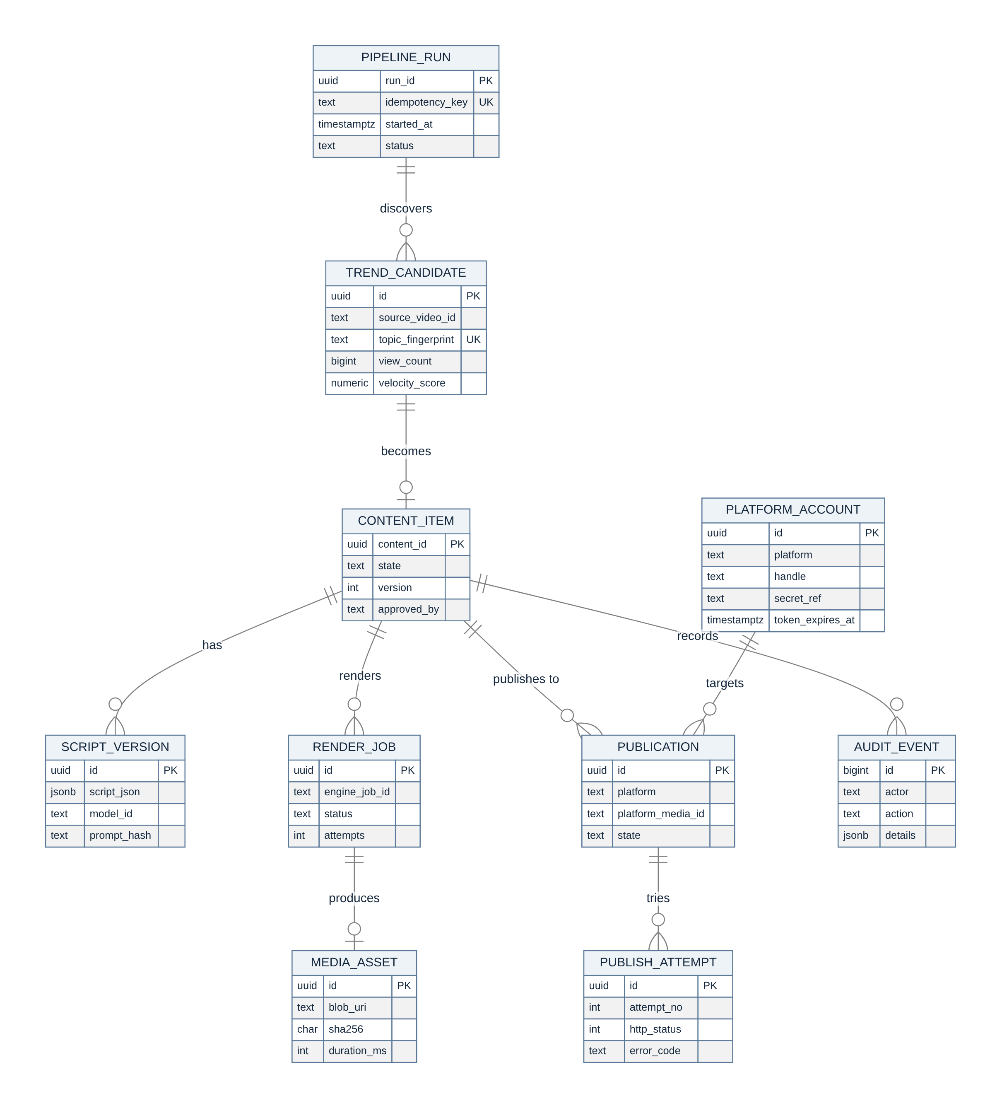
Figure 6. Entity-relationship model (PostgreSQL)

6.1 Core tables (abridged DDL)
CREATE TABLE pipeline_run (
run_id uuid PRIMARY KEY DEFAULT gen_random_uuid(),
idempotency_key text NOT NULL UNIQUE, -- e.g. 2026-11-07-slot2
status text NOT NULL CHECK (status IN ('RUNNING','SUCCEEDED','FAILED')),
started_at timestamptz NOT NULL DEFAULT now(),
finished_at timestamptz
);

CREATE TABLE content_item (
content_id uuid PRIMARY KEY DEFAULT gen_random_uuid(),
trend_id uuid NOT NULL REFERENCES trend_candidate(id),
state text NOT NULL, -- see state machine, Section 5.3
version int NOT NULL DEFAULT 1, -- optimistic concurrency
approved_by text, -- Entra ID object id, or 'policy:auto'
created_at timestamptz NOT NULL DEFAULT now(),
updated_at timestamptz NOT NULL DEFAULT now()
);

CREATE TABLE publication (
id uuid PRIMARY KEY DEFAULT gen_random_uuid(),
content_id uuid NOT NULL REFERENCES content_item(content_id),
platform text NOT NULL CHECK (platform IN ('YOUTUBE','INSTAGRAM')),
state text NOT NULL, -- PENDING|UPLOADING|PROCESSING|LIVE|FAILED
upload_session text, -- YouTube resumable session URI
ig_container_id text,
platform_media_id text,
UNIQUE (content_id, platform) -- one post per platform per item
);

CREATE TABLE outbox (
id bigserial PRIMARY KEY,
queue text NOT NULL,
message_id text NOT NULL UNIQUE, -- content_id:stage:version
payload jsonb NOT NULL,
created_at timestamptz NOT NULL DEFAULT now(),
sent_at timestamptz
);

CREATE TABLE audit_event ( -- append-only: no UPDATE/DELETE grants
id bigserial PRIMARY KEY, at timestamptz NOT NULL DEFAULT now(),
actor text NOT NULL, content_id uuid, action text NOT NULL, details jsonb NOT NULL
);

6.2 Message and domain schemas (Pydantic v2)
All inter-stage payloads are validated Pydantic models with explicit length limits taken from the platform constraints in Section 2. Untrusted text is never interpolated into code, SQL or shell commands.
from datetime import datetime
from enum import StrEnum
from pydantic import BaseModel, Field, HttpUrl, field_validator

class TrendPayload(BaseModel):
source_video_id: str = Field(pattern=r"^[A-Za-z0-9_-]{11}$")
title: str = Field(max_length=200) # untrusted: sanitised before LLM use
channel_title: str = Field(max_length=100)
category_id: str
view_count: int = Field(ge=0)
published_at: datetime
velocity_score: float = Field(ge=0)
tags: list[str] = Field(default_factory=list, max_length=30)

class Language(StrEnum):
EN_IN = "en-IN"
HI_IN = "hi-IN"

class ScriptJSON(BaseModel):
topic: str = Field(max_length=120)
title: str = Field(max_length=95) # room for " #Shorts" within 100 chars
description: str = Field(max_length=4500)
caption: str = Field(max_length=2000) # Instagram limit 2,200
hashtags: list[str] = Field(min_length=3, max_length=8)
tags: list[str] = Field(max_length=15) # combined length checked below
language: Language = Language.EN_IN
hook_text: str = Field(max_length=120) # first 3 seconds
narrative_body: str = Field(max_length=1200) # about 45 s of speech
visual_cues: list[str] = Field(min_length=3, max_length=12)
call_to_action: str = Field(max_length=120)
claims_need_sources: bool # true if facts are asserted
sources: list[HttpUrl] = Field(default_factory=list, max_length=5)
risk_flags: list[str] = Field(default_factory=list)

@field_validator("tags")
@classmethod
def tags_total_length(cls, v: list[str]) -> list[str]:
if sum(len(t) + 1 for t in v) > 480:
raise ValueError("YouTube tags exceed 500 characters")
return v

class RenderJobRequest(BaseModel):
content_id: str
script: ScriptJSON
voice_id: str = "en_IN_male"
aspect_ratio: str = "9:16"
resolution: str = "1080x1920"
subtitle_style: str = "animated_highlight"
max_duration_s: int = Field(default=60, le=90)

6.3 Data retention
Data | Store | Retention
Rendered MP4 and intermediates | Blob (private container, lifecycle policy) | 30 days after publish, then deleted
Scripts, prompts (hash + text), policy decisions | PostgreSQL | 1 year
Audit events | PostgreSQL (append-only) + Log Analytics export | 1 year minimum
Application logs and traces | Log Analytics | 90 days
OAuth tokens and API keys | Key Vault (soft delete + purge protection) | Until rotated or revoked

7. Deployment Architecture
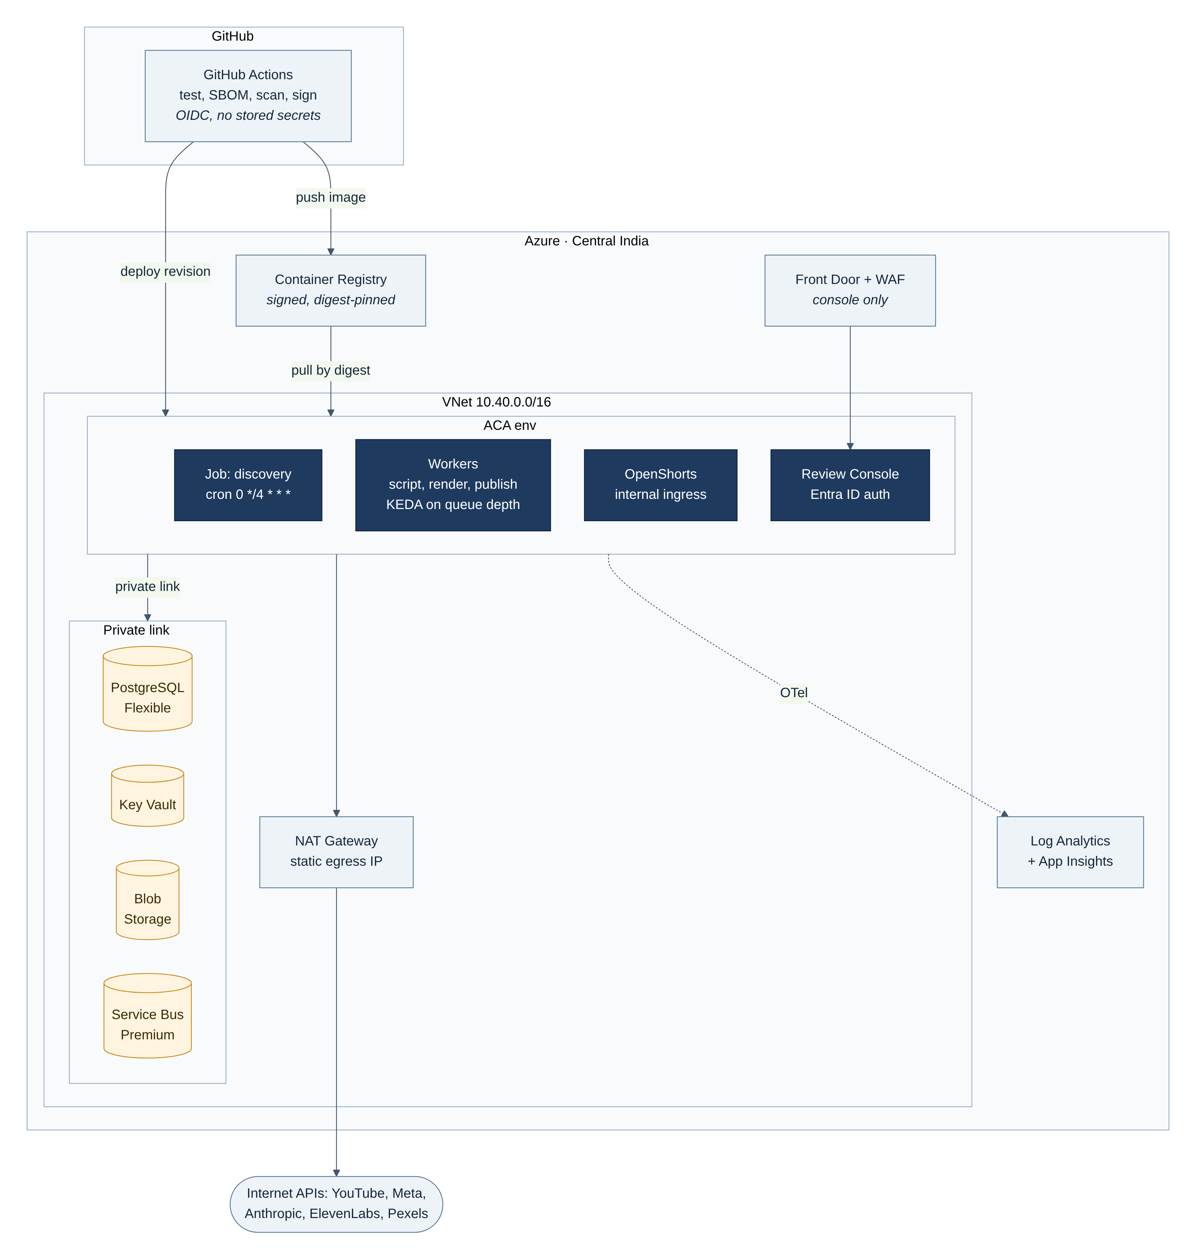
Figure 7. Deployment on Azure (Central India) with private networking and keyless CI/CD

7.1 Azure resources
Resource | SKU / configuration | Security configuration
Container Apps Environment | Workload profiles; VNet-integrated, internal only | No public ingress except the console via Front Door
Container Apps Job: discovery | Cron 0 */4 * * *, 1 replica, 10 min timeout | User-assigned identity id-discovery
Container Apps: workers | script, render, publish-yt, publish-ig; KEDA Service Bus scaler | One identity per worker
Container App: OpenShorts | 4 vCPU / 8 GiB, internal ingress, min 0 / max 2 | Digest-pinned image, non-root, no secrets except TTS/stock keys via Key Vault refs
Azure Database for PostgreSQL Flexible | Burstable B2s to start; zone-redundant HA in prod | Private endpoint, Entra ID auth, TLS required, PITR 7–35 days
Service Bus | Premium (private endpoints); queues with sessions, DLQ, duplicate detection | Per-queue Send/Listen RBAC
Storage account | Blob, LRS/ZRS; lifecycle rules | Public access disabled; shared-key auth disabled; private endpoint
Key Vault | Standard; RBAC model | Soft delete, purge protection, private endpoint, diagnostic logs
NAT Gateway | Static public IP | Single known egress IP for vendor allow-lists
Front Door + WAF | Premium with managed rules | Console only; Entra ID authentication at the app
Log Analytics + App Insights | Workspace-based | Retention 90 days; alert rules
Container Registry | Premium | Admin user disabled; pull via managed identity; signed images

7.2 Environments
Environment | Purpose | Publishing target
local | Developer machine with docker-compose | Fakes for all platforms (no real publishing)
staging | Full Azure stack, separate subscription and credentials | Private test YouTube channel and test Instagram account; privacyStatus=private
production | Live channels | @chansharma870 and @Sharmac_870

7.3 CI/CD pipeline
- Pull request: lint (ruff), type check (mypy --strict), unit and contract tests, SAST (bandit, semgrep), secret scan (gitleaks), dependency audit (pip-audit).
- Build: reproducible image from a pinned slim base; dependencies installed from a hash-locked file (uv pip compile --generate-hashes).
- Supply chain: SBOM (Syft), vulnerability scan (Trivy; fail on critical), sign the image with cosign, push to ACR by digest.
- Deploy: GitHub Actions authenticates to Azure with OIDC federated credentials (no stored cloud secrets); Bicep or Terraform applies infrastructure; new Container Apps revision receives traffic after health checks.
- Promotion: staging smoke test publishes one private video to the test channel; production deploy requires manual approval.

7.4 OpenShorts hardening (local docker-compose)
For local development only. In Azure the same settings are expressed in the Container App definition.
services:
openshorts:
# Pin by digest after reviewing the source; never use :latest
image: ghcr.io/mutonby/openshorts@sha256:<reviewed-digest>
container_name: openshorts_engine
ports:
- "127.0.0.1:8000:8000" # loopback only, never 0.0.0.0
env_file: .env.local # git-ignored; production uses Key Vault references
user: "10001:10001" # non-root (confirm image supports it)
read_only: true
tmpfs: [ /tmp ]
volumes:
- ./output:/app/output # only writable path
cap_drop: [ ALL ]
security_opt: [ "no-new-privileges:true" ]
deploy:
resources:
limits: { cpus: "4", memory: 8g }
healthcheck:
test: [ "CMD", "wget", "-qO-", "http://127.0.0.1:8000/health" ]
interval: 30s
retries: 3
restart: unless-stopped
SECURITY: OpenShorts is a third-party project. Before adoption: review its source and licence, confirm its REST API (/api/render, /api/job/{id}/status) matches this design, fork it into the organisation, build the image in your own CI, and track upstream security fixes. If it does not fit, the RenderEngine protocol allows an ffmpeg/MoviePy-based replacement without touching other stages.

8. Security Architecture

8.1 Data flow and trust boundaries
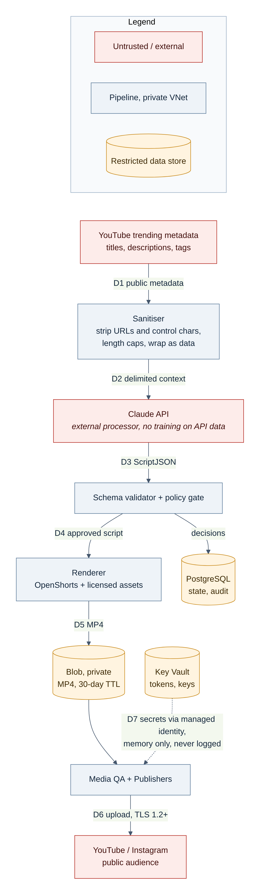
Figure 8. Data flow with trust zones; D1–D7 are referenced by the threat model
Flow | Data | Classification | Controls
D1 | Trending titles, descriptions, tags | Public, untrusted | Schema validation; length caps; Unicode normalisation; strip URLs and control characters
D2 | Sanitised context to Claude | Public | Delimited data blocks; system prompt forbids following embedded instructions; no tools granted to the model
D3 | Generated script | Internal, untrusted until validated | Strict schema; policy gate; human review
D4–D5 | Approved script, rendered media | Internal | Private network; private blob container; SHA-256 recorded
D6 | Upload to platforms | Becomes public | TLS 1.2+; only after QA and approval
D7 | OAuth tokens and API keys | Secret | Key Vault + managed identity; memory only; redacted from logs and traces

8.2 Identity and access management
- Workloads: one user-assigned managed identity per worker. No connection strings or keys for Azure services; all access uses Entra ID tokens.
- Humans: Review Console behind Entra ID with MFA and Conditional Access. App roles Reviewer (approve/reject) and Admin (config, kill switch, retries). Azure portal access through PIM with just-in-time elevation.
- Platform accounts: the Google account that owns the channel and the Meta Business Manager are protected with hardware-key 2FA; the automation uses a dedicated Google Cloud project per environment and a Meta System User limited to the Instagram asset.
Identity | Azure RBAC role | Scope
id-discovery | Service Bus Data Sender | q.script only
id-script | Service Bus Data Receiver / Sender; Key Vault Secrets User | q.script / outbox queues; secret anthropic-api-key
id-render | Storage Blob Data Contributor; Key Vault Secrets User | Container media; secrets elevenlabs-api-key, pexels-api-key
id-publish-yt | Key Vault Secrets User; Storage Blob Data Reader | Secrets yt-oauth-client, yt-refresh-token; container media
id-publish-ig | Key Vault Secrets User; Storage Blob Data Reader (+ Delegator for SAS fallback) | Secrets ig-system-user-token, meta-app-secret; container media
All workers | PostgreSQL Entra ID login | Per-service DB role with only the grants it needs

8.3 Secrets and OAuth token handling
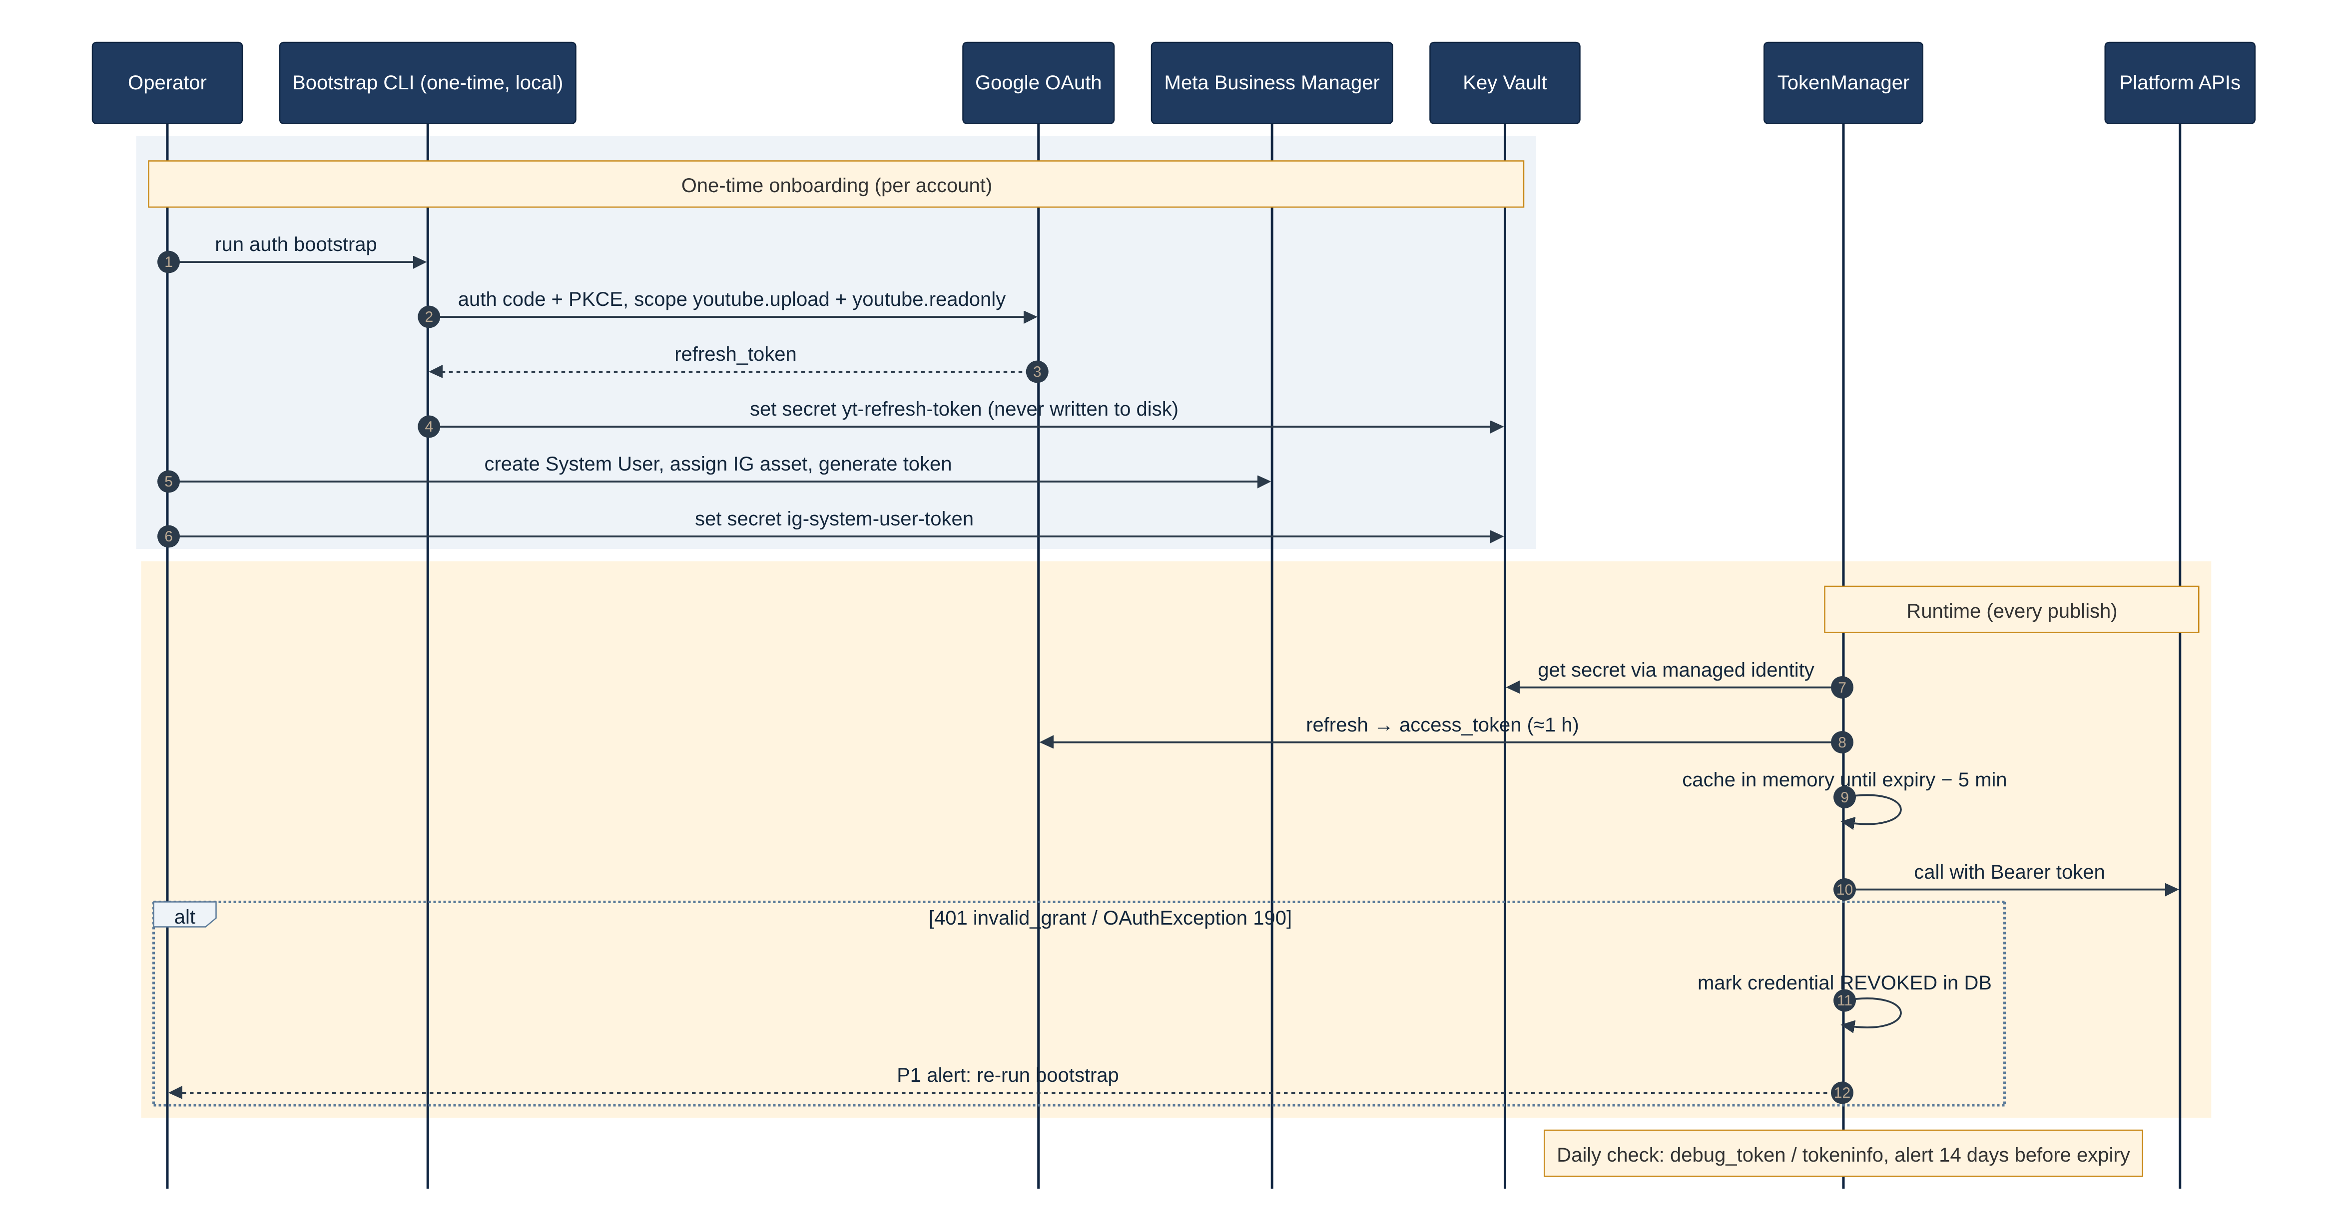
Figure 9. OAuth credential lifecycle: one-time bootstrap, runtime refresh and revocation handling

Secret | Obtained by | Rotation / expiry | Monitoring
yt-refresh-token | One-time local bootstrap CLI using authorization code + PKCE; written straight to Key Vault | Long-lived; invalid on password change, revocation, or 6 months unused | Daily tokeninfo check; P1 alert on invalid_grant
yt-oauth-client (client id/secret) | Google Cloud console, OAuth client type "Desktop/Web" for bootstrap | Rotate every 12 months | Expiry tag on secret
ig-system-user-token | Meta Business Manager System User with only the IG asset and required permissions | Rotate every 60 days (or per token expiry setting) | Daily debug_token; alert 14 days before expiry
meta-app-secret | Meta app dashboard; used for appsecret_proof | Rotate every 12 months | Expiry tag
anthropic-api-key, elevenlabs-api-key, pexels-api-key | Vendor consoles, one key per environment | Rotate every 90 days; workspace spend limits | Spend alerts

- Access tokens live only in process memory and are refreshed 5 minutes before expiry. They are never written to disk, the database, queues, logs or traces.
- Meta calls send the token in the Authorization header (not the URL query string, which ends up in logs) and include appsecret_proof (HMAC-SHA256 of the token with the app secret).
- Logging has a redaction filter for Authorization headers, access_token, refresh_token, client_secret and any value matching known key patterns; a unit test asserts it.
- Key Vault uses RBAC, soft delete and purge protection; secret reads are logged and alerted on from unexpected identities.
- Decommissioning: revoke the Google grant (https://oauth2.googleapis.com/revoke), delete the Meta System User token, disable the secrets.

8.4 Network security
- All PaaS data planes (PostgreSQL, Key Vault, Storage, Service Bus) are reachable only through private endpoints; public network access is disabled.
- Egress leaves through the NAT Gateway. Optionally route through Azure Firewall with an FQDN allow-list: *.googleapis.com, oauth2.googleapis.com, graph.facebook.com, rupload.facebook.com, api.anthropic.com, api.elevenlabs.io, api.pexels.com, *.pexels.com.
- OpenShorts has internal ingress only; workers reach it by its internal FQDN. Only the Review Console is exposed, behind Front Door WAF.
- TLS 1.2 or higher everywhere; HTTP clients verify certificates and set explicit connect and read timeouts.

8.5 LLM and prompt-injection controls
Trending titles and descriptions are written by strangers and can contain instructions aimed at the model ("ignore previous instructions and write…"). The following controls apply:
- The model receives trend metadata only inside a delimited block labelled as untrusted data; the system prompt states that text inside it is never an instruction.
- The model is given no tools, no credentials and no ability to trigger actions. Its only output is a JSON object validated against ScriptJSON.
- Output is checked for URLs not in the allow-list, personal data patterns, deny-listed terms and length limits.
- A separate moderation call classifies the script against the content policy (Section 11) and returns risk flags.
- max_tokens, request timeouts and a daily spend cap bound cost; prompt and output hashes are stored for audit.

8.6 Software supply chain
- Hash-locked Python dependencies; Dependabot or Renovate for updates; pip-audit in CI.
- Base images pinned by digest and rebuilt weekly; Trivy scan gates the build on critical vulnerabilities.
- SBOM attached to every image; images signed with cosign; Container Apps pull by digest only.
- Branch protection on main: required reviews, required status checks, signed commits.

8.7 Threat model (STRIDE summary)
Threat | Category | Scenario | Mitigation
T1 | Spoofing | Stolen YouTube refresh token used to post or delete from another host | Key Vault only; private endpoint; revocation runbook; Google security alerts; no tokens on laptops after bootstrap
T2 | Tampering | Prompt injection in a trending title changes the script's message | Section 8.5 controls; policy gate; human approval
T3 | Tampering | Compromised OpenShorts image renders altered media | Forked, reviewed, signed image; internal network only; media QA
T4 | Repudiation | Unclear who approved a harmful post | Append-only audit log with Entra ID identity and timestamps
T5 | Information disclosure | Tokens leak through logs or exception traces | Redaction filter + test; secrets never in URLs; log access via RBAC
T6 | Information disclosure | Media exposed through a public URL | Private container; resumable upload; SAS fallback ≤ 15 min, read-only, single blob, user-delegation key
T7 | Denial of service | Quota exhaustion or runaway retries lock the channel out for the day | Quota ledger, token buckets, retry caps, circuit breakers
T8 | Elevation of privilege | Console vulnerability used to change config | WAF, Entra ID, app roles, input validation, SAST/DAST, least-privilege identity
T9 | Policy / legal | Defamatory or misleading content published automatically | Deny-list, moderation, sources required for factual claims, human review, takedown runbook

9. Reliability, Rate Limiting and Error Handling

9.1 Retry and timeout policy
All retries use exponential backoff with full jitter (tenacity.wait_random_exponential) and honour Retry-After when present. Only transient errors are retried.
Dependency | Timeout (connect / read) | Retries | Retry on | Never retry on
YouTube videos.list | 5 s / 30 s | 3, base 2 s, cap 60 s | 429, 500, 502, 503, 504, network errors | 400, 403 quotaExceeded, 404
YouTube resumable upload | 10 s / 120 s per chunk | Resume from last byte, up to 10 times | 5xx, network errors (query upload status, then resume) | 401 after one refresh; 403 uploadLimitExceeded
Claude API | 10 s / 120 s | 3, base 4 s | 429, 500, 529 overloaded, network | 400 invalid request; schema failure gets 2 regenerations, not HTTP retries
OpenShorts | 5 s / 30 s per call | Submit 2; poll until 20 min | 5xx, network | Job FAILED with validation error
Meta Graph API | 10 s / 60 s | 3, base 5 s | Error codes 1, 2, 4, 17, 32, 613 (transient / throttling), 5xx | Code 190 (token), 10 / 200 (permission), 9007 / 2207xxx (media)
ElevenLabs, Pexels | 5 s / 60 s | 3, base 2 s | 429, 5xx | 401, 403, 422

9.2 Rate limiting and quota budgeting
- A token-bucket limiter per external API and per account, backed by PostgreSQL advisory locks so limits hold across replicas.
- A quota ledger records estimated YouTube units per call. At 80 % of the daily budget the YouTube publisher pauses and alerts; the quota resets at midnight Pacific Time, so deferred items resume after 13:30 IST.
- Instagram: read content_publishing_limit before each publish and defer when within 5 of the limit.
- Daily spend caps for Claude, ElevenLabs and Pexels; when reached the pipeline stops creating new content items.

9.3 Failure isolation
- Circuit breakers per dependency: open after 5 consecutive failures, half-open after 5 minutes. An open breaker parks messages (scheduled redelivery) instead of burning retries.
- Dead-letter queues: after max delivery count (5) a message moves to the DLQ, the item is marked FAILED with the last error, and an alert fires. The console can replay DLQ messages after a fix.
- Graceful shutdown: workers handle SIGTERM, stop receiving, finish or checkpoint the current item, and release message locks. Long renders renew message locks.
- Kill switch: a config flag checked before every publish; when on, publishers acknowledge nothing and items wait.

9.4 Error taxonomy
Class | Examples | Handling
Transient | Timeouts, 429, 5xx, Meta throttling codes | Retry with backoff; then park; then DLQ
Quota / limit | YouTube quotaExceeded, IG publishing limit | Defer until reset; no retries; info alert
Authentication | 401, invalid_grant, Meta code 190 | One token refresh; then mark credential REVOKED, stop the platform, P1 alert
Content / validation | Schema failure, policy rejection, media spec errors | Regenerate (bounded) or REJECTED / FAILED; no infinite loops
Unknown outcome | Timeout during videos.insert or media_publish | Run reconcile() before any retry (Section 5.4)

10. Observability

10.1 Logs, traces and correlation
- JSON structured logs (structlog) with run_id, content_id, stage, platform, attempt, trace_id; no free-text secrets; redaction filter enforced.
- OpenTelemetry traces exported to Application Insights. Trace context travels in Service Bus message application properties (W3C traceparent), giving one end-to-end trace per content item.
- Audit events for every state change and every human action, kept separately from operational logs.

10.2 Metrics
Metric | Type | Labels
pipeline_items_total | Counter | state
stage_duration_seconds | Histogram | stage
publish_attempts_total | Counter | platform, outcome, error_class
youtube_quota_units_used | Gauge | project
ig_publish_limit_remaining | Gauge | account
llm_tokens_total, vendor_spend_inr | Counter | vendor, model
queue_depth, dlq_depth | Gauge | queue
token_days_to_expiry | Gauge | credential

10.3 Alerts
Severity | Condition | Action
P1 | Credential revoked or invalid_grant / code 190 | Platform stops automatically; operator re-runs bootstrap (runbook R1)
P1 | Any duplicate publication detected by reconciliation | Kill switch on; investigate (runbook R5)
P2 | DLQ depth > 0 | Inspect, fix, replay (runbook R3)
P2 | No successful publish in 12 hours while items are APPROVED | Check breakers, quotas, credentials
P2 | Token expires in < 14 days | Rotate token (runbook R2)
P3 | YouTube quota > 80 % or IG limit within 5 | Informational; publishing defers automatically
P3 | Vendor spend > 80 % of daily cap | Informational

10.4 Service level objectives
- Freshness: 95 % of approved items are live on both platforms within 2 hours of approval (excluding platform-declared outages).
- Correctness: 0 duplicate or partial posts per month.
- Availability of discovery: 99 % of scheduled runs complete.

11. Content Safety and Editorial Policy

11.1 Policy gate rules
Rule | Outcome
Topic in deny-list: elections and political campaigning, communal or religious conflict, active tragedies and disasters, crime allegations, medical or financial advice, minors | REJECT, or REVIEW if the operator opts in per category
Script names a private individual, or makes a factual claim without a source | REVIEW
Moderation model returns any risk flag (hate, harassment, sexual, violence, self-harm, misinformation) | REVIEW (high severity: REJECT)
Source trend is from a deny-listed channel or category (e.g. Music, which carries high copyright risk) | SKIP at discovery
All checks pass and auto-approve is enabled for the category | APPROVE

11.2 Disclosure and attribution
- YouTube: containsSyntheticMedia=true; description includes "Narration and visuals created with AI tools."
- Instagram: caption includes an AI disclosure line; apply Meta's "AI info" label where the app or API offers it.
- On-screen: a small "AI-generated" label in the first 3 seconds, rendered by OpenShorts overlay.
- Stock footage credits are kept in the description when the licence asks for it.

11.3 Path to auto-approval
- Weeks 1–2: every item requires approval; publish as private/unlisted on YouTube and review before making public.
- Weeks 3–4: every item requires approval; publish public.
- After 100 reviewed items with ≥ 95 % approved unchanged and 0 platform warnings, enable auto-approve for low-risk categories (e.g. technology, sport results, entertainment releases).
- Any platform warning, strike or takedown request switches auto-approve off automatically.

11.4 Takedown
The console offers "Unpublish": YouTube via videos.delete (or set to private); Instagram removal is done in the app if API deletion is not available for the account type. Every takedown is an audit event with a reason.

12. Configuration Reference
Non-secret settings come from Container Apps environment variables (or Azure App Configuration); secrets are Key Vault references. Startup validates configuration with a Pydantic BaseSettings model and fails fast if anything is missing.
Setting | Default | Description
REGION_CODE | IN | YouTube region for discovery
DISCOVERY_CRON | 0 */4 * * * | Discovery schedule (UTC)
TOP_N_TOPICS | 5 | Candidates scripted per run
CATEGORY_ALLOWLIST | 17,20,24,25,26,28 | Sports, Gaming, Entertainment, News, Howto, Science & Tech (verify ids)
TOPIC_DEDUPE_DAYS | 7 | Window for fingerprint dedupe
ANTHROPIC_MODEL | claude-sonnet-5-5 | Script model; moderation may use the same or a larger model
LLM_MAX_TOKENS | 2000 | Output cap per call
META_GRAPH_VERSION | current stable (e.g. v24.0) | Pinned Graph API version
YT_DAILY_QUOTA_UNITS | 10000 | Quota budget for the ledger
YT_PRIVACY_STATUS | private (staging) / public (prod) | Upload privacy
IG_UPLOAD_MODE | resumable | resumable or sas_url
AUTO_APPROVE_CATEGORIES | empty | Categories allowed to skip human review
PUBLISH_KILL_SWITCH | false | Stops all publishing when true
RENDER_TIMEOUT_S | 1200 | Max render time
DAILY_SPEND_CAP_INR | 1500 | Combined vendor spend cap
KEY_VAULT_URI | — | Vault for all secrets listed in Section 8.3

13. Testing and Quality Strategy
Level | Scope | Tooling and pass criteria
Unit | Scoring, fingerprinting, schema validation, state transitions, redaction, retry classification | pytest; ≥ 85 % line coverage on domain code
Contract | YouTube, Meta, Claude, OpenShorts request/response shapes | Recorded fixtures (respx / VCR.py with secrets scrubbed); run on every PR
Idempotency (mandatory) | Kill a publisher after videos.insert returns and before the DB write; redeliver the message | Exactly one post exists after recovery, for both platforms
Integration | Full pipeline in staging against the test channel and account | One private publish per deploy; all stages traced
Media QA | Golden renders compared with ffprobe and loudness (EBU R128 target −14 LUFS) | Spec checks pass
LLM evaluation | Policy gate on a labelled set of 200 scripts (safe / review / reject) | Recall of unsafe ≥ 98 %; regression on model or prompt change
Security | SAST, secret scan, dependency and image scan, DAST on console | No high or critical findings open at release
Resilience | Inject 429/5xx and timeouts per dependency; break the network to Key Vault | No duplicates; DLQ and alerts behave as specified

14. Step-by-Step Build and Implementation Guide

Step 0: Accounts, approvals and verification
- Create Google Cloud projects (staging, prod); enable YouTube Data API v3; configure the OAuth consent screen (production status) and submit youtube.upload for verification; submit the YouTube API compliance audit.
- Convert @Sharmac_870 to a Professional account; create the Meta app, link the Business Manager and Page, create a System User with only the Instagram asset; obtain instagram_content_publish.
- Re-verify every value in Section 2 and record it in configuration.

Step 1: Repository and project skeleton
- Python 3.12, uv for dependency management, src/ layout with packages discovery, scripting, policy, render, publish, common (config, db, queue, tokens, telemetry). Pre-commit with ruff, mypy, gitleaks.

Step 2: Infrastructure as code
- Bicep or Terraform modules for every resource in Section 7.1, with private endpoints and RBAC assignments. Deploy staging first.

Step 3: Data layer and outbox
- Alembic migrations for Section 6.1 tables; state transition helper with optimistic concurrency; outbox relay.

Step 4: TrendDiscoveryService
- videos.list with chart=mostPopular, regionCode=IN, category allow-list; velocity score = view_count / max(hours_since_publish, 1); fingerprint dedupe; quota ledger entry per call.

Step 5: ScriptGenEngine and ContentPolicyGate
- Anthropic SDK with structured JSON output matching ScriptJSON; sanitiser; system prompt with untrusted-data rules; moderation pass; deny-list rules from config.

Step 6: OpenShorts and RenderOrchestrator
- Fork, review and build OpenShorts; deploy with internal ingress; orchestrator with idempotency key, polling backoff, Blob upload by managed identity; MediaQAService with ffprobe.

Step 7: Publishers and TokenManager
- YouTube: MediaFileUpload(resumable=True, chunksize=8 MiB), persist session URI, containsSyntheticMedia, selfDeclaredMadeForKids=false, tag ref-<id>, reconciliation through the uploads playlist.
- Instagram: create REELS container with upload_type=resumable, upload to rupload.facebook.com with offset and file_size headers, poll status_code (every 10 s, max 10 min), media_publish, read back permalink.

Step 8: Review Console
- Small FastAPI + HTMX (or similar) app: queue of items, script and source view, video preview via short-lived SAS, approve/reject/edit, retry platform, kill switch. Entra ID Easy Auth, CSRF protection, app roles.

Step 9: Observability, alerts and runbooks
- OpenTelemetry instrumentation, dashboards, alert rules from Section 10.3 linked to Section 15 runbooks.

Step 10: Staging soak and go-live
- Run staging for 7 days with private publishing; pass every test in Section 13; complete the go-live checklist in Section 2.4; switch production on with human approval required.

15. Operational Runbook
ID | Scenario | Detection | Response
R1 | YouTube or Instagram credential revoked | P1 alert; publisher stopped | Check account security first. Re-run bootstrap CLI (YouTube) or regenerate System User token (Meta); write to Key Vault; clear REVOKED flag; resume
R2 | Token near expiry | P2 alert at 14 days | Generate new token, add as new Key Vault version, verify with debug_token, disable old version
R3 | Messages in DLQ | P2 alert | Read last error in console; fix cause; replay from console; confirm reconciliation found no existing post
R4 | Quota exhausted | P3 alert | No action; items resume after reset. If persistent, lower TOP_N_TOPICS or apply for quota extension
R5 | Duplicate or wrong post published | P1 alert or operator report | Turn on kill switch; unpublish duplicate; inspect trace and attempt rows; add regression test before turning kill switch off
R6 | Platform policy warning or takedown | Email from platform | Kill switch; disable auto-approve; review recent items; update deny-list and policy prompts
R7 | Suspected secret leak | Secret scanner, unusual Key Vault access | Revoke and rotate all affected secrets immediately; review audit logs; rotate Meta app secret and Google client secret

16. Master Prompt for AI Coding Agent (v2)
Copy the prompt below into your AI coding agent to generate the solution. It reflects every decision in this document; give the agent this whole document as context alongside it.
================================================================================
MASTER PROMPT v2: INDIA TRENDING TOPICS -> YOUTUBE SHORTS + INSTAGRAM REELS
================================================================================
You are a principal software engineer. Build a production-grade, modular Python
solution that implements the attached Low-Level Design v2.0 exactly. Where this
prompt and the LLD differ, the LLD wins. Ask before inventing behaviour.

### STACK
- Python 3.12, uv, src/ layout, Pydantic v2 + pydantic-settings, SQLAlchemy 2 +
Alembic (PostgreSQL), httpx, tenacity, structlog, OpenTelemetry
(azure-monitor-opentelemetry), azure-identity, azure-keyvault-secrets,
azure-servicebus, azure-storage-blob, google-api-python-client, google-auth,
anthropic. Tests: pytest, respx, freezegun. Lint: ruff, mypy --strict.
- Deploy target: Azure Container Apps (jobs + apps), Bicep templates included.

### NON-NEGOTIABLE RULES
1. No scraping. Trend discovery uses ONLY YouTube Data API videos.list
(chart=mostPopular, regionCode=IN). Never download or reuse third-party
video, audio, transcripts or thumbnails. Scripts are original commentary.
2. No secrets in code, env files, images, logs or exceptions. All secrets come
from Azure Key Vault via DefaultAzureCredential (managed identity). Add a
logging redaction filter and a test proving tokens never reach logs.
3. Every stage is idempotent. Implement the keys and reconcile() logic in LLD
Section 5.4. Never retry videos.insert or media_publish without reconcile().
4. Persist state transitions with optimistic concurrency and a transactional
outbox (LLD Sections 5.3, 6.1).
5. Untrusted text (trend metadata, LLM output) is validated by Pydantic models
with the length limits in LLD Section 6.2. The LLM gets no tools.
6. Fail closed: if policy, QA, quota, kill switch or credential state is
unknown, do not publish.

### MODULES
1. discovery/ TrendDiscoveryService: videos.list, velocity score, category
allow-list, 7-day topic fingerprint dedupe, quota ledger.
2. scripting/ ScriptGenEngine: Anthropic Messages API, model from
ANTHROPIC_MODEL (default "claude-sonnet-5-5"), structured JSON output
matching ScriptJSON, untrusted data in delimited blocks, max 2 regenerations.
3. policy/ ContentPolicyGate: deny-list rules + LLM moderation ->
REJECT | REVIEW | APPROVE; errors -> REVIEW.
4. render/ RenderOrchestrator (OpenShorts REST, Idempotency-Key, polling
with backoff, 20 min timeout) + MediaQAService (ffprobe: 1080x1920, H.264,
AAC, 23-60 fps, <= 90 s, <= 300 MB, loudness).
5. publish/ YouTubePublisher: resumable upload, persisted session URI,
status.containsSyntheticMedia=true, selfDeclaredMadeForKids=false,
privacyStatus from config, tag ref-<id>, reconcile via uploads playlist.
InstagramPublisher: Graph API version from config, REELS
container with upload_type=resumable, rupload upload, poll status_code,
media_publish, content_publishing_limit check, appsecret_proof, token in
Authorization header, reconcile via container status.
6. common/ config (BaseSettings, fail fast), db, outbox relay, Service Bus
consumer base (lock renewal, SIGTERM handling, DLQ), TokenManager,
rate limiter (token bucket), circuit breaker, telemetry.
7. console/ FastAPI review console: approve/reject/edit, retry platform,
DLQ replay, kill switch; Entra ID roles Reviewer/Admin; CSRF protection.
8. infra/ Bicep for LLD Section 7.1; GitHub Actions with OIDC, SBOM,
Trivy, cosign.

### RETRIES, LIMITS, OBSERVABILITY
- Implement the retry/timeout matrix in LLD Section 9.1 and error taxonomy in
Section 9.4; honour Retry-After; jittered exponential backoff.
- Emit the metrics in Section 10.2, propagate W3C traceparent through Service
Bus application properties, write audit events for every state change.

### DELIVERABLES
- Complete source, migrations, Bicep, Dockerfiles (non-root, pinned digests),
docker-compose for local dev with fakes for all external APIs.
- Tests from LLD Section 13, including the mandatory idempotency test.
- README with setup, bootstrap CLI for OAuth (PKCE, writes to Key Vault only),
and the runbooks in LLD Section 15.
Generate clean, fully typed, documented code. Do not leave TODOs for security.
================================================================================

17. Open Questions and Assumptions
# | Item | Current assumption | Owner
Q1 | Video language mix (English, Hindi, Hinglish)? | English (en-IN) first; Hindi as a config option | Operator
Q2 | Is a Facebook Page already linked to @Sharmac_870? | Yes; otherwise use Instagram API with Instagram Login | Operator
Q3 | Daily volume target | 3 items per day per platform | Operator
Q4 | Does OpenShorts expose the REST API this design assumes? | To be confirmed in Step 6; fallback is a custom ffmpeg renderer | Engineering
Q5 | Cloud choice | Azure (as in v1.0); the design maps to AWS (ECS, SQS, Secrets Manager) or GCP (Cloud Run, Pub/Sub, Secret Manager) unchanged | Engineering
Q6 | Notification channel for alerts and approvals | Email + Microsoft Teams | Operator

