ADVANCED CPU SCHEDULING SIMULATOR USING HEAP DATA STRUCTURES
A mini-Project report submitted
To Manipal Academy of Higher Education
For The Partial Fulfillment of the Requirement for the
Award of The Degree
Of
MASTER OF TECHNOLOGY
In
Computer Science and Engineering (NETWORKS)
By
Aditi A Kalgi - 251091020007
Aadithya Satyendra Shet - 251091020011
Chethan Sharma - 251091020012
Under the Guidance of
Dr. Preetham Kumar
Professor, School of Computer Engineering
preetham.kumar@manipal.edu
Mr. Vignesh K
Research Scholar, School of Computer Engineering
vignesh2.mitmpl2024@learner.manipal.edu



TABLE OF CONTENTS

Abstract | 1
Problem Statement | 2
Objectives | 3
Proposed Solution | 4
Technology Stack | 5
Methodology Used | 6
Results | 8-9
Key Learning and Take Aways | 10
Conclusion | 11
References | 12
Similarity Report | 3%

LIST OF FIGURES
Input Process Parameters for CPU Scheduling Simulation | Figure 1
Comparative Performance of CPU Scheduling Algorithms | Figure 2
GUI of Heap-Based CPU Scheduler with Animated Gantt Chart | Figure 3

ABSTRACT
This project illustrates an advanced, high performance CPU process scheduling simulator developed with Python. The system's framework makes use of heap-based priority queues (using Python's heapq module) to accomplish efficient O(log n) process selection, thereby excels over standard O(n) linear searches. The simulator integrates various key scheduling algorithms, namely Priority, Shortest Job First (SJF), and First Come, First Serve (FCFS), in both preemptive and non-preemptive modes. Furthermore, the simulator integrates a Round Robin (RR) scheduler with a deque which allows a thorough comparative analysis. The system optimizes scheduling efficiency through enhanced process selection by implementing heap data structures, minimizes the waiting period by dynamically prioritizing tasks, and improves CPU utilization by minimizing idle time. The system is displayed in an effective graphical user interface (GUI) developed with Tkinter, which presents a real-time, animated Gantt chart. The simulator determines and presents crucial performance metrics such as average waiting time, average turnaround time, CPU use, and total context modifications, allowing for a complete evaluation of algorithm efficiency.

PROBLEM STATEMENT
In typical operating systems, the ready queue, which contains all processes that are ready for execution, is usually implemented as a standard First In First Out (FIFO) queue or linked list. While foundational, these data structures create substantial inefficiencies in advanced scheduling algorithms like Preemptive Priority Scheduling and Shortest Job First (SJF). With regard to the next process, the scheduler must search the entire ready queue seeking the process with the highest priority or the shortest burst time.
This search operation has a time complexity of O(n), where 'n' represents the number of processes in the ready queue. In a high-load system with hundreds of processes, the O(n) search for each scheduling decision becomes a significant performance constraint. The purpose of this project is to create a dynamic heap-based scheduler that addresses issues like starvation and long wait times by optimizing process selection and improving execution efficiency. By implementing the ready queue as a priority queue, we minimize process selection to an O(log n) operation, significantly enhancing system response time and effectiveness.

OBJECTIVES
The main goals of this project are:
The key goals of this project as realized in the code are:
- Create and implement a Process class that has all of the attributes required for modern scheduling (PID, arrival time, burst time, priority, and remaining time).
- To create a fundamental Process Scheduler class that handles the system clock and process state.
- To efficiently manage the ready queue for many algorithms, use heap data structures (priority queues) with Python's heapq package.
- Implement the following heap-based scheduling algorithms:
a. First Come, First Serve (FCFS): Using a minimum heap based on arrival time.
b. Shortest Job First (SJF): A minimum-heap based on burst time.
c. Priority Scheduling: A max-heap (used as a min-heap for negated priority values).
- Enable heap-based algorithms to execute in both preemptive and non-preemptive mode.
- Implement Round Robin (RR) scheduling with a deque as a standard queue, which will serve as a benchmark for comparing heap-based approaches.
- To calculate and display key performance metrics such as CPU utilization, throughput, average wait time, average turnaround time, and context switches.
- Using Tkinter, create an interactive and user-friendly Graphical User Interface (GUI) for process input and control.
- Create a real-time, animated Gantt chart with Matplotlib that shows CPU activity and process execution flow, including idle time.
PROPOSED SOLUTION

There are three main layers regarding the simulator’s architecture, assuming a separation of concerns:

Data Model Layer (Process Class): This layer defines the construction of a process, including its metadata and state.

Backend Logic Layer: The simulator’s ‘engine’ contains all the scheduling algorithms, state management, and metric’s calculation.
- Frontend/Presentation Layer (Scheduler GUI Class): The Tkinter application that synthesizes user control, directive data input, and overview.
There are two key elements within the system:
- Process Class - Describes process characteristics such as arrival time, burst time, and priority, which are crucial for scheduling decisions.
2. ProcessScheduler Class - Controls process selection with heap queues, ensuring efficient scheduling logic by dynamically modifying priorities and supporting both preemptive and non-preemptive modes.
Core Data Structures
The Process class, defined in scheduler_code_rr.py, functions as the foundational data structure. The essential attributes include pid, arrival, burst, priority, remaining, start, finish, waiting, turnaround, and response_time.
The Heap (Priority Queue): The Priority, SJF, and FCFS algorithms implement the ready queue as a min-heap using Python's heapq module. This structure is perfect for a scheduler.
The Deque (Double-ended Queue): The Round Robin (RR) algorithm fails to work with a
heap data structure. RR follows a tight FIFO policy. For this, we use the collections.deque object with O(1).

TECHNOLOGY STACK
The simulator was entirely developed in Python 3, utilizing several powerful, standard libraries.
The heapq Module is a standard library that generates a min-heap efficiently and in place. It is the foundation of the O(log n) scheduling algorithm.
collections.deque: This standard library provides an efficient, O(1) implementation of a double-ended queue, that serves in the Round Robin algorithm's ready queue.
Tkinter (Tkinter) is Python's standard GUI toolkit. It was used for developing the entire frontend, featuring process entry, algorithm selection, and control buttons.
Matplotlib is the standard Python plot library. It is used to generate a Gantt chart. The FigureCanvasTkAgg class on its backend enables the Matplotlib chart to be embedded directly into the Tkinter window.
Threading Module: This is a vital component for the GUI. The animated scheduling simulation runs in an alternate thread. This prevents the long-running animation from stalling the Tkinter main loop, ensuring that the GUI is responsive and the "Pause" button works properly.
The project is logically divided into two files.
1. scheduler_code_rr.py: This file contains the backend logic (the Process and ProcessScheduler classes).
2. gui_scheduler_animated_rr.py: This file contains the frontend logic (the SchedulerGUI class).

METHODOLOGY USED
The ProcessScheduler class contains all of the fundamental logic. It preserves the system clock and a list of processes classified by arrival time.
Step 1: Initialization
Set the clock to zero, assign to ready_heap an empty list, and sort the main process list by arrival time.
Step 2: Main Scheduling Loop
The simulation persists when processes are still arriving, the ready_heap is not empty, or a process is running.
Step 3: Handle Arrivals
Inside the loop, first establish if any processes from the main list have an arrival time less than or equal to the current clock. All new processes are pushed to the ready_heap.
Step 4: Configure Heap for Algorithm
The design utilizes the same scheduling process for several separate algorithms by simply altering the structure of the tuple pushed onto the heap.
1. FCFS: heapq.heappush(ready_heap, proc.arrival, proc.pid, proc)
The heap will be organized depending on proc.arrival.
SJF:heapq.heappush(ready_heap, proc.remaining, proc.arrival, proc.pid, proc)
The heap is sorted by proc.remaining and effectively executes both non-preemptive and
- Preemptive SJF (SRTF).
3. Priority: heapq.heappush(ready_heap, (-proc.priority, proc.arrival, proc.pid, proc)).
The heap sorts by -proc.priority, altering the min-heap into a max-heap for priority (assuming that a greater value equals higher priority, as in the GUI).

Step 5: Manage Preemption
If a process is running and the mode is "preemptive," look at the ready_heap at the top. If the top process has a higher priority (e.g., shorter job or higher priority number).The executing process is preempted and returned to the ready_heap.
Step 6: Select and Execute Process
If no processes are running and ready_heap is not empty, use heappop() to extract the highest-priority process. Reduce the remaining time and set the clock.
Step 7: Handle Completion and Repeat.
If a process's remaining time hits zero, it is identified as "TERMINATED," and its metrics are calculated. The loop remains until all processes have concluded.
Round Robin (RR) Implementation
The RR algorithm is implemented in a separate function, _round_robin(), which utilizes a deque. It takes a process from the front (popleft), executes it for the specified time quantum, and adds it to the back (append).

RESULTS
Input Process Parameters for CPU Scheduling Simulation
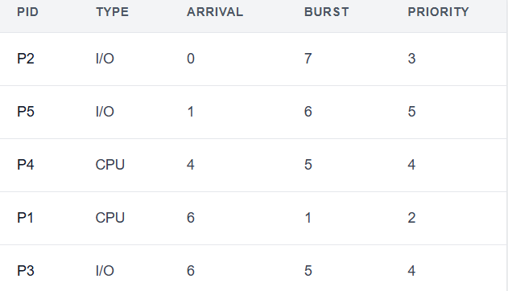
Figure 1
The Gantt Chart in the output clearly demonstrates the execution flow:
Time 0–7: P2 (Priority 3) runs.
Time 7–13: P5 (Priority 5) runs. (Note: P4 arrived at T=4, P1/P3 at T=6, however P2 and P5 were provided with higher priority).
Time 13-18: P4 (Priority 4) runs.
Time 18-19: P1 (priority 2, highest) runs.
P3 (Priority 4) spans from 19 to 24.
The simulator computes the following final metrics:
CPU utilization: 100.00%.
Average wait time: 8.00
Average turnaround time is 12.80.
Context switches: four.
Comparative Analysis
To show the simulator's efficiency, the same process set was carried out through all implemented algorithms (preemptive mode, RR quantum=2).

Comparative Performance of CPU Scheduling Algorithms
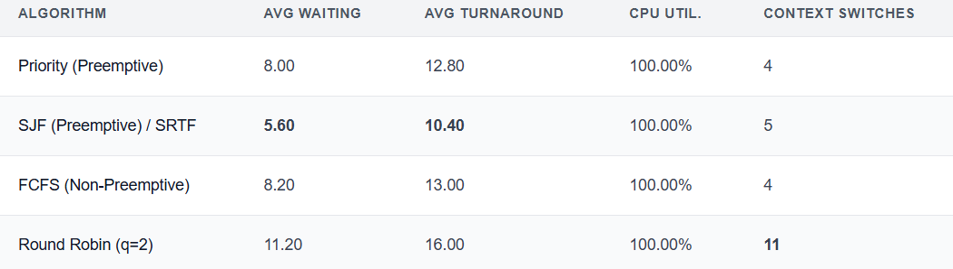
Figure 2
Based on this table, we can conclude:
As expected, SJF/SRTF has the lowest average waiting and turnaround times.
Round Robin has the worst waiting/turnaround time and significantly greater context switch overhead, which is the "cost of fairness."
GUI of Heap-Based CPU Scheduler with Animated Gantt Chart
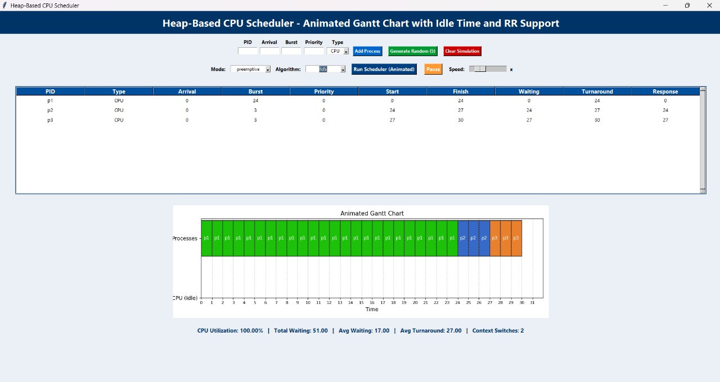
Figure 3
KEY FINDINGS AND TAKEAWAYS
While this simulator is robust, it can be optimized in several ways:
I/O Blocking and Wait Queues: Completely integrate I/O. When a "I/O" process runs, it may go to a "wait" queue for an established period of time before returning to the ready heap.
Multi-Level Feedback Queue (MLFQ)- use one of the most complex scheduling approaches, which employs many queues with varying priority levels and time quanta.
Real-time scheduling- include support for strategies like earliest deadline first.

CONCLUSION

This project effectively demonstrates the design and implementation of an advanced CPU scheduling simulator. The key development is the use of heap-based priority queues to manage the ready queue, which scales effectively with a time complexity of O(log n), considerably lower than the O(n) of linear searches. The simulator correctly implements four key scheduling algorithms which comprises a robust, multi-threaded, animated user experience for visualization. The comparison analysis indicates the theoretical trade-offs of each algorithm, with SJF having a shorter waiting time than Round Robin, which has a higher fairness and overhead.

REFERENCES

- Silberschatz, Galvin, and Gagne. Operating System Concepts, 10th Edition.
- William Stallings. Operating Systems: Internals and Design Principles.
- Python Documentation: heapq Module.
- Research Articles on Heap-Based CPU Scheduling and OS Performance Optimization.

