**SEO bestreads**

Search Engine Optimization (SEO) e-marketing strategy for BESTREADS along with the requirements and the kind of technologies used:

Search Engine Optimization (SEO) Strategy for **“bestreads”**

Here is a real-time overview of the search volume for our brand name in the UK and globally.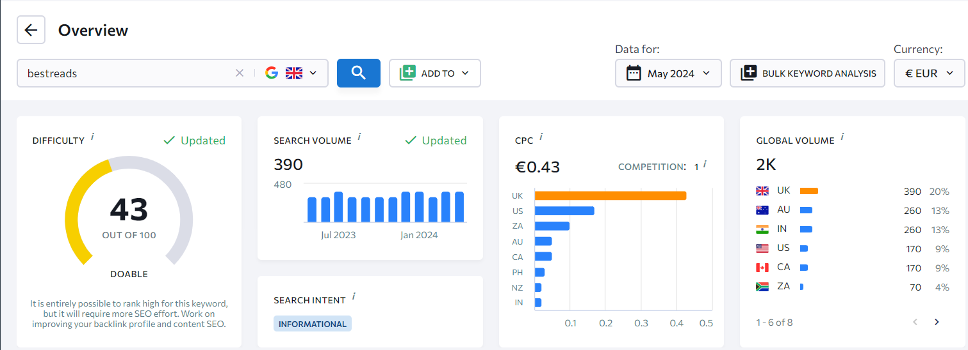

1. **Keyword Research:** Here are the best keywords according with reference to our brand name which is retrieved from SEranking and Semrush:

|  |  |  |  |  |  |  |
| --- | --- | --- | --- | --- | --- | --- |
| Keyword | Difficulty | Search vol. | Search intent | SERP features | CPC | Competition |
| best reads | 43 | 390 | I | Featured Snippets, Reviews, Video, People also ask | 0,43 | 1 |
| what are the best books to read | 43 | 110 | I | Video, People also ask | 0,27 | 0,99 |
| what is the best book to read | 41 | 110 | C | Featured Snippets, Reviews, Video, People also ask, Shopping Results | 0,27 | 0,99 |
| what is the best books to read | 42 | 110 | I | Video, People also ask, Images | 0,27 | 0,99 |
| best books which everyone should read | 34 | 70 | C | Video, People also ask, Shopping Results | 0 | 0,99 |
| best book to read when pregnant | 20 | 70 | C | Reviews, Video, People also ask, Images, Shopping Results | 0,33 | 1 |
| what is the best magnifier for reading books | 8 | 70 | I | Reviews, Video, People also ask, Images | 0,12 | 1 |
| what is the best bible to read | 15 | 70 | I | Reviews, Video, People also ask, Images | 0,23 | 1 |
| which is the best bible to read | 17 | 50 | C | Reviews, Video, People also ask, Images, Top Ads, Shopping Results | 0 | 0,9 |

**Organic Results:**

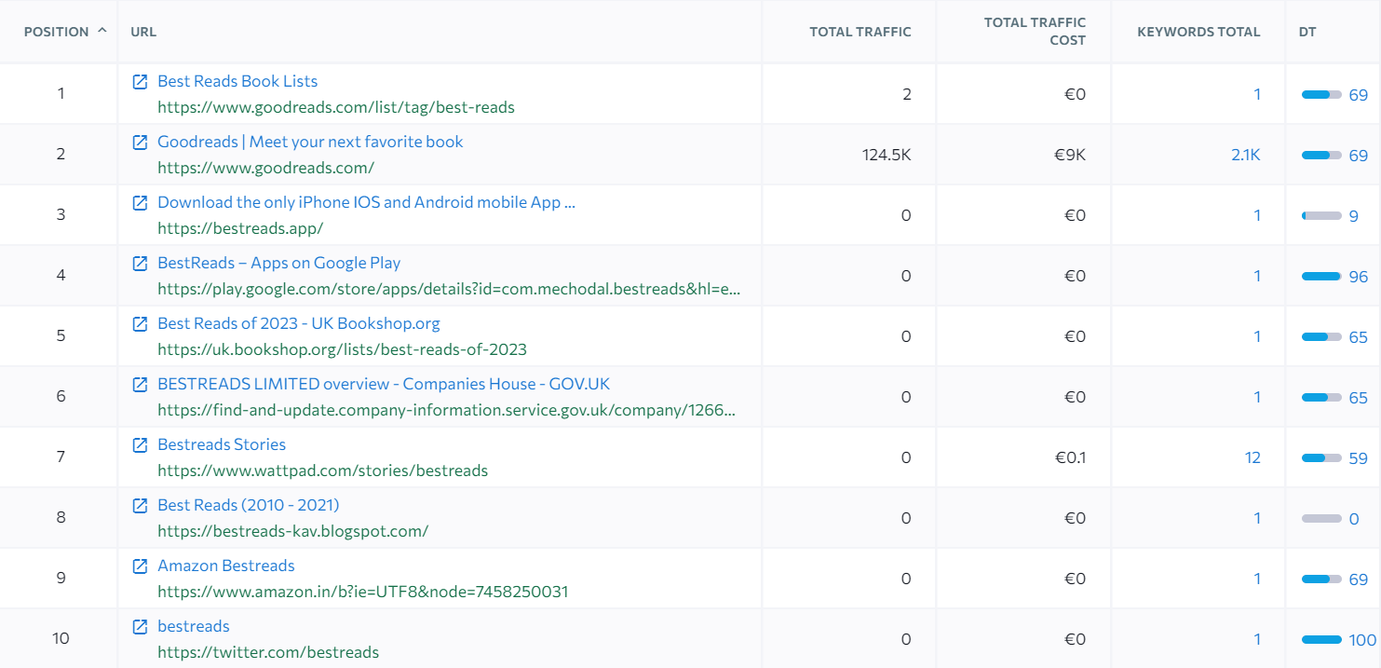

1. **On-Page SEO:** Optimization of website's content and meta tags with the identified keywords as:

* **Title Tags**
* **Primary Keyword Placement:** To Place "bestreads" at the beginning of the title tag to highlight its importance.
* **Length and Clarity:** To Keep title tags within 50-60 characters to ensure they display properly in search engine results.
* **Compelling Titles**: Make the title engaging to increase click-through rates (CTR). **For example:** "BestReads: Your Ultimate Online Bookstore for All Genres".
* **Meta Descriptions**
* **Keyword Inclusion**: Include "bestreads" naturally within the meta description.
* **Compelling Call to Action:** Use of actionable language to encourage clicks, such as **"**Discover a wide range of books and unbeatable prices at BestReads**."**
* **Length:** To Keep meta descriptions within 150-160 characters to ensure full display in search results.
* **Headers (H1, H2, H3)**
* **H1 Tag**: Use "bestreads" in the main header (H1) of the page to signal the primary focus of the content. Example: "Welcome to BestReads: Your Premier Online Bookstore".
* **Subheadings:** Incorporate variations of the keyword in H2 and H3 tags to provide structure and improve readability. **For Example, H2:** "Why BestReads is the Best Choice for Book Lovers".
* **Content Optimization**
* **Keyword Density:** Include **"bestreads"** naturally throughout the content and will aim for a keyword density of around 1-2% to avoid keyword stuffing.
* **LSI Keywords:** Use Latent Semantic Indexing (LSI) keywords related to "bestreads" to provide context. **For Example:** include "online bookstore," "buy books online," and "best book deals."
* **Engaging Content:** To write high-quality, informative, and engaging content that provides value to users. Include book reviews, recommendations, and author interviews relevant to BestReads.
* **Internal Linking**
* **Link to Relevant Pages:** Create internal links to other pages on the site using anchor text that includes "bestreads." This helps distribute page authority and improves navigation.
* **Sitemap:** Ensure the site has a well-organized sitemap that includes links to all important pages.
* **Image Optimization**
* **Alt Text:** To Use descriptive alt text for images that includes "bestreads" to improve image SEO. **Example:** "BestReads book collection."
* **File Names:** Name image files descriptively and include the keyword where appropriate. **Example:** bestreads-books.jpg.
* **Mobile Optimization**
* **Responsive Design:** Ensure the website is fully responsive and provides a good user experience on all devices.
* **Page Speed:** Optimize images, use browser caching, and minimize JavaScript to improve page load times.

1. **Technical SEO:** In this section, we will ensure that the website has a clean URL structure, fast load times, and is indexed by search engines. Google Search Console can be used to monitor and resolve technical SEO issues. Here’s a comprehensive technical SEO strategy:

* **Clean URL Structure**
* **Descriptive URLs:** Ensure that URLs are clean and descriptive, and include the keyword "bestreads" where relevant. **Example:** `www.bestreads.com/online-bookstore`.
* **Consistent URL Format:** Maintain a consistent format for URLs across the site. Avoid mixing uppercase and lowercase letters, and ensure that URLs are structured logically within the site hierarchy.
* **Fast Load Times**
* **Optimize Images:** Compress images using tools like TinyPNG or JPEG Optimizer to reduce file size without compromising quality. Use appropriate image formats For Example: WebP for faster loading.
* **Minimize HTTP Requests:** Combine CSS and JavaScript files to reduce the number of HTTP requests. Use asynchronous loading for non-critical JavaScript.
* **Indexing by Search Engines**
* **XML Sitemap:** To Create and submit an XML sitemap to Google Search Console and Bing Webmaster Tools. This helps search engines understand the site structure and index all relevant pages.
* **Robots.txt File:** Configure your `robots.txt` file to allow search engines to crawl and index your site appropriately. Ensure it does not block important pages.
* **Mobile Optimization**
* **Responsive Design:** Ensure your website is fully responsive and provides a seamless experience across all devices. Use media queries in CSS to adjust layouts for different screen sizes.
* **Mobile-Friendly Testing:** Use Google’s Mobile-Friendly Test tool to check how easily a visitor can use your page on a mobile device. Follow the recommendations to improve mobile usability.

**Example Implementation:**

* **URL Structure:** 
  + - Before: `www.bestreads.com/?p=123`
    - After: `www.bestreads.com/online-bookstore`
* **Image Optimization:**
* Compress all images to reduce load times.

By following above strategies we will improve the visibility, loading and performance of the website for the better user experience.

1. **Content Optimization:** Regularly update the website with fresh, keyword-rich content, such as maintaining a blog related to books and reading. Here’s a comprehensive content optimization strategy:

* **Regular Content Updates**
* **Frequency:** Update existing content regularly, ideally every few months, to keep it current and relevant. This can include adding new information, updating statistics, or refining keyword usage.
* **Content Refresh:** Revisit older posts and pages to refresh them with the latest information and insights.
* **Keyword Research and Integration**
* **Primary and Secondary Keywords:** By the use of tools like Google Keyword Planner, Ahrefs, or SEMrush to identify primary and secondary keywords related to "bestreads." It will include variations and long-tail keywords to capture a broader audience.
* **Natural Integration:** Integration of keywords naturally within the content helps avoid keyword stuffing; instead, ensures the text flows naturally and provides value to the reader.
* **Create High-Quality, Engaging Content**
* **In-Depth Articles:** To write comprehensive, in-depth articles that thoroughly cover topics related to "bestreads." It will include book reviews, reading lists, author interviews, and literary analyses.
* **Multimedia Content:** Incorporate multimedia elements such as images, infographics, videos, and podcasts to enhance the user experience and make the content more engaging.
* **Content Diversification**
* **Different Formats:** Produce various content formats, including blog posts, videos, podcasts, infographics, and eBooks. This helps reach different audience segments and keeps the content dynamic.
* **User-Generated Content:** Encourage users to contribute content, such as reviews, ratings, and comments. User-generated content can increase engagement and provide fresh perspectives.

**Example Implementation:**

* **Blog Post Update:** To compose an existing blog post titled **"Top 10 Books to Read in 2024"**. Also will refresh the list with new book recommendations and update the introduction to reflect current trends.
* **Keyword-Rich Article:** For content optimization will write a new article titled **"Why BestReads is the Go-To Online Bookstore for Avid Readers."** Also will ensure the keyword "bestreads" is used naturally throughout the article, in the title, headers, and meta description.

**5. Link Building:** The following is the strategy applied for building backlinks such as:

* **High-Quality, Shareable Content**
* **In-depth Guides and Reviews:** To write comprehensive guides and reviews on popular books and reading topics which is more likely to be linked by other websites.
* **Infographics and Visual Content:** Create visually appealing infographics related to reading trends, book summaries, or literary statistics. Visual content is highly shareable and often attracts backlinks.
* **Engage in Outreach and Relationship Building**
* **Connect with Influencers:** Build relationships with book bloggers, authors, and influencers in the literary community. Engage with them through social media, comments, and collaborations, which can lead to backlinks from their websites.
* **Collaborate with Other Websites**: Partner with educational institutions, libraries, and book clubs for collaborative projects and content sharing.
* **Broken Link Building:** To find broken links on other websites that used to point to resources similar to our offer. To reach out to the site owners and suggest they replace the broken link with a link to our relevant content.
* **Leverage Content Marketing and PR**
* **Press Releases:** Issue press releases for significant events, such as new book releases, partnerships, or awards can generate backlinks from news websites.
* **Content Syndication:** The Syndication of content on platforms like Medium, LinkedIn, and relevant forums will help to generate backlinks to original posts.
* **Participate in Online Communities:** Active online communities such as Reddit, Quora, and book forums provide valuable input and link back to the content where relevant.

**There are some tools to Help Execute the link building Strategy:**

* **Ahrefs:** For backlink analysis and competitor research.
* **BuzzSumo:** To find popular content and influencers in your niche.
* **SEMrush:** For tracking keyword rankings and identifying backlink opportunities.
* **Google Search Console:** To monitor backlinks and website performance.
* **Pitchbox:** For outreach and relationship management.