MATLAB Reinforcement Learning Onramp
Agent Training & Learning Curve Analysis

Name | JAY KUMAR SHARMA
Roll / Registration No. | BL.SC.P2DSC25032
Course / Branch | MTECH DATA SCIENCE
Subject | Reinforcement Learning
Assignment Title | RL Onramp: Agent Training & Learning Curve
Date of Submission | 09/09/2026
Github | https://github.com/sharmajay0711-ai/Reinforcement-learning

1. Aim / Objective
The objective of this assignment is to complete the MATLAB Reinforcement Learning Onramp course offered by MathWorks, understand the core concepts and workflow of reinforcement learning (RL), train a reinforcement learning agent using the exercises provided in the course, and capture and analyse the learning curve (training progress plot) produced during training. The assignment also requires obtaining the official course completion certificate and documenting the process through screenshots.

2. Introduction to Reinforcement Learning
Reinforcement Learning (RL) is a branch of machine learning in which an agent learns to make decisions by interacting with an environment. Unlike supervised learning, the agent is not given labelled examples of correct behaviour. Instead, it learns through trial and error, guided only by a reward signal that indicates how good or bad its actions are. Over many interactions, the agent gradually improves its behaviour so as to maximise the total reward it receives over time.
The interaction follows a repeating loop. At each step the agent observes the current state of the environment, selects an action according to its policy, and the environment returns a new state along with a numerical reward. The agent uses this feedback to update its policy so that future decisions lead to higher long-term reward. This trial-and-error process is what allows an RL agent to learn control and decision-making tasks without being explicitly programmed for them.

2.1 Key Terminology
- Agent — the learner and decision maker that chooses actions.
- Environment — everything the agent interacts with and responds to its actions.
- State / Observation — the information describing the current situation of the environment.
- Action — a decision made by the agent that affects the environment.
- Reward — a scalar feedback signal indicating the immediate value of an action.
- Policy — the strategy the agent uses to map states to actions.
- Episode — one complete run from an initial state until a terminal condition is reached.

3. Course Modules Completed
The Reinforcement Learning Onramp is structured as a set of interactive modules that build up from basic concepts to training and validating an agent. All modules and their embedded programming exercises were completed in sequence. A summary of each module is given below.

3.1 What Is Reinforcement Learning?
Introduces the idea of learning through interaction and reward, and contrasts reinforcement learning with supervised and unsupervised learning. Establishes the agent–environment interaction loop as the central framework.

3.2 The Reinforcement Learning Workflow
Presents the end-to-end workflow used to solve an RL problem in MATLAB: defining the environment, defining the reward, creating the agent, training the agent, and validating the trained policy.

3.3 Setting Up the Environment
Explains how the environment is represented in MATLAB, including the observation space and action space, and how the reward function shapes the behaviour the agent will learn.

3.4 Creating the Agent
Covers the selection of an agent type and the underlying policy representation, together with the key hyperparameters and training options that influence how the agent learns.

3.5 Training and Validation
Describes how the agent is trained over many episodes, how training progress is monitored using the Episode Manager and the reward plot, and how the resulting policy is validated by running simulations.

3.6 Final Project
Applies the complete workflow to train an agent on the course task, capture the training progress, and evaluate the learned behaviour — which forms the basis of the analysis in this report.

4. Agent Training Procedure
The reinforcement learning agent provided in the Onramp exercise was trained by executing the MATLAB code supplied in the course. The training process followed the standard steps below.
- The environment, observation space, action space, and reward function were defined as provided in the exercise.
- An agent was created with its policy representation and training options (such as the number of episodes and stopping criteria).
- Training was started, and the agent repeatedly interacted with the environment across many episodes.
- The episode reward was recorded after each episode and displayed on the training progress plot in real time.
- Training continued until the stopping criterion (a target average reward or the maximum number of episodes) was met.
- The trained policy was then validated by simulating the agent in the environment and observing its performance.

5. Learning Curve Analysis
The learning curve (training progress plot) shows the reward obtained by the agent in each episode against the episode number. It is the primary tool for judging whether the agent is actually learning. The captured learning curve was analysed with respect to the five aspects required by the assignment: initial learning behaviour, improvement, reward variation, approximate convergence, and final performance.

5.1 Initial Learning Behaviour
At the beginning of training the agent has no useful knowledge of the task, so its policy is effectively random. The early episodes therefore produce low and highly inconsistent rewards, since the agent is exploring the environment and mostly taking poor actions. This low starting point is expected and simply reflects that learning has not yet taken place.

5.2 Improvement Over Training
As training progresses, the agent uses the reward feedback to refine its policy and begins to favour actions that lead to higher reward. This is visible as a general upward trend in the episode reward: the curve rises as the agent discovers better strategies. The rate of improvement is usually fastest in the early-to-middle stage of training, where there is the most to learn.

5.3 Reward Variation (Noise / Fluctuation)
The learning curve is not smooth. Even while the overall trend is upward, individual episode rewards fluctuate from one episode to the next. This variation is caused by continued exploration and by randomness in the environment and starting conditions. The episode-by-episode reward is therefore noisy, but the averaged (running mean) reward smooths out this noise and makes the underlying learning trend clearer.

5.4 Approximate Convergence
After sufficient training the reward stops increasing significantly and begins to level off, oscillating within a relatively narrow band around a high value. This flattening of the curve indicates approximate convergence: the agent has learned a good policy and further episodes produce only small changes. The point at which the curve plateaus marks the approximate convergence of the training.

5.5 Final Performance
Once converged, the agent consistently achieves rewards close to the target value, and the trained policy successfully performs the task when validated through simulation. The gap between the low initial rewards and the high, stable final rewards demonstrates that meaningful learning has occurred over the course of training.

5.6 Summary of Learning Curve Behaviour
Training Stage | Observed Behaviour
Initial phase | Low, inconsistent rewards due to random exploration.
Learning phase | Steady upward trend as the policy improves.
Variation | Episode rewards fluctuate; running average is smoother.
Convergence | Reward plateaus and stabilises within a narrow band.
Final performance | High, stable reward; task performed successfully on validation.

6. Screenshots / Evidence of Completion
The following screenshots document the completion of the Reinforcement Learning Onramp course, the training of the RL agent, and the learning curve produced during training. Each image should be pasted into the placeholder provided directly below its title.

Figure 1: Course Completion
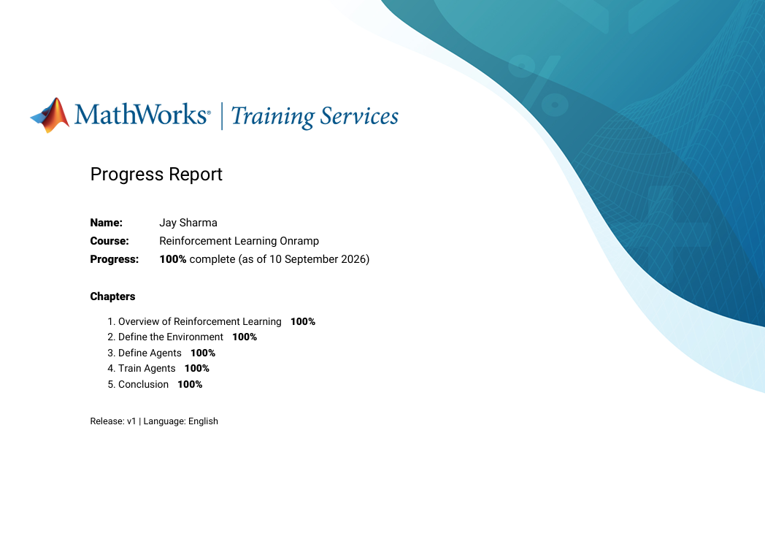

Figure 1 — Reinforcement Learning Onramp course completion

Figure 4: Course Completion Certificate
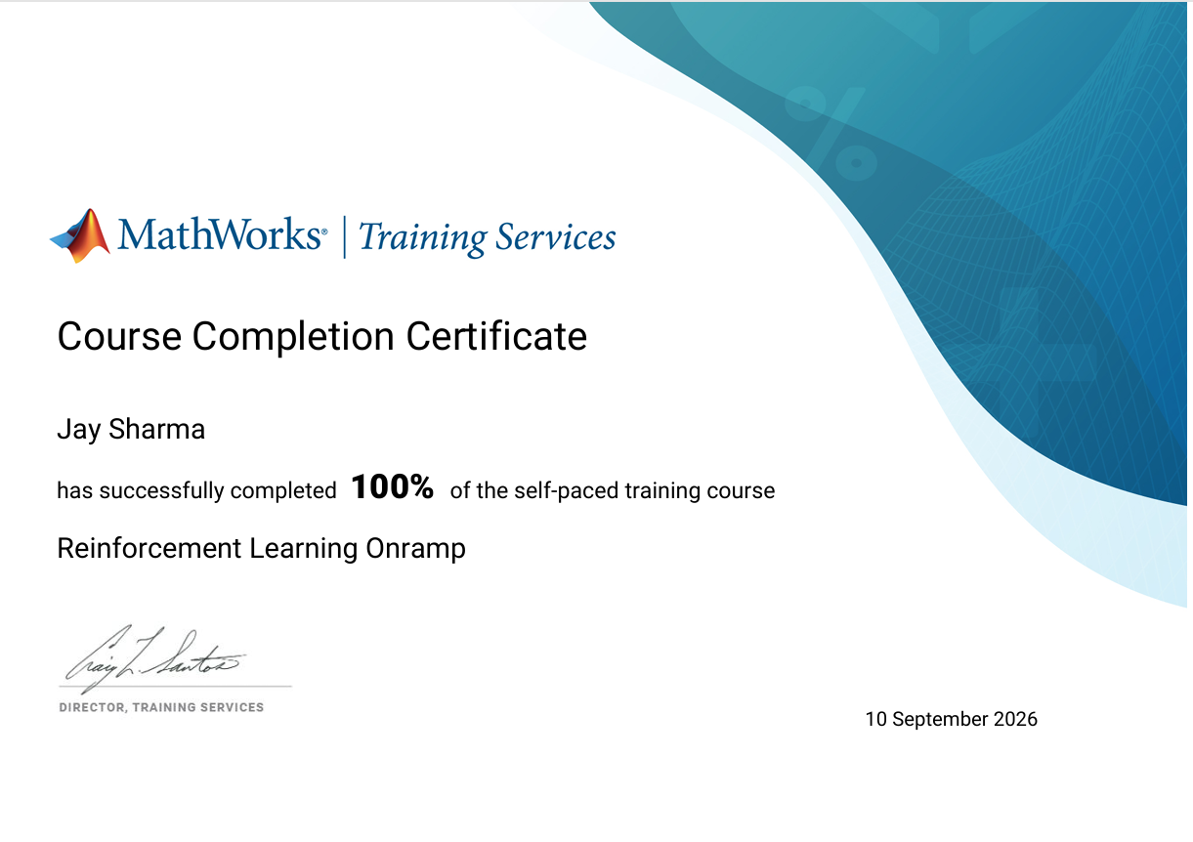

Figure 4 — MathWorks Reinforcement Learning Onramp certificate

7. Conclusion
The MATLAB Reinforcement Learning Onramp course was completed in full, including all modules, programming exercises, and assessments, and the official course completion certificate was obtained. Through the course, the reinforcement learning workflow — defining the environment and reward, creating an agent, and training and validating it — was understood and applied. The reinforcement learning agent was trained successfully, and its learning curve was captured and analysed. The analysis showed the characteristic pattern of low and noisy initial rewards, a steady improvement as the policy was refined, fluctuation around an upward trend, an approximate convergence where the reward plateaued, and a strong and stable final performance. This confirms that the agent learned an effective policy for the task through reinforcement learning.

