UTD Free and For Sale

UberTrix

* Install Visual Studio 2013
* Install Microsoft SQL Server 2013
* Install Microsoft SQL Server Management Studio 2013
* Import the Project given inside the compressed file
  + Open Visual Studio 2013
  + Go to File -> Open -> Project/Solution
  + Open the folder where the Project is stored
  + Click Open
* Next thing is to create a Database. Open SQL Server Management Studio 2013
* Click on Connect

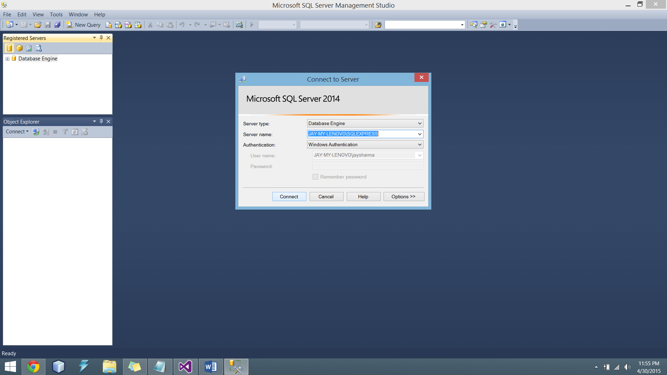

* Right-Click Database in Object Explorer. Click On New Database

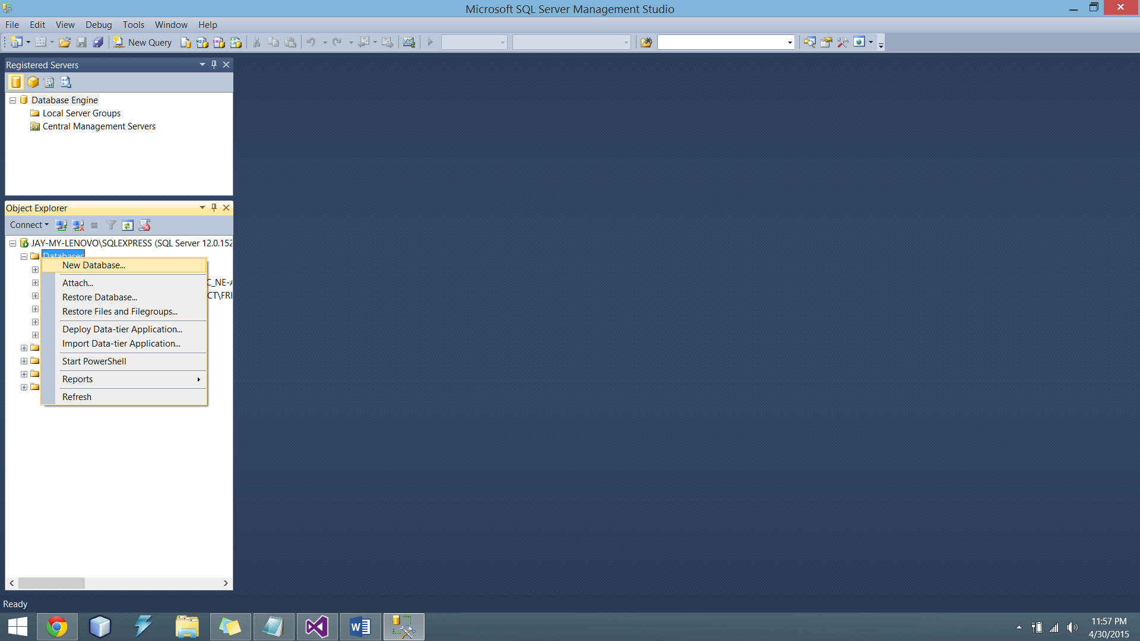

* Enter Name of Database as ‘UTD’. Click OK

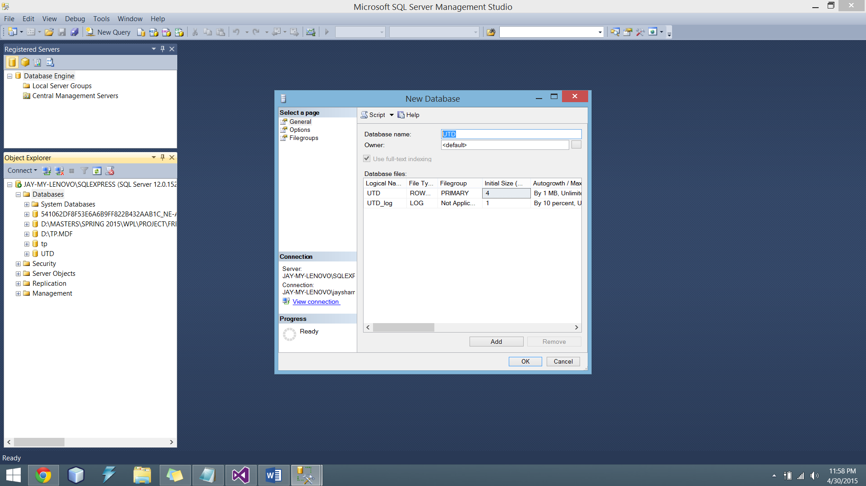

* Now open UTD_Queries.sql provided in the folder and fire the queries under the database UTD
* Next Step is to connect our database to Visual Studio 2013. Go to Visual Studio 2013. Right Click the Solution. Click on Add -> ADO.NET Entity Data Model

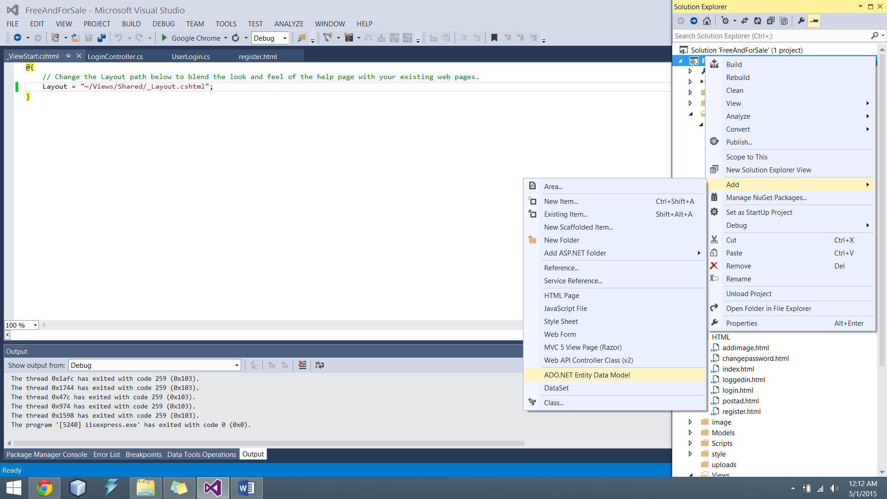

* Select Generate from Database. Click Next

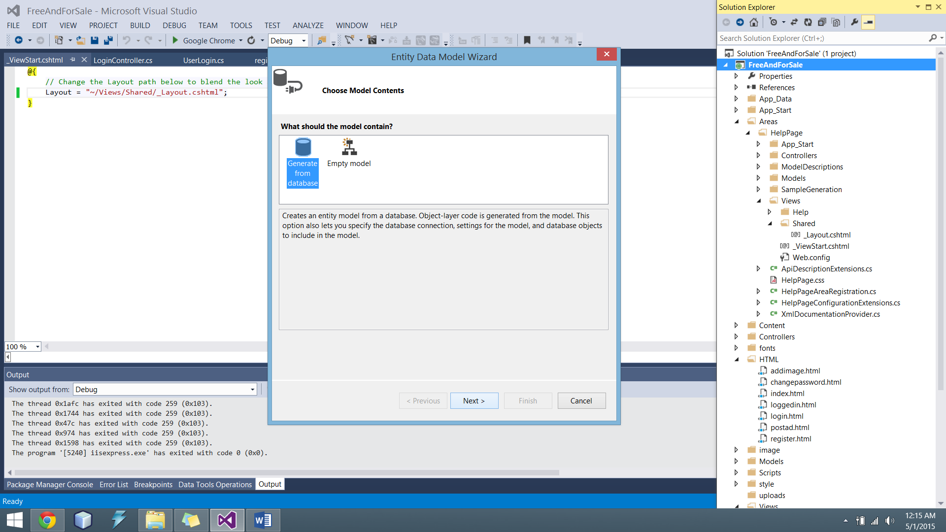

* Click on New Connection

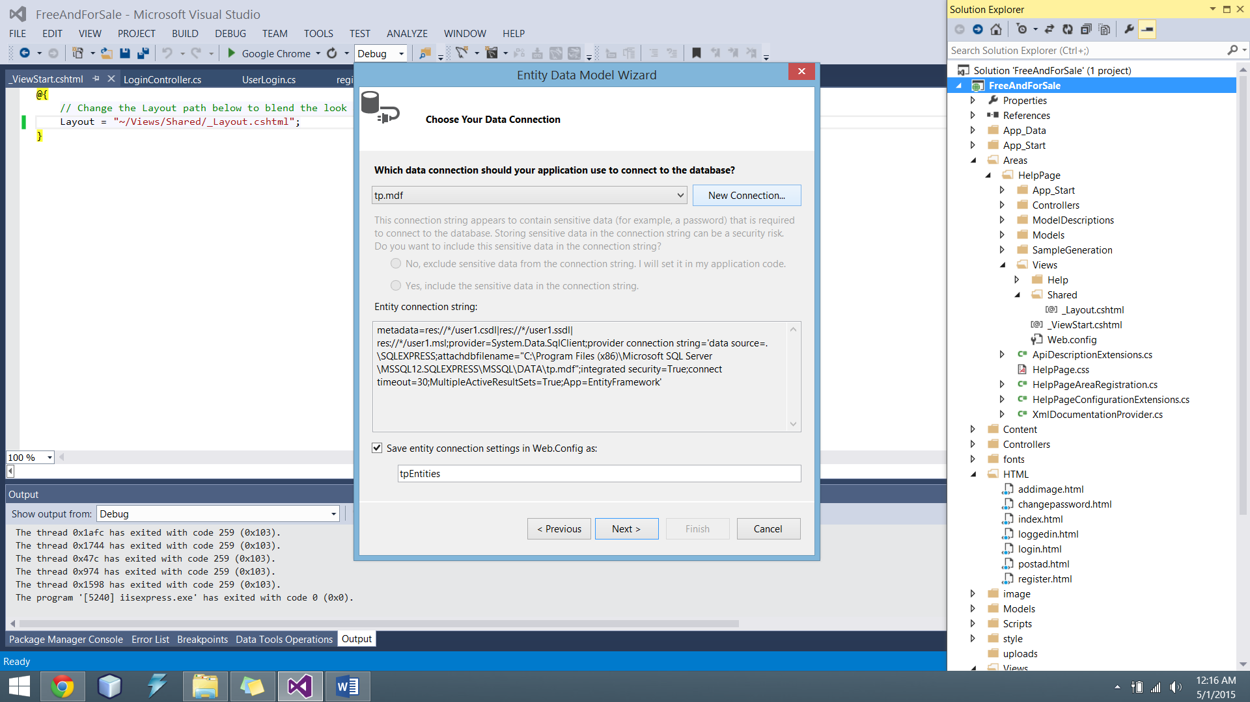

* Select Microsoft SQL Server Database File. Then Click Continue.

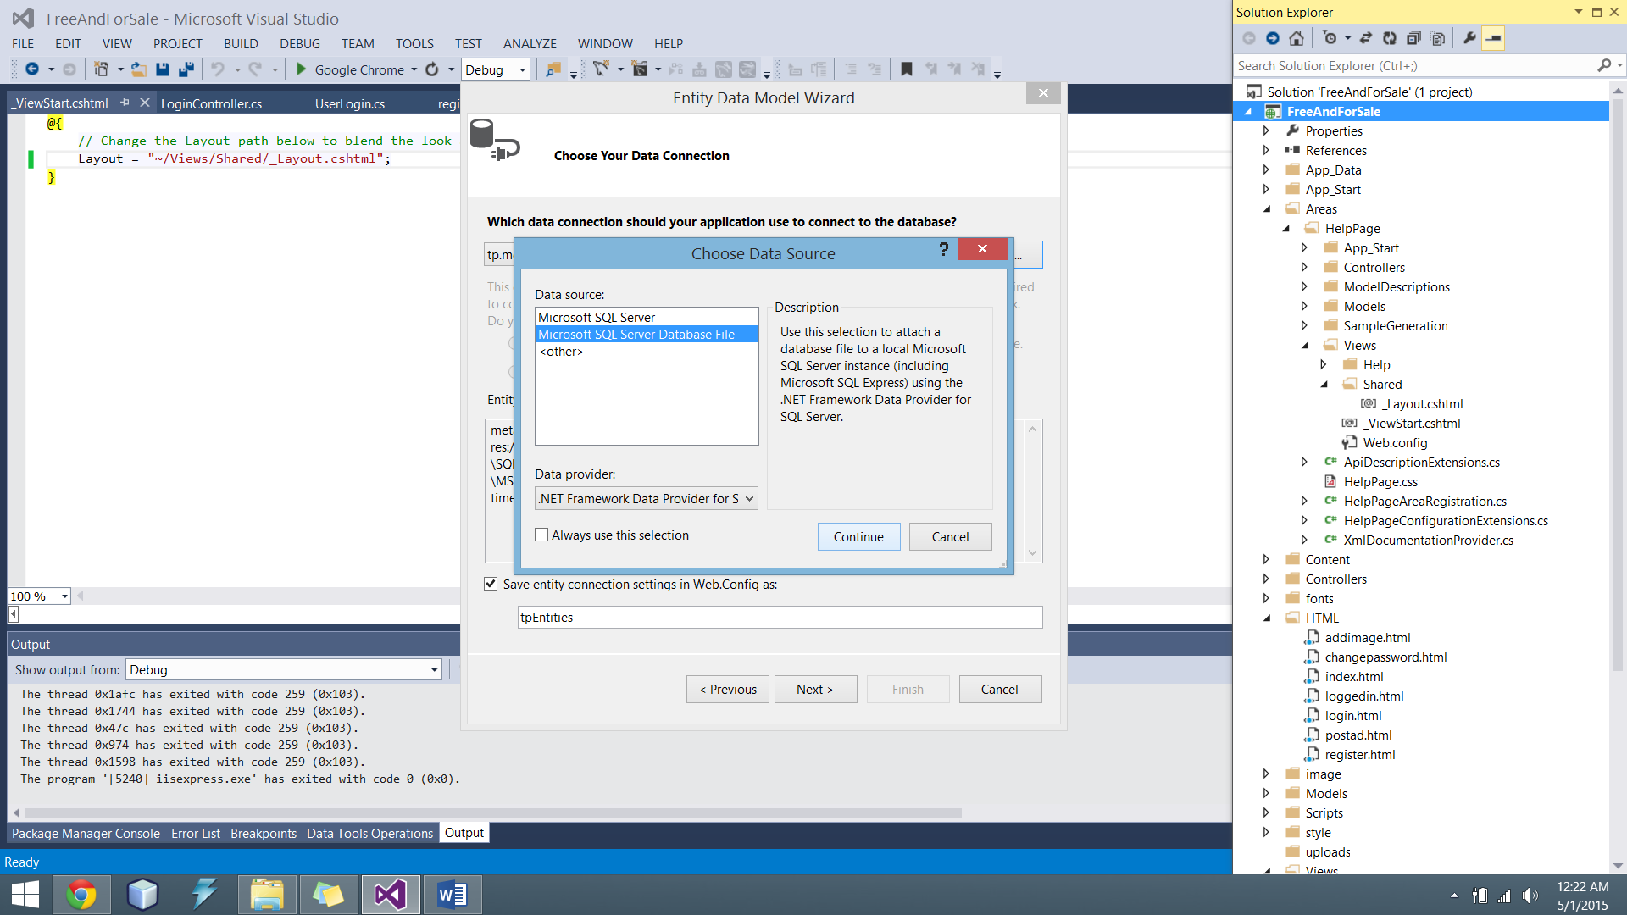

* Import the Database file using Browse Button



* Click Ok. Then Click Finish. Database will then be integrated with our Solution
* The project is set up successfully. Run the project and the website will be loaded.