AWS NETWORKING PROJECT
VPC Peering
& Private Connectivity
GitHub Portfolio Report • Architecture • Configuration • Evidence • Validation
PROJECT: EWB VPC Peering Lab
STUDENT: Kartikey Sharma
REGION:
DATE: 28 October 2026
BUILD • ROUTE • TEST • EXPLAIN
Purpose: demonstrate private IPv4 communication between two non-overlapping VPCs using VPC peering, explicit routes, least-privilege security group rules, and a bastion host for administration

EVIDENCE STATUS: CONFIGURATION SCREENSHOTS PROVIDED • CONNECTIVITY TESTS STILL NEED
TERMINAL PROOF

01 | Project Overview

This project connects two Amazon Virtual Private Clouds (VPCs) through a VPC peering connection. App-A and App-B remain on private IPv4 addresses without public IPs. A bastion host in VPC A provides an administrative SSH entry point.

Objective | Implementation | Proof required
Connect two private workloads | VPC peering + routes in both directions | Forward and reverse ping output
Keep application instances private | No public IPv4 on App-A or App-B | EC2 details screenshots
Limit administrative access | SSH via bastion; source-scoped security groups | Successful SSH to App-A and App-B
Show security control works | Remove and restore App-B ICMP Echo  Request rule | Failure followed by recovery

Project outcomes
- Practice CIDR planning and subnet design.
- Configure internet gateway and explicit route table associations.
- Create, accept, and activate a peering connection.
- Understand forward and return routing.
- Validate security rules with positive and negative tests.
Scope note: this report is based on the two supplied PDFs. It does not connect to your AWS account, so resource
states and test outcomes must be verified from your own console and terminal.

02 | Architecture & Address Plan

The two VPC CIDR blocks do not overlap. VPC B has no internet gateway and does not gain internet access through VPC peering.

 | LAPTOP  Local ewb-lab.pem  SSH / ProxyJump |  | BASTION  VPC A public subnet  10.10.1.10 + public IPv4 |  | VPC PEERING pcx-…  Private routes both ways
 | VPC A — 10.10.0.0/16  Public: 10.10.1.0/24  Private: 10.10.2.0/24  App-A: 10.10.2.10 |  | Route to VPC B  10.20.0.0/16 → pcx-ID  Public & private RTs |  | VPC B — 10.20.0.0/16  Private: 10.20.1.0/24  App-B: 10.20.1.10  No public IP
Resource |  | CIDR / Private IP |  | Notes
ewb-vpc-a |  | 10.10.0.0/16 |  | VPC A
ewb-a-public |  | 10.10.1.0/24 |  | Bastion subnet; route to IGW
ewb-a-private |  | 10.10.2.0/24 |  | App-A private subnet
ewb-vpc-b |  | 10.20.0.0/16 |  | VPC B; no internet gateway
ewb-b-private |  | 10.20.1.0/24 |  | App-B private subnet
ewb-bastion / ewb-app-a / ewb-app-b |  | 10.10.1.10 / 10.10.2.10 / 10.20.1.10 |  | Set the planned addresses only if available

Important: AWS reserves the first four and last IPv4 address in each subnet. For 10.10.2.0/24, 10.10.2.1 is reserved by AWS; use the planned host address 10.10.2.10 if available.

03 | Routing & Security Design

A peering connection alone does not route packets. Each relevant subnet route table needs a route to the other VPC, and security groups must permit the required traffic.

Route table | Destination | Target | Purpose
ewb-rt-a-public | 10.10.0.0/16 | local | Local VPC A traffic
ewb-rt-a-public | 0.0.0.0/0 | ewb-igw-a | Bastion internet entry/egress path
ewb-rt-a-public | 10.20.0.0/16 | pcx-ID | Bastion to App-B via peering
ewb-rt-a-private | 10.10.0.0/16 | local | Local VPC A traffic
ewb-rt-a-private | 10.20.0.0/16 | pcx-ID | App-A to App-B
ewb-rt-b-private | 10.20.0.0/16 | local | Local VPC B traffic
ewb-rt-b-private | 10.10.0.0/16 | pcx-ID | Return path to VPC A

Security group checklist
Security group | Inbound rule | Source
ewb-sg-bastion | SSH TCP 22 | Your current public IPv4 /32
ewb-sg-app-a | SSH TCP 22 | 10.10.1.10/32 (bastion)
ewb-sg-app-a | ICMPv4 Echo Request | 10.20.1.10/32 (App-B)
ewb-sg-app-b | SSH TCP 22 | 10.10.1.10/32 (bastion)
ewb-sg-app-b | ICMPv4 Echo Request | 10.10.2.10/32 (App-A)

Keep SSH restricted. Do not use 0.0.0.0/0 as the SSH source. Default outbound rules are assumed for this beginner lab; custom network ACLs require return-traffic rules too.

04 | Access & Verification Commands

Use the commands below from the relevant machine. Replace placeholders only with actual values. Save terminal screenshots with the command and its complete result visible.

On your laptop (WSL / macOS / Linux)
ssh ewb-bastion ssh ewb-app-a ssh ewb-app-b

On App-A — baseline before peering routes, then repeat after configuration
hostname hostname -I ping -c 4 10.20.1.10

On App-B — reverse-direction test
hostname hostname -I ping -c 4 10.10.2.10

Expected evidence
Test | Expected result | Evidence status in supplied report
Baseline App-A → App-B ping before peering routes | No replies
App-A → App-B ping after routes | 4 replies; 0% packet loss
App-B → App-A ping after routes | 4 replies; 0% packet loss
ssh ewb-app-b through bastion | Shell opens on App-B
Remove App-B ICMP rule, ping; restore rule, ping again | Fail while removed; recover after restore

05 | Troubleshooting Guide
Symptom | Check in this order
Bastion SSH times out | Current bastion public IPv4 → your current public IP /32 in bastion SG → public subnet route table association → 0.0.0.0/0 route to attached IGW → instance status checks.
Permission denied (publickey) | Correct key pair → correct local IdentityFile path and file permissions → ec2-user username. If authentication is reached, network routing is likely working.
App-A SSH fails | App-A private IP → TCP 22 source 10.10.1.10/32 → same key pair → running instance.
App-B SSH fails | Public route table has 10.20.0.0/16 → pcx-ID → VPC B return route 10.10.0.0/16 → pcx-ID → App-B SG allows TCP 22 from bastion private IP.
Ping fails after peering is Active | Check Active state → both private route tables → correct pcx-ID → destination ICMP Echo Request rule → actual private IPs → OS firewall.
Peering request cannot be created | Inspect all CIDRs associated with both VPCs, including secondary CIDRs, for overlap.
Launch rejects 10.10.2.1 | AWS reserves .0 network, .1 VPC router, .2 DNS, .3 future use, and the final address in each IPv4 subnet. Use a valid host IP such as 10.10.2.10 if available.

Viva questions to prepare
- Why is a return route required?
- Why does App-B see the bastion private IP as the SSH source?
- Why does Active peering not guarantee successful ping?
- Can VPC B use VPC A’s internet gateway through peering? (No.)
- Why are non-overlapping CIDRs necessary?

06 | Supplied AWS Console Evidence

The existing report contains labelled console evidence pages.
These screenshots are retained as configuration context;
They should not be treated as proof of terminal connectivity unless the actual command output is visible.
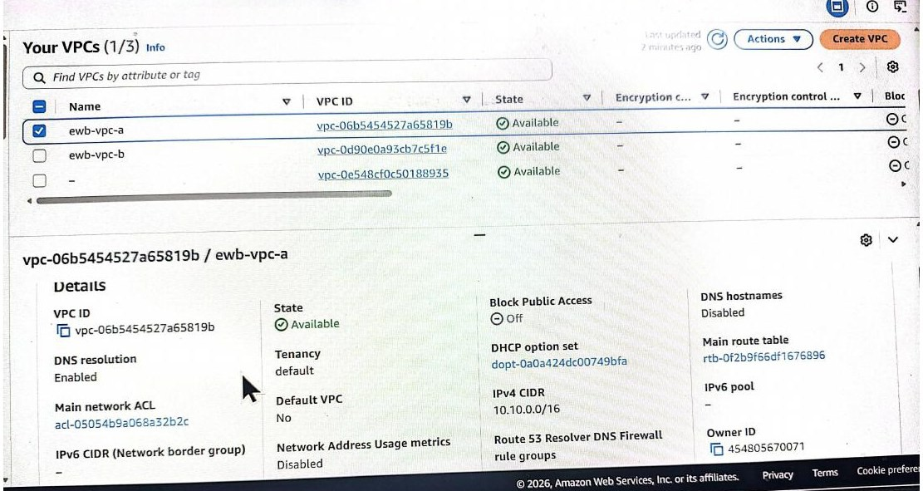
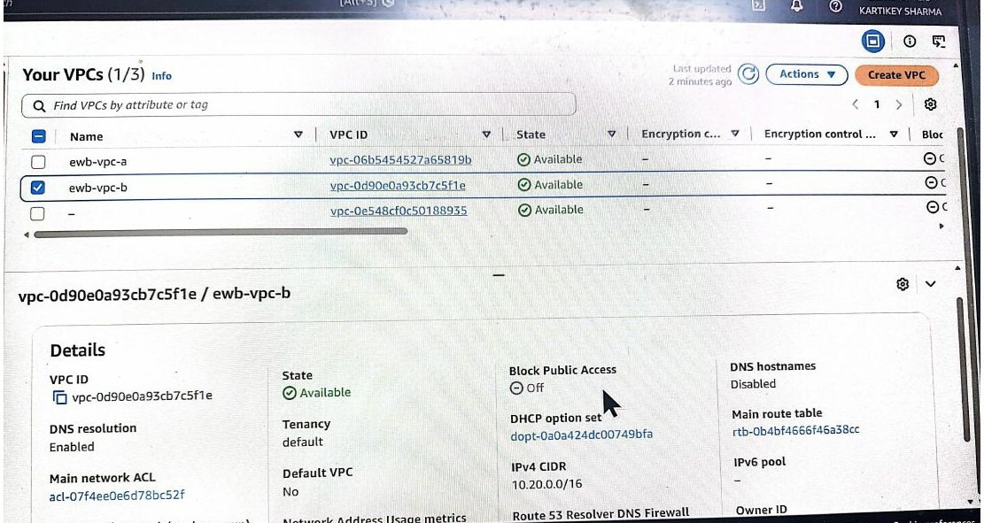
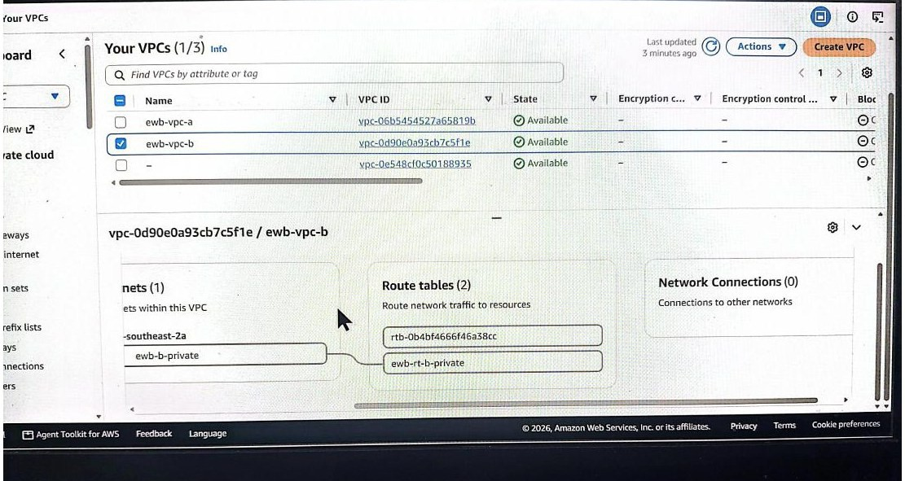
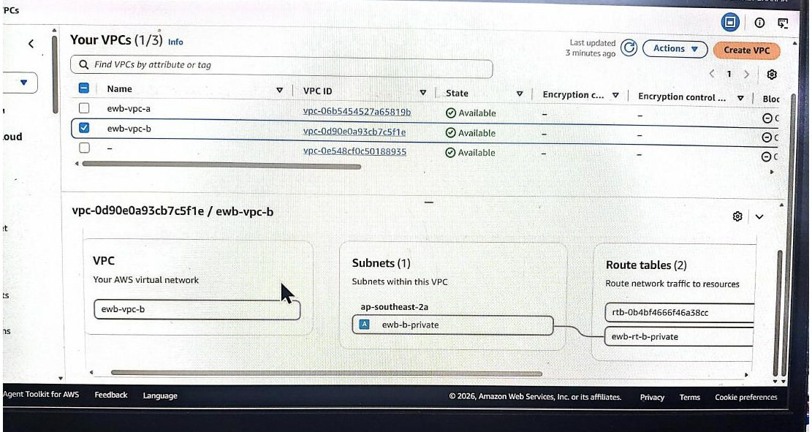
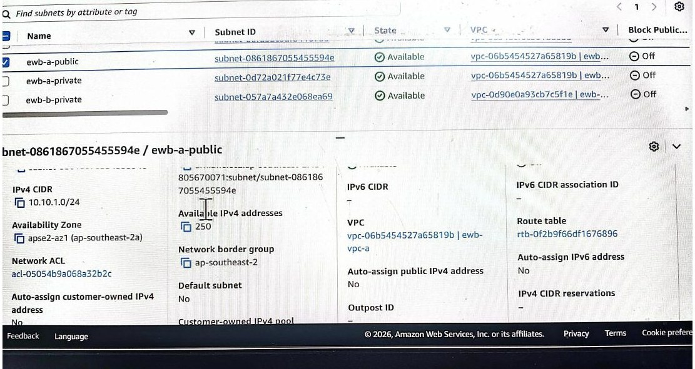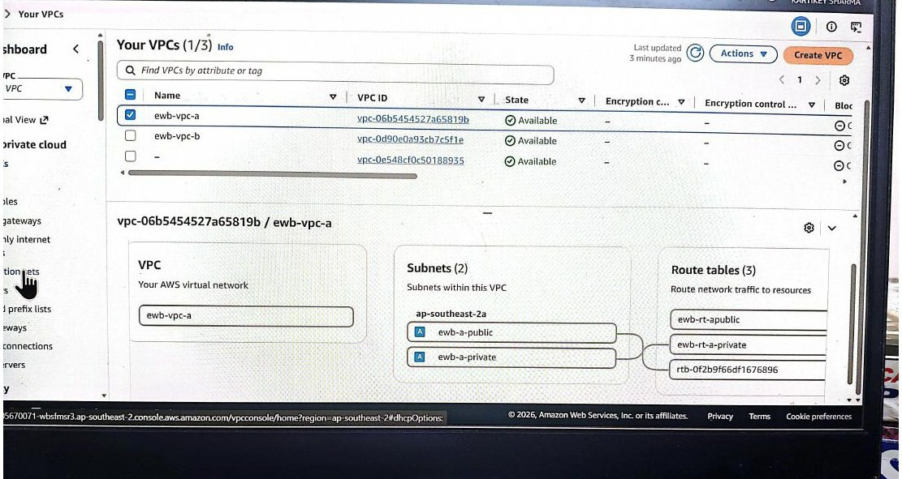
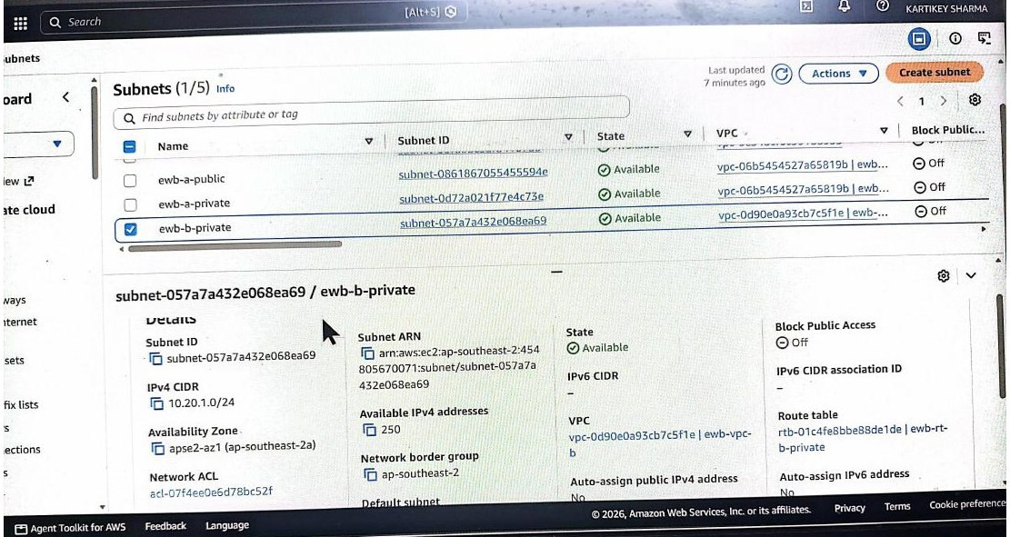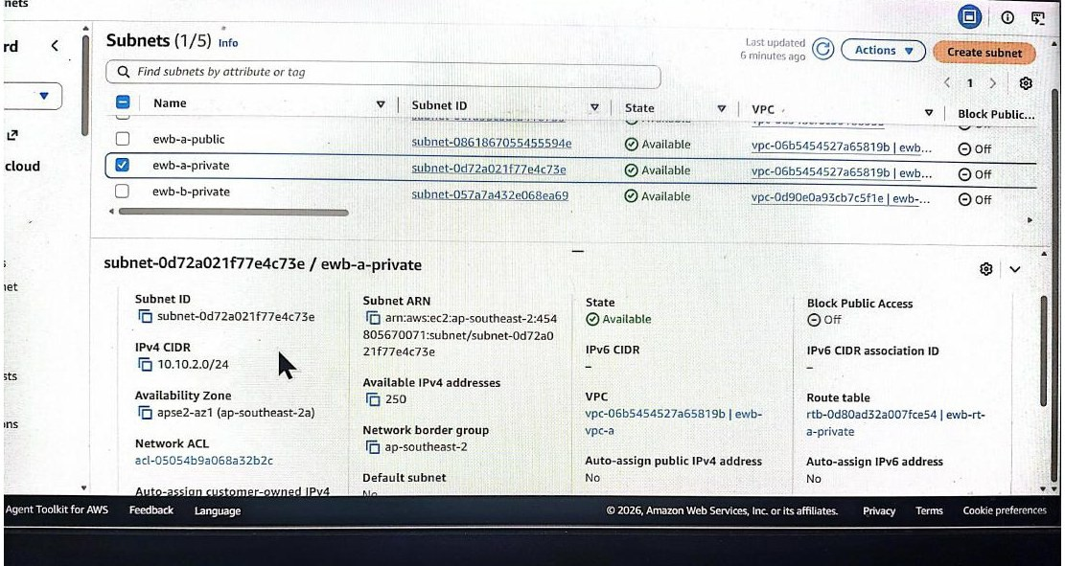

07 | Cleanup & Submission Checklist

Save all required evidence before deleting resources. AWS usage can incur charges depending on resources, region, and account credits.

Cleanup sequence
- Terminate ewb-bastion, ewb-app-a, and ewb-app-b.
- Check for remaining EBS volumes, snapshots, and Elastic IP allocations created for the lab.
- Delete peering routes and the ewb-a-b-peer connection.
- Delete lab security groups after dependent network interfaces are gone.
- Remove subnet associations as needed; delete lab subnets and custom route tables.
- Detach and delete ewb-igw-a; delete both lab VPCs.
- Verify remaining resources and Billing in the same Region. Billing updates may lag.

Final report completion checklist

Item | Status
Name, batch, Region and completion date | Fill in actual details
Resource IDs and current private IPs | Missing — record from AWS console
Active peering + all routes | Capture / verify
Security group rules | Capture / verify
Real SSH and ping outputs | Missing — must capture
Controlled ICMP failure and recovery | Missing — must capture
Cleanup status | Record actual status

Final note
This enhanced report organizes the supplied project material, adds a clearer architecture and routing explanation, includes troubleshooting and GitHub guidance, and lists the missing evidence. It does not independently verify live AWS resources. Update the evidence status after capturing real results.

Learn • Elevate • Empower | AWS Networking Portfolio Project

Area | Expected configuration
VPC peering | Peering connection status should be Active
Public route table | 0.0.0.0/0 → attached Internet Gateway; 10.20.0.0/16 → peering connection
VPC A private route table | 10.20.0.0/16 → peering connection
VPC B private route table | 10.10.0.0/16 → peering connection
Bastion security group | SSH TCP 22 from your current public IP /32
App security groups | SSH TCP 22 only from intended bastion/private source; ICMP echo allowed as required for testing

AWS VPC PEERING CONNECTION
Supplementary Results & Terminal Demonstration Appendix

Evidence integrity notice

Project resources represented in this report

VPC A: ewb-vpc-a — 10.10.0.0/16; public subnet ewb-a-public — 10.10.1.0/24; private subnet ewb-a-private — 10.10.2.0/24. VPC B: ewb-vpc-b — 10.20.0.0/16; private subnet ewb-b-private — 10.20.1.0/24. Planned hosts: bastion10.10.1.10, App-A 10.10.2.10, App-B 10.20.1.10.
Expected route and security configuration

Terminal illustration: Bastion SSH
output only

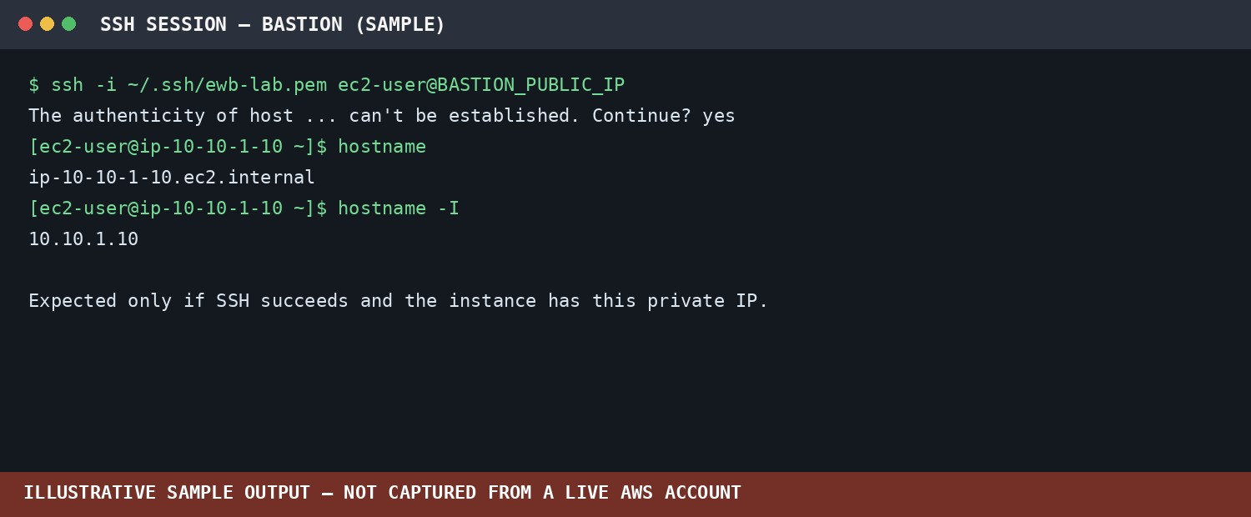

Terminal illustration: App-A → App-B ping
output only 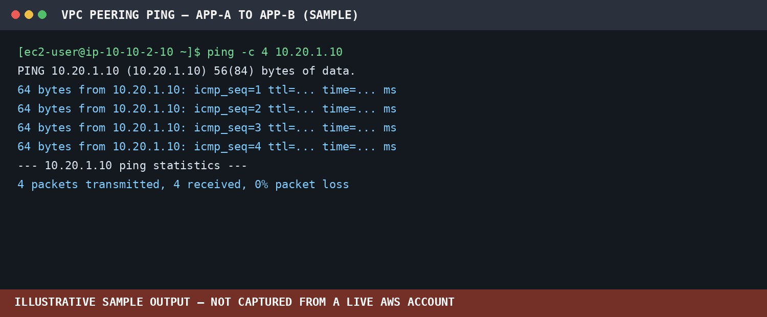

Terminal illustration: App-B → App-A ping
output only

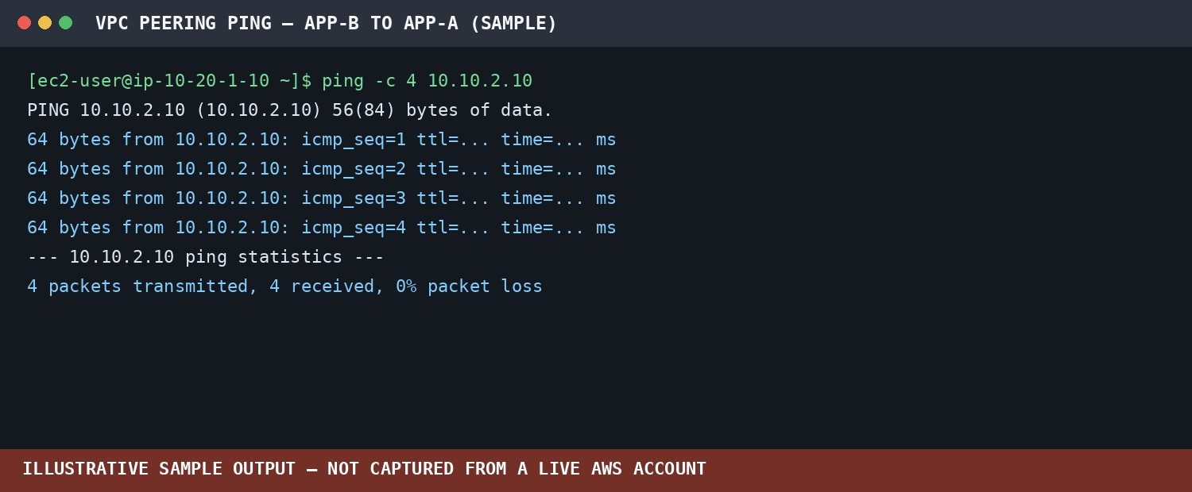
Terminal illustration: SSH to App-B through bastion
Illustrative output only — replace with a genuine terminal screenshot from your own run.
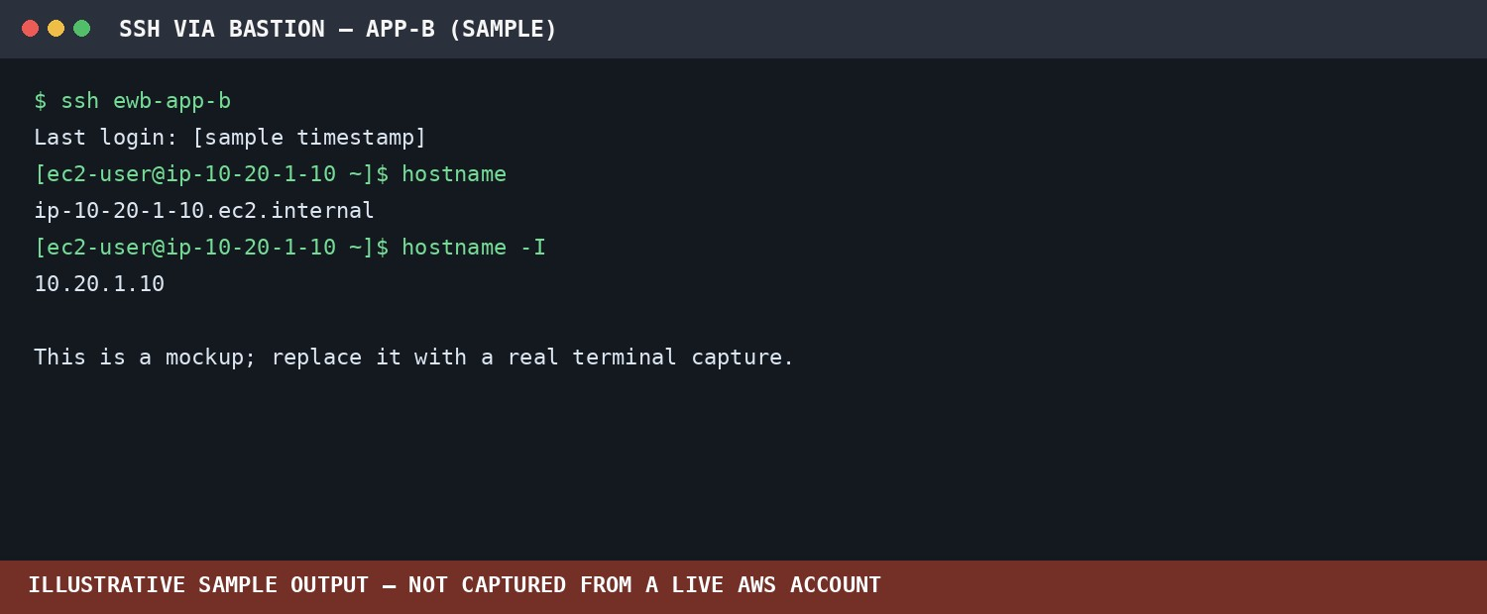

How to produce genuine proof of connectivity
- Confirm the peering connection is Active and capture the Peering connections page.
- Capture the Routes tab for ewb-rt-a-public and both private route tables, including targets.
- Capture Subnet associations showing ewb-a-public associated with ewb-rt-a-public.
- Connect to the bastion and run: hostname; hostname -I
- Connect to App-A and run: hostname; hostname -I; ping -c 4 10.20.1.10
- Connect to App-B and run: hostname; hostname -I; ping -c 4 10.10.2.10
- Capture the real terminal window with command and full output visible; do not alter results.
- If a test fails, record the failure and fix routes/security groups before retesting.
- Never include ewb-lab.pem, private keys, AWS access keys, passwords, or other secrets in the PDF or GitHubrepository.

